FARM DATABASE MANAGEMENT

ABSTRACT:

India is called the land of farmers, as most of the people of the country are directly or indirectly involved in the agriculture sector.

It would not be wrong to say that 'Indian farmers' are the backbone of the economy and the farmers are indeed the beloved children of Mother India.

Creating a Farm database would be beneficial for farmers as to track their crop’s prices, which month they were sowed and harvested, their quality and to pay due wages to their farm labours of their work.

Here I have tried to create a dummy database of farm database management system.

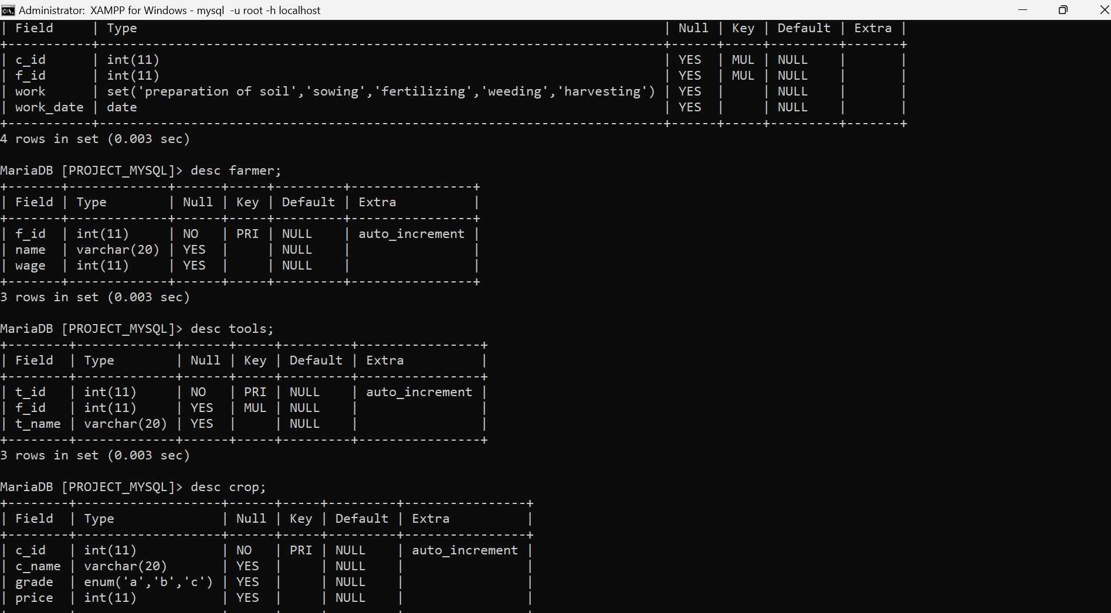Desc table_name:

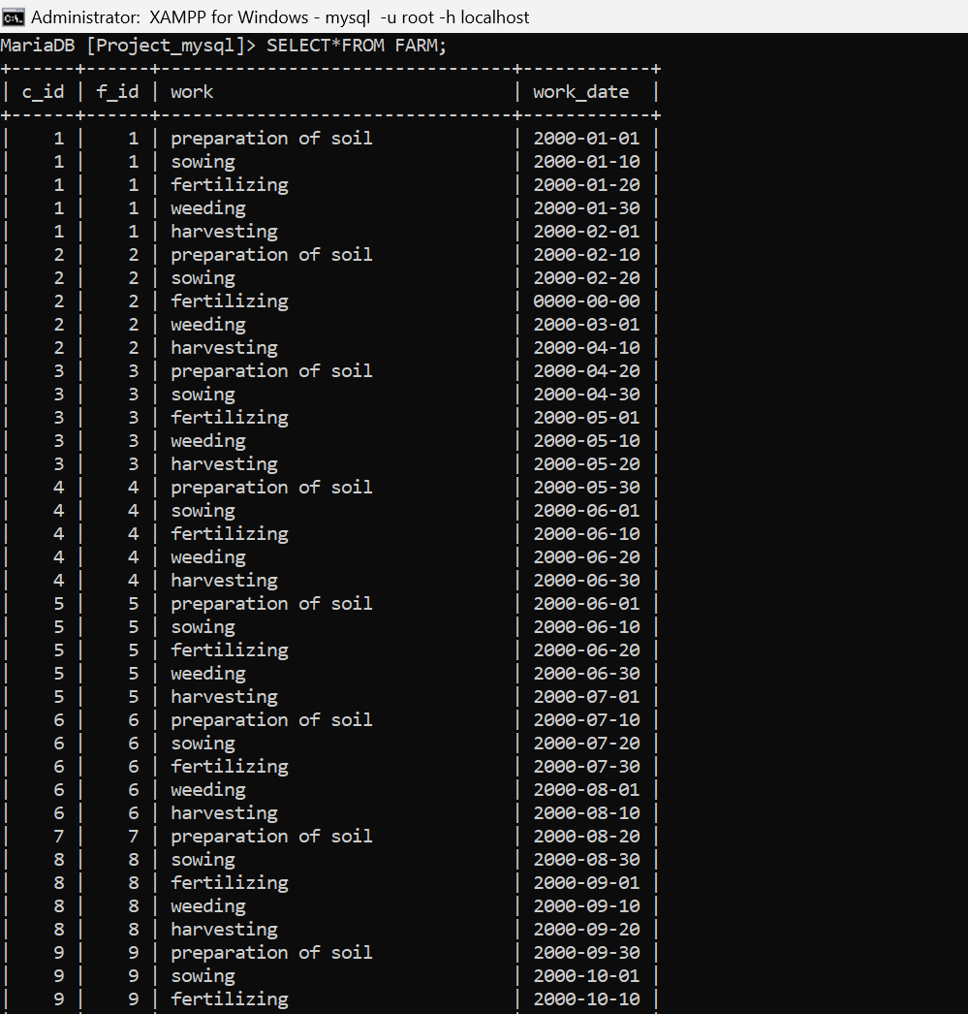Select*from

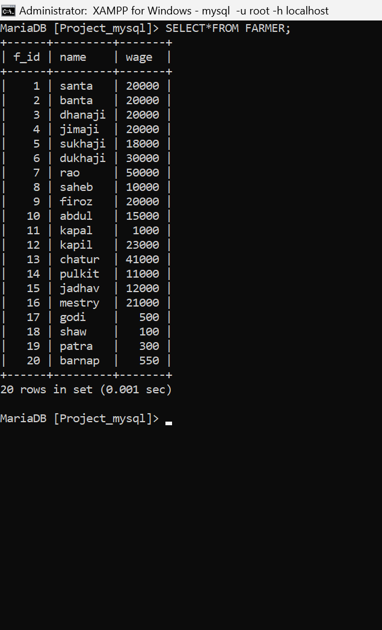

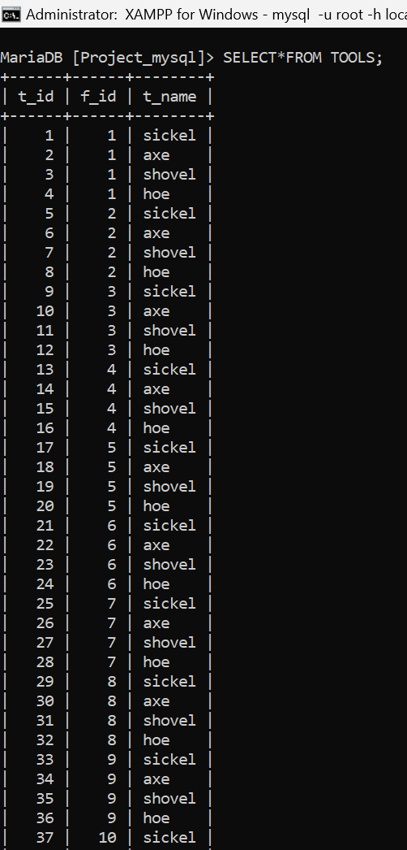

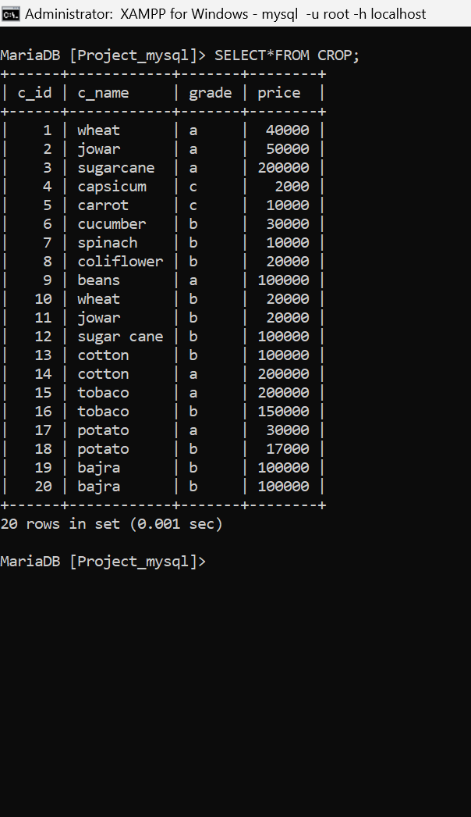

VIEWS:

CREATE VIEW WORK_OF_A_FARMER AS SELECT WORK,WORK_DATE FROM FARM WHERE F_ID=8;

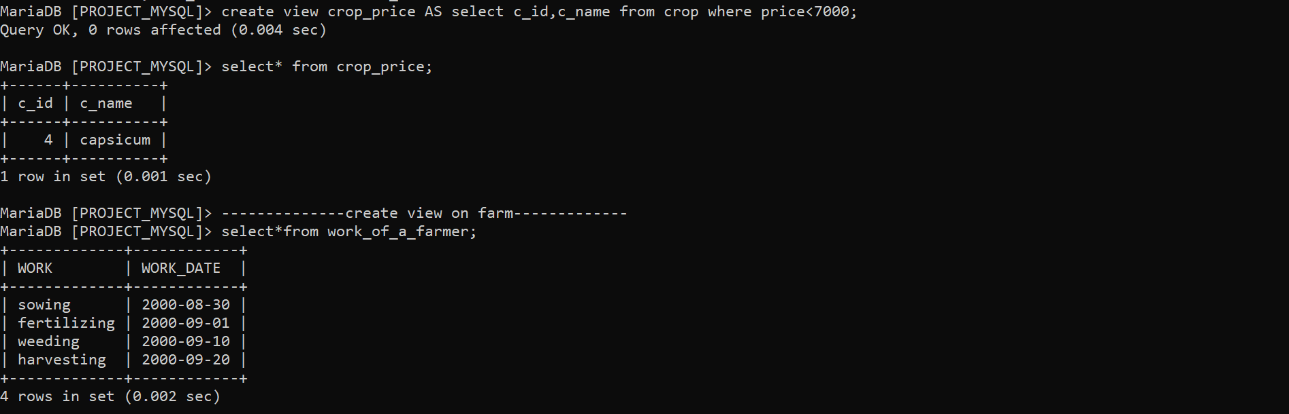CREATE VIEW CROP_PRICE AS SELECT C_ID,C_NAME FROM CROP WHERE PRICE<7000;

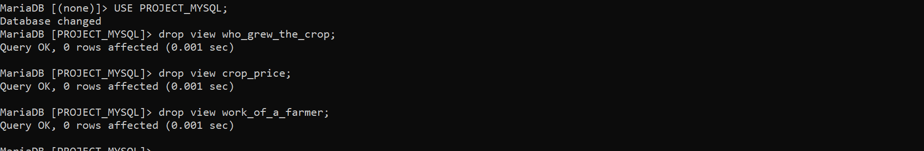DROP VIEWS:

JOINS- INNER JOIN

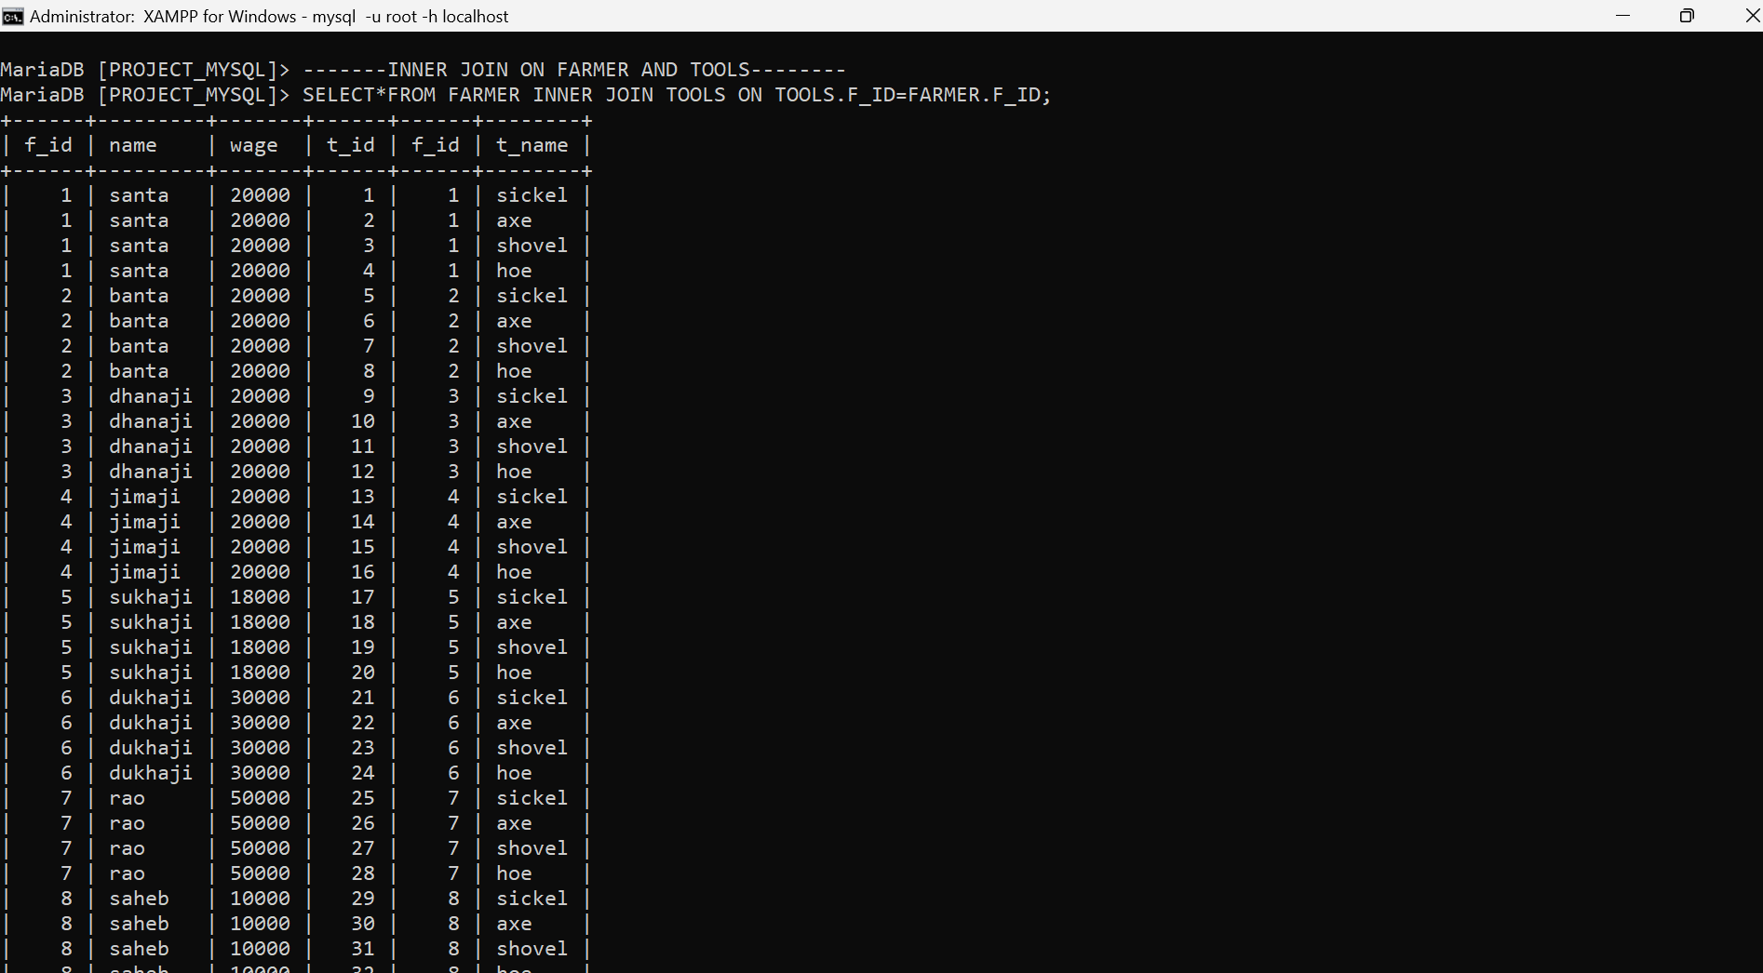SELECT*FROM FARMER INNER JOIN TOOLS ON TOOLS.F_ID=FARMER.F_ID;

RIGHT JOIN-

select farm.f_id,farm.work,farm.work_date,crop.c_name from farm right join crop on farm.c_id=crop.c_id;

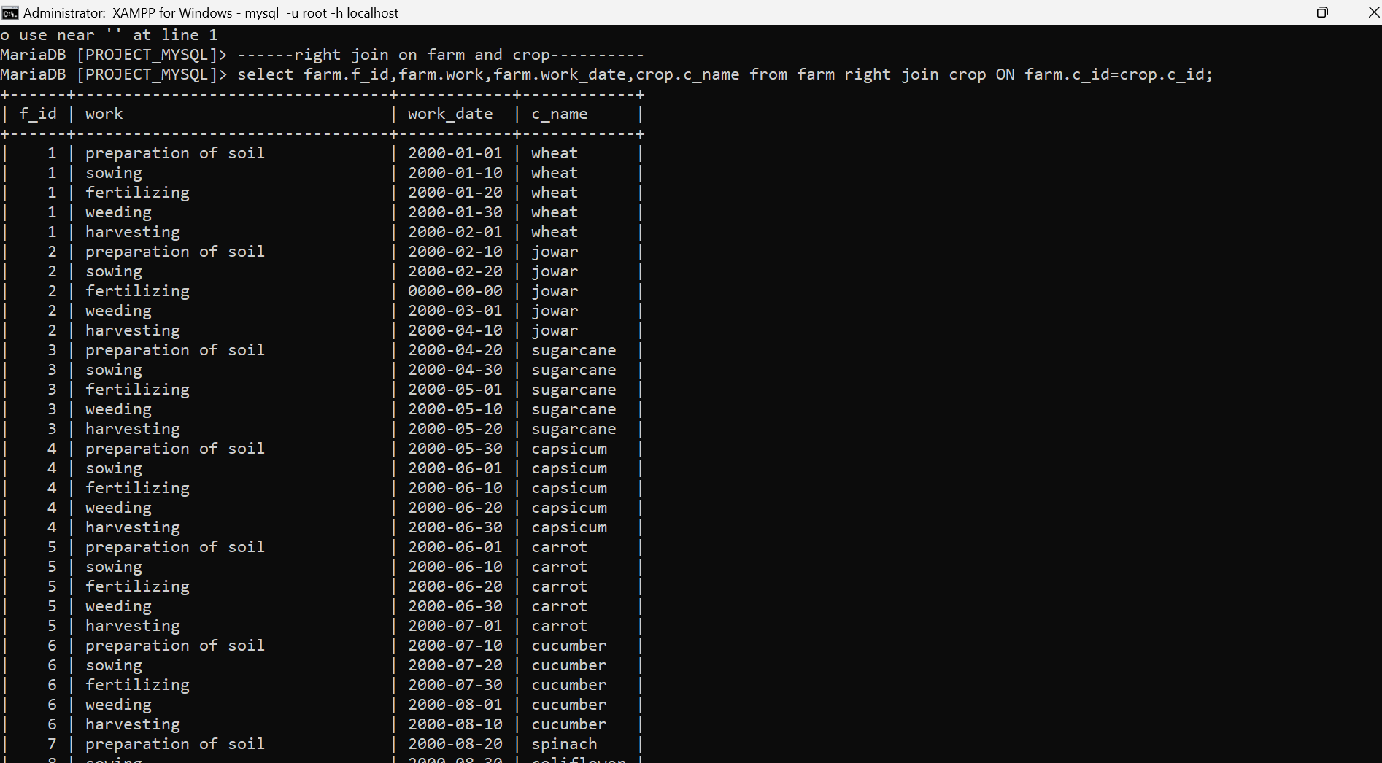

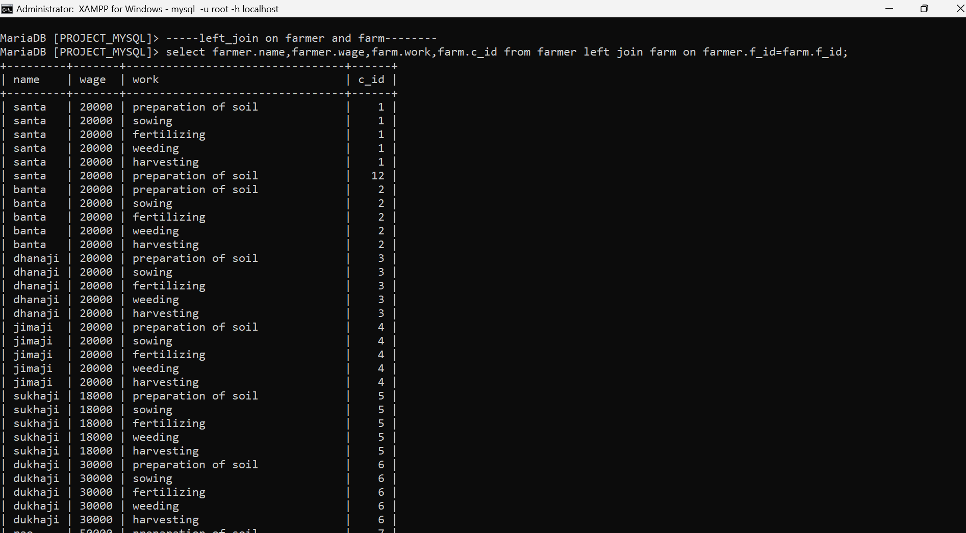left join-select farmer.name,farmer.wage,farm.work,farm.c_id from farmer left join farm on farmer.f_id=farm.f_id;

sub query 1- to display c_id and c_name of crops who’s price is greater than 20000

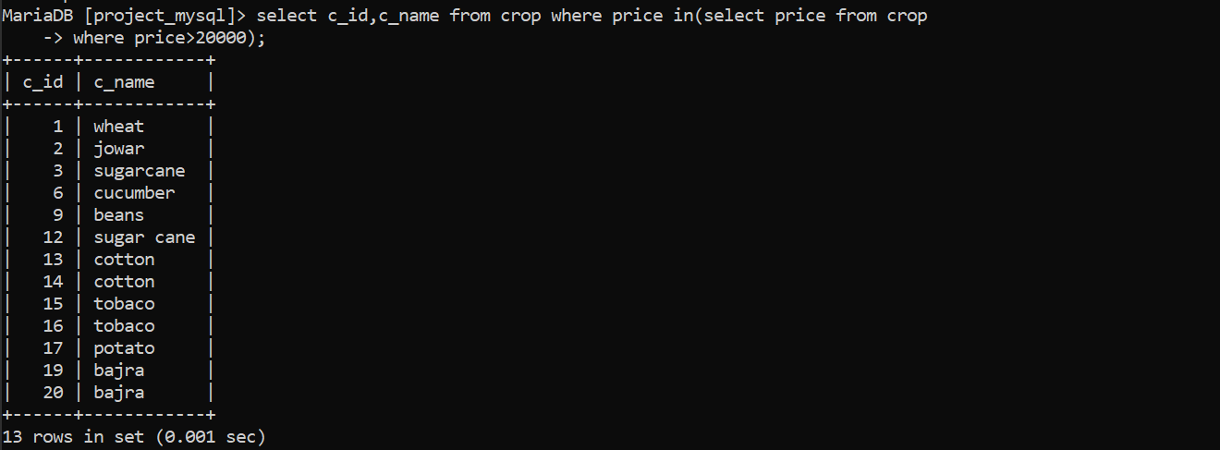

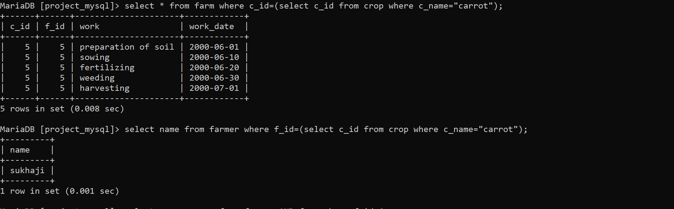sub query 2- to display c_id,f_id , work and work_date of crop carrot

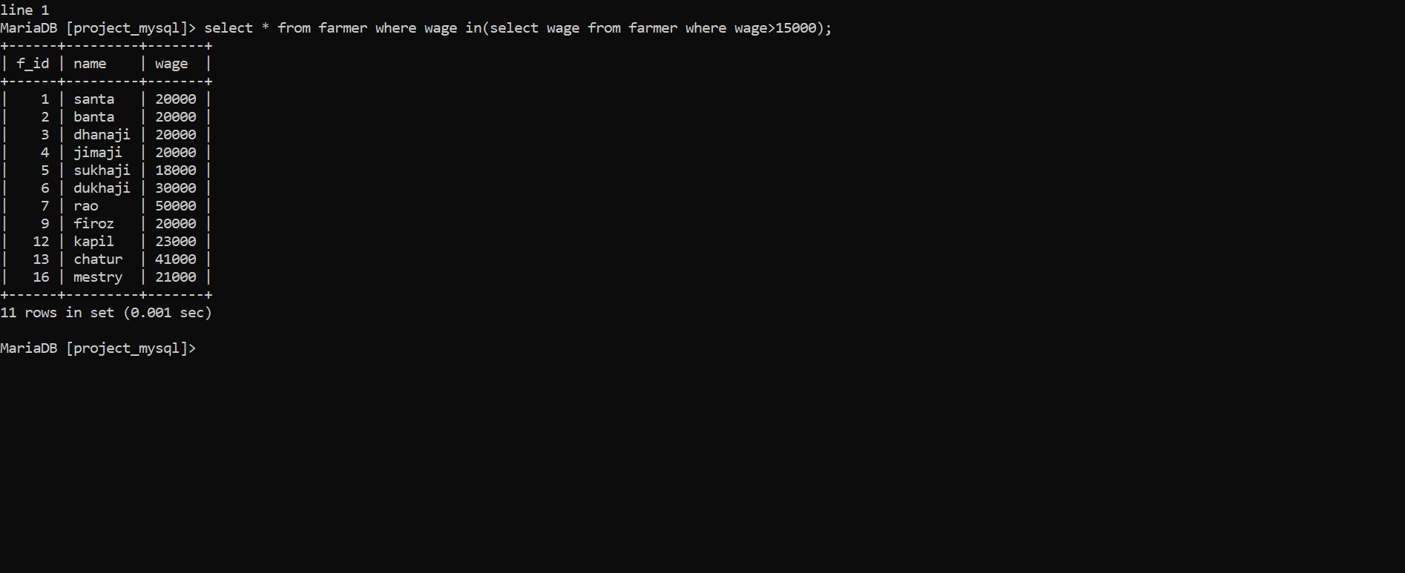sub query 3- to display farmers details who’s wage is greater than 15000

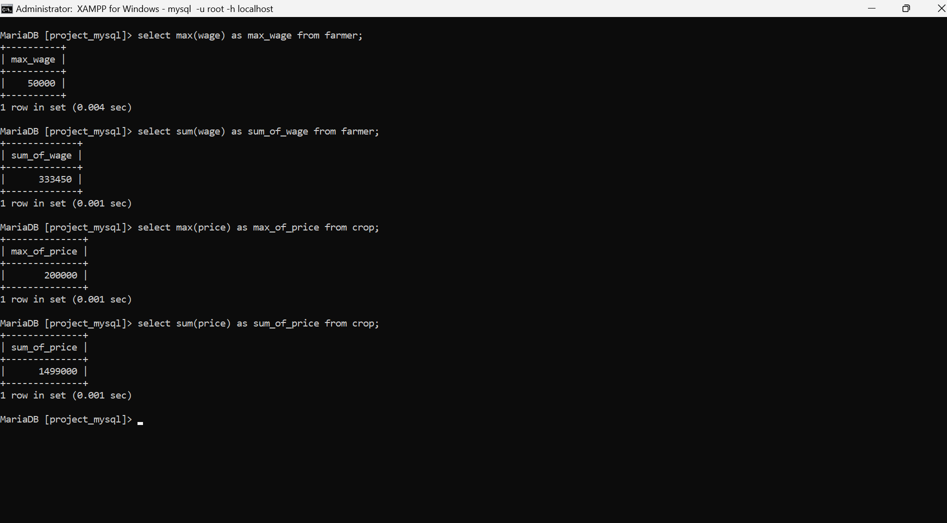AGGREGATE FUNCTIONS: