Report Front Sheet
Molecular Biology, Master Course
EXPERIMENTAL CELL BIOLOGY
Name of Experiment: |  | Exercise 1: Cell counting and NaBu treatment
Date for performance of experiment: |  |  |  |  |  | 15-06-2026 – 19-06-2026
Teacher: | Ole Vang
Team | Green |  |  |  |  | Group Number: |  |  | 3
Experiment was performed by: |  |  | Andreas Giovanni Olesen, Lars Christoffersen, Line Trust
 |  |  | Names and signatures
- - - - - - - - - - - - - - - - - - - - - - - - - - - - - - - - - - - - - - - - - - - - - - - - - - - - - - - - - - - - - - - - - - - - -
Date(s) for handing in the report to the teacher:
Date for 1. time |  |  |  | Date for 2. time |  |  |  | Date for 3. Time
Teacher comments:
1) Remember the figure legends; 2) describe the results in the text; 3) Discuss your results, relate to expected results; 4) use the questions in the manual for the discussion
Report approved by teacher:
 |  |  |  |  |  |  | Signature |  |  | Date
This is the front page for the reports and has to be attached to the report. The original front page should be attached when a revised report is handed in.
The Biology Study Board
Exercise 1 Cell Counting and NaBu treatment

Sub cultivation, and growth rate
- Include your laboratory notebook (scan the pages related to experiment 1)
- Briefly, describe challenges in generating reproducible data using cells growing in culture.
It can be challenging to generate reproducible data in cell culture experiments because of sensitivity to handling procedures and environments. Every person handles the cell culture differently, and the environment can also change. Even if you try to mimic, the cells can still be sensitive to any changes. Factors such as batches can change, and therefore also affect reproducibility.
- How were the on-going cell cultures growing? Which challenges did you experienced?

Mangler billede. Venter på at det bliver uploadet på moodle. | 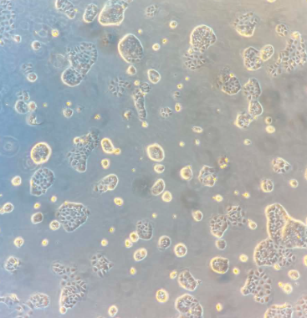
Caco-2 2026.06.17 magnification 10x | Caco-2 2026.06.18 magnification 10x

Mangler billede. Venter på at det bliver uploadet på moodle. | 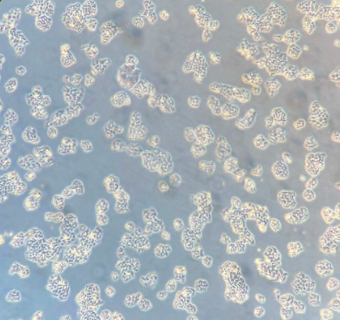
DLD-1 2026.06.17 magnification 10x | DLD-1 2026.06.18 magnification 10x

Construct a table showing the total cell counts obtained from the Coulter counter and the hemocytometer (use your sub cultivation data) together with the number of cells you seeded 3-4 days in advance.
- Determine the growth rate. Use the following equation
to estimate a provisional cell division time based on the cell counts from your maintenance cultures, where t1 and t2 are the times of cell counting, and Q1 and Q2 the respective total cell numbers.
- How successful was the freezing-thawing procedure?
We have not yet thawed cells.

Results:
When counting the cell areas in ImageJ, we found it to be relatively hard to quantify cell areas as it was not always clear where the demarcation lay between cells or what was potentially debris or dead cells. Overall we do not see a significant correlation between cell area and mM NaBu treatment (Figure 1).
Figure 1. Mean area per well as a function of mM NaBu.
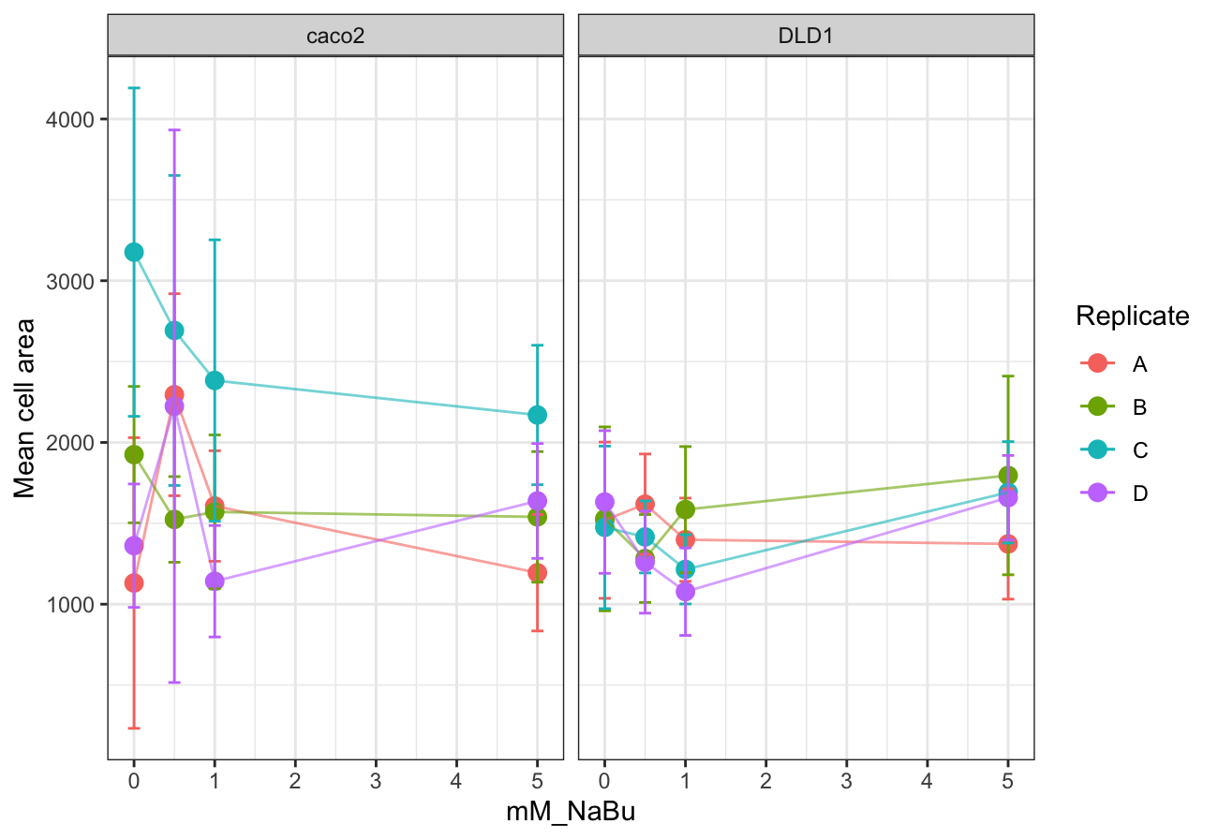

We could not figure out how to use multisizer and fitterbj, so we instead extracted the values directly from the m4 files. Using the estimated area here, we do see an increase in size upon treatment of NaBu on the area for DLD1, while for Caco2 it’s less obvious. (figure 2).
Figure 2.
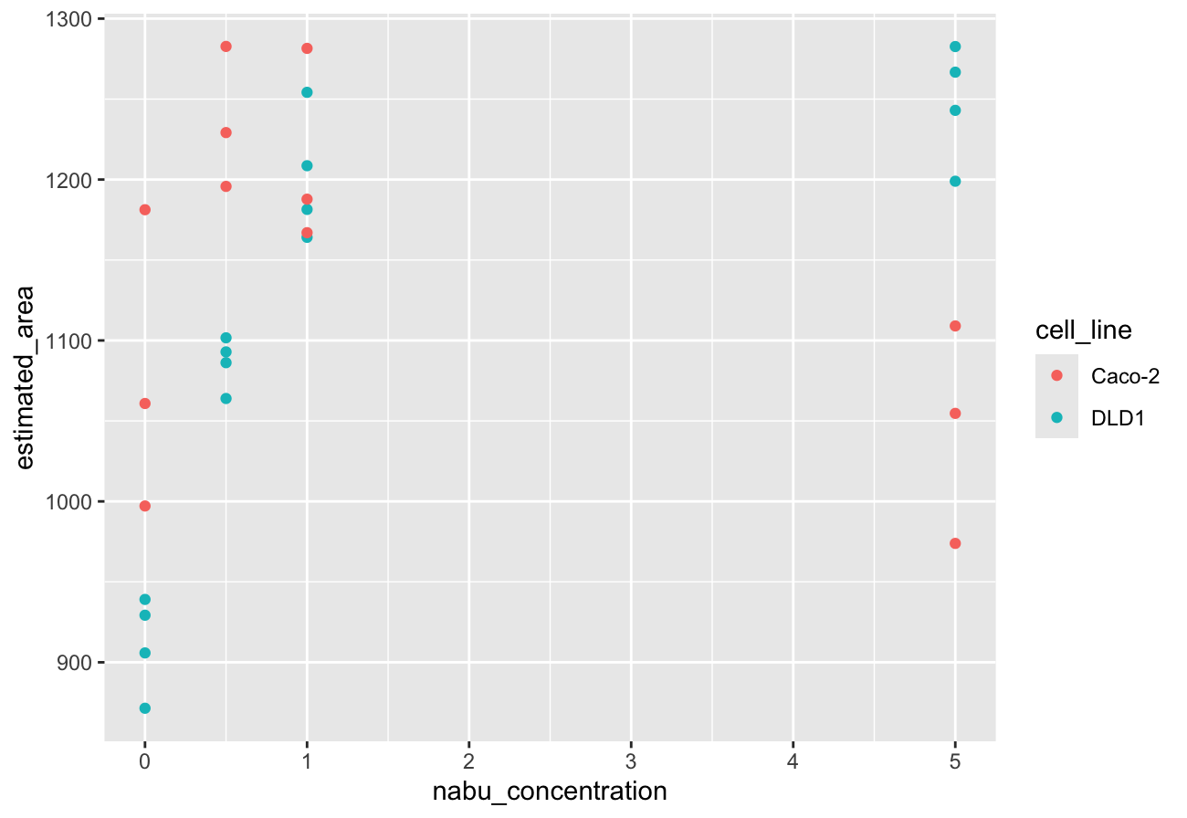

Next, we visualized the counted cells for each concentration. Again, we see a decrease in the numbers of DLD1 consistent with the results in figure 2 for DLD1, while for caco2 the numbers are less clear (figure 3).
Next, in order to determine how well the numbers correlate for the areas determined by manual segmentation in ImageJ and the numbers extracted from the coulter counter, we plotted the ImageJ area as a function of the coulter counter Area and see no correlation (figure 4). This shows that estimating cell area by hand might be quite hard and very prone to bias, hiding potential underlying real biology.

Figure 3. Cell counts as a function of mM NaBu
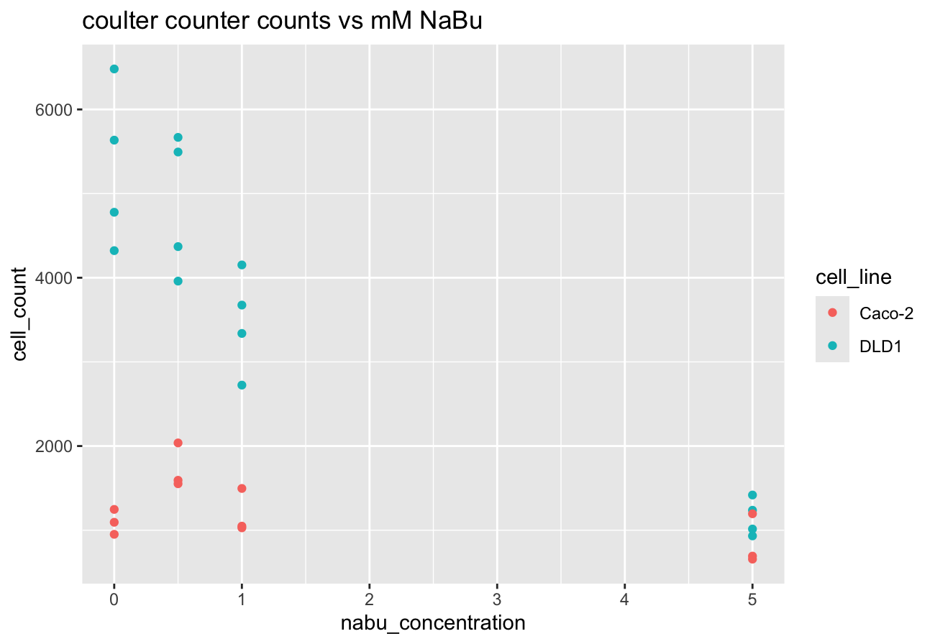

Figure 4. Correlation between imageJ area and coulter counter area
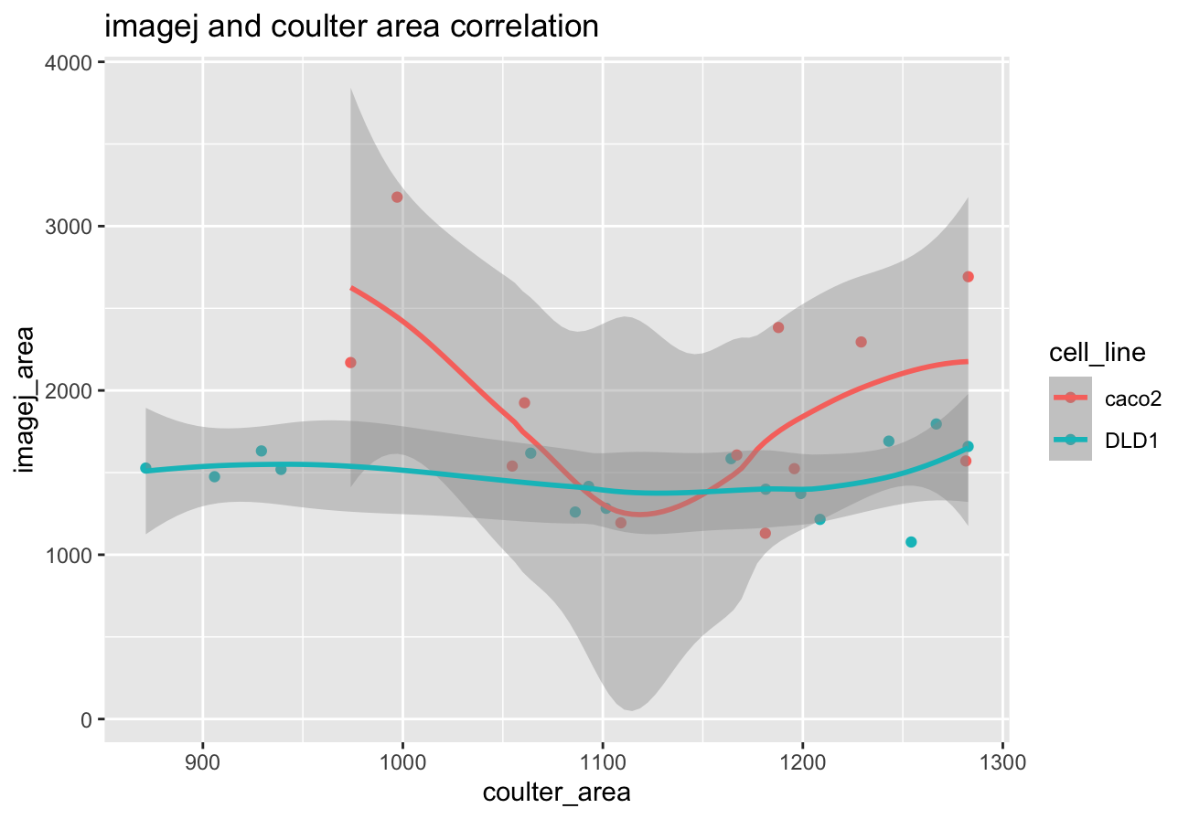

Growth rate:
DLD1:
We seeded 0.56 ml of 885870 cells/ml for DLD1 on Monday i.e. 496087 cells, and upon splitting on Thursday we counted 497913 cells/ml in a volume of 8.75 (this was the volume read on the tube after spinning) for 4356738 cells. This gives us a doubling time of 23 hours (not counting the log phase).
Caco2:

Discussion of your results is lacking
Remember to count your cells in a coulter counter and hemacytometer for comparison several times

Appendix: Lab journal
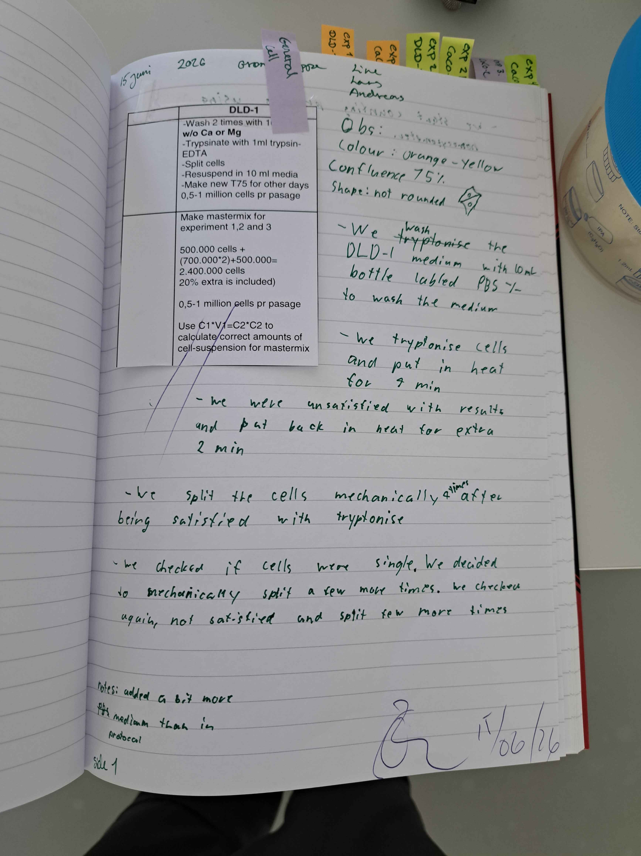

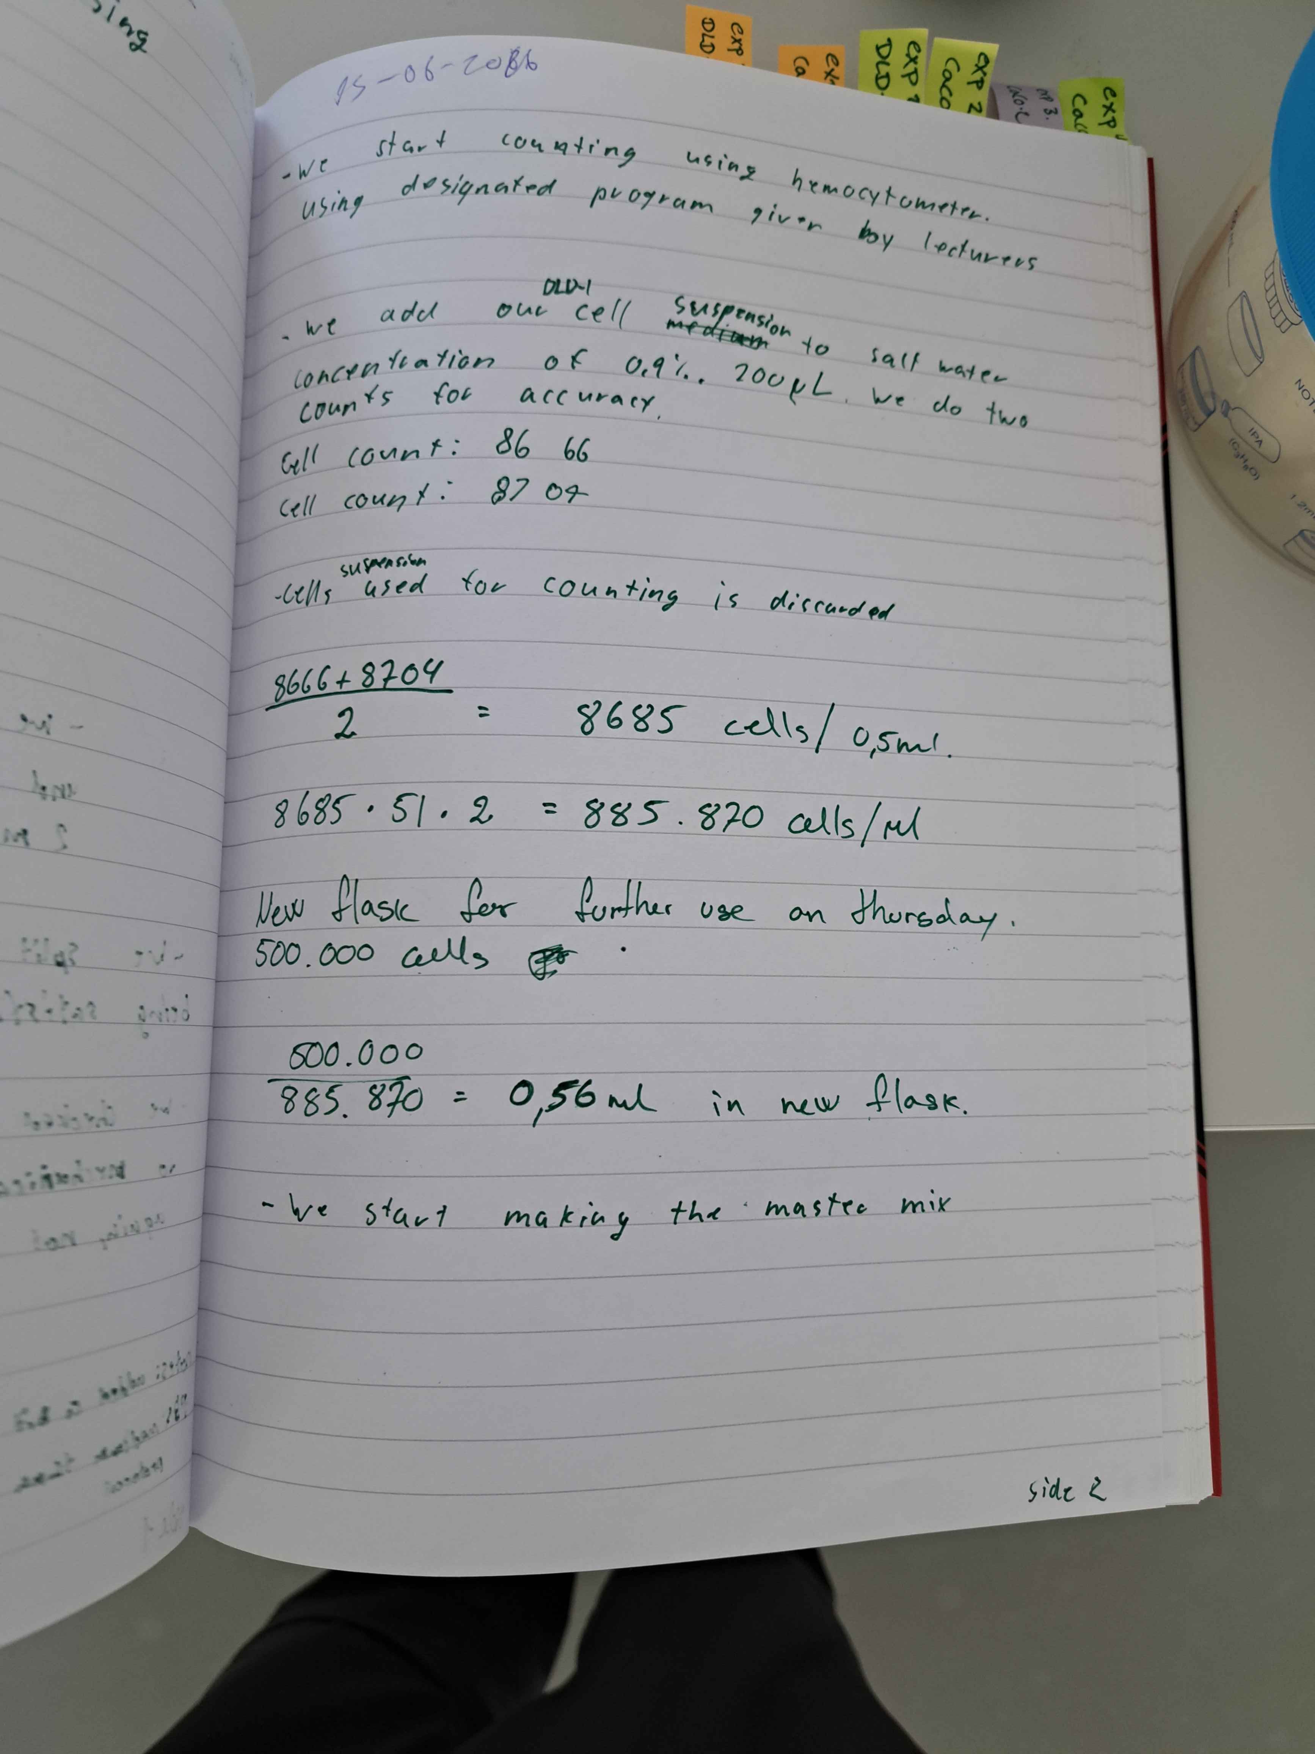

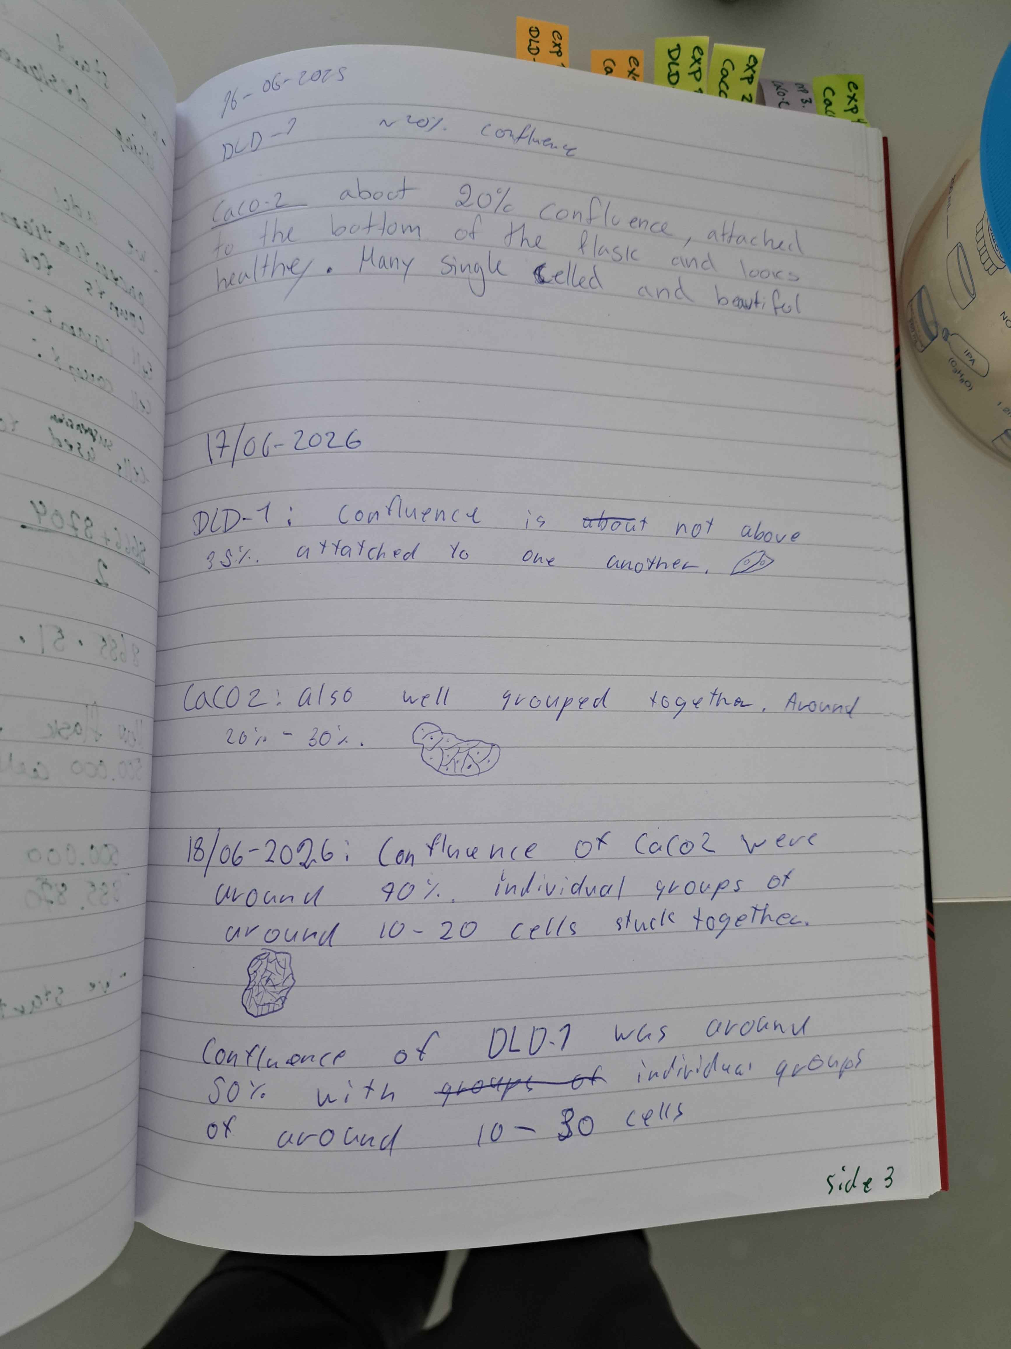x

