Report Front Sheet
Molecular Biology, Master Course
EXPERIMENTAL CELL BIOLOGY
Name of Experiment: |  | Exercise 2 A/B week 1-2: Cell Cycle Analysis and Hoechst 33342 / Alamar Blue 96 well assays
Date for performance of experiment: |  |  |  |  |  | 15-06-2026 -- 26-06-2026
Teacher: | Camilla Michelle Thorup Andersen
Team | Green |  |  |  |  | Group Number: |  |  | 3
Andreas Giovanni Kristian Frilev Olesen,  Line Babette Trust,  Lars Eivind Bustamante Christoffersen |  |  |       Names and signatures
Date(s) for handing in the report to the teacher:
Date for 1. Time  26.06.2026 |  |  |  | Date for 2. time |  |  |  | Date for 3. Time
Teacher comments:
Report approved by teacher:
 |  |  |  |  |  |  | Signature |  |  | Date
This is the front page for the reports and has to be attached to the report. The original front page should be attached when a revised report is handed in.
The Biology Study Board
Contents
Cell cycle analysis (2a): 2
Introduction 2
Methods 2
Results week 1 2
Results week 2 7
Discussion 9
Hoechst 33342 / Alamar Blue 96 well assays (2b): 11
Introduction 11
Methods 11
Week 1 11
Week 2 11
Results 12
Week 1 12
Week 2: 14
Discussion 15
Conclusion 15
Appendix: 17

Cell cycle analysis (2a):

Introduction
In this experiment, flow cytometry-based cell cycle analysis were used to investigate the effects of sodium butyrate (NaBu) on DLD-1 cell lines, for week 2 resveratrol was also used as treatment. Flow cytometry with propidium iodide (PI) staining allows quantification of cellular DNA content and determination of the distribution of cells in the G1, S, and G2/M phases of the cell cycle. Changes in cell cycle distribution can indicate altered proliferation or cell cycle arrest induced by experimental treatments.

Methods
DLD-1 were seeded in T75 flasks and cultured for 24 h before treatment. Cells were exposed to either PBS control, 10 mM NaBu or 20 µm resveratrol for 48 hours..
Following treatment, cells were harvested by trypsinization, washed in PBS w/o + 5 mM EDTA+ 0.5% BSA (PBS-EB), and fixed in 70% ethanol. Fixed cells were stained with propidium iodide and RNase A before analysis by flow cytometry. Data acquisition and analysis were performed using the free software Floreada.io with cell cycle analysis based on the Watson pragmatic model. Single-cell population was gating on FSC-A versus FSC-H plots. Cell cycle distributions was analysed based on DNA content histograms.

Results week 1
Single-cell populations was gated from FSC-A versus FSC-H. The same gate was applied to all samples to minimize analysis bias, gating is seen in figure 1 for PBS-treatment and figure 2 for NaBu-treatment.

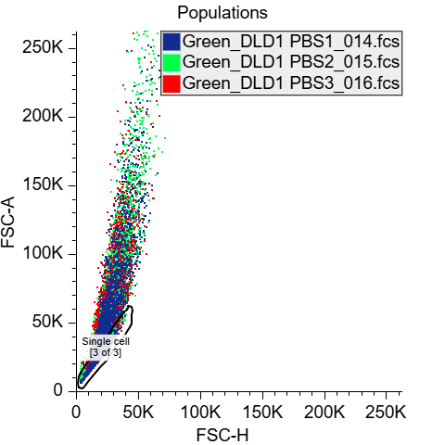 | 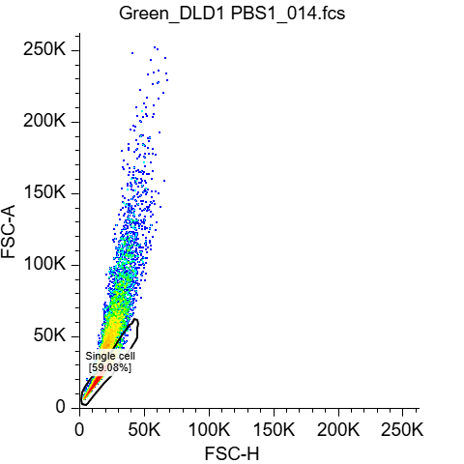
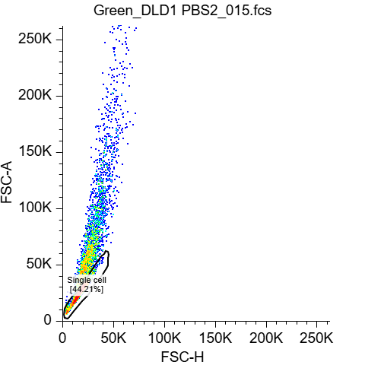 | 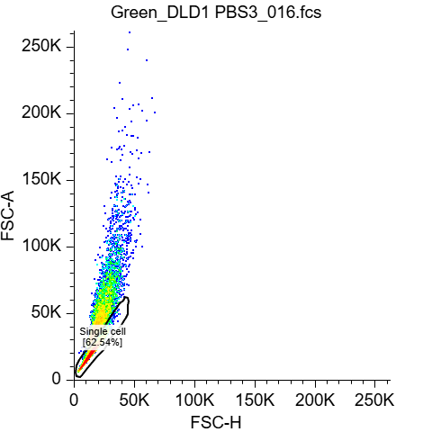
Figure 1. FSC-A plotted against FSC-H for all samples of PBS, and each sample individually. The same gating for single cell, were used for all replicates, to minimize bias. Eventcounts for PBS1= 10.000, PBS2= 3739 PBS2: 10.000 before gating.
After gating is applied PBS1= 5908, PBS2= 1653, PBS3= 6254.
Data acquisition and analysis were performed using the free software Floreada.io.

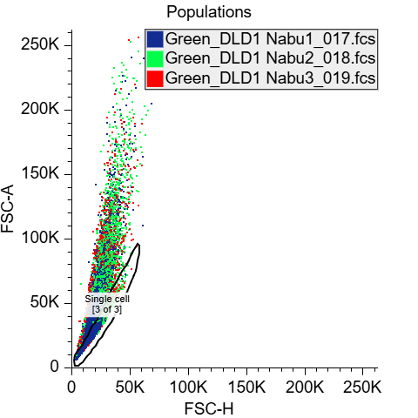 | 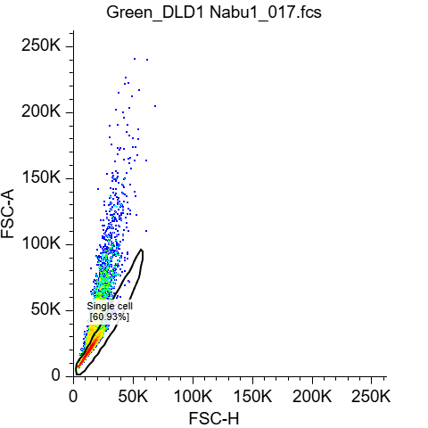
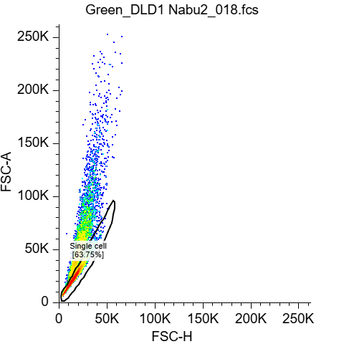 | 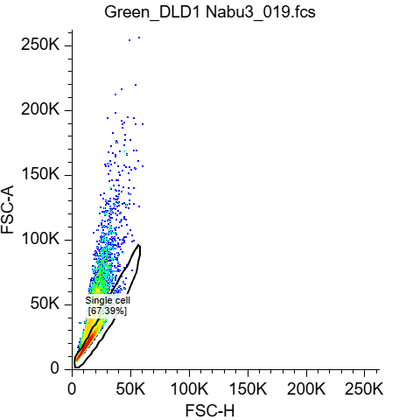
Figure 2. FSC-A plotted against FSC-H for all samples of NaBu, and each sample individually. The same gating for single cell, were used for all replicates, to minimize bias. Eventcounts for NaBu1= 5076, NaBu2: 10.000, NaBu3=10.000 before gating.
After gating is applied NaBu1= 3093, NaBu2= 6375, NaBu3= 6739
Data acquisition and analysis were performed using the free software Floreada.io.

As observed in figure 3, the PBS-treated control cells showed a relatively similar cell cycle distribution across all three replicate. Approximately 33% of cells were present in G1 phase, 50–52% in S phase, and 15–18% in G2 phase. Treatment with NaBu altered DNA content histograms compared with PBS-treated controls as displayed on figure 3. In the NaBu-treated samples, the population in G2/M phase appeared increased relative to the controls. However, the automatic cell-cycle modelling performed by floreada.io did not accurately fit the NaBu histograms, as the fitted S-phase distribution overlapped substantially with the G2/M. The calculated percentage should be regarded as approximate estimates rather than quantitative measurements. However the visual shift of the histograms supports an accumulation of cells in G2/M following NaBu treatment.
PBS | NaBu
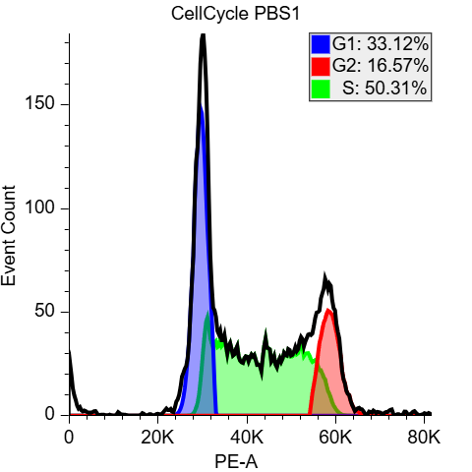 | 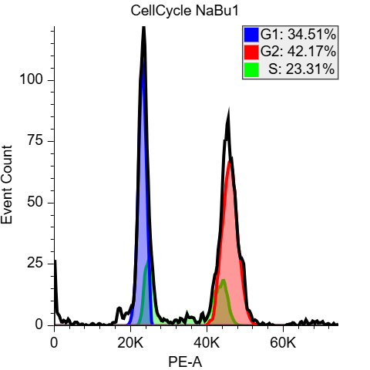
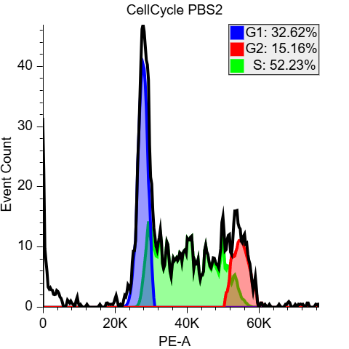 | 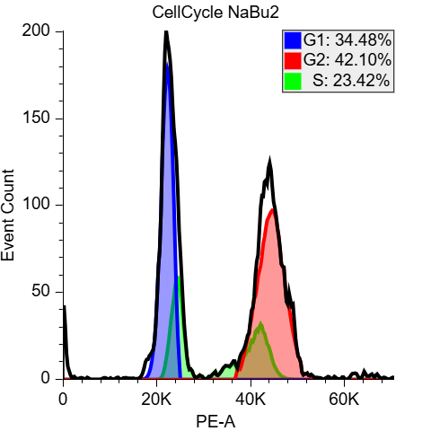
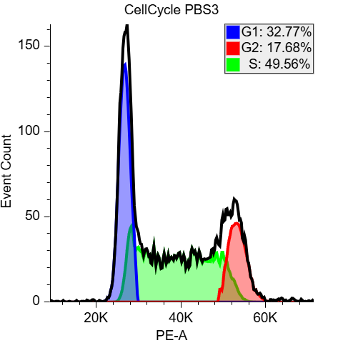 | 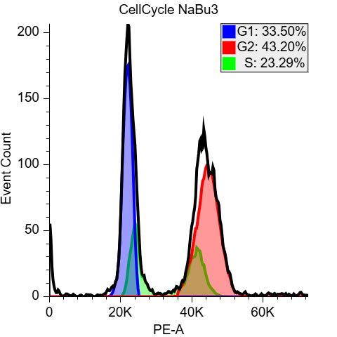
Figure 3. DNA-content histograms of gated single DLD-1 cells after treatment with PBS or 10 mM sodium butyrate (NaBu) for 48 h. Histograms were generated in Floreada.io using the Watson pragmatic model. Although the software estimated the proportion of cells in G1, S and G2/M phases, the automatic fitting did not adequately resolve the histograms because the fitted S-phase distribution overlapped the G2/M peak. Therefore, the displayed percentages should be interpreted as approximate.

 | G1 | G2 | S
PBS1 | 33,12% | 16,57% | 50,31%
PBS2 | 32,62% | 15,16% | 52,23%
PBS3 | 32,77% | 17,68% | 49,56%
 | G1 | G2 | S
NaBu1 | 34,51% | 42,17% | 23,31%
NaBu2 | 34,48% | 42,10% | 23,42%
NaBu3 | 33,50% | 43,20% | 23,29%

Table 1. Estimated cell-cycle phase distribution generated automatically by Floreada.io using the Watson Pragmatic model. Due to imperfect fitting of the Histograms, particularly the overlap between the S-phase and the G2/M-phase, these values should be interpreted only as approximates estimates, rather than precise measurements.

Figure 4. Estimated cell-cycle phase distribution of DLD-1 cells treated with PBS or 10 mM NaBu. Bars represent the mean estimated distribution obtained from Floreada.io. Values should be interpreted qualitatively rather than as exact percentages.

Results week 2

Cell cycle analysis was repeated in week 2 using PBS-treated control cells together with cells treated with 10 mM sodium butyrate (NaBu) or 40 µM resveratrol as displayed on figure 5.
The PBS-treated cells displayed the expected DNA-content histogram with distinct G1 and G2/M peaks and an intermediate S-phase population. Similar to the week 1 experiment, NaBu treatment visibly altered the DNA-content distribution by increasing the DNA content, consistent with an accumulation in the G2/M phase.
As in the week 1 analysis, the automatic Watson model implemented in Floreada.io did not accurately resolve the histograms. Therefore, the numerical phase percentages were not considered reliable and were not used for quantitative interpretation. Instead, conclusions were based on the qualitative changes observed in the DNA-content histograms.

Resveratrol NaBu Control | 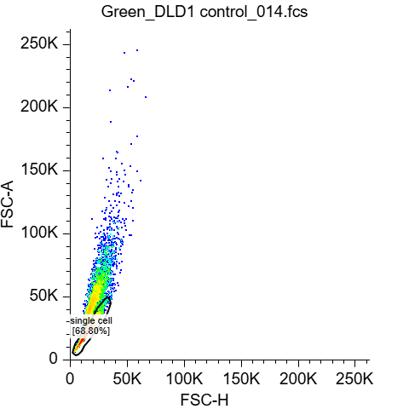 | 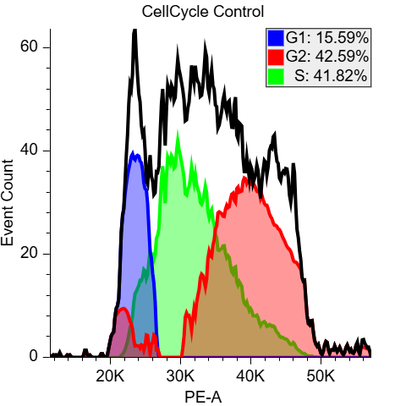
 | 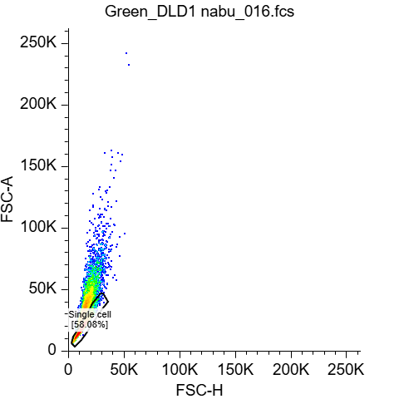 | 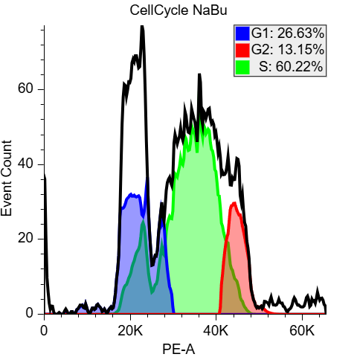
 | 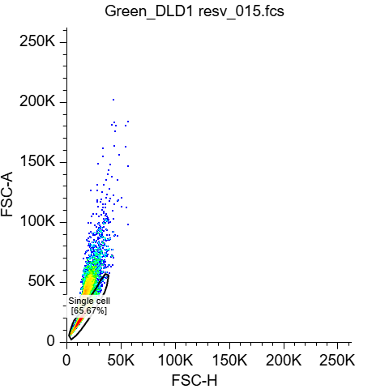 | 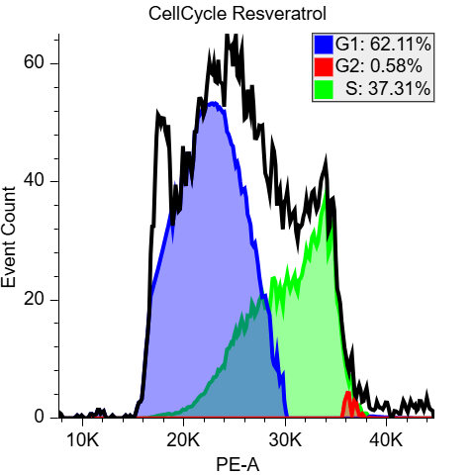
Figure 5. FSC-A plotted against FSC-H and Cell cycle analysis for each sample in week 2 (PBS, NaBu, Resv,). Event counts for all samples before gating was 10.000. Data acquisition and analysis were performed using the free software Floreada.io with Cell Cycle analysis based on the Watson pragmatic model.

Discussion
Cell cycle analysis estimates proliferation by determining the percentage of cells in G0/G1, S, and G2/M phases. This provides information about the distribution of cells across different phases of the cell cycle, and not just whether the cells are proliferating, which is an advantage because it can identify cell cycle arrest of delays caused by exposure of chemicals, drugs etc. Another advantage of the cell cycle analysis is also that it analyses a large number of cells. Some of the drawback from cell cycle analysis is that it measures DNA content rather than DNA synthesis directly, which makes it an indirect measurement of proliferation, and it cannot distinguish between cells that are actively progressing through the cell cycle and cells that are arrested in a cell cycle phase.
It provides a insight into the cell population at one time (snapshot), so if you want to measure at different timepoint, new experiments should be initiated with different time points for harvesting. Furthermore, cells with abnormal DNA content can complicate the interpretation.
Bromodeoxyuridine (BrdU) incorporation directly measures DNA synthesis because BrdU is incorporated into newly replicated DNA during S phase of the cell cycle. Therefore, it could be interpreted as a more direct measurement of proliferating cells. However, BrdU assays require additional staining procedures, DNA denaturation to expose incorporated BrdU, and may affect cell physiology. Unlike cell cycle analysis, BrdU labeling specifically identifies cells actively synthesizing DNA.
Cell cycle analysis provides broader information about cell cycle dynamics and checkpoints, whereas BrdU incorporation offers direct measurement of DNA replication and cell proliferation.

The flow cytometry experiments performed in both weeks consistently showed that NaBu altered the DNA-content distribution of DLD-1 cells. Visual inspection of the histograms demonstrated an increased population of cells with DNA content following NaBu treatment, suggesting an accumulation in the G2/M phase of the cell cycle. Although Floreada generated numerical estimates for the G1, S and G2/M fractions, the automatic fitting was suboptimal for the NaBu-treated samples because the fitted S-phase distribution overlapped with the G2/M peak. Consequently, these percentages should be regarded as approximate estimates rather than precise measurements.
The observed accumulation of cells with DNA content is consistent with a NaBu-induced delay or arrest in G2/M and provides a explanation for the reduced proliferation observed in the Hoechst and resazurin assays (see results from Hoechst and resazurin assay). Cells that fail to progress through mitosis divide less frequently, leading to a reduction in cell number while maintaining metabolic activity proportional to the remaining viable cells. Together, the viability assays and flow cytometry therefore support the conclusion that NaBu primarily inhibits proliferation by interfering with cell-cycle progression rather than causing acute cell death.

Hoechst 33342 / Alamar Blue 96 well assays (2b):

Introduction
In this experiment, fluorescence-based viability assays were used to investigate the effects of sodium butyrate (NaBu) on DLD-1 and Caco-2 cell lines. Cell viability and metabolic activity were assessed using the Hoechst 33342 and resazurin (Alamar Blue) assays. Hoechst 33342 binds DNA and provides an estimate of relative cell number, whereas resazurin is converted to a fluorescent product by metabolically active cells and reflects cellular metabolic activity.

Methods

Week 1

DLD-1 and Caco-2 cells were seeded in 96-well plates at 10,000 cells per well. Cells were treated with increasing concentrations of NaBu (0.5, 1, and 5 mM). For viability measurements, cells were incubated with Hoechst 33342 (5 µg/mL) and resazurin (25 µg/mL). Resazurin fluorescence was measured first to estimate metabolic activity. Cells were subsequently washed and Hoechst fluorescence was measured to estimate relative cell number. Results were normalized to untreated control cells.

Week 2

We deviated from the protocol in week 2 by accident and only made one plate with DLD-1 occupying columns 2-6 and Caco-2 occupying columns 7-11. Due to this mistake we could not make a dose response curve, but instead we went with a binary assay using fixed concentrations of 1 mM NaBu and 40 µM Resveratrol, both alone and combined. Cells were incubated with the same Hoechst and resazurin concentrations as in week 1 and fluorescence was measured. Results were normalized to untreated control cells. Note that since columns 2 and 11 in the plate contained cells+media (but not media+vehicle) they were not used for the final analysis (see page the appendix, page 36).

Results

Week 1

The effect of NaBu on cell number was assessed using the Hoechst 33342 assay, while cellular metabolic activity was evaluated using the resazurin assay.
For DLD-1 cell line NaBu treatment reduced both cell number and metabolic activity in a concentration-dependent manner as seen on figure 5. Relative cell number measured by Hoechst fluorescence decreased from 100% in the control group to approximately 88%, 67%, and 26% following treatment with 0.5, 1, and 5 mM NaBu, respectively.
Similarly, resazurin fluorescence decreased to approximately 87%, 65%, and 23% of control values at 0.5, 1, and 5 mM NaBu, respectively. The reduction in metabolic activity closely followed the reduction in cell number.
Figure 6. Effect of increasing NaBu concentrations (0, 0.5, 1 and 5 mM) on DLD-1 cells measured using resazurin (metabolic activity) and Hoechst 33342 (relative cell number). Fluorescence values were normalized to untreated controls (100%). Bars represent the mean of replicate measurements, and error bars indicate ± SEM.

Caco-2 cells appeared less sensitive to NaBu treatment than DLD-1 cells. At 0.5 and 1 mM NaBu, Hoechst and resazurin signals remained close to control levels. At 5 mM NaBu, however, cell number decreased to approximately 61% of control and metabolic activity decreased to approximately 57% of control.

Figure 7. Effect of increasing NaBu concentrations (0, 0.5, 1 and 5 mM) on Caco-2 cells measured using resazurin (metabolic activity) and Hoechst 33342 (relative cell number). Fluorescence values were normalized to untreated controls (100%). Bars represent the mean of replicate measurements, and error bars indicate ± SEM.

Week 2:

The week 2 experiment reinforced the previous NaBu results, with DLD-1 cells responding relatively strongly to 1 mM NaBu by showing a ~30-40% decrease in fluorescence intensity relative to the control for both stains (figure 2). Addition of 40 µM Resveratrol strongly reduces cell proliferation by a factor of ~x10, and the combination of NaBu and Resveratrol shows the same result. For Caco-2 cells, we observe an increase in cell proliferation for both NaBu and Resveratrol treatment, and only the combined treatment shows a level around the control. However, we must note that our Caco-2 samples for week 2 showed a very high variance for multiple treatments, making it harder to draw firm conclusions. In addition, while the relative signal for the two stains is quite aligned for DLD-1 cells it is more decoupled for Caco-2, with the Hoechst signal showing a greater relative effect for all treatments.
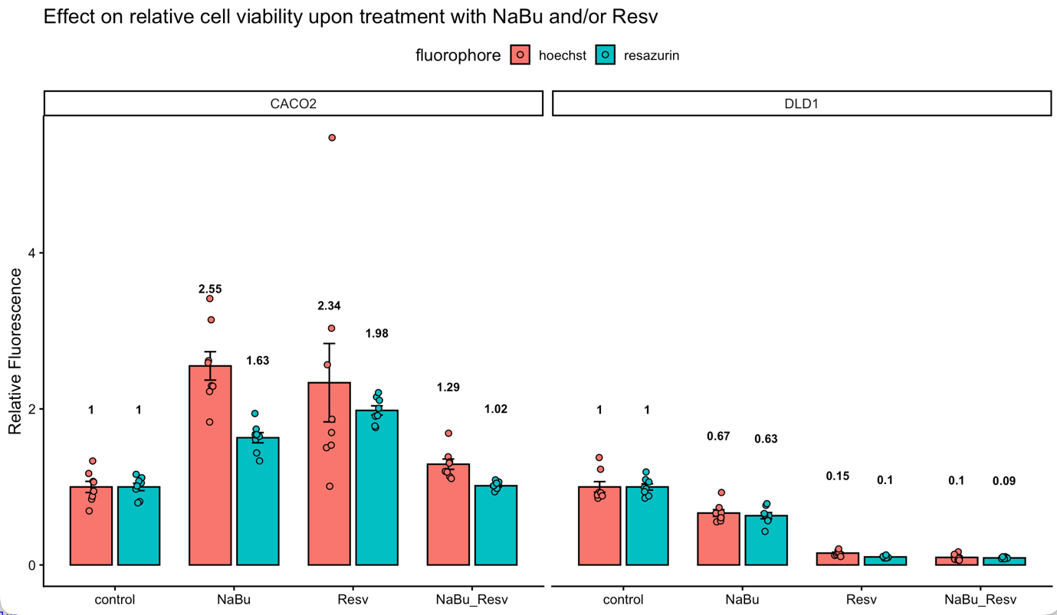
Figure 8, Cell viability measured both by DNA synthesis (Hoechst stain) and cell metabolism (resazurin stain). The control samples used vehicle PBS and DMSO in matching volumes. Concentration of NaBu: 1mM, concentration of Resveratrol: 40 µM. The bar charts indicate the group means relative to the control. Error bars: standard deviation of the mean.

Discussion

In the week 1 assay, the Hoechst 33342 stain demonstrated that sodium butyrate reduced the relative number of viable cells in both cell lines. However, the effect was substantially greater in DLD-1 cells than in Caco-2 cells. In DLD-1 cells, cell number decreased progressively with increasing NaBu concentration, reaching approximately 26% of control at 5 mM NaBu. In contrast, Caco-2 cells were less affected at lower concentrations and retained approximately 61% of control cell number at 5 mM NaBu. The resazurin assay showed a similar concentration-dependent decrease in metabolic activity. The decrease in resazurin fluorescence closely matched the decrease in Hoechst fluorescence.
For the week 2 assay, we again saw more evidence that DLD-1 cells responded to 1mM NaBu by having reduced proliferation, as evidenced by both Hoechst and resazurin fluorescence being decreased in tandem, while Caco-2 cells in fact showed increased proliferation in our assay. DLD-1 cells showed a very strong response to 40 µM Resveratrol and Resveratrol+NaBu. Due to the uncertainty in our results, especially for the Caco-2 cells, more research needs to be conducted to verify whether this cell line indeed shows a replicable increase in cell proliferation in response to NaBu or Resveratrol.

The flow cytometry results indicated that the NaBu treatment caused an accumulation in the proportion of cells in the G2 phase of the cell cycle and a corresponding decrease in the S-phase population. This indicates that NaBu induced cell cycle arrest, which likely contributed to the reduction in cell proliferation observed in the viability assays.

Conclusion
Treatment with NaBu reduced both the relative cell number and metabolic activity of DLD-1 cells in a concentration-dependent manner, whereas Caco-2 cells were less sensitive to the treatment. Resveratrol causes a strong reduction in the overall relative cell number and metabolic activity in DLD-1 cells, while leaving Caco-2 cells more or less unaffected, although the uncercainty for the Caco-2 results warrant further investigation.
Flow cytometry demonstrated that NaBu altered the DNA-content distribution of DLD-1 cells, consistent with an accumulation of DNA content and therefore indicative of cell-cycle arrest. Because the automatic cell-cycle fitting performed by Floreada.io inadequately histograms, the calculated phase percentages should be interpreted cautiously. Nevertheless, the qualitative changes observed in the DNA-content histograms together with the viability assays support the conclusion that NaBu suppresses DLD-1 cell proliferation.

Appendix:
Lab journal:
2A:












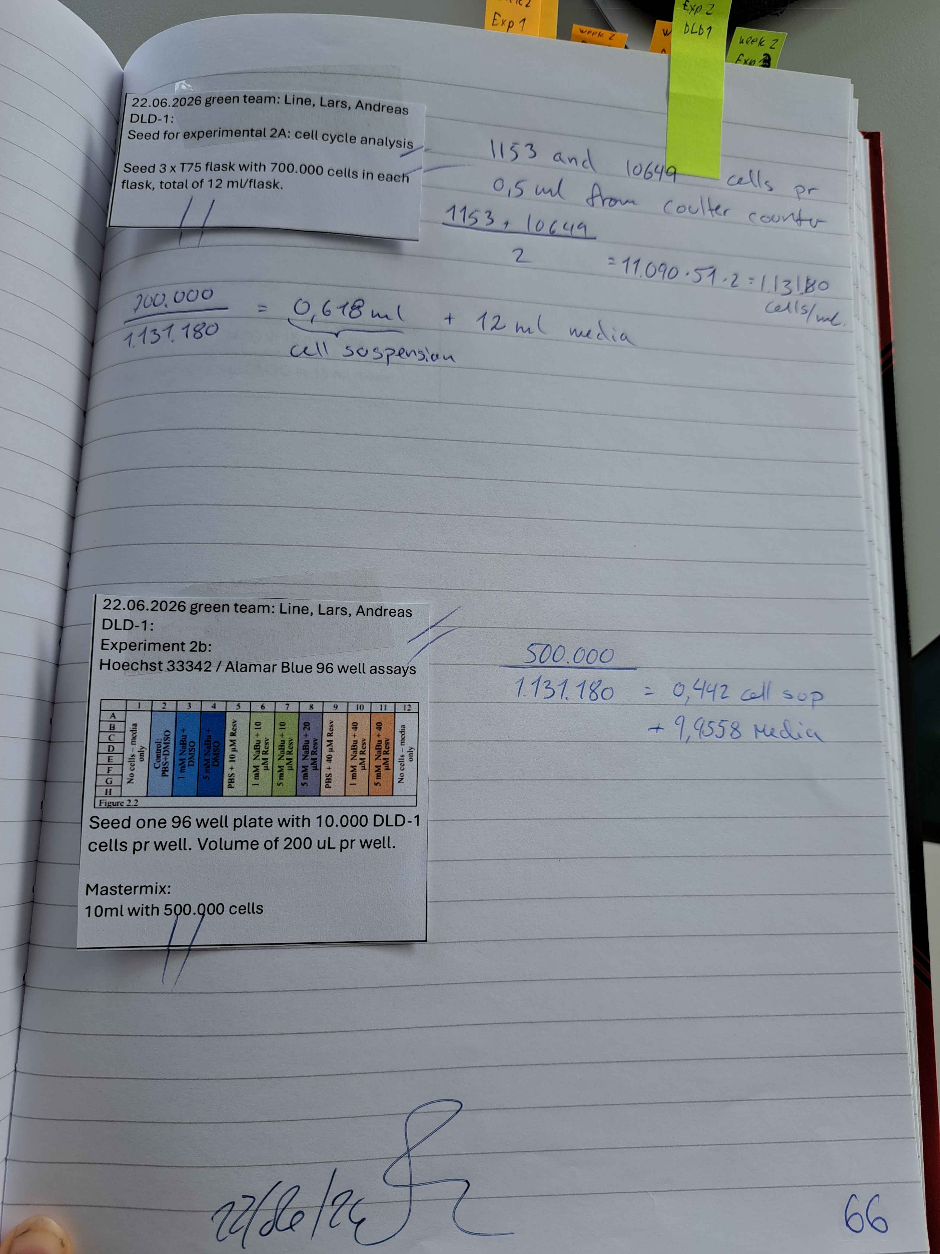



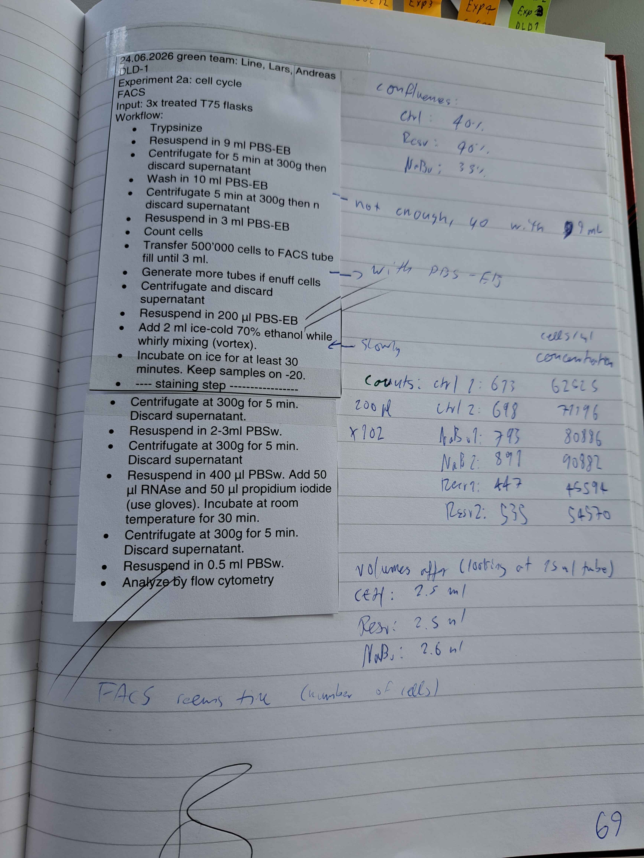

Experiment 2B:














