Problems from old exams– Chapters 4-7

- [June, 2025] Chromatin structure and gene expression
- A scientist isolates mouse blood stem cells and performs a chromatin immunoprecipitation with different antibodies that bind to histones. After isolation the scientist performs a PCR to test for the Plau gene in the immunoprecipitated DNA. Then the PCR products are runned on an agarose gel. The result is shown in figure 1.

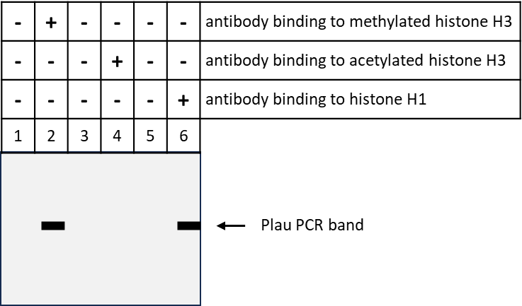
Figure 1 Immunoprecipitation of chromatin from blood stem cells with three, different antibodies followed by PCR of the Plau gene and agarose gel electrophoresis.

- What does the result of this experiment indicate about the chromatin structure of the Plau gene in mouse blood stem cells?

Next, the scientist isolates mouse fully differentiated white blood cells and performs a chromatin immunoprecipitation with the same antibodies that bind to chromatin. After isolation the scientist performs a PCR to test for the Plau gene. The result is shown in figure 2.
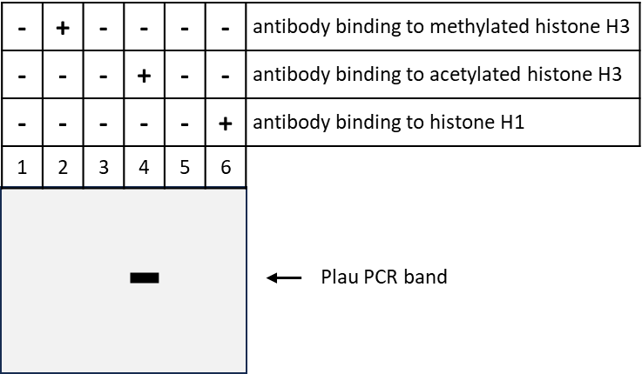
Figure 1 Immunoprecipitation of chromatin from fully differentiated white blood cells with three, different antibodies followed by PCR of the Plau gene and agarose gel electrophoresis.
- What does the result of this experiment indicate about the chromatin structure of the Plau gene in fully differentiated white blood cells?

Promoter studies show that expression of the Plau gene requires binding of the two transcription factors AP-1 and PEA3 to its promoter. Moreover, Illumina sequencing shows that the Plau gene is silent in blood stem cells but expressed in white blood cells.
Our scientist shows that AP-1 is present in blood stem cells but does not bind to the Plau gene promoter. In white blood cells the scientist finds that both AP-1 and PEA3 are present and bind to the Plau gene promoter. See figure 3 for illustration.

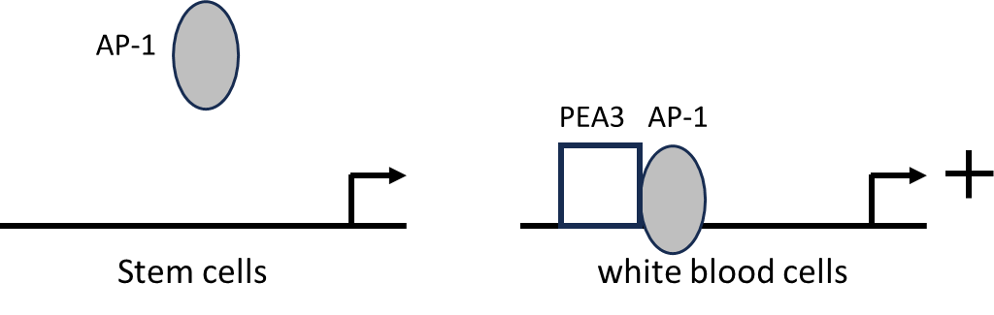
Figure 3. Model of the Plau one gene in blood stem cells and differentiated white blood cells. AP-1 is present in both cell types but PEA3 is only detected in white blood cells. The Plau gene is only expressed in white blood cells.

- Suggest a mechanism for how PEA3 can make AP-1 bind to the promoter and induce transcription of the Plau gene?

Our scientist tries to activate the Plau gene in the mouse blood stem cells by overexpressing the human PEA3 transcription factor in these cells. Surprisingly, overexpression of PEA3 makes the stem cells differentiate into white blood cells. When the scientist removes the human PEA3 transcription factor the newly differentiated cells keep expressing the endogenous mouse PEA3 transcription factor.

- Suggest a mechanism to explain this observation.

The mouse Plau gene is located on chromosome 14. Next to the Plau gene about 100 kilobases away is the insulin gene. The scientist performs a Hi-C experiment in white blood cells by the following steps:
1. Crosslinking the DNA in chromatin. 2. Cut with a restriction nuclease. 3. Ligate the fragmented DNA together. Sequence the DNA by Illumina sequencing.
The result is shown in the figure 4.

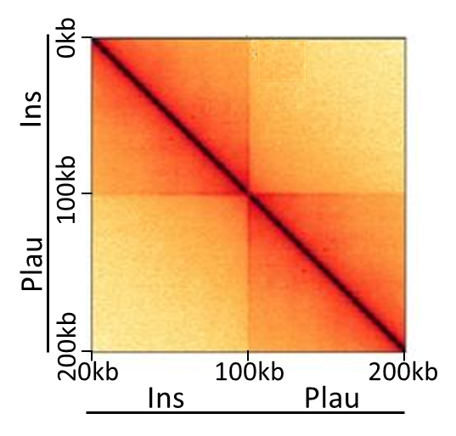
Figure 4 Result of Hi-C experiment for 200 kb of mouse chromosome 14 that contains the Ins and Plau genes. The intensity of the orange color denotes the number of times that any DNA sequence region whose position is indicated on the X-axis was found to be ligated to any DNA sequence region whose position is indicated on the Y-axis. The darker the color the more often these two regions we located in close proximity inside the cell.

- Please, draw the chromatin loop structure of the part of chromosome 14 that contains the Ins and Plau genes and explain why the Ins and the Plau genes are in different or in the same chromatin loop(s).
The boundaries of chromatin loops are denoted by CTCF protein complexes binding to each end of the loops.
- Which kinds of proteins hold the two ends of a chromatin loop together?

- [August, 2025] RNA processing and gene expression
A research team on a hospital performs a project on sequencing of the genome of one thousand healthy persons. In the genome of a guy called Bob the scientists find that one allele of the KRAS gene has the G12D mutation that leads to expression of a KRAS protein with the amino acid aspartic acid in position 12 (instead of a glycine). This G12D mutation is known to be dominant and lead to cancer. However, Bob is 57 years old and according to his hospital records he has never had any cancer.
In addition to the genome sequence, the researcher team has also sequenced the total mRNA of the white blood cells of Bob. They find that the white blood cells of Bob contain the mature mRNA for the healthy KRAS allele but not the G12D mutant allele. However, they find small amounts of spliced G12D mRNA without the polyA tail.

- Why is the G12D mRNA that is missing the polyA-tail not expressed?

Next, the research examines Bobs KRAS gene with the G12D mutation further and finds that at the end of the gene the sequence AATAAA for termination of the primary RNA transcript is missing.

- Explain why the missing transcription termination signal prevents the KRAS G12D allele from causing cancer in Bob.

- [August 2023] Control of gene expression
Gene X is regulated by the transcription factors Bicoid, Giant, Hunchback and Krüppel in order to be expressed exclusively in a specific region of the Drosophila embryo. Figure 2-A shows the promoter of gene X indicating the binding sites for Bicoid, Giant, Hunchback and Krüppel. In Figure 2-B the lines indicate the expression level of the four transcription factors along the length of the Drosophila embryo. Gene X is only expressed in the yellow part of the embryo.

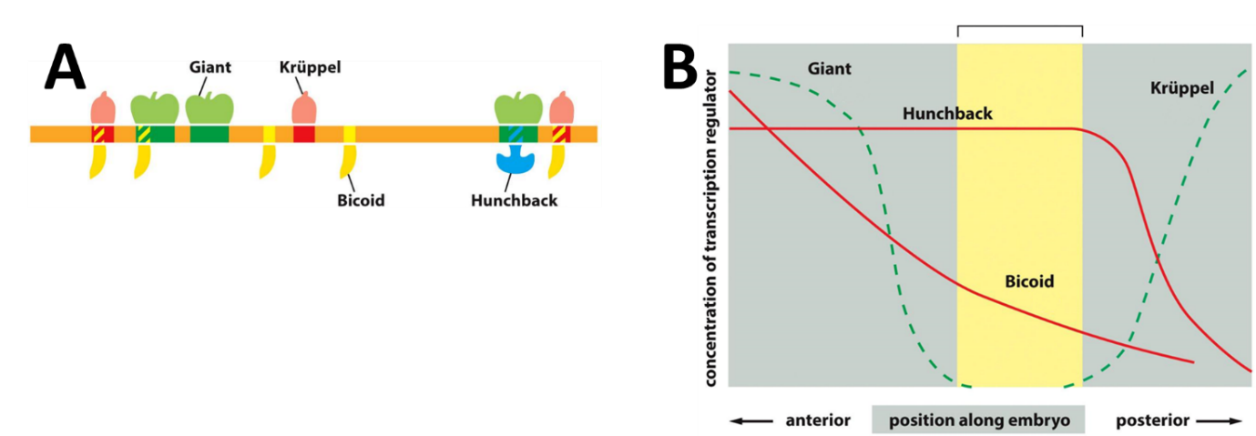
Figure 2: Regulation of Gene X expression

Explain the effect of Bicoid, Giant, Hunchback and Krüppel, respectively, on the expression of gene X.

- [March 2024] Transcription factor specificity
A single sequence-specific DNA-binding transcription factor typically recognizes a redundant DNA sequence of 6 – 8 base pairs. This implies that there are typically 50,000 sites in the human genome where such a transcription factor can bind to the DNA. Nevertheless, transcription factors only activate a small number of genes.
- Explain two mechanisms that make it possible for sequence-specific transcription factors only to activate a small number of genes.

- [June 2019] Gene expression can be modified by methylation and packing in chromatin structures, which are interceded by daughter cells. One striking example is the inactivation of one of the X chromosomes in females, so they do not get a double amount of gene product.
  - Describe how DNA methylation patterns are inherited.
  - Describe how this inactivation happens.

- [April 2023] Chromatin structure - Solved in Lecture 1

  - What are the most general differences between open and closed chromatin?
  - Which enzyme(s) are necessary for converting closed chromatin to open chromatin and open chromatin to closed chromatin?

- [June 2020a] Chromatin structure of a promoter - Solved in Lecture 1

  - How many nucleosomes can form on a 2000 base pairs long piece of DNA?
  - Describe the structure of a core nucleosome.

A chromatin analysis by chromatin immunoprecipitation with a histone H1 antibody followed by genome sequencing shows that histone H1 is missing from the nucleosomes on a 2000 base pairs long promoter. An additional experiment (chromatin immunoprecipitation followed by quantitative PCR of the promoter) further shows that SWI/SNF is bound to the promoter.
  - What do these two results tell about the chromatin structure of the promoter?

- [August 2020] Chromatin structure of a gene locus: - Solved in Lecture 1
a) What are chromatin loops?
b) What is the function of insulators in chromatin?
Two genes are located close to each other on a chromosome (Figure 2). Gene A is strongly expressed in cardiac myocytes due to high activity of the enhancer sequence (“HS1” on figure 2) whereas gene B is completely silent.

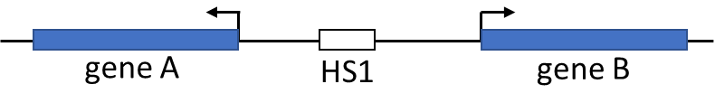
Figure 2: The blue boxes indicate the two genes. The transcription start point and the direction of transcription is indicated with a bended arrow. The white box indicates the enhancer, HS1.

- Describe a plausible mechanism for why HS1 only activates gene A but not gene B.
- Which proteins bind to HS1 and how do they activate transcription at a distance?

- [August 2024] Chromatin - Solved in Lecture 1
A scientific team purifies a SMC-type protein complex called Cohesin from the nuclei of mouse cells. To test the binding of Cohesin to DNA they set up a pull-down experiment in the following way: A long piece of DNA is attached to a tungsten bead and incubated with Cohesin. After incubation, the beads are pelleted by centrifugation (“Pull-down”) and the supernatant is removed. After a wash with buffer the content of the pull-down pellet is analyzed for Cohesion by SDS-PAGE and for DNA by agarose gel electrophoresis. The experimental set up is shown in the drawing in figure 4 (left side), and the results in the right side of figure 4.

a) Explain what the result of the experiment illustrated in figure 2 shows about the role of ATP in binding of Cohesin to DNA (10p)
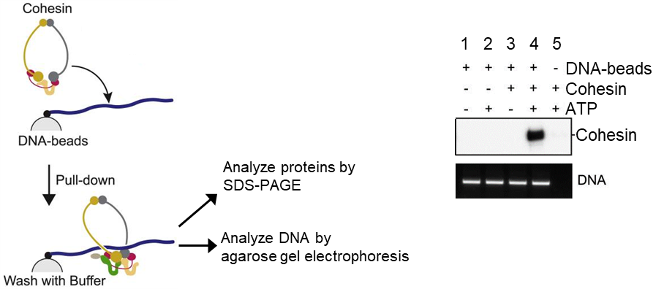

Figure 4: The experiment is performed with and without DNA-beads, Cohesin and ATP.
The right part of the figure shows the result of the experiment. The upper gel with the white background is the SDS-PAGE and the lower gel with black background is the agarose gel. The presence of DNA-beads, Cohesin and ATP in each of the five samples is indicated with a “+” above each lane.

- [August 2023] Gene expression - Solved in Lecture 2

The human genome contains approximately 21,000 protein-coding genes. However, more than 100,000 different proteins are made in human cells.
Suggest a molecular mechanism that can account for this difference between the number of protein-coding genes and the number of proteins. Describe in general terms how this mechanism works and how it can produce more than 100,000 proteins from only 21,000 genes. A drawing is welcome.
- [April 2019] RNA splicing - Solved in Lecture 2
How do eukaryotic cells achieve specificity in RNA splicing? Drawings are welcome but you do not need to explain the mechanism of the spliceosome.

- [June 2020b] Transcription factors - Solved in Lecture 3
Gene expression is regulated by transcription factors that binds to specific sites (consensus sequences) in the genome.
a) Describe briefly how transcription factors regulate gene expression
b) How is the specificity of transcription factors ensured, so that they only bind where they are supposed to?
c) A transcription factor TF recognizes a specific 8-nucleotide sequence in the DNA and binds perfectly. How many possible binding sites for transcription factor TF are there in the human genome (containing roughly 3 x 10⁹ nucleotide pairs)?
d) Is more specificity needed for the binding of transcription factor Z, and if so, how could this be ensured?

- [April 2023] Control of gene expression - Solved in Lecture 3
Overexpression of the transcription factors Oct4, Sox2 and Klf4 in fibroblasts can convert these cells to pluripotent stem cells. Once produced, the pluripotent stem cells will remain stable, meaning that they will produce pluripotent stem cells for several generations. Describe the mechanism that makes the stem cells stable.

- [April 2021] DNA packing - Solved in Lectures 1 & 3
The activity of many genes is epigenetically regulated by addition of methyl groups to CG sequences in the DNA.
  - Describe how DNA methylation influences transcription and how methylation patterns are passed to the newly synthesized DNA during mitosis.
Methylation can also influence how densely the DNA is packed in chromatin.
  - Explain what hetero- and euchromatin is, and how it can influence gene-expression

- [March 2024] Nuclear organization - Solved in Lectures 3

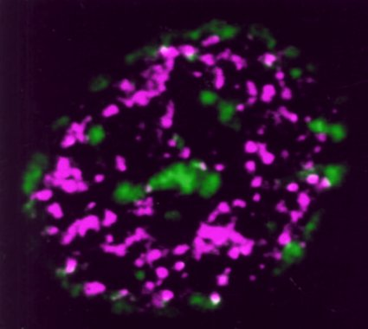
The figure shows the nucleus of a human bladder cancer cell that has been labelled by incorporation of labelled dTTP into newly synthesized DNA (green) and by incorporation of labelled UTP into newly synthesized RNA (magenta).
- Different parts of the nucleus are stained in either green or magenta. What does this tell you about the organization of replication and transcription in the nucleus of the cell? (10 p)

- [March 2024] Transcription factors and differentiation - Solved in Lecture 3
When haematopoietic stem cells differentiate into blood cells they start expressing the transcription factor GATA-1. Continued, stable expression of GATA-1 is necessary for maintenance of the differentiated state of the blood cells. Describe a molecular mechanism that can ensure that once GATA-1 is turned on, the blood cells keep expressing this gene.

- [August 2024] Gene expression and mRNA synthesis - Solved in Lecture 3
The protein VP1 activates transcription of genes that contain a DNA sequence called ABRE in the promoter. However, DNA footprinting shows that VP1 does not bind to ABRE.
  - Suggest how VP1 could activate transcription. (5p)

The hormone ABA induces VP1 expression at a specific developmental stage. The VP1 gene continues to be stably expressed long time after ABA disappears.
  - Suggest a mechanism that ensures stable expression of VP1 once the VP1 gene is induced. (5p)

