IDENTIFY COURSES PROJECT

Software Requirements Specification

|  |  |  |  |
| --- | --- | --- | --- |
|  | Prepared By | Reviewed By | Approved By |
| Name | Team 2 | Balakrishnan Venkatesan |  |
| Role | Programmer Analyst Trainee | Batch Trainer |  |

**Table of Contents**

Table of Contents…………………………………………………………...….......II

1. Introduction……………………………………………………………………..1

1.1 Intended Audience……………………………………………….......1

1.2 Project Scope…………………………...……………………………1

2. Overall Description…………………………………………….……………….1

2.1 Operating Environment……………………...……………………....1

3. Requirements……………………………………………………………...…….1

3.1.1 Functional Requirements…….……………………………..2

**1. Introduction**

Coursera is a widely used online learning platform. In this project, we focus on testing a specific functionality of the website—searching for Web Development courses. Additionally, we aim to extract information related to various levels of Language Learning courses available on the platform.

**1.1 Intended Audience**

This document is intended for the following stakeholders:

* Business Unit (BU) Subject Matter Experts (SMEs)
* Academy Coaches
* Technical Trainers

**1.2 Project Scope**

This document outlines the functional aspects of the system, including the business processes it supports and the rules governing those processes. It also highlights key technical requirements, both high-level and low-level.

The scope is based on the proposed Framework, Business Rules, and Technical Architecture documentation.

It includes:

* Classification of requirements based on functional domains
* Detailed descriptions of each system process, including inputs, outputs, and data transformation rules

**2. Overall Description**

**2.1 Operating Environment**

Windows operating system

Web-based Application

**3. Requirements**

This part of the requirements document serves to present the "Coursera for web development courses" of the application and also we need to extract all the levels in “Language Learning”.

**3.1.1 Functional Requirements**

**3.1.1.1 Req0001**

**Req0001a**- The user accesses the web URL: <https://www.coursera.org/>

**Req0001b-** The user scrolls down to the bottom of the homepage.

**Req0001c-** The user clicks on the **“For Enterprise”** link.

**Req0001d-**The system navigates to the “For Business” page.

**Req0001e-** The user enters an invalid email in the **“Ready to transform your campus?”** form.

**Req0001f-** An error message is displayed for invalid email input**.**

**3.1.1.2 Req0002**

**Req0002a**-The user accesses the web URL: https://www.coursera.org/.

**Req0002b**- The user scrolls down to the bottom of the homepage**.**

**Req0002c-**The user clicks on the “For Enterprise” link.

**Req0002d-**The system navigates to the “For Business” page.

**Req0002e-**The user attempts to submit the “Ready to transform your campus?” form without entering any details.

**Req0002f-**An error message is displayed indicating that required fields must be filled

**3.1.1.3 Req0003**

**Req0003a**-The user accesses the web URL: https://www.coursera.org/.

**Req0003b**- The user scrolls down to the bottom of the homepage**.**

**Req0003c-**The user clicks on the Facebook icon.

**Req0003d-**The system opens a new window and navigates to the Coursera Facebook page.

**3.1.1.4 Req0004**

**Req0004a**-The user accesses the web URL: https://www.coursera.org/.

**Req0004b**- The homepage is displayed.

**Req0004c-** Clicking on “Join for Free Button”

**Req0004d-** The system navigates to the **Signup** page.

**Req0004e-**The user clicks the “Join for Free” button without entering any credentials.

**Req0004f-**An error message is displayed indicating that required fields must be filled.

**3.1.1.5 Req0005**

**Req0005a**-The user accesses the web URL: https://www.coursera.org/.

**Req0005b**- The homepage is displayed.

**Req0005c-** The user clicks on the **“Login”** button.

**Req0005d-** The system navigates to the **Login Form**.

**Req0005e-**The user clicks the “Login” button without entering any credentials.

**Req0005f**- An error message is displayed indicating that required fields must be filled.

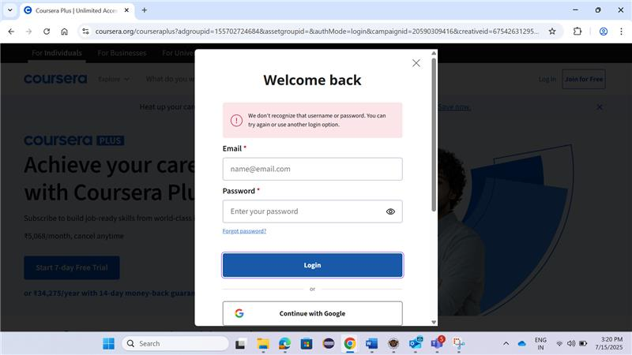

**3.1.1.6 Req0006 - Search and Display Beginner-Level Web Development Courses**

**Req0006a**-The user accesses the web URL: https://www.coursera.org/.

**Req0006b**- The homepage is displayed.

**Req0006c-** The user enters **“Web Development”** in the search tab.

**Req0006d-**The user clicks on the Search icon.

**Req0006e**-The system displays a page containing **Web Development** courses.

**Req0006f**- The user clicks on the **“Sort by”** dropdown and selects **Best Match**.

**Req0006g** – The user applies filters:

* + Level: Beginner
  + Language: English

**Req0006h** – The system updates the course list based on the applied filters.

**Req0006i** – The user extracts and displays the following details for the first two courses:

* + Course Name
  + Total Learning Hours
  + Rating

**3.1.1.7 Req0007 - Extract Language Learning Levels and Counts**

**Req0007a –** The user accesses the web URL: https://www.coursera.org.

**Req0007b –** The homepage is displayed.

**Req0007c –** The user enters “Language Learning” in the search tab.

**Req0007d –** The user clicks on the Search icon.

**Req0007e –** The system displays a page containing Language Learning courses.

**Req0007f –** The user scrolls to the filter section and clicks on “Show More” under Language.

**Req0007g –** The system displays all available languages and levels.

**Req0007h –** The user extracts and displays:

* + List of Languages
  + Levels (Beginner, Intermediate, Advanced)
  + 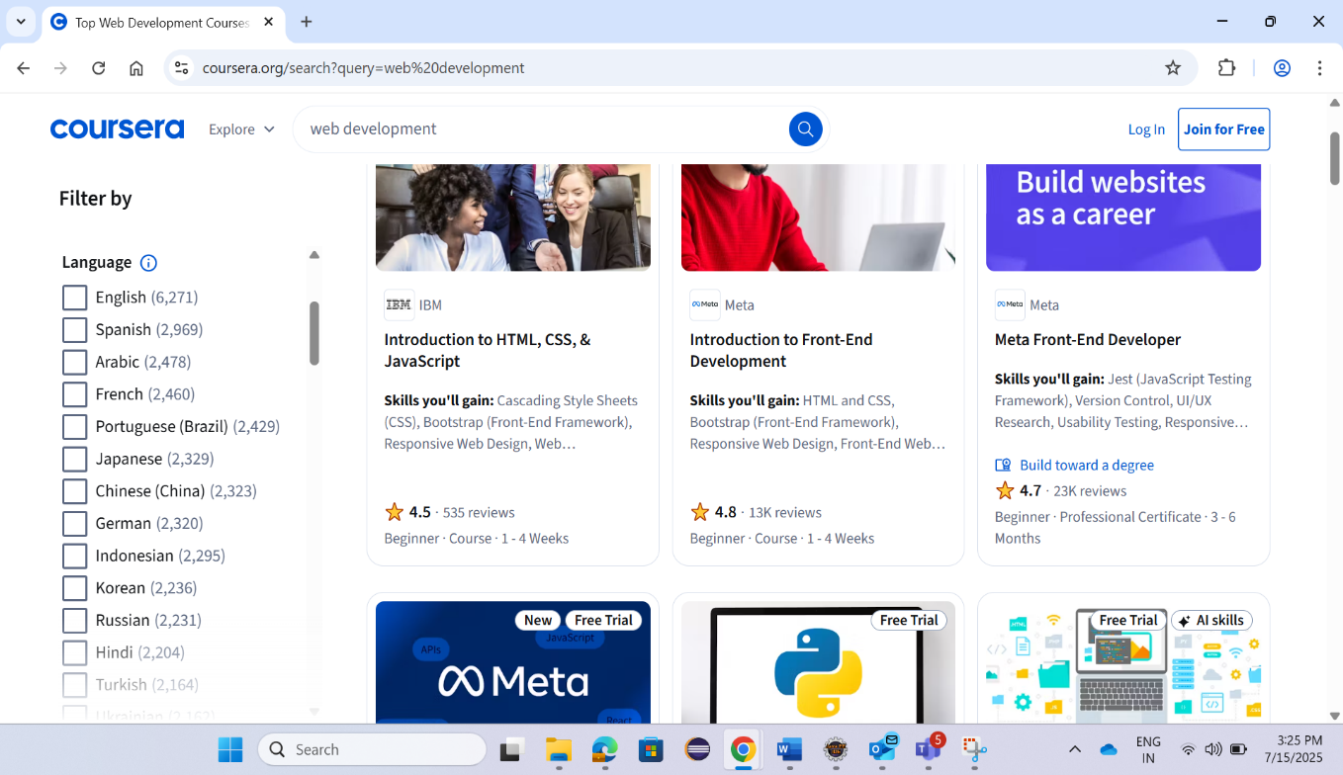Count of courses per language and level