MIMO Random Vibration Control Laws
Modifications, measured effects, and behaviour on a level-dependent plant
Rattlesnake vibration controller — six-drive / twelve-response frame
Work of 5 – 26 September 2026 · 62 commits · 40 instrumented runs
Scope
This report covers three weeks of control-law development on an 8-control-channel / 6-drive frame. It is organised in two parts. Part I is the law-by-law record: what each law does, what was changed in it, and what each change measurably bought or cost on the linear plant. Part II covers the nonlinear plant built to test those laws against a structure whose FRF moves with level.
Every number quoted is measured from a saved run unless explicitly labelled as a prediction or a model calculation. Three claims made earlier in this period were subsequently withdrawn on evidence; they are flagged where they arise so the record is not re-contaminated.

Contents
1 The plant, and why its rank matters
2 All six laws on the linear plant — the short version
3 What was changed in each law, and what it did
4 Tracking a moving plant — what the nonlinear work showed
5 A plant whose FRF moves with level
6 The laws on the moving plant
7 What is open

1 The plant, and why its rank matters
The test article is a six-shaker frame with twelve response channels, of which eight are used for control, over a 100–1000 Hz band at 1 Hz resolution — 901 in-band lines. Every result in this report is bounded by one property of it.
The 8×6 plant has rank 5, not 6. Computed analytically from the model's mass, stiffness and damping matrices — validated against the measured FRF, which it matches to a median 0.21 dB in magnitude — the sixth singular value is ~1e-17. The six shakers span a five-dimensional response subspace at these eight control locations. In the measured FRF that direction returns at 3.9e-05 to 4.1e-04 of the first singular value, and the numeric rank over the control band is 5 in all twelve runs of the reference set. It is identification noise.
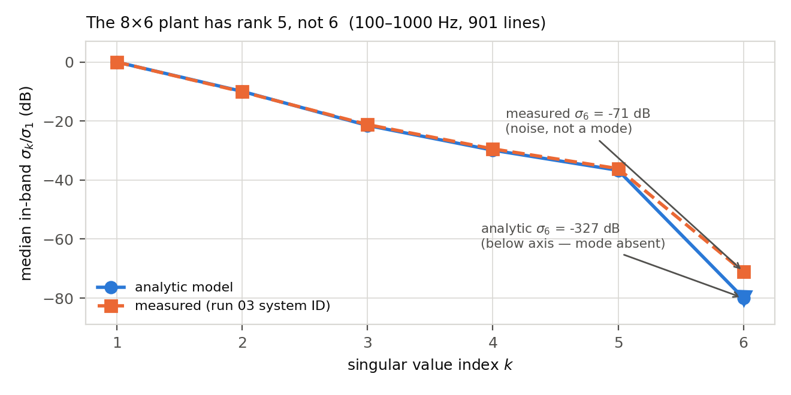
Figure 1 — Singular values of the control FRF, median over the in-band lines, normalised to σ₁. The analytic model and the measured identification agree to a few percent on σ₁…σ₅ and diverge entirely on σ₆, which exists only in the measurement.
Withdrawn claim. An earlier version of this work attributed roughly 1.6 dB of the achievable-accuracy floor to the rcond = 1e-3 truncation and made relaxing rcond the first recommended action. That was wrong. Truncating the measured FRF to rank 5 and recomputing with no rcond restriction gives 3.56–3.90 dB against an operational floor within 0.21 dB at every run. rcond = 1e-3 is not costing headroom; it is rejecting a direction the hardware cannot reach, and lowering it would invert noise.
Two consequences run through everything below. Eight channels cannot be independently controlled by five usable directions, so every law must decide which channels to sacrifice — and the laws differ mainly in how they make that decision. And every accuracy figure in this report is a rank-5 floor, not an absolute one.

2 All six laws on the linear plant — the short version
Six laws were exercised on the linear plant across 34 instrumented runs. The summary below is the best each achieved, and the qualification that matters is that accuracy and level control are separate problems: two laws never held total level at all.
Law | Loop | Best rms | % out | Level held? | Verdict
optimal_diagonal | model | 5.62 dB | 11.2 | yes (+0.08) | carry forward
optimal_diagonal_fast | model | 5.64 dB | 10.9 | yes (+0.21) | carry forward
match_trace_pseudoinverse | model + error | 7.21 dB | 21.1 | yes (+0.05) | carry forward
diagonal_congruence | error | 5.23 dB | 18.7 | no (best 2.78) | promising, level unsolved
buzz | none | 5.91 dB | 13.6 | yes (−0.30) | open loop, no tracking
pseudoinverse | none | 7.01 dB | 17.8 | no (best 1.28) | open loop, no tracking
“Loop” is what the law closes on. model = re-solves against the live FRF every cycle; error = reads the measured response; none = neither. Best rms is the lowest in-band per-channel rms error achieved while holding total level within ±0.5 dB, except where marked, where no run held level and the unconstrained best is shown instead.
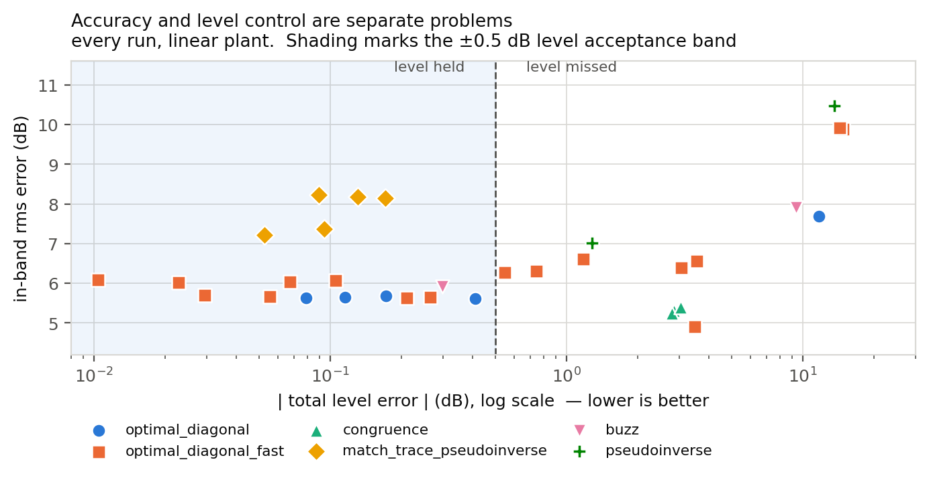
Figure 2 — Every run on the linear plant. Accuracy on the vertical axis, level control on the horizontal. The two are largely independent: the best accuracy in the set sits outside the level acceptance band, and the laws that hold level cluster on the left regardless of accuracy.

2.1 What this says about the three laws worth carrying
- optimal_diagonal and its fast variant give the best accuracy that is simultaneously achievable with correct level — 5.62 and 5.64 dB — and do it on roughly a third of the drive power the other laws need. They concede two of the eight channels to buy the other six.
- match_trace_pseudoinverse is 1.6 dB worse but is the only law of the three that reads the measured response, and its level control is the tightest in the set. Its per-line correction is a single real scalar, which is both its safety property and its accuracy ceiling.
- diagonal_congruence reaches the best raw accuracy of any law, 5.23 dB, correcting every channel rather than the total. It has never held level — its best is 2.78 dB — and that is the open problem on it, not its accuracy.
Withdrawn claim. Two laws were at one point classified as feedback and later as open loop; both classifications were wrong. optimal_diagonal and its fast variant are closed on the identified plant model — they re-solve against the live FRF every cycle — and open on the response error, since the objective is the predicted response diag(H X Hᴴ) and last_response_cpsd is accepted and never read. The three-way classification in the table above is the corrected one.

3 What was changed in each law, and what it did
This is the substance of the three weeks. The changes fall into four groups: the startup level cap, the drive-coherence cap, making the FRF update real, and per-law guards. A fifth entry records the decision to default every behaviour change back off.

3.1 The startup level cap — two bugs, present in every law that had one
The guard clamps the first control command to a ceiling relative to specification, so the rig is not hit with an unbounded first shot. It was present in six laws and wrong in both of the ways it could be.
Wrong domain. The clamp compared tr(specification) — a response quantity — against tr(output), which is the drive CPSD in V². That ratio is not dimensionless: it carries units of (response/volt)², so its value tracked the plant gain and the response channels' units rather than the overshoot it was meant to bound. On run 01's identification the raw solve sat −2.04 dB re spec; the clamp as written took it to a median −18.88 dB, where the clamp as documented takes it to exactly −9.00 dB. Roughly 10 dB too aggressive, and unit-dependent. It now clamps on the predicted response, tr(H X Hᴴ).
Wrong order. The drive-coherence cap ran after the clamp and lifted the level straight back through the ceiling. The cap shrinks off-diagonal drive terms while preserving the diagonal, which destroys the inter-drive cancellation a pseudoinverse solve relies on, so the same drive produces far more response. Both were fixed in all six laws, and the four laws that had no ceiling at all were given one.
This is the one behaviour change left enabled by default, at −9 dB, on every law.

3.2 The drive-coherence cap — free as a constraint, costly as a correction
The 0.95 cap on drive coherence exists to keep the commanded drives from becoming near-identical, which is both physically unrealisable and numerically fragile. Its cost was measured law by law with matched cap-on / cap-off pairs.
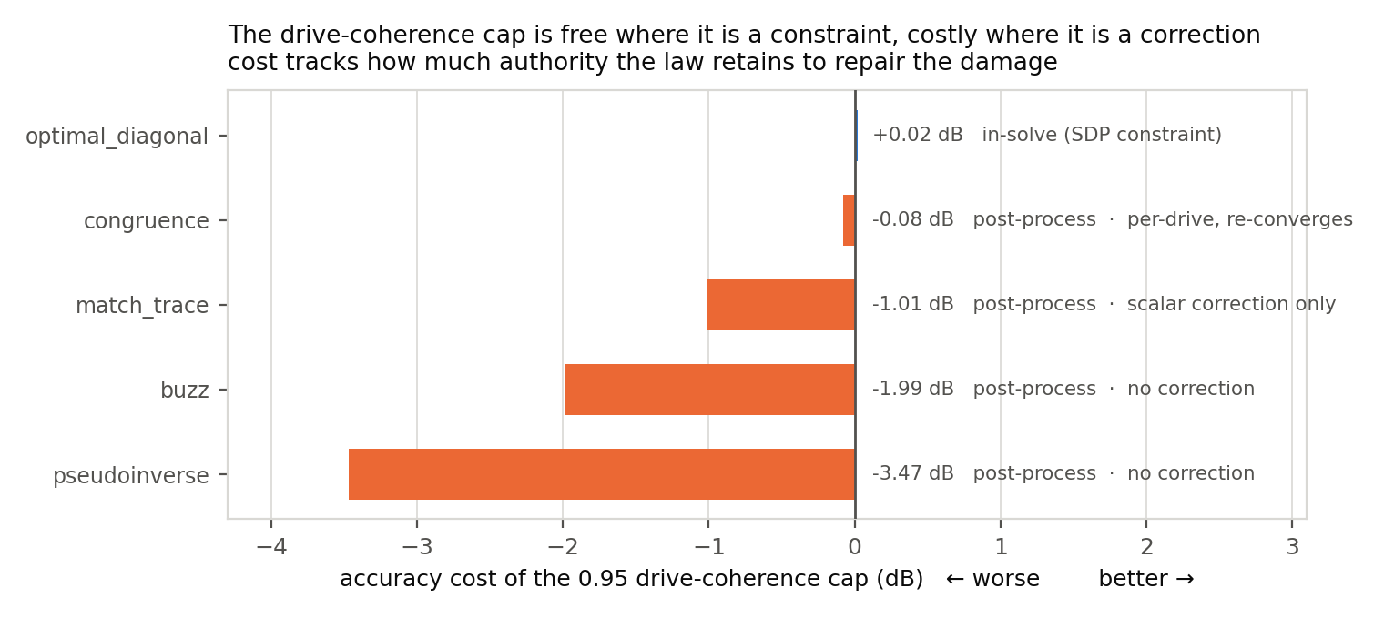
Figure 3 — Accuracy cost of the 0.95 drive-coherence cap. The determining factor is not the law family but where the cap is applied and how much authority the law retains afterwards.
optimal_diagonal solves subject to the cap as an SDP constraint, so the returned solution is already the best one that honours it and the cap costs essentially nothing. Every other law post-processes the cap onto an already-computed solve, and what it then costs depends on how much correction authority is left: congruence re-converges per drive and loses 0.08 dB; match_trace has only a scalar per line and loses 1.01 dB; buzz and pseudoinverse have no correction mechanism at all and lose 1.99 and 3.47 dB.
Withdrawn claim. An earlier version explained this spread by loop family. That explanation depended on the mistaken loop classification and never fitted the measurements anyway. Where the cap is applied is what fits.

3.3 Making “Update Transfer Function During Control” real
An audit of what an updated FRF actually does to each law found three where the setting did not work as anyone would assume, and one place where it was actively unsafe. The call contract had been misunderstood: Rattlesnake passes a transfer_function to control() every cycle whether the setting is on or off — the setting only chooses which array, live or frozen — and system_id_update() is never called during control at all. A law that reacts to a new FRF only inside system_id_update is therefore a silent no-op under the setting.
match_trace ignored the updated FRF entirely. Its steady state is a per-line real scalar applied to the previous command, so the FRF entered once at startup and never again: it tracked level against a re-estimated plant while holding a drive shape synthesised from the plant as it looked before the test started. It now re-synthesises the shape from the current FRF and carries the level forward explicitly.
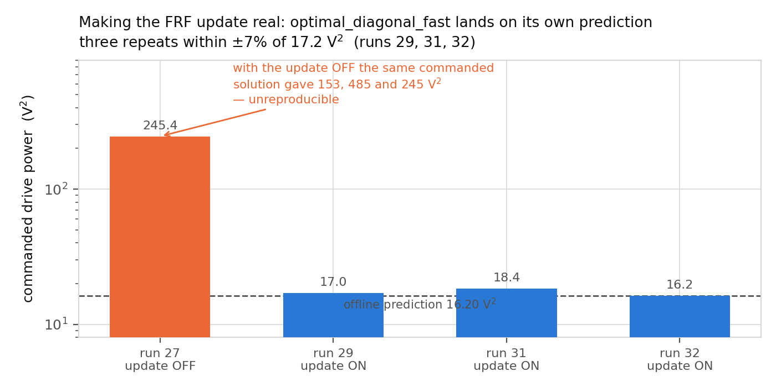
Figure 4 — optimal_diagonal_fast with the FRF update working. Three repeats land within ±7% of 17.2 V² and on the offline prediction of 16.20 V². With the update off, the same commanded solution gave 153, 485 and 245 V² across repeats.
That reproducibility is the point. An unreproducible drive is not a control law, it is a coincidence; making the update real is what turned the fast law from an interesting solver into something that can be tested.

3.4 Per-law guards and refinements

match_trace_pseudoinverse
- Gated FRF refresh. The refresh is gated per line on change since that line's own last solve, not since the previous cycle — which can never see slow monotonic drift. Ungated refresh re-solves on estimator noise, because the published FRF is already exponentially averaged. Best result on the linear plant improved from 8.17 to 7.37 dB rms with the gate at 0.05.
- Gap-based rank selection. Rather than an absolute rcond, the truncation point is located by the largest gap in the singular-value spectrum — 8.9× between σ₅ and σ₆ against 2.1–3.8× elsewhere. Cross-estimate agreement rose from 24.5% to 88.7%.
- The drive-shape refresh defaults OFF, so the reference runs reproduce.

optimal_diagonal and optimal_diagonal_fast
- drive_rcond expressed as a multiple of the plant's own singular-value spread, measured from the system ID the law already holds, rather than an absolute ratio that must be re-tuned per article. The reference is σ₅/σ₁ = 0.0152, located by the spectral gap; default 2.0. Two errors were made and fixed building it — measuring the spread over all lines rather than in-band only, and scaling off σ_min rather than σ₅.
- A dB-domain objective as an alternative to the linear one. It gives better pooled rms but spreads error across every channel instead of sacrificing the two the plant cannot reach, which is not what this rig wants. Opt-in; the default is unchanged.
- A response-error trim, to close the loop the law leaves open. See §6.3 — it does not earn its place.

diagonal_congruence
- The anti-windup ceiling now judges level from the measured response extrapolated over one bounded step, not from the response predicted through H. The principal limit was otherwise only as trustworthy as the model — exactly what cannot be relied on when the FRF is being re-estimated live, which is the regime the earlier laws failed in.
- The projected target is read lazily on the first control() call rather than in __init__, which runs before system identification. Reading it in __init__ demanded a file derived from an FRF that does not yet exist, so the operator could only ever supply a stale projection.
- Its startup clamp was already in the response domain, but ran before the floor-and-silence and drive-coherence steps, both of which lift the level back through the ceiling. Reordered.

3.5 Every behaviour change defaulted back off
Several of these changes silently altered the laws that produced the twelve-run reference set. Each was made opt-in so that the defaults reproduce those runs exactly, with one exception: the startup level cap at −9 dB stays on, because it is wanted. This is the discipline that makes the comparison table in §2 meaningful — without it, every improvement would have quietly invalidated the baseline it was measured against.

4 Tracking a moving plant — what the nonlinear work showed
The second half of the period built a plant whose FRF moves with drive level and ran the surviving laws against it. §5 describes how that plant was built and §6 gives the run-by-run detail; this section is the answer to the question the whole exercise was for — how well does each law update as the plant changes underneath it.

4.1 A law updates in two places, and they are not the same thing
Every law in the set re-solves the drive from a plant estimate on every control cycle. That is not plant tracking. Plant tracking requires the estimate itself to be replaced from control-time data, which is a separate switch — Update Transfer Function During Control — and until this period it was a silent no-op in two of the three laws (§3.3). The distinction matters because the two updates fail differently: a stale estimate degrades gracefully, while a live estimate fed by distorted control-time data can degrade the very model it is meant to improve.
The nonlinear plant separates the two cleanly, because 27 of its 33 modes soften and six do not. Refreshing the estimate below 300 Hz, where nothing moves, buys 0.62 dB — that is the estimator refining a fixed plant. Above 300 Hz the same refresh buys 1.5–2.6 dB, and that increment is genuine plant tracking. The two jobs separate in frequency only because the control group was built to make them.

4.2 Law by law, on a plant that moves
Law | Estimate update | Runs | How it behaved as the plant moved
match_trace_pseudoinverse | live, gated | 49, 50 | Tracks. Better at every level with the refresh on; accuracy flat with level. Pays in coherence.
optimal_diagonal | live | 51, 52, 55 | Tracks shape best of any law — and loses level control completely by +4 dB.
optimal_diagonal_fast | live | none | Untested on a moving plant. Profiles ready.
diagonal_congruence | live | none | Untested. Never held level on the linear plant, so a moving one is premature.
buzz / pseudoinverse | none | none | Open loop by construction. Cannot track and were not asked to.

match_trace_pseudoinverse — tracking works, and it is not free
The clean pair is runs 49 and 50: one parameter different, four levels each. With the refresh on, coherent-column accuracy is 7.40, 7.41, 7.38 and 7.47 dB from −18 dB to 0 dB — a 0.09 dB spread while the plant softens 0.745% and the drive voltage spans 12.7×. With the refresh off the same law runs 7.91, 7.95, 7.99 and 8.10 dB. The refresh is worth 0.52, 0.55, 0.62 and 0.63 dB, and the margin widens with level, which is the signature of tracking rather than of a fixed offset. Lines out of band improve from about 26% to 20–23% at every level.
The cost appears where the estimate is fed by control-time data on a distorting plant. At 0 dB coherence falls from 0.938 to 0.697, out-of-band response rises from −30.8 to −24.5 dB, and the drive rises 2.8 dB. The loop also never settles: 211 cycles with the per-cycle FRF change held at 0.020–0.031 against 0.007 with the refresh off. Tracking bought accuracy and spent model quality to get it.

optimal_diagonal — the best tracker and the worst level control
At 0 dB it reaches 5.58 dB against match_trace’s 7.47 on the same plant, using 38% less drive and holding coherence at 0.953 where match_trace falls to 0.697. Asking less of the plant keeps the plant closer to the model it is being identified against, so the tracking chain reinforces itself instead of eroding. On shape, this is the law to carry.
And it does not track level at all. Level error runs +0.31 dB at −18, +1.98 at 0 and +8.00 at +4. At the +4 dB point the drive rose 0.9 dB for a 4 dB increase in demand while the response overshot by eight, because the law closes on its own predicted response and never reads the measured one. On a linear plant that costs nothing. On a softening plant it is a runaway, and it is the outstanding defect in the whole family.

What was tried to close that loop, and why it failed
The response-error trim exists to close exactly that loop and had never run live. It ran twice on the moving plant and was worse on every measure at the one level where it had real work to do (§6.3). The cause is structural rather than a tuning problem: on a rank-5 plant the solver deliberately concedes channels it cannot reach, and a trim that reads residual response error as model error buys those channels back at full price. Level tracking on this family needs an outer loop on total power, not a per-channel correction.

4.3 The limit that will matter on hardware
The refresh gate responds to the rate of plant change, not the amount. A level change ramped over 2 s and smoothed by 0.04 exponential averaging arrives as roughly 25 increments fifty times under the 0.05 threshold, and two of the four level changes in run 50 produced no refresh activity at all where 321 and 447 lines had been predicted. The tracking demonstrated above therefore happened on the changes that were fast enough to be seen. A real structure heating or loosening over a test would drift arbitrarily far under this gate without ever tripping it. An accumulated-change criterion alongside the per-cycle one is the single change most needed before any of this meets hardware.
One further caution carries from §5.3: on a moving plant the scoring metric is itself suspect. Raw rms counts distortion as signal and flattered one run by 1.55 dB; rms about zero partly cancels on a uniformly hot response, so the +4 dB runaway scores better than the converged 0 dB point. Every accuracy number above is on the coherence-weighted column, read alongside level error.

5 A plant whose FRF moves with level
Every result above is on a linear plant. Real structures are not linear, and the laws that track an FRF should be tested against one that actually moves. That required building a nonlinear plant, which took two attempts.

5.1 Why the first attempt failed four times
The first nonlinear article used a softening cubic in each modal coordinate. Four runs were attempted on it and all four ended the same way — arithmetic overflow in the time integration. That is escape, not a jump: a softening cubic gives a finite potential well, and beyond q_esc = ωₙ/√|k₃| the restoring force reverses and the solution runs away.
The trap is worth stating, because it cost four runs. You cannot buy frequency shift by turning up k₃. The shift rises linearly with |k₃| while q_esc falls as 1/√|k₃|, so the shift available at escape is fixed at 3/8 whatever k₃ is. With 4σ random peaks that caps the usable shift near 0.5–1%, and the final calibration achieved 0.375% — at the noise.
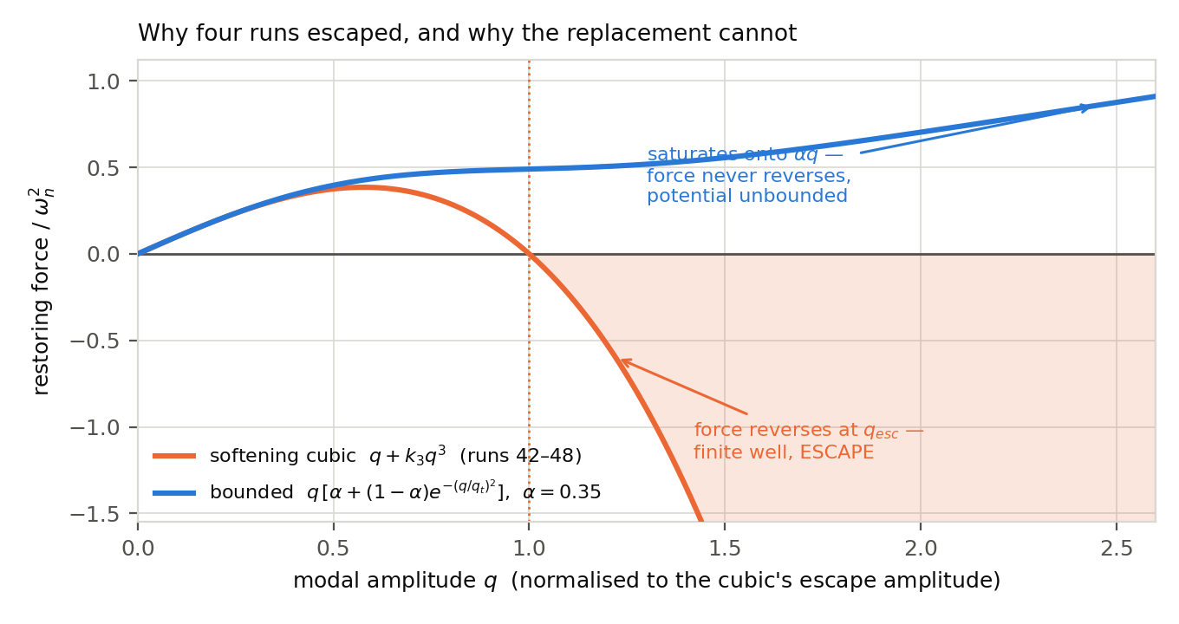
Figure 5 — The two kernels. The cubic's restoring force reverses sign at the escape amplitude, giving a finite well. The bounded kernel saturates onto a residual linear stiffness αωₙ²q and never reverses, so the potential is unbounded and there is nothing to escape from.
The replacement, a bounded softening kernel g(q) = α + (1−α)·exp(−(q/q_t)²), removes the failure mode structurally rather than by margin. Verified by direct integration at 400× the design nonlinearity and 4× the maximum test level: finite, with the frequency shift saturating at 40.84% — exactly the 1 − √α asymptote. The cubic escaped at 25× design.

5.2 The design decision that made the results readable
All 33 flexible modes lie between 120 and 899.5 Hz. Rather than soften all of them, only the 27 above 300 Hz were made nonlinear; the six below stay exactly linear — their nonlinear term is identically zero, measured at 2e-13% shift, not merely small.
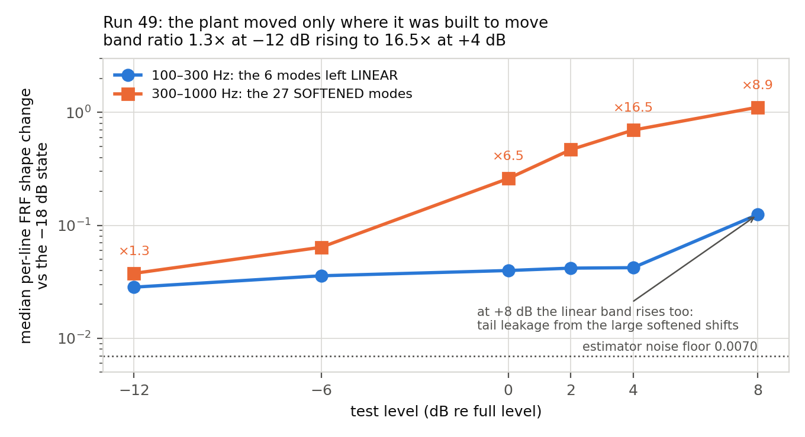
Figure 6 — Run 49. The six linear modes and the 27 softened modes, measured as per-line FRF shape change against the −18 dB state. The linear band is flat across a 12.7× span of drive voltage while the softened band rises 18×.
Those six modes cost nothing — they were already there — and they convert “the FRF changed” into “the FRF changed in exactly the 27 modes we made nonlinear and in none of the six we did not”, inside a single run. They paid again when the FRF refresh was tested: below 300 Hz, where nothing moves, the refresh still buys 0.62 dB, which is estimate refinement; above 300 Hz it buys 1.5–2.6 dB, and that increment is plant tracking. The two functions separate in frequency only because of the control group.

5.3 The measurement lesson
Control quality appeared to improve monotonically with level — rms 7.89 dB at −18 dB falling to 4.96 dB at +8 dB — while the plant moved further from the frozen FRF the drive was solved against. That is backwards, and it is an artifact. Weighting the response auto-spectra by the measured coherence and scoring only the part correlated with the drive, the improvement vanishes: control is flat to slightly worse, 7.9 to 8.3 dB.
The extra “signal” was distortion. The scoring metric cannot distinguish driven response from distortion, and neither can the law — match_trace is matching the trace of a response that is partly not its own. Every accuracy number in this report is therefore taken on the coherence-weighted column. Raw rms flattered one run by 1.55 dB.
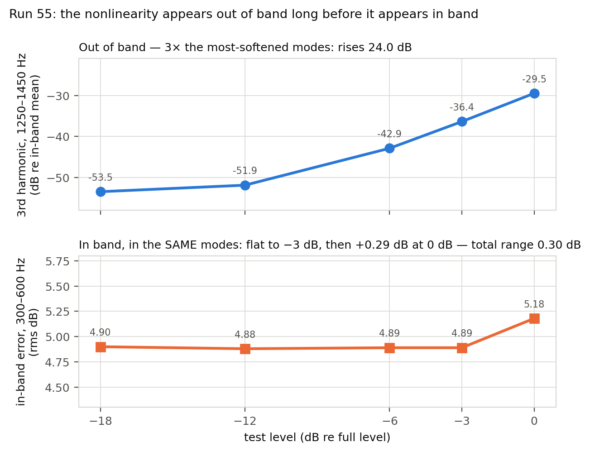
Figure 7 — Run 55. Out-of-band third-harmonic content against in-band error, in the same modes. 1250–1450 Hz is three times the most-softened mode cluster; the plant has no modes above 899.5 Hz, so nothing there is resonant.
This is the most portable finding of the three weeks. On this rig the nonlinearity appears in the out-of-band harmonic long before it appears in the in-band control error — 24 dB of range against 0.30 dB. The in-band error is set by the rank-5 geometry, not by the plant moving. The harmonic needs no reference run and is free to measure from any saved spectrum.

6 The laws on the moving plant

6.1 match_trace with and without the FRF refresh
A clean pair — one parameter different — at four levels. On the coherent column the refresh is better at every level, by 0.52, 0.55, 0.62 and 0.63 dB. With it on, accuracy is 7.40, 7.41, 7.38 and 7.47 dB across the sweep; with it off, 7.91, 7.95, 7.99 and 8.10 dB. Both configurations are nearly flat with level, but the gap widens as the plant moves, which is what tracking should look like. The refresh-on result at 0 dB, on a plant softened by 0.745%, is better than the refresh-off result at −18 dB on the same plant when it was effectively linear — the two differ in configuration as well as level, so that comparison bounds what the refresh is worth rather than claiming the softened plant is intrinsically easier.
Two costs. Coherence falls from 0.938 to 0.697 as control-time estimates carrying distortion are fed back into the solve, and the loop never converges — 211 cycles with the per-cycle FRF change held at 0.020–0.031 against 0.007 with the refresh off, and the refresh count parked at a median of 300 with no decay. Three coupled time constants with nothing damping between them.
An unanticipated property. The gate responds to the rate of plant change, not the amount. A level change ramped over 2 s and smoothed by 0.04 exponential averaging arrives as roughly 25 increments fifty times under the 0.05 threshold, so two of the four level changes produced no refresh activity at all where 321 and 447 lines had been predicted. A slowly drifting real structure would slip under this gate no matter how far it eventually drifted. This wants an accumulated-change criterion alongside the per-cycle one before the law sees hardware.

6.2 optimal_diagonal on the moving plant
At 0 dB it beats the best match_trace result by 1.89 dB on the coherent column — 5.58 against 7.47 — using 38% less drive, and holds coherence at 0.953 where match_trace falls to 0.697. Less drive means less distortion, which means a cleaner FRF, which means better control; the chain follows from asking less of the plant.
Its weakness is level. The level error runs +0.31, +1.98 and +8.00 dB at −18, 0 and +4 dB. At +4 dB the response is eight dB above specification and the law is blind to it: the drive rose only 0.9 dB for a 4 dB increase in demand while the response overshot by 8. That is the open-on-response-error property, not as a subtlety but as an eight dB miss. That point is a level runaway, not a control point.
A scoring trap worth carrying. The coherent rms at that +4 dB point reads 5.53 dB — better than the same run's 0 dB result — while the test is eight dB over specification, because rms-about-zero partly cancels on a uniformly hot response. rms alone cannot see a level runaway. Read level error alongside it, always.

6.3 The response-error trim: a negative result
The trim was built to close exactly the loop §6.2 shows open, and had never run live. It ran twice. At 0 dB — the one level where the model gap gives it real work — it is worse on every measure than the same law with the trim off: 0.10 dB worse on the coherent column, 1.7 points more lines out of band, 0.73 dB further off level, 25% more drive, and coherence down from 0.953 to 0.896.
The per-channel breakdown says why. The trim improved the two channels the solver had conceded — 10.34 to 9.20 dB and 7.71 to 7.42 dB — and degraded five of the six it was serving, the sixth improving by 0.13 dB. It pulls drive toward channels the SDP deliberately gave up on, because it reads a rank-deficiency trade-off as model error. The solver concedes those channels because serving them costs more elsewhere; the trim cannot see that trade and buys them back at full price.
That is a design mismatch rather than a tuning problem, and it is the reason the remaining windup repair is now low priority — a perfect trim would still buy back conceded channels.

The windup, and four fixes
The trim also failed its own null check, ending with corrections pinned across the ±3 dB clamp at a level whose true model gap is 0.012 dB, and costing 30% more drive for the same response. The cause is integrator windup behind a conditional gate: the solver-agreement gate is evaluated before the error term, and gated bins kept their correction permanently, so the gate blocked harmful accumulation and corrective unwinding equally.
Attempt | Change | Outcome
1 | Leak every idle bin | Steady state sat at the deadband edge — a limit cycle
2 | Leak on any single gate failure | Bled away corrections merely waiting to be re-solved
3 | Leak after 50 consecutive gate failures | Committed. Partial cure — 28% of the excess drive recovered
4 | Pay down the counter instead of resetting | Swamped a real 3 dB model error. Reverted
All four attempts assumed that gate-failure frequency identifies a spurious correction. It cannot: with 20 bins re-solved per cycle out of 901, a bin waiting its turn fails the gate about 98% of the time and so does a bin the solver genuinely cannot reach. The discriminator is whether a bin passes on the cycles it is actually re-solved, which requires the refinement scheduler to tell the trim which bins it touched. Three of the four were caught by the regression suite rather than by reasoning.

7 What is open

7.1 Ready to run
- optimal_diagonal_fast on the nonlinear plant. Profiles exist and are untouched. Note that the trim's leak constant is tuned against the slow law's 20-bins-per-cycle refinement rate and is probably wrong for the fast variant.
- A Δf = 10 Hz system identification was captured as run 56 to test control on a wider bandwidth, but the environment was never run against it. The sysid file is saved.
- octave_band_switching_control has never been run. Its parameter positions collide with the base class's — it reads fields 5–9 as its own where the base now reads drive_rcond and the startup cap — so it needs a five-line fix before it can work at all. This is the vehicle for wider-bandwidth control, keeping fine acquisition and aggregating only the control decisions into bands.

7.2 Known defects
- The level runaway in the optimal-diagonal family is the real outstanding defect, and the trim is not the fix. A level-only outer loop reading total power would be.
- The refresh gate is rate-sensitive and will miss slow drift; it wants an accumulated-change criterion.
- diagonal_congruence has never held level on any run.

7.3 Unrepeated
Both the match_trace pair and the optimal_diagonal pair on the nonlinear plant are one run each. Run 49's +4 dB down-sweep is unresolved as a hysteresis question — the two +4 dB points differ, but the level loop landed 1.31 dB apart, which accounts for most of it.

7.4 Portability
The three laws will run on stock Rattlesnake: the control-law interface is byte-identical to upstream, and everything the laws consume — the live control FRF, the last response and drive CPSDs, the update-during-control switch, and the test-level normalisation — is upstream-native. They import only numpy. Three things do not travel: the nonlinear virtual hardware is a local component and the profiles select it by a hardware index upstream does not define; the exponential control-phase averaging is a local profile field; and the level-change hook the trim and the octave law use is never called upstream. Portable as code, not as results.

