TALLINNA TÖÖSTUSHARIDUSKESKUS

**ANDROID VS IOS**  
Kodutöö

Juhendaja: Helen Nagel  
Koostaja: Aleksei Nikiforov  
TARgv17

TALLINN  
2018

# Android

**Android** is a mobile operating system developed by Google, based on a modified version of the Linux kernel and other open source software and designed primarily for touchscreen mobile devices such as smartphones and tablets. In addition, Google has further developed Android TV for televisions, Android Auto for cars, and Wear OS for wrist watches, each with a specialized user interface. Variants of Android are also used on game consoles, digital cameras, PCs and other electronics.

Initially developed by Android Inc., which Google bought in 2005, Android was unveiled in 2007, with the first commercial Android device launched in September 2008. The operating system has since gone through multiple major releases, with the current version being 9.0 "Pie", released in August 2018. The core Android source code is known as Android Open Source Project (AOSP), and is primarily licensed under the Apache License.

Android is also associated with a suite of proprietary software developed by Google, including core apps for services such as Gmail and Google Search, as well as the application store and digital distribution platform Google Play, and associated development platform. These apps are licensed by manufacturers of Android devices certified under standards imposed by Google, but AOSP has been used as the basis of competing Android ecosystems, such as Amazon.com's Fire OS, which use their own equivalents to the Google Mobile Services.

Android has been the best-selling OS worldwide on smartphones since 2011 and on tablets since 2013. As of May 2017, it has over two billion monthly active users, the largest installed base of any operating system, and as of June 2018, the Google Play store features over 3.3 million apps.

### Platform usage

  Oreo (14.6%)

  Nougat (30.8%)

  Marshmallow (22.7%)

  Lollipop (19.2%)

  KitKat (8.6%)

  Jelly Bean (3.5%)

  Ice Cream Sandwich (0.3%)

  Gingerbread (0.3%)

Charts in this section provide breakdowns of Android versions, based on devices accessing the Google Play Store in a seven-day period ending on August 31, 2018. Therefore, these statistics exclude devices running various Android forks that do not access the Google Play Store, such as Amazon's Fire tablets.

| **Version** | **Code name** | **Release date** | **API level** | **Runtime** | **Distribution** | **First devices to run version** |
| --- | --- | --- | --- | --- | --- | --- |
| **9.0** | Pie | August 6, 2018 | **28** | ART | N/A | Essential Phone, Pixel, Pixel XL, Pixel 2, Pixel 2 XL, Nokia 7 Plus, OnePlus 6, Oppo R15 Pro, Sony Xperia XZ2, Vivo X21UD, Vivo X21, Xiaomi Mi Mix 2S [360] |
| **8.1** | Oreo | December 5, 2017 | 27 | ART | 3.2% | Pixel, Pixel XL, Nexus 6P, Nexus 5X |
| **8.0** | August 21, 2017 | 26 | ART | 11.4% | N/A |
| **7.1** | Nougat | October 4, 2016 | 25 | ART | 10.5% | Pixel, Pixel XL |
| **7.0** | August 22, 2016 | 24 | ART | 20.3% | Nexus 5X, Nexus 6P |
| **6.0** | Marshmallow | October 5, 2015 | 23 | ART | 22.7% |
| **5.1** | Lollipop | March 9, 2015 | 22 | ART | 15.4% | Android One |
| **5.0** | November 3, 2014 | 21 | ART 2.1.0 | 3.8% | Nexus 6, Nexus 9 |
| **4.4** | KitKat | October 31, 2013 | 19 | Dalvik (and ART 1.6.0) | 8.6% | Nexus 5 |
| **4.3** | Jelly Bean | July 24, 2013 | 18 | Dalvik | 0.5% | Nexus 7 2013 |
| **4.2** | November 13, 2012 | 17 | Dalvik | 1.8% | Nexus 4, Nexus 10 |
| **4.1** | July 9, 2012 | 16 | Dalvik | 1.2% | Nexus 7 |
| **4.0** | Ice Cream Sandwich | October 19, 2011 | 15 | Dalvik | 0.3% | Galaxy Nexus |
| **2.3** | Gingerbread | February 9, 2011 | 10 | Dalvik 1.4.0 | 0.3% | Nexus S |
|  | | | | | | |

As of August 2018, 77.1% of devices have OpenGL ES 3.0 or higher.

# iOS

**iOS** (formerly **iPhone OS**) is a mobile operating system created and developed by Apple Inc. exclusively for its hardware. It is the operating system that presently powers many of the company's mobile devices, including the iPhone, iPad, and iPod Touch. It is the second most popular mobile operating system globally after Android.

Originally unveiled in 2007 for the iPhone, iOS has been extended to support other Apple devices such as the iPod Touch (September 2007) and the iPad (January 2010). As of January 2017, Apple's App Store contains more than 2.2 million iOS applications, 1 million of which are native for iPads. These mobile apps have collectively been downloaded more than 130 billion times.

The iOS user interface is based upon direct manipulation, using multi-touch gestures. Interface control elements consist of sliders, switches, and buttons. Interaction with the OS includes gestures such as *swipe*, *tap*, *pinch*, and *reverse pinch*, all of which have specific definitions within the context of the iOS operating system and its multi-touch interface. Internal accelerometers are used by some applications to respond to shaking the device (one common result is the undo command) or rotating it in three dimensions (one common result is switching between portrait and landscape mode). Apple has been significantly praised for incorporating thorough accessibility functions into iOS, enabling users with vision and hearing disabilities to properly use its products.

Major versions of iOS are released annually. The current version, iOS 11, was released on September 19, 2017. It is available for all iOS devices with 64-bit processors; the iPhone 5S and later iPhone models, the iPad (2017), the iPad Air and later iPad Air models, all iPad Pro models, the iPad Mini 2 and later iPad Mini models, and the sixth-generation iPod Touch.

### Platform usag

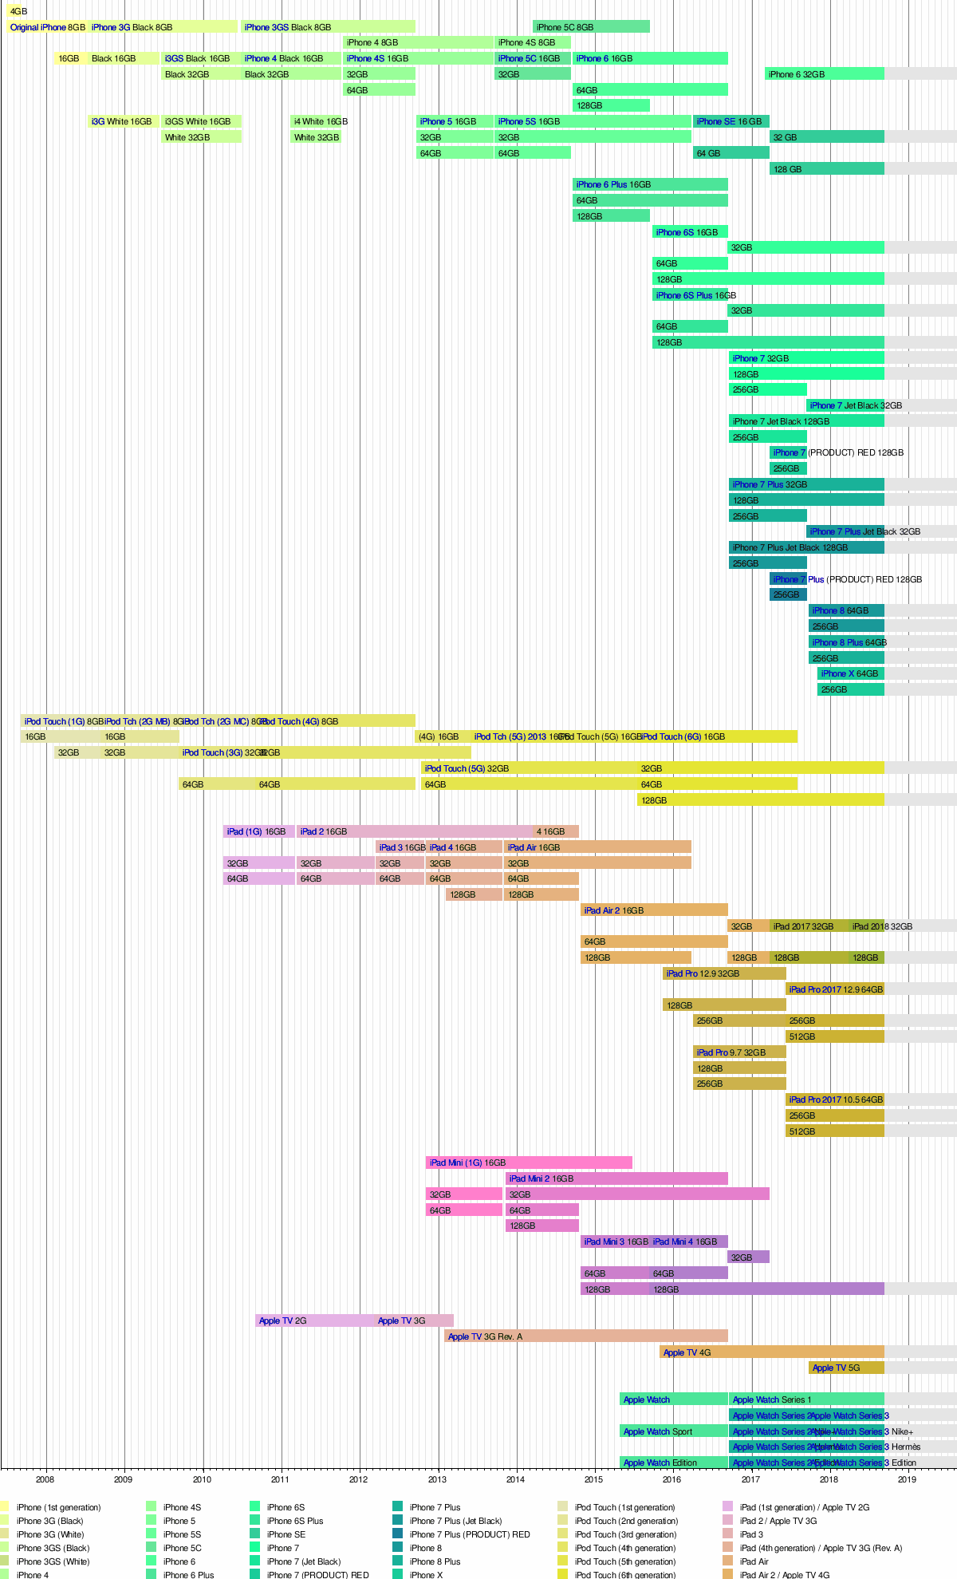

# Android vs iOS

### Comparison chart

|  |  |  |
| --- | --- | --- |
|  | **Android** | **iOS** |
| **Customizability** | A lot. Can change almost anything. | Limited unless jailbroken |
| **Developer** | Google, Open Handset Alliance | Apple Inc. |
| **Initial release** | September 23, 2008 | July 29, 2007 |
| **Source model** | Open source | Closed, with open source components. |
| **OS family** | Linux | OS X, UNIX |
| **Widgets** | Yes | No, except in NotificationCenter |
| **File transfer** | Easier than iOS. Using USB port and Android File Transfer desktop app. Photos can be transferred via USB without apps. | More difficult. Media files can be transferred using iTunes desktop app. Photos can be transferred out via USB without apps. |
| **Available on** | Many phones and tablets. Major manufacturers are Samsung, Motorola, LG, HTC and Sony.. Nexus and Pixel line of devices is pure Android, others bundle manufacturer software. | iPod Touch, iPhone, iPad, Apple TV (2nd and 3rd generation) |
| **Calls and messaging** | Google Hangouts. 3rd party apps like Facebook Messenger, WhatsApp, Google Duo and Skype all work on Android and iOS both. | iMessage, FaceTime (with other Apple devices only). 3rd party apps like Google Hangouts, Facebook Messenger, WhatsApp, Google Duo and Skype all work on Android and iOS both. |
| **Internet browsing** | Google Chrome (or Android Browser on older versions; other browsers are available) | Mobile Safari (Other browsers are available) |
| **App store , Affordability and interface** | Google Play – 1,000,000+ apps. Other app stores like Amazon and Getjar also distribute Android apps. (unconfirmed ".APKs") | Apple app store – 1,000,000+ apps |
| **Available language(s)** | 100+ Languages | 34 Languages |
| **Video chat** | Google Duo and other 3rd party apps | FaceTime (Apple devices only) and other 3rd party apps |
| **Voice commands** | Google Now, Google Assistant | Siri |
| **Maps** | Google Maps | Apple Maps (Google Maps also available via a separate app download) |
| **Latest stable release and Updates** | Android 8.0.0, Oreo (Aug 21, 2017) | 11 (Sep 19, 2017) |
| **Alternative app stores and side loading** | Several alternative app stores other than the official Google Play Store. (e.g. Aptoide, Galaxy Apps) | Apple blocks 3rd party app stores. The phone needs to be jailbroken if you want to download apps from other stores. |
| **Battery life and management** | Many Android phone manufacturers equip their devices with large batteries with a longer life. | Apple batteries are generally not as big as the largest Android batteries. However, Apple is able to squeeze decent battery life via hardware/software optimizations. |
| **Open source** | Kernel, UI, and some standard apps | The iOS kernel is not open source but is based on the open-source Darwin OS. |
| **File manager** | Yes. (Stock Android File Manager included on devices running Android 7.1.1) | Not available |
| **Photos & Videos backup** | Apps available for automatic backup of photos and videos. Google Photos allows unlimited backup of photos. OneDrive, Amazon Photos and Dropbox are other alternatives. | Up to 5 GB of photos and videos can be automatically back up with iCloud. All other vendors like Google, Amazon, Dropbox, Flickr and Microsoft have auto-backup apps for both iOS and Android. |
| **Security** | Android software patches are available soonest to Nexus device users. Manufacturers tend to lag behind in pushing out these updates. So at any given time a vast majority of Android devices are not running updated fully patched software. | Most people will never encounter a problem with malware because they don’t go outside the Play Store for apps. Apple's software updates support older iOS devices also. |
| **Rooting, bootloaders, and jailbreaking** | Access and complete control over your device is available and you can unlock the bootloader. | Complete control over your device is not available. |
| **Cloud services** | Native integration with Google cloud storage. 15GB free, $2/mo for 100GB, 1TB for $10. Apps available for Amazon Photos, OneDrive and Dropbox. | Native integration with iCloud. 5GB free, 50GB for $1/mo, 200GB for $3/mo, 1TB for $10/mo. Apps available for Google Drive and Google Photos, Amazon Photos, OneDrive and Dropbox. |
| **Working state** | Current | Current |
| **Interface** | Touch Screen | Touch Screen |
| **Supported versions** | Android 5.0 & later (Android 4.4 is also supported but with patches) | iOS 8 & later |
| **First version** | Android 1.0, Alpha | iOS 1.0 |

# Sources:

<https://en.wikipedia.org/wiki/Android_(operating_system)>

<https://en.wikipedia.org/wiki/IOS>

<https://www.diffen.com/difference/Android_vs_iOS>

Contents

A. Android 2

Platform usage 2

B. iOS 4

Platform usag 5

C. Android vs iOS 6

Comparison chart 6

D. Sources: 9