**CREATE TABLE** **tPaymentMethod.**



* Table specifications:
  + PaymentMethodID field:
    - Primary Key
    - Will be int type.
    - Will not accept null values.
    - Will auto-increment by 1 starting with 1.
  + PaymentMethod field:
    - Will accept nvarchar type.
    - Max character length 15.
* Actions:
  + Write a script that will drop the table if the table exists
  + Create the table with the above specifications.
  + Write the script to insert the values as shown above.
  + Write a script that will list all the table values.
  + Save all the above actions into a single SQL script file on your local hard drive with the name *CreateTable_tPaymentMethod.sql*
  + Create a stored procedure with a name spCreate_*tPaymentMethod*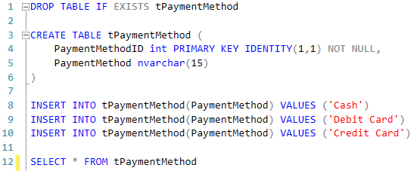

**CREATE TABLE tTillType:**



* Table specifications:
  + TillTypeID field:
    - Primary Key
    - Will be int type.
    - Will not accept null values.
    - Will auto-increment by 1 starting with 1.
  + TillDescription field:
    - Will accept nvarchar type.
    - Max character length 15.
* Actions:
  + Write a script that will drop the table if the table exists
  + Create the table with the above specifications.
  + Write the script to insert the values as shown above.
  + Write a script that will list all the table values.
  + Save all the above actions into a single SQL script file on your local hard drive with the name *CreateTable_tTillType.sql*
  + Create a stored procedure with a name spCreate_*tTillType*A screenshot of a computer code

    Description automatically generated

**CREATE TABLE** **tBankCardCharge:**



* Table specifications:
  + BankCardChargeID field:
    - Primary Key
    - Will be int type.
    - Will not accept null values.
    - Will auto-increment by 1 starting with 1.
  + CreditCardName field:
    - Will accept nvarchar type.
    - Max character length 15.
  + BankCharge
    - Will accept float values.
* Actions:
  + Write a script that will drop the table if the table exists
  + Create the table with the above specifications.
  + Write the script to insert the values as shown above.
  + Write a script that will list all the table values.
  + Save all the above actions into a single SQL script file on your local hard drive with the name *CreateTable_tBankCardCharge.sql*
  + Create a stored procedure with a name spCreate_*tBankCardCharge*A screenshot of a computer

    Description automatically generated

**CUSTOMER TABLE TRANSFORMATIONS**

**Modify the tCustomer_ETL table structure**

**tCustomer_ETL data wrangling**

