CS-340 README (Project Two)

Owen Merchant
August 9, 2026

About the Project
This project was designed to take CSV data from animal shelters, apply it to a dashboard powered by a MongoDB-connected Python CRUD module (README for CRUD in repo), and allow users to filter the animals to show dogs that meet their organization's needs, with a chart showing what percentage of each type are available per filter and a geolocation map to help users find the dogs.

Motivation
Grazioso Salvare is an animal rescue training company that finds potential search-and-rescue animals and trains them to save lives. This software not only helps them but also local animal shelters by allowing them to use shelter data to find animals that suit their needs by various categories (age, breed, etc.), resulting in more useful animals in their organization and less in shelters. With its public release on GitHub, hopefully more organizations like Grazioso Salvare can use this software to help animals and people, as it is adaptable to meet the needs of different types of organizations (ex. mapping out and sorting through a database of hurricane survivors to get them aid based on need).

Getting Started
These simple steps should allow you to easily use the software after setup:
- Create a Mongo database. By default, the database value in the CRUD module is aac.
- Create an admin user (read/write permissions enabled)
- Import the database data
- Log into the account and launch the Mongo shell with mongosh to verify functionality
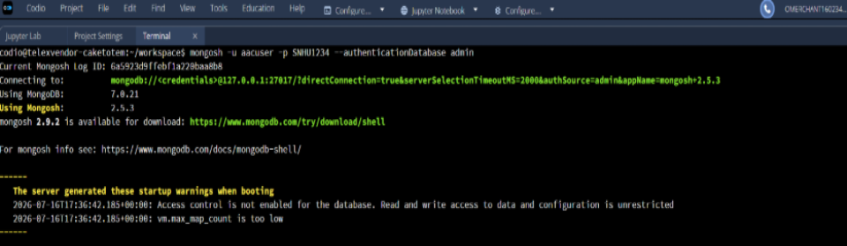
- Enter Jupyter Lab (ProjectTwoDashboard.ipynb)
- Replace this default data with your own username and password:
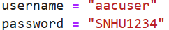
- Launch the program with the play button in Jupyter
- Click on the link below the code to access the dashboard (port may vary):

Installation
This project, while fairly simple, has a few required tool downloads:
- Download the MongoDB Community Server and install according to the installation documentation. MongoDB was chosen due to it being highly flexible and scalable, with complete compatibility with Python. If you are new to MongoDB, the documentation has some helpful information to help get you started.
- Install the latest version of Python. Though it is already imported, you will need the Dash library, which was chosen because it makes implementing user friendly dashboards as easy as programming a standard Python class, to render the dashboard and charts. Other required libraries include Plotly Express (px), needed for the pie chart, Dash Leaflet (dl), needed for the geolocation map, and Pandas (pd) to convert queries into DataFrames for the dashboard.
- Install Jupyter Lab by entering pip install jupyterlab in the Python terminal.

Code Examples
Filter system:
Uses JSON Mongo queries to find dogs in the system that match the required breeds, gender and age for the job, water rescue dogs in this example. It drops the '_id' field for Dash compatibility.
Pie chart:
Using graph-container and graph-id, creates a pie chart next to the map. This pie chart sorts the
breeds of preferred animals and tells the user what percentage of each is in each filter.
Geolocation Map:
Using the latitude and longitude of a selected animal, creates a map and a marker, and centers the marker on the location of the animal.

Usage and Testing
As it was developed in a Python notebook, this project was primarily tested by running the dashboard and checking for errors in all cases (startup, water rescue selected, water rescue and animal selected, etc.). This allowed me to find errors easily and oversee its development visually.
Default at Startup:
Water Rescue:
This filter, when activated, only shows dogs that are of breeds that are good for water rescue in the table. It also changes the pie chart to show what percentage of each breed makes them up. The other two have a similar effect.
Mountain or Wilderness Rescue:
The change in the pie chart with a new filter is visible on this one: of the four dogs available, two are huskies, one is a rottweiler and one is a malamute.
Disaster or Individual Tracking:
Filter Reset:
When the Reset button is selected, the dashboard will revert to a state identical to startup, along with the map changing if an animal was selected.
(Note: these screenshots were taken at 90% zoom so the whole screen will fit)

Challenges
One major challenge I had was with developing my DataTable. I kept getting syntax errors that suggested that I change my equals signs in it into walrus operators, and while that barely got it to load, nothing appeared on the screen. Then, once I found a way around that so I could use equals again, I got a " positional argument follows keyword argument" error. It turned out that the issue was that my RadioItems (to make filter buttons) were in my DataTable, so I had to take them out. Another big issue I had was with the filters, as, while they theoretically worked, I was repeatedly getting errors about the data not being JSON serializable. While including the '_id' field allowed the rest of the project to work perfectly fine, after some considerable trial and error, I eventually realized that this was not compatible with Dash, so I had to add a line to each filter so it gets dropped when filtered.

Contact
Owen Merchant
Lead Developer at Global Rain
owen.merchant@snhu.edu

