Heuristic Analysis

Isolation

Joe Chavez

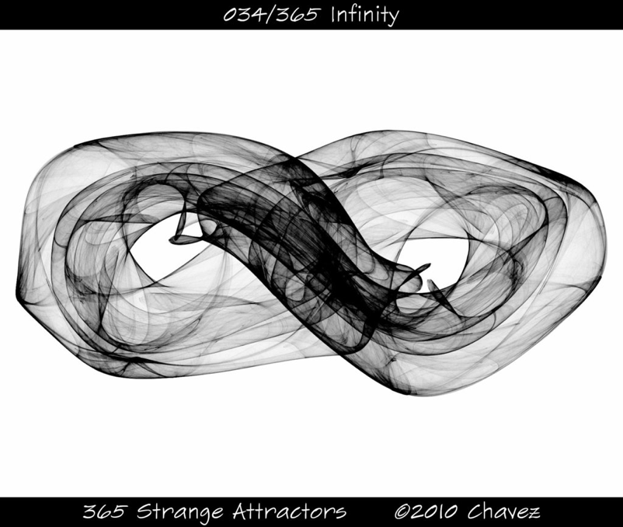

# Optimal Plan

*For each of your three custom heuristic functions, evaluate the performance of the heuristic using the included tournament.py script. Then write up a brief summary of your results, describing the performance of the agent using the different heuristic functions verbally and using appropriate visualizations.*

|  |  |  |  |  |  |  |  |  |  |  |
| --- | --- | --- | --- | --- | --- | --- | --- | --- | --- | --- |
| Match # | Opponent | AB_Improved | |  | AB_Custom | | AB_Custom_2 | | AB_Custom_3 | |
| 1 | Random | Won | Lost |  | Won | Lost | Won | Lost | Won | Lost |
| 2 | MM_Open | 10 | 0 |  | 10 | 0 | 10 | 0 | 10 | 0 |
| 3 | MM_Center | 7 | 3 |  | 10 | 0 | 8 | 2 | 9 | 1 |
| 4 | MM_Improved | 7 | 3 |  | 10 | 0 | 7 | 3 | 8 | 2 |
| 5 | AB_Open | 5 | 5 |  | 4 | 6 | 4 | 6 | 5 | 5 |
| 6 | AB_Center | 6 | 4 |  | 6 | 4 | 5 | 5 | 5 | 5 |
| 7 | AB_Improved | 3 | 7 |  | 5 | 5 | 5 | 5 | 4 | 6 |
|  | Win Rate: | 67.1% | |  | 78.6% | | 70.0% | | 72.9% | |