**Databases Laboratory Work Nr 1**

**Title:** Database Creation and Maintenance

**Done by:** Tcacenco Igor, FAF-191

**Prerequisites:** Microsoft SQL Server 2017, Microsoft SQL Server Management Studio 18 and “*Microsoft SQL Server 2017 pas cu pas*” by Marian and Vitalie COTELEA

**Objectives:**  This laboratory enables the student to get accustomed to the SQL Server tool. At the same time, the student will get familiar the SSMS interface and explore some general functionalities.

**Tasks:** Download, install, feature checking, connection establishment, service initialization, server registration, user creation and assignment, roles management

**Implementation:**

* Configuration management. Initial services working well, nothing changed.

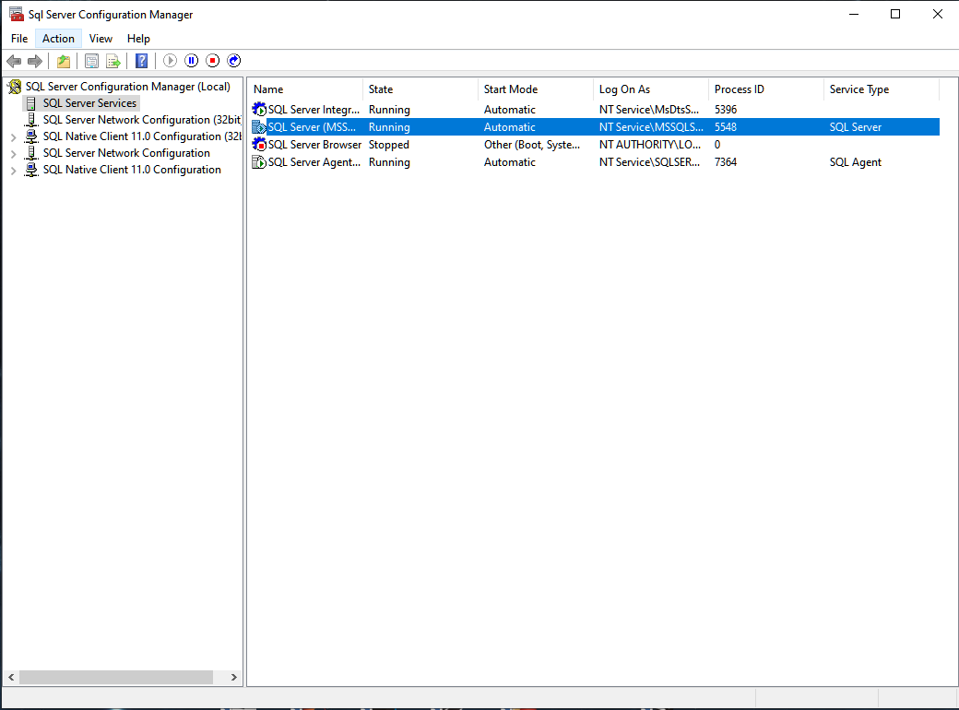

* Authentication via SQL Server Authentication.

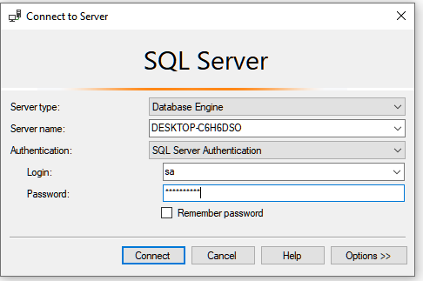

* After the DB has been registered, new logins have been added
* Quick look upon Login Properties  
  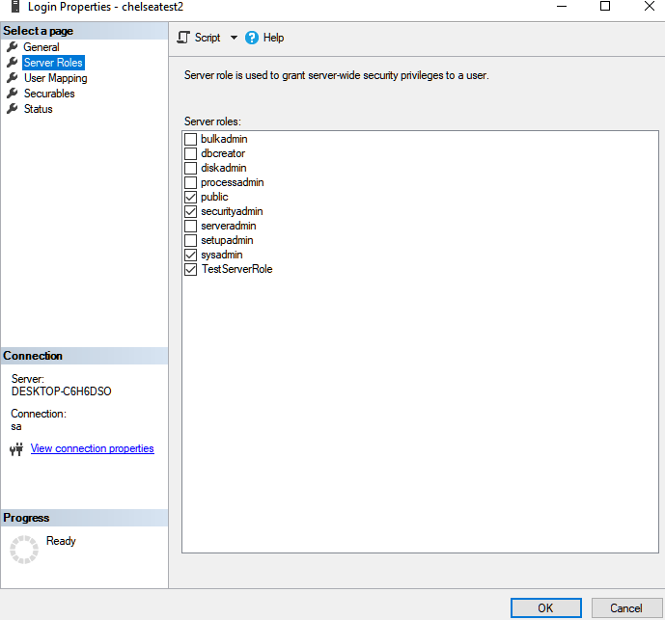

All 3 logins have different roles and mappings, thus they have different levels of access to the data which will be stored in the future.

**Conclusion**

To sum up, this laboratory work was useful in learning how to create databases and manage them. SQL Server Management Studio helps a lot in interacting with databases and is extremely helpful.