@ More About Docker

Docker is a free piece of S/W that allows users to develop and manage apps in an environment that takes **advantage of Linux-based software containers**. It's a great tool because it gives developers the ability to perform app management and development **without needing to use a virtual server or any extra hardware**.

This basically means that you can get **various IT infrastructure components to work together** with much less troubleshooting than other methods.

The **container technology** was originally developed with the aim of running several virtual operating systems in isolated environments on the same kernel. These are known as full-system containers.

The **Docker container** platform, on the other hand, focuses on so-called **application containers**, in which each application runs in its own virtual environment. While full-system containers are designed so that different processes can be executed in them, an application container always contains just one single process.

Extensive applications are therefore implemented as multi-container apps with Docker.

Pros : Efficient Tools,  Affordable, Requires Limited System Resources, Open-Source

Cons: Large Learning Curve, Requires Perfect Syntax

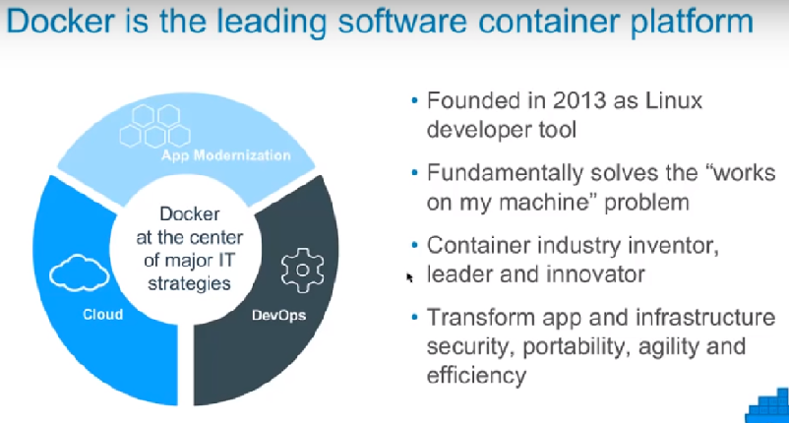

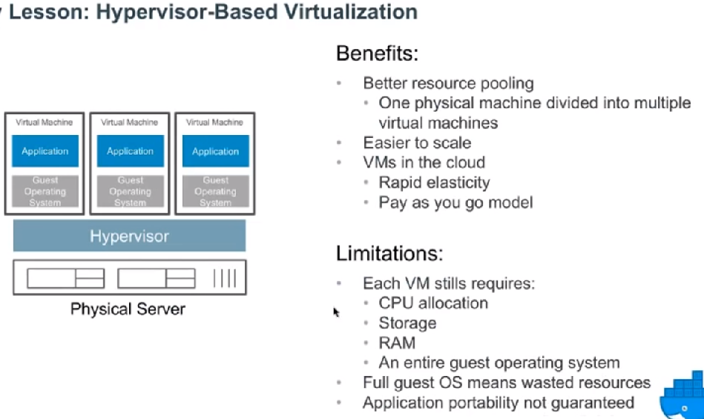

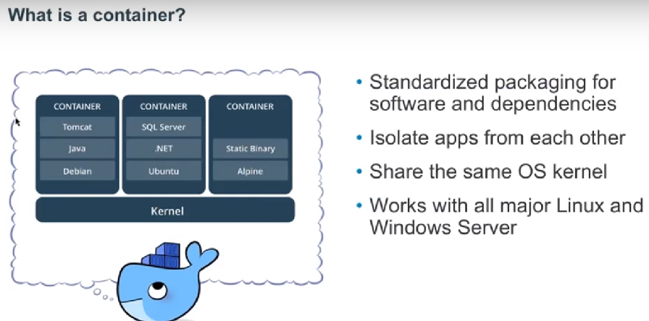

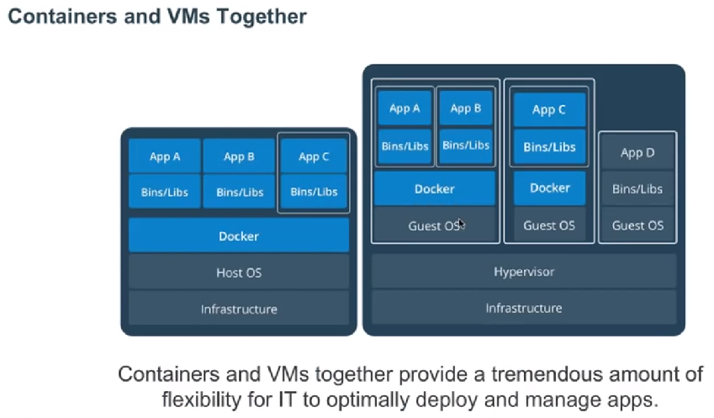

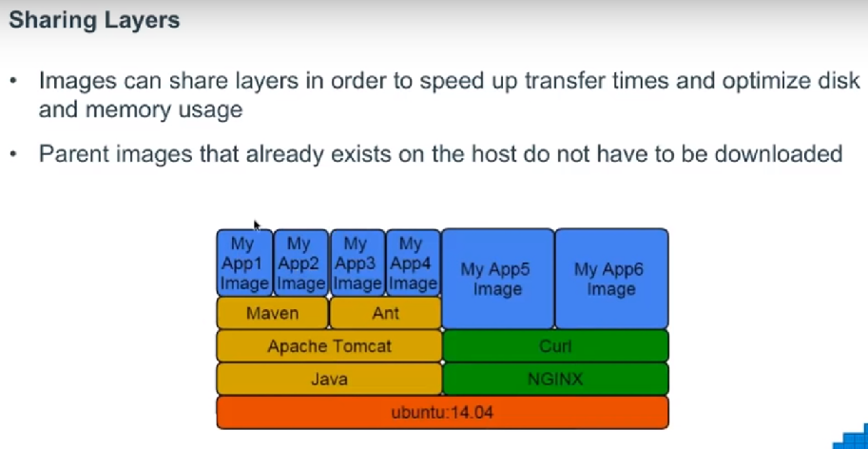

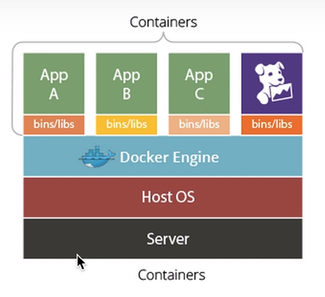

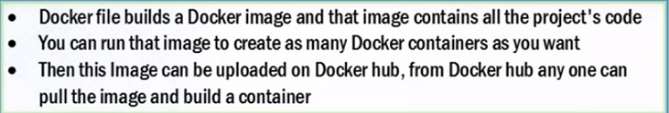

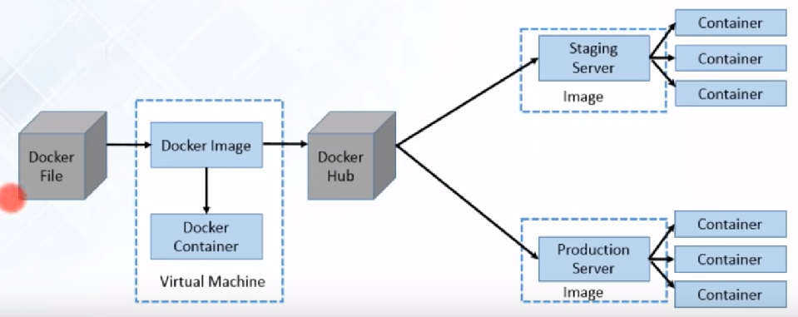

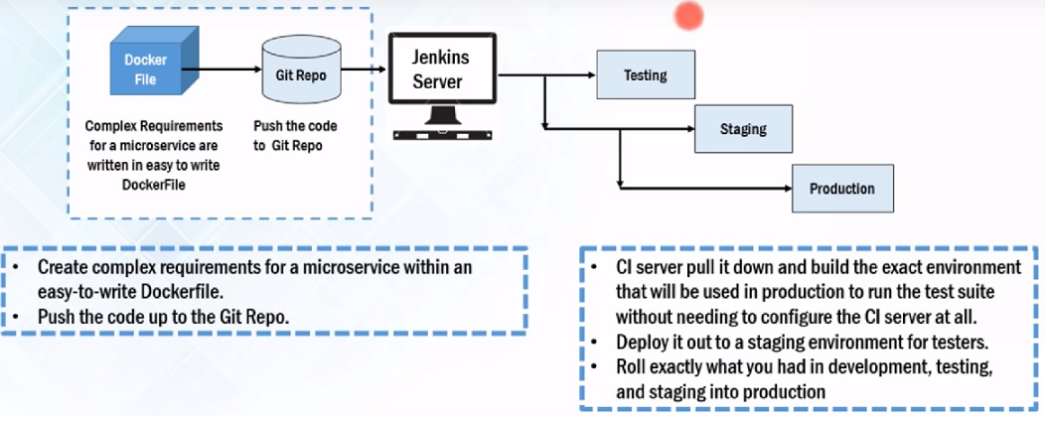

Before Jenkins

