**Block and Input File Splitter:**

Instructions on how to use the block splitter can be found in [Block Splitter](http://cfl3d.larc.nasa.gov/Cfl3dv6/cfl3dv6_splitter.html)

To insure that split grids produced the same results as the original unsplit grids ***when fully converged***, two modifications were made to previous versions of CFL3D:

* A new flux limiter, number 4, was introduced. This new limiter is a modified version of the heretofor recommended limiter number 3. Both versions are tuned to the k=1/3 ("third order" upwind) scheme. The new number 4 is similar to the old number 3, but with a cutoff parameter based on the total number of cells, rather than block dimensions. As a grid is split, the total number of cells remains fixed, but of course block dimensions do not. **Use iflim=4 whenever a limiter is required for k=1/3**. The graphic shows the effect of the choice of the k=1/3 limiter on a 2D airfoil solution:
  + [compare limiters](http://cfl3d.larc.nasa.gov/Cfl3dv6/Gifs/compare_limiter.gif)

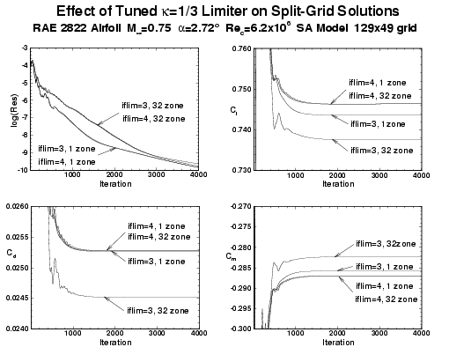

Note 1: iflim=3 and iflim=4 will generally give slightly different results even for single block grids, since iflim=3 actually bases the cutoff parameter on the dimension in each direction for which the limiter is applied; iflim=4 uses a cutoff parameter that is isotropic.

Note 2: limiters iflim=1 and iflim=2 (and iflim=0, no limiting) are uneffected by block splitting ***when fully converged***.

* Correct cell volumes at 1-1 interfaces are now used. The volumes at block interfaces are used in the viscous flux routines; in previous versions of CFL3D, these interface volumes were simply extrapolated from interior cells. If a block is split, what was an interior volume now lies on a block interface. How that volume is treated can affect the solution, depending on how highly streched that grid is in that region. Version 6 uses the exact interface volumes at 1-1 interfaces, so that the same results can be obtained before and after splitting. **EXCEPTION**: The Menter SST turbulence model (ivisc=7) uses a blending function that is not split exactly. Very slight differences may be observed if a block is split in a region of strong gradients when using ivisc=7. The graphic shows the effect of the treatment of cell volumes at 1-1 interfaces.
  + [compare v5/v6](http://cfl3d.larc.nasa.gov/Cfl3dv6/Gifs/compare_v5_v6.gif)

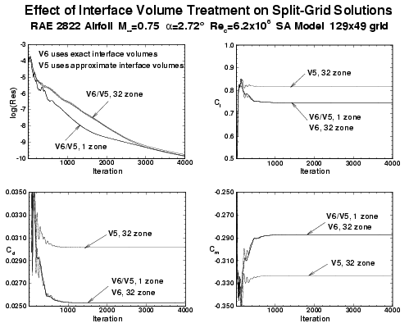

The convergence rate may be expected to deteriorate as blocks are split finer and finer since the implict nature of the scheme extends only over points that lie in the same block. However, in many cases, this deterioration may be quite small, as evidenced in the 2D airfoil case above. The following graphic shows the convergence rate for a 3D ONERA M6 wing with approximately 1 million points, with 1 zone (289x65x49), 96 zones (each 37x17x17) and 216 zones (each 17x17x17), with remarkably little deterioration in convergence of either the residual or the drag:

* [split convergence](http://cfl3d.larc.nasa.gov/Cfl3dv6/Gifs/m6_split_convg.gif)

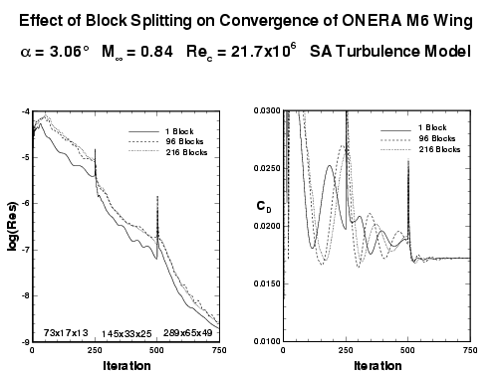

**Specifying transition through BC 2014:**

New to Version 6.2 is the capability to specify transition location through a BC type, rather than through ilamlo, ilamhi, etc. This type, BC 2014, is not documented in the printed manual. The main advantage to the new method is that you are no longer limited to having only one laminar region per zone. BC 2014 is exactly the same as BC 2004 (viscous surface), described in the manual, except that it also forces the specified region to be laminar by zeroing out the turbulence production term. It only works for ivisc greater than 3.

The standard required input data is:

**ndata = 3**

with

**Twtype, Cq, Index**

specified via the input file. Note that this is different from BC 2004 in that BC 2004 only uses 2 items of input data. The **Twtype** and **Cq** parameters here are the same as the 2 inputs required for BC 2004 (see manual). The additional **Index** parameter for BC 2014 represents the index range *normal* to the surface over which the laminar region is to extend. Setting **Index**=0 defaults to the entire normal index range. For example, say that a laminar viscous wall patch (adiabatic, no blowing/suction) is desired on a jmin surface from i=17-33 and k=65-129, over *all* j-indices normal to the surface. The input would look like:

J0: GRID SEGMENT BCTYPE ISTA IEND KSTA KEND NDATA

1 1 2014 17 33 65 129 3

TWTYPE CQ INDEX

0. 0. 0

On the other hand, if you wanted to limit the laminar range in the normal direction to be between j=1 and j=25, the input would be:

J0: GRID SEGMENT BCTYPE ISTA IEND KSTA KEND NDATA

1 1 2014 17 33 65 129 3

TWTYPE CQ INDEX

0. 0. 25

As another example, say that a laminar viscous wall patch is desired on a jmax surface from i=17-33 and k=65-129, where the wall is at jmax=81; and the laminar range is desired to act over 25 points in the j-direction (from j=57 to 81). In this case, the input would be the same as in the last example:

JDIM: GRID SEGMENT BCTYPE ISTA IEND KSTA KEND NDATA

1 1 2014 17 33 65 129 3

TWTYPE CQ INDEX

0. 0. 25

Unless there are walls at both jmin and jmax, usually one would probably want to use the first method above (**Index**=0). Note that the old ilamlo, ilamhi, etc method for prescribing laminar regions still works. In fact (although not recommended), both methods can be used simultaneously. The laminar regions are the *unions* of the regions defined by ilamlo, ilamhi, etc. and those defined by the 2014 boundary condition. In general, however, we recommend doing either one method or the other, to avoid confusion.

[**Return To Top**](http://cfl3d.larc.nasa.gov/Cfl3dv6/cfl3dv6_new.html#top)

**Turbulence Data Input For 2000 Series BC's:**

The following 2000 series bc's will now allow the user to input data for the turbulence field equations: 2003, 2007, 2008, 2018, 2028, and 2009 (note: standard data specification for 2008 has changed for Version 6, see [above](http://cfl3d.larc.nasa.gov/Cfl3dv6/cfl3dv6_new.html#bc2008)). The standard values of ndata for bc's 2003, 2007, 2008, 2018, 2028, and 2009 are 5, 5, 4, 4, 4, and 4, respectively. If these standard ndata are increased by 1 (for 1 equation turbulence models) or 2 (for 2 equation turbulence models), then the additional data is used to set the boundary conditions for the turbulence equations (Note: this is not applicable to Baldwin-Lomax). If the standard ndata is used, then the boundary condition for the turbulence data is the same as before: for 2003 and 2009, the turbulence variables are set to freestream values if inflow, or extrapolated from the interior if outflow; for 2007, 2008, 2018, or 2028, the turbulence variables are set to freestream values.

**Note: the additional turbulence data must be input as nondimensional, appropriate for the particular turbulence model in use.** See Appendix H of the Version 5 manual for details of the turbulence models and the appropriate nondimensionalizations.

As an example, consider bc2008, and assume that the 2-equation SST model is used (ivisc=7):

J0: GRID SEGMENT BCTYPE ISTA IEND KSTA KEND NDATA

1 1 2008 0 0 0 0 6

RHO/RHOINF U/AINF V/AINF W/AINF TURB1 TURB2

1.000 0.95 0.000 0.000 1.e-6 9.e-9

These new turbulence data treatment also supports data read in from files, if ndata is negative.