Software Requirement Specification

Project name | BCMAS
Product name | BreathCare Management System
Document No. | BCMAS-SRS-001
Version No. | A/1


  Author: | Date:
  Reviewer: | Date:
Approver: | Date:

Change record

Version | Change Date | Author | Change No. | Change content
01 | 2023/10/17 | Wei Yuchen | NA | First release
A/0 | 2024/10/24 | Wei Yuchen | CR2024093001 | Requirement change
A/1 | 2025/2/13 | Wei Yuchen | CR2025021301 | Document change
draft-20260413144146 | 2026/04/13 | AI Bot | CR2026041301 | Requirement update test

Table of contents
1 Introduction 3
1.1 Purpose 3
1.2 Scope 3
1.3 Definitions and abbreviations 3
1.4 References 3
2 Product overview 4
2.1 Scope of application/intended purpose 4
2.2 Use scenario 4
2.3 Restrictions on clinical use 4
2.3.1 User restrictions 4
2.3.2 Product restriction 4
2.4 Operating environment 4
2.5 Necessary hardware and software 6
2.6 Logical structure 6
2.7 Physical structure 7
2.7.1 Physical topology 7
2.7.2 Technical specification 8
2.8 User interface diagram 8
2.9 Market assessment 9
2.9.1 Clinical application and value 9
3 Specification 10
4 Requirements of regulations and standards 18
5 Software Maintenance Records 22
6 Remarks 22

Introduction

Purpose
This document is developed to describe the product and specify its requirements in details, so that all parties or personnel concerned strictly consider all the requirements before design, and reduce the redesign, re-coding and re-testing in the future. Ensure the quality of software development, integrity and traceability of requirements, and ensure that business requirements proponents, requirements analysts, developers, testers and other relevant stakeholders reach a consensus on requirements.

Scope
This document is applicable to BreathCare Management System.

Definitions and abbreviations
N/A

References
- IEC 62304:2006+AMD1:2015 Medical device software - Software life cycle processes
- MDCG 2019-16 rev.1 Guidance on cybersecurity for medical devices
- MDCG 2018-5 UDI assignment to medical device software
- EN ISO 15223-1:2021 Medical devices - Symbols to be used with medical device labels, labelling and information to be supplied - Part 1: General requirements
- EN ISO 20417:2021 Medical devices — Information to be supplied by the manufacturer
- IEC 62366-1:2020 Medical devices – Part 1: Application of usability engineering to medical devices
- BCMAS-URS-001 User Requirements Design Specification

Product overview

Scope of application/intended purpose
BreathCare Management System is a web-based solution for healthcare specialists intended to:
• assist in the diagnosis of sleep disordered breathing in adult patients through analysis of data recorded by the compatible home sleep test device of this system.
• ransfer and display device and therapeutic information that has been transmitted remotely from the patient’s therapy device. It is intended to support the standard follow-up care of patients who have been prescribed a compatible Yuwell therapeutic device (including but not limited to YH-390N, YH-390 and YH-680).The system can also adjust settings remotely for non-life support devices only.

Use scenario
This product is used for clinicians and healthcare providers to manage the individual users who use ventilators and the treatment data generated, and to remotely adjust device parameters.

Restrictions on clinical use

User restrictions
The main users of this software are clinicians and healthcare providers, and it can be used with basic computer operation foundation.

Product restriction
It is lower than the product running environment configuration, thus it is not recommended to use this product.

Operating environment
（1）Operating environment

Parameter | Server | Client
CPU | 4 cores and above | 4 cores and above
RAM | 8GB and above | 4GB and above
GPU | N/A | N/A
Hard Disk Memory | 80GB and above | 80GB and above
Network card | 3 Gbit/s and above | 1 Gbit/s and above
Operation system | Ubuntu22.x and its compatible versions | Windows7 and its compatible versions
Monitor | N/A | 1280*800 and above
Browser | N/A | Chrome kernel, Chrome kernel 92 version, IE11, Firefox116, 360 Browser15, Chrome127
Network architecture | BS
Network type | WAN
Network bandwidth | 10 Mbit/s and above
（2）Cloud computing
Amazon cloud service
Service mode：SaaS
Deployment mode: Cloud deployment
Core functions: account registration, login, data upload and download
Data interface: https
Network security capability: It has a mature network Ana dog protection architecture, including WAF (WEB application firewall), security time analysis platform and RASP (application adaptive security protection system)

Necessary hardware and software
Not applicable, the product runs on general-purpose computer and operating system platform.

Logical structure
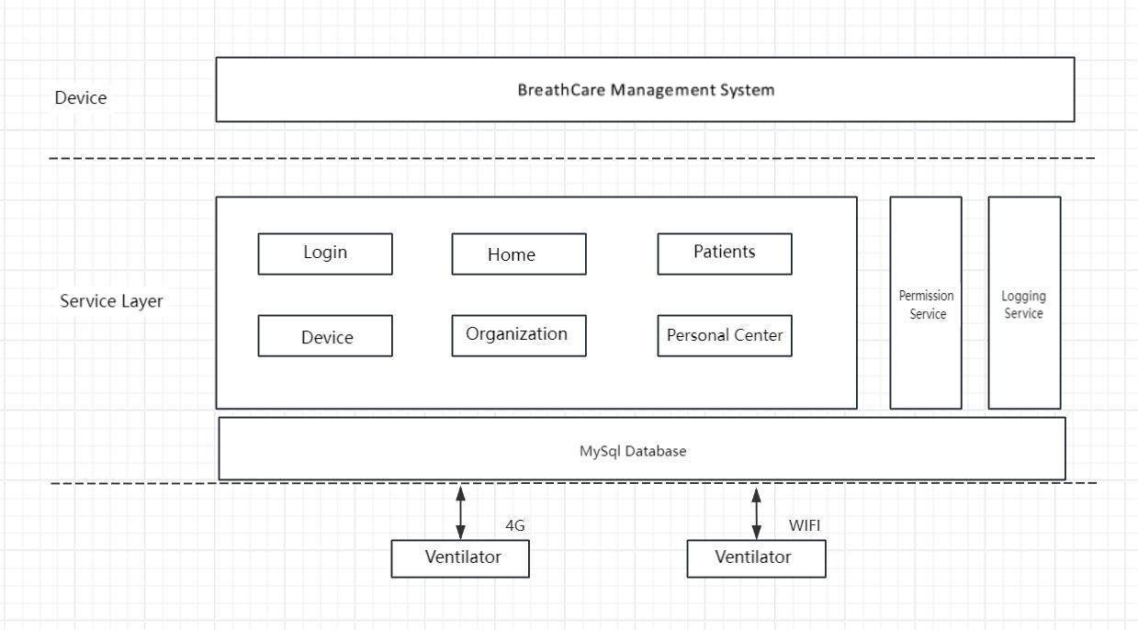
The system consists of the following modules: "Login, Home, Patient, Device, Organization, and Personal Center".
Module | Primary function | Secondary function | Function description
Login | Login | / | Use the account and password to login.
Home | Statistics | / | Provide data overview, view total number of users, total number of devices, number of online devices, total number of physicians in overall situation. Display patients' compliance overview and treatment data overview, device status and usage.
Patient | Patient list | / | Add, query, search and delete patients, export patient information.
 | Patient details | Patient information | View and edit user basic information, bind and modify device information.
 |  | Data summary | Information on user's device usage indicators in different time dimensions (duration of use, leak, pressure, AHI, SPO2, pulse rate PR)
 |  | Detailed graph | Detailed daily ventilator usage data.
 |  | Device information | Current device's basic information and parameter information, modify parameter settings, view log status.
 |  | Follow-up | Add, edit, delete follow-up records.
Device | Device list | / | Search and view device information.
Organization | Organizational information | / | Maintain and edit organizational information.
 | Physician management | / | Add and view associated physicians, unbind
 | Distributor management | / | Filter, view, manage distributor information
 | Account management | / | Edit, delete accounts and reset passwords.
 | Hospital management | / | Add, edit, delete hospitals, edit hospital information.
Personal Center | / | / | View and maintain personal information, view organizational information, user manual, about page, and submit feedback.

Physical structure

Physical topology
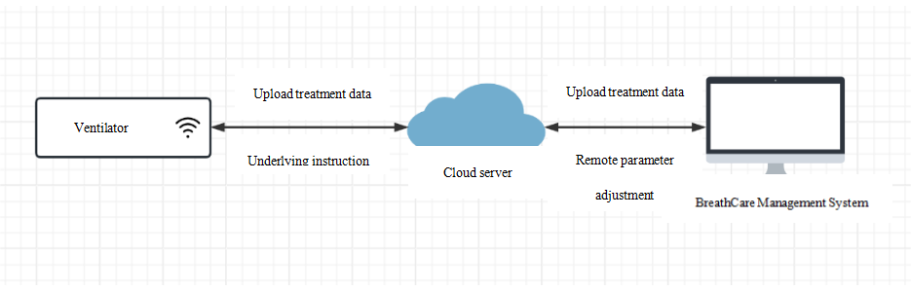
Data flow process: N/A
Software composition modules: Login, Home, Patient, Device, Organization, and Personal Center module.
Necessary software: N/A
Cloud computing: Amazon cloud service
General-purpose computer platform: Server, client computer
Physical connection relationship between medical device hardware/components: N/A

Technical specification
Technical and hardware requirements for product operation:
Communication protocol | MQTT, HTTPS
Storage mode | Two-tier storage mode (online and backup)
Storage format | Binary Files of MySQL Database
Network type | Wide area network
Transmission content | json data
Storage medium | HD
Monitor | Resolution: 1920*1080

User interface diagram
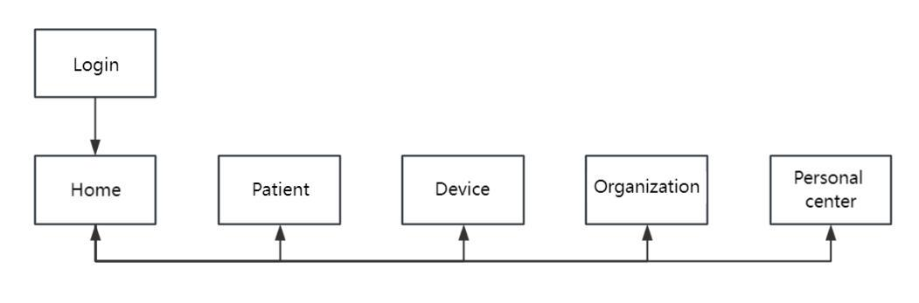
After logging into the BreathCare Management System, enter home page to view data overview. Users can view the total number of users, devices and physicians, along with the number of online devices. It displays patients' compliance overview and treatment data overview, device status and usage. In the patient module, users can view and edit user basic information, bind and modify patients' device information on the patient list page. On the data summary page, it allows viewing information on user's device usage indicators in different time dimensions (duration of use, leak, pressure, AHI, SPO2, pulse rate PR etc.) On the detailed chart page, users can view daily detailed ventilator usage data. On the device information page, users can view current device's basic information and parameter information, modify parameter settings and view log status. It also allows adding, editing and deleting follow-up records. On the device page, users can view device-related information. On the organization page, users can maintain and edit organizational information, add and view associated physicians, unbind, filter and view physician information. It also allows managing distributor and hospital information, along with editing, deleting accounts and resetting passwords. In the personal center, users can view and maintain personal information, view organizational information, user manual, about page, and submit feedback.
Software interface | Function | Purpose
Login | Login | User Authentication: system access permissions are enforced through role-based access control.
Home | Statistics | Provide data overview, view total number of users, total number of devices, number of online devices, total number of physicians in overall situation. Display patients' compliance overview and treatment data overview, device status and usage.
Patient | Patient list, patient details (patient information, data summary, detailed graph device information, follow-up records) | Add, query, search and delete patients, export patient information. View and edit user basic information, bind and modify device information. Information on user's device usage indicators in different time dimensions (duration of use, leak, pressure, AHI, SPO2, pulse rate PR). Current device's basic information and parameter information, modify parameter settings, view log status. Add, edit, delete follow-up records.
Device | Device list | View device information.
Organization | Distributor list, account list, device list | Search and view device information. Maintain and edit organizational information. Add and view associated physicians, unbind, filter, view. Manage distributor and hospital information. Edit, delete accounts and reset passwords.
Personal center | Maintain and view personal information, user manual, about, feedback | View and maintain personal information, view organizational information, user manual, about page, and submit feedback

Market assessment

Clinical application and value
BreathCare Management System, combined with Yuwell ventilator equipment, aims at helping physicians provide data support for patients' diagnosis and treatment, and help service providers track users' device usage and provide management basis. After the patient uses the device, the data is transmitted from the device to clinicians or service providers through the cloud. Physicians and service providers view the user's use of the device and data reports through BreathCare Management System, conduct follow-up management, and help patients adjust the use parameters of the device through remote settings.

Specification
ID |  | Title |  | Description |  | Description of Requirement Change Points |  | Type of Change | Whether the Change Affects User Experience | Trace From (Risk /User)
SRS_001 |  | Processing object |  | The processing object of this product is data generated by ventilators in accordance with software standards/formats |  | Not applicable |  | / | / | /
SRS_002 |  | Data interface |  | The software side accesses the server data through HTTPS protocol;  The server accesses the data in the ventilator through MQTT protocol |  | Not applicable |  | / | / | /
SRS_003 |  | Portability |  | Use computer access to a specific address to use the system. |  | Not applicable |  | / | / | /
SRS_004 |  | Copyright protection |  | Copyright protection through software copyright. |  | Not applicable |  | / | / | /
SRS_005 |  | Product constraint |  | Password length must be 8-20 characters and include both letters and numbers. |  | Adjust password length and format requirements |  | Major version X （significant enhancement) | Yes, users cannot operate correctly by following the original manual. | /
SRS_006 |  | User interface |  | The system has a text and graphical operation interface, which is concise and clear, and the text interface is easy to understand. |  | Adjust page layout |  | Major version X （significant enhancement) | Yes, users cannot operate correctly by following the original manual. | URS_001
SRS_007 |  | Login |  | Enter the correct user name and password and log in to the account by clicking the login button. |  | Adjust page layout |  | Major version X （significant enhancement) | Yes, users cannot operate correctly by following the original manual. | URS_002
SRS_008 |  | Home |  | Provide data overview, view total number of users, total number of devices, number of online devices, total number of physicians in overall situation. Display patients' compliance overview and treatment data overview, device status and usage. |  | Adjust page layout |  | Major version X （significant enhancement) | Yes, users cannot operate correctly by following the original manual. | URS_003
SRS_009 |  | Patient |  | Include patient list, add patients, search patients, and patient details content, manage patients, view data/reports, remotely control user devices, set parameters. |  | 1. Adjust page layout  2. Add adjustable parameters |  | Major version X （significant enhancement) | Yes, users cannot operate correctly by following the original manual. | URS_004
SRS_010 |  | Device |  | Include device list, device search, and basic information viewing. |  | /Adjust page layout |  | Major version X （significant enhancement) | Yes, users cannot operate correctly by following the original manual. | URS_005
SRS_011 |  | Organization |  | Maintain and edit organizational information. Add and view associated physicians, unbind, filter and view.  Manage distributor and hospital information. Edit, delete accounts and reset passwords. |  | 1. Adjust page layout  2. Add features |  | Major version X （significant enhancement) | Yes, users cannot operate correctly by following the original manual. | URS_006
SRS_012 |  | Personal Center |  | View and maintain personal information, view organizational information, user manual, about page, and submit feedback |  | 1. Adjust page layout  2. Add features |  | Major version X （significant enhancement) | Yes, users cannot operate correctly by following the original manual. | URS_007
SRS_013 |  | Server-side single respiratory data synchronized to system time (10M broadband, maximum concurrency 100) |  | On the premise of 10M broadband and the maximum concurrency number of 100, the average synchronization time is less than 4s when the server-side single respiratory data is synchronized to the system. |  | Not applicable |  | / | / | /
SRS_014 |  | Error message |  | When the user name and password are incorrectly entered, an error message will be displayed |  | Not applicable |  | / | / | /
SRS_015 |  | Cybersecurity requirements |  | 1. Authorization: Unauthorized users are unable to access device data running on the software system.  2. Cryptography: Ensure the confidentiality of healthy data during transmission between authenticated nodes.  3. Authentication: Users need to log in to the system with their account and password before they can use the system  4. Code, Data, and Execution Integrity: Code repository management; Data backup  5. Confidentiality: Control server access through JumpServer+SSH whitelist mechanism  6. Event Detection and Logging: The software has operation logs and error logs.  7. Resilience and Recovery: The system automatically runs database/file backup scripts on a daily/weekly schedule for data backup.  8.Updatability and Patchability: Provide professional personnel for operation and maintenance deployment and system updates  9. This product ensures the confidentiality, integrity, and accessibility of medical device related data, and is a network security capability for medical devices. |  | Not applicable |  | / | / | /
SRS_016 |  | Data is not lost after failure |  | The system may be interrupted or unresponsive due to power failure, network failure and hardware failure. After restarting, it shall be able to run normally, and the saved data will not be lost. |  | Not applicable |  | / | / | /
SRS_017 |  | Log generation function |  | The software has an operation log and an error log. |  | Not applicable |  | / | / | /
SRS_018 |  | Default role and permission setting |  | 1. Service Provider: Full system access  2. Medical Staff: Full permission except home and device modules |  | Role permission adjustments |  | Major version X （significant enhancement) | Yes, users cannot operate correctly by following the original manual. | /
SRS_019 |  | Usability requirements |  | The interface should be user-friendly, with fresh colors and clear menus, enabling users to quickly get started and operate easily. For example: Adopt a conventional T-shaped web layout overall, with header menu and content below. To ensure clear hierarchy, use light gray for the background and white for the content area; to emphasize the characteristics of the respiratory and sleep industry, use navy blue as the primary color. Secondary colors should be conventional blue, yellow, green. Text should be in black. |  | Adjust page layout |  | Major version X （significant enhancement) | Yes, users cannot operate correctly by following the original manual. | /
SRS_020 |  | Compatibility requirements |  | Hardware, software, or hardware-software combined systems mutually adapt，mutually coordinate.During work it can mutually cooperate, operate stably, avoid failures, maintain compatibility stability. |  | Add compatible devices |  | Major version X （significant enhancement) | No | /
SRS_021 |  | Scheduled data backup |  | The system daily/weekly automatically runs database/file backup scripts for data backup. |  | Not applicable |  | / | / | /
SRS_022 |  | Corrective maintenance |  | When abnormalities or failures occur during system operation, diagnose and correct errors remaining in system. |  | Not applicable |  | / | / | /
SRS_023 |  | Adaptive maintenance |  | To make the system adapt to changes in software-hardware environments, perform maintenance work, adjust the system to adapt to application object changes, meeting user needs. |  | Not applicable |  | / | / | /
SRS_024 |  | Preventive maintenance |  | Conduct preventive maintenance on systems that may undergo changes or adjustments. |  | Not applicable |  | / | / | /
SRS_025 |  | Multi-node cluster availability |  | Multi-node cluster deployment ensures remote service high availability |  | Not applicable |  | / | / | CS01
SRS_026 |  | Validate integrity and format of device-uploaded data |  | Perform completeness and format validation on uploaded data, and record abnormal data. |  | Not applicable |  | / | / | CS02
SRS_027 |  | Verify data format correctness |  | Record parsing-failed data into the database, regularly query database failure records. |  | Not applicable |  | / | / | CS03
SRS_028 |  | Validate data length |  | Through data length defined in protocol, verify whether uploaded data length matches defined data length. |  | Not applicable |  | / | / | CS04
SRS_029 |  | Remote parameter adjustment |  | The system will verify parameters before remote adjustment, if not compliant returns error prompt. |  | Adjust parameter validation rules |  | Major version X （significant enhancement) | / | CS05
SRS_030 |  | Repair and upgrade software |  | If abnormalities occur, promptly contact manufacturer, manufacturer will arrange repair or upgrade. |  | Not applicable |  | / | / | CS06
SRS_031 |  | Update and maintain software |  | Provide professionals for operation deployment and system updates. |  | Not applicable |  | / | / | CS07
SRS_032 |  | Disk space expansion |  | Cloud servers perform online disk expansion. |  | Not applicable |  | / | / | CS08
SRS_033 |  | Software commercial maintenance cycle |  | The system's "About" page displays software maintenance cycle information of 5 years. |  | Not applicable |  | / | / | CS09
SRS_034 |  | System logout |  | 1. When users exit the system, click the logout button.  2. The system automatically logs out after 2 hours of inactivity. |  | Not applicable |  | / | / | CS10
SRS_035 |  | Pre-use software preparation |  | Professionals perform software deployment;  Conduct training before using the software, strictly follow the manual for operations |  | Not applicable |  | / | / | CS11
SRS_036 |  | Safety usage information |  | Provide safety information through software interface pop-up prompts and the manual |  | Not applicable |  | / | / | CS12
SRS_037 |  | Software layout |  | Detailed interface descriptions and more reasonable interface design that aligns with user experience |  | Not applicable |  | / | / | CS13
SRS_038 |  | Parameter validation in sleep reports |  | Perform completeness and format validation on device-uploaded data |  | Not applicable |  | / | / | CS14
SRS_039 |  | Menu |  | Optimize user interface menu design to reduce menu hierarchy |  | Not applicable |  | / | / | CS15
SRS_040 |  | Non-professional system usage |  | Professionals receive training and refer to the manual to use the system |  | Not applicable |  | / | / | CS16
SRS_041 |  | Unauthorized system access |  | The system adds permission access control, only authorized users can access |  | Not applicable |  | / | / | CS17
SRS_042 |  | Data storage |  | 1. Sensitive data is encrypted before storage  2. Data storage operations require permission authentication |  | Not applicable |  | / | / | CS18
 | SRS_043 |  | Insufficient server hardware/software resources to meet minimum performance requirements |  | Hardware resources for upgrading servers |  | Not applicable | / | / | CS19
 | SRS_044 |  | Resolution |  | The manual provides computer resolution information. |  | Not applicable | / | / | CS20
 | SRS_045 |  | Bandwidth |  | The manual specifies minimum network bandwidth requirements. |  | Not applicable | / | / | CS21
 | SRS_046 |  | Database backup |  | 1. Use cloud provider's database backup service to configure full scheduled backups every night.  2. Restore data from backup databases in case of abnormalities. |  | Not applicable | / | / | CS22
 | SRS_047 |  | Version release |  | 1. Automated release pipeline tools built via GitLab  2. Each release triggers jobs through code tag mode |  | Not applicable | / | / | CS23
 | SRS_048 |  | Incomplete configuration in DevOps code releases |  | DevOps engineers use Docker tools to quickly roll back to previous versions |  | Not applicable | / | / | CS24
 | SRS_049 |  | Browser |  | The manual lists required browser types and versions |  | Not applicable | / | / | CS25
 | SRS_050 |  | Confirmation pop-up for delete/update operations |  | Display confirmation pop-ups when performing delete/update operations |  | Not applicable | / | / | CS26
 | SRS_051 |  | HTTPS certificate expiration |  | Check the validity period of the HTTPS certificate annually to prevent it from expiring. |  | Not applicable | / | / | CS27
 | SRS_052 |  | Client device offline status |  | The browser shows a "no internet connection" message |  | Not applicable | / | / | CS28
 | SRS_053 |  | Minimum client hardware requirements |  | The manual specifies minimum client hardware configurations for system operation |  | Not applicable | / | / | CS29
 | SRS_054 |  | Excessive database records |  | Upgrade database server hardware resources |  | Not applicable | / | / | CS30
 | SRS_055 |  | Patient-device SN binding |  | Only device SN not associated with patients can be bound. |  | Adjust the binding logic | Major version X(significant enhancement) | / | CS31

Requirements of regulations and standards
SN | Statute name
 | ISO /IEC 25051: 2014 ,Software engineering-Systems and software Quality Requirements and Evaluation CSQuaRE) Requirements for quality of Ready to Use Software Product CRUSP) and instructions for testing , MOD)
 | Regulation（EU）2017/745 Medical Device Regulation
 | MDCG 2020-13 Clinical evaluation assessment report template
 | MDCG 2020-5 Guidance on Clinical Evaluation
MDCG 2020-10/2 Guidance on safety reporting in clinical investigations
Appendix: Clinical investigation summary safety report form
 | MDCG 2021-24 Guidance on classification of medical devices
 | MDCG 2020-1 Guidance on Clinical Evaluation (MDR)/Performance Evaluation (IVDR) of Medical Device Software
 | MDCG 2019-16 rev.1 Guidance on cybersecurity for medical devices
 | MDCG 2019-11 Qualification and classification of software - Regulation (EU) 2017/745 and Regulation (EU) 2017/746
 | MDCG 2018-5 UDI assignment to medical device software
 | IEC 62304:2006+AMD1:2015 Medical device software - Software life cycle processes
 | IEC 62304: 2015 Medical devices – Part 1: Application of usability engineering to medical devices
 | IEC 62304:2015/AMD1:2020 Medical devices – Part 1: Application of usability engineering to medical devices
 | IEC TR 62366-2: 2016 Medical devices Part 2: Guidance on the application of usability engineering to medical devices
 | EN ISO 14971:2019/ A11:2021 Medical devices - Application of risk management to medical devices
 | Off-The-Shelf Software Use in Medical Devices: Guidance for Industry and Food and Drug Administration Staff (2023)
 | Design Considerations and Pre market Submission Recommendations for Interoperable Medical Devices: Guidance for Industry and Food and Drug Administration Staff (2017)
 | Cybersecurity in Medical Devices: Quality System Considerations and Content of Premarket Submissions: Guidance for Industry and Food and Drug Administration Staff (2023)
 | Postmarket Management of Cybersecurity in Medical Devices: Guidance for Industry and Food and Drug Administration Staff (2016)
 | Content of Premarket Submissions for Device Software Functions: Guidance for Industry and Food and Drug Administration Staff (2023)
 | General Principles of Software Validation: Guidance for Industry and FDA Staff (2002)
 | EN ISO 15223-1:2021 Medical devices - Symbols to be used with medical device labels, labelling and information to be supplied - Part 1: General requirements
 | EN ISO 20417:2021 Medical devices — Information to be supplied by the manufacturer
 | MEDDEV 2.7.1 Rev. 4 Medical Devices Regulation Clinical Evidence Requirements Key Changes and Clarifications
 | ASTM E1104-98（2016）Standard Specification for Clinical Thermometer Probe Covers and Sheaths
 | Pre-market Requirements for Medical Device Cybersecurity [2019-06-26]
 | Guidance Document Software as a Medical Device (SaMD): Classification Examples [2019-12-18]
 | Guidance Document Software as a Medical Device (SaMD): Definition and Classification [2019-12-18]
 | Medical Devices Regulations (SOR/98-282)Part 1
 | Medical Devices Post Market Surveillance Global Guidance for Adverse Event Reporting for Medical Devices
 | How to Complete the Application for a New Medical Device Licence Medical Device Licence Amendment for a Private Label Medical Device
 | Management of Applications for Medical Device Licences
 | Guidance for the Interpretation of Significant Change of a Medical Device
 | Guidance for the Labelling of Medical Devices, Not Including In Vitro Diagnostic Devices - Appendices for the Labelling of Soft Contact Lenses, Decorative Contact Lenses, and Menstrual Tampons
 | Guidance for the Interpretation of Sections 28 to 31 - Licence Application Type
 | Guidance on How to Complete the Application for a New Medical Device License
 | Guidance on Medical Device Establishment Licensing (GUI-0016)
 | Guidance on the Risk-Based Classification System for Non-In Vitro Diagnostic Devices (Non-IVDDs)
 | Pre-Market Requirements for Medical Device Cybersecurity
 | Therapeutic Goods Act 1989 Volume 1 409 pages
 | Therapeutic Goods Act 1989 Volume 2 453 pages
 | Therapeutic Goods (Medical Devices) Regulations 2002
 | Australian Regulatory Guidelines for Advertising Therapeutic Goods (ARGATG)Guidance for advertisers
 | Medical device cyber security guidance for industry
 | Australian Regulatory Guidelines for Medical Devices (ARGMD)
 | Researcher Considerations for Medical Devices - Meeting the Evidence Requirements for Market Authorisation
 | Therapeutic Goods Legislation Amendment (2024 Measures No. 3) Regulations 2024
 | Therapeutic Goods (Medical Devices) Regulations 2002 Schedule 3, Part 1 -Full Quality Assurance System
 | Ordinance 384
 | RDC NO.185 2001 Classification and Registration Requirements of Medical Products
 | RDCRDC Nº 546 2021 Dispõe sobre os requisitos essenciais
 | RDC ANVISA 665/2022 -Good Manufacturing Practices
 | RDC ANVISA n. 551/2021 -Field Actions
 | RDC ANVISA n.67/2009 -Vigilance
 | Guia 38-2020 Guidance on Principles for Medical Device Cybersecurity
 | MHLW Ministerial Ordinance No.169 (2004), as amended by MHLW Ministerial Ordinance No.60 (2021)
 | Japan PMD Act (as applicable)
 | Management of Vulnerabilities to Ensure Cybersecurity of Medical Devices
 | Basic Principles for Adverse Events Reporting Regarding Cybersecurity of Medical Devices
 | Confirmation of compliance with Article 12, Paragraph 3 of the Essential Principles for Medical Devices
 | Labeling of Codes on Containers to Identify Medical Devices, In Vitro Diagnostics, etc.
 | MHLW Ordinance No. 169
 | MHLW Ordinanance No. 135
 | Order for Enforcement of the Act on Securing Quality, Efficacy and Safety of Products Including Pharmaceuticals and Medical Devices
 | MHLW Ordinance No. 95
 | MHLW Ordinance No. 38
 | CFR 21 Part 801 Labeling
 | 21 CFR Part 803 - Medical Device Reporting
 | 21 CFR Part 806 - Reports of Corrections and Removals
 | 21 CFR Part 807 (Subparts A to D)- Establishment Registration and Device Listing
 | 21 CFR Part 820 - Quality System Regulation
 | 21 CFR Part 821 - Device Tracking
 | 21CFR Part 830 UDI
 | Global-Unique-Device-Identification-Database-(GUDID)---Guidance-for-Industry-and-Food-and-Drug-Administration-Staff

Software Maintenance Records
SN | System Version | Main Modification Content | Reviser | Scheduled Release Date
1 | V1.0.0.0 | First Release | Wei Yuchen | 2024-10
2 | V1.0.1.0 | Bug Fixes | Wei Yuchen | 2024-11
3 | 2.0.0.0 | Requirement change | Wei Yuchen | 2025-10

Remarks
N/A

