SUBJECT | To ensure the Petty cash incurred for correct purpose.
RECORDER (Name Designation) | Malsha Nirmani (Accounts Executive )
APPROVED BY (Name Designation) | Stanley Samidas
CREATED DATE | 01/12/2016
NO. OF PAGES INCLUDING THIS PAGE | 03

OFFICE PROCESS RECORD

Date : 1st Dec 2016
Process : Petty Cash Report

Objective : To ensure the Petty cash incurred for correct purpose.

Process is as bellow.

- All petty cash should be record in QB and Excel and should check petty cash balance at the end of the week

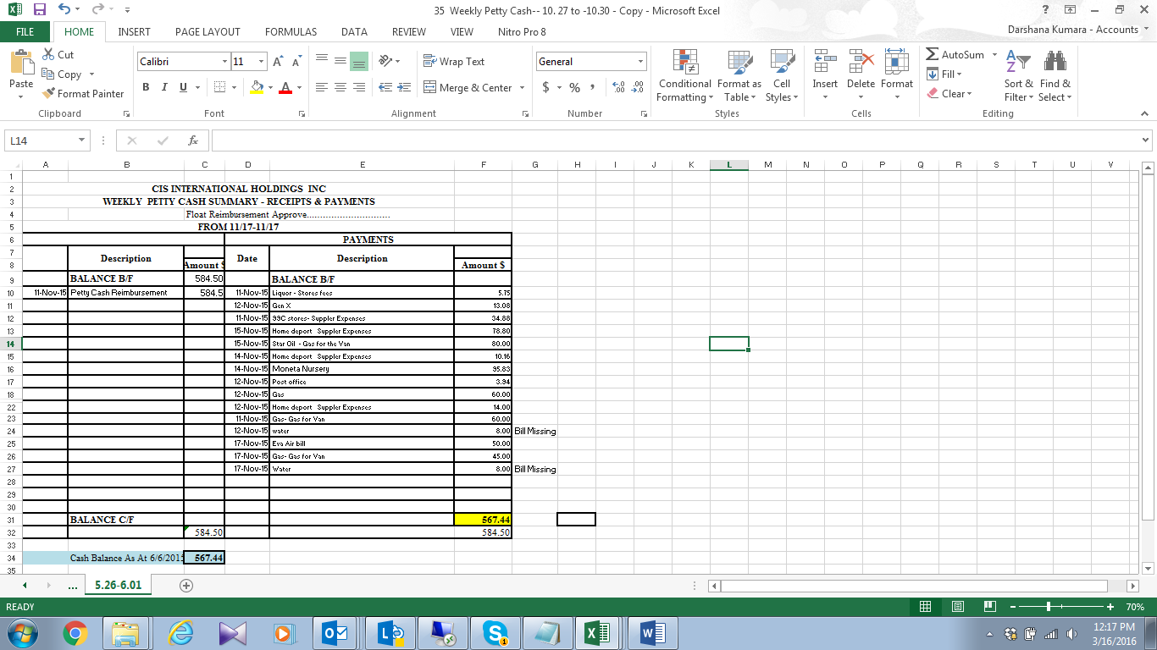

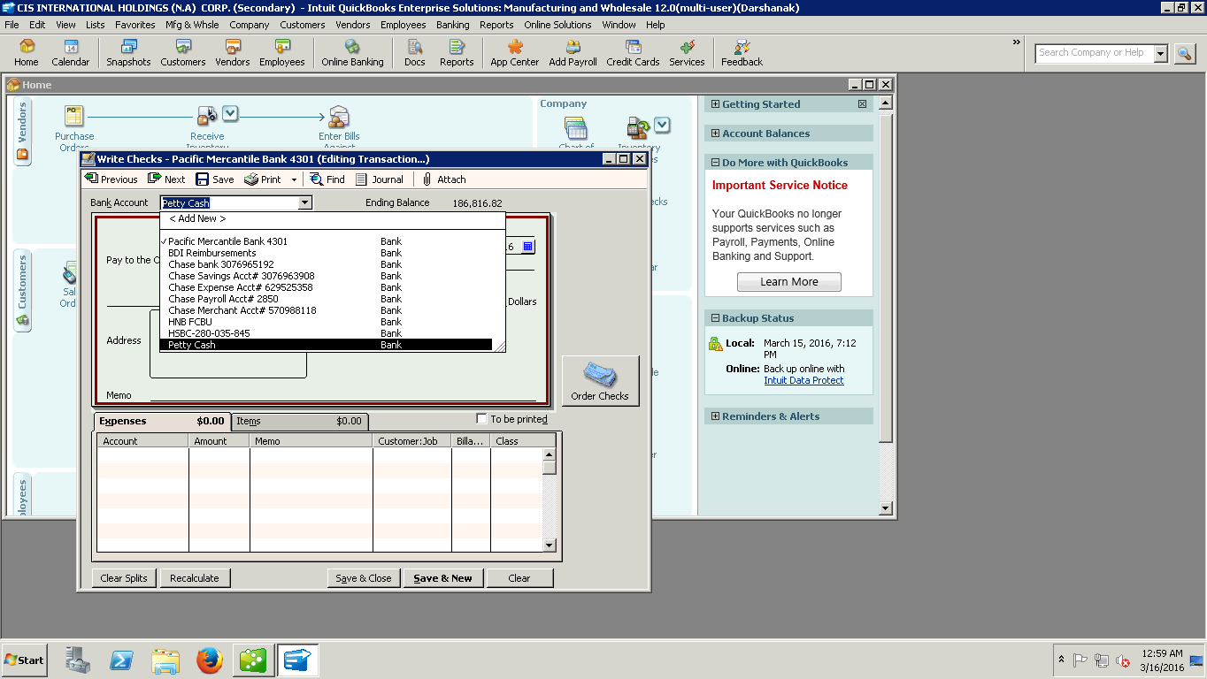

03. Discussed and report to management, if have issues with petty cash incurred

