OFFICE PROCESS RECORD

Subject | How to Complete SL Ingiriya Productivity work sheets Deficiencies report
Department | Labor Planing
Recorder | Sanduni Madushani
Approved by | Dilan Maduranga
Created date | 09/02/2015
Last updated | 20/03/2016
No. of pages including this page | 05

SL Ingiriya Farm Deficiencies report

- The Deficiencies report for Daily

- Daily Productivity Deficiencies report need to be reviewed and post in SL Ingiriya Farm Management.

Following guidelines can be used when updating the Deficiencies report.

    - Correct Station ID
    - Accurate time started & completed
    - Accurate # of Production Units
    - Worksheet must filled according to the order of the task accomplished
    - Timely submission - Daily
    - Correct Item Description
    - Auditor Signature

Correct Station Id

- Check Station Id with SL Ingiriya Station Id report

Accurate time started & completed

- Daily work start time and end time must be recorded in to productivity work sheet that tally with daily attendance report.

Accurate # of Production Units

- All employee’s must be filled completed # of units and time accordingly

Correct Item Description

- Production date item description will be bag, boxes and fish type

Auditor Signature

- Farm Auditor need to be check for task completion details as well as productivity work sheets completion errors.

How to Prepared Deficiencies report

- Checking Production Date.
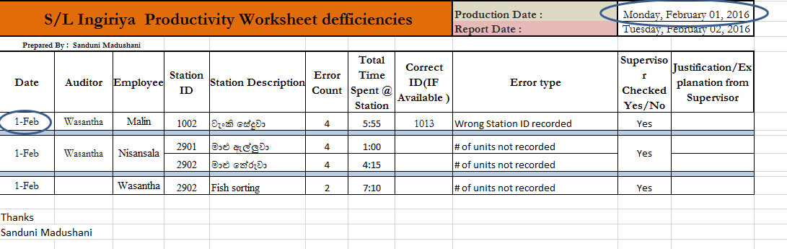

- Identify Error Type.
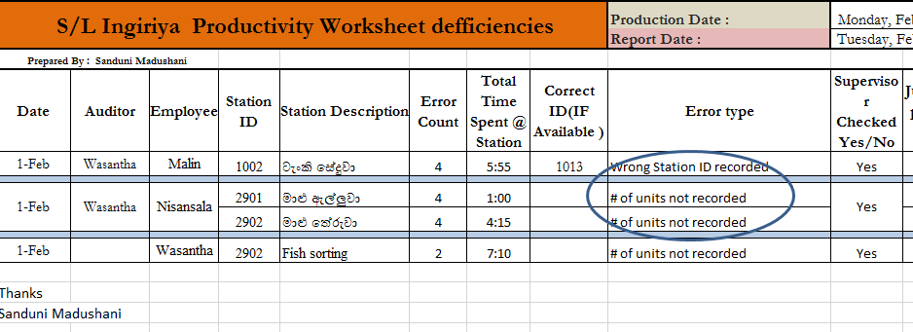

- Recording error counting and spent time.

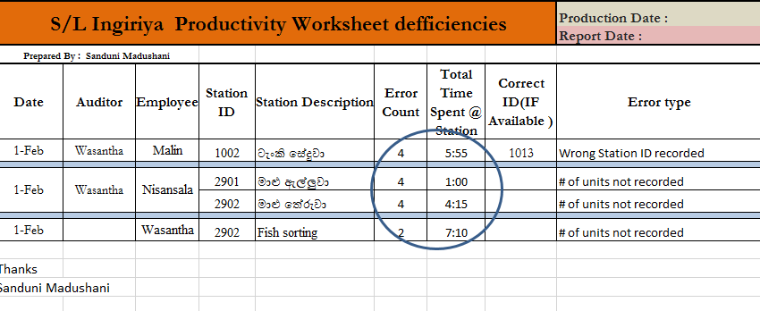

- Recording Deficiencies Station Id and Station Description.

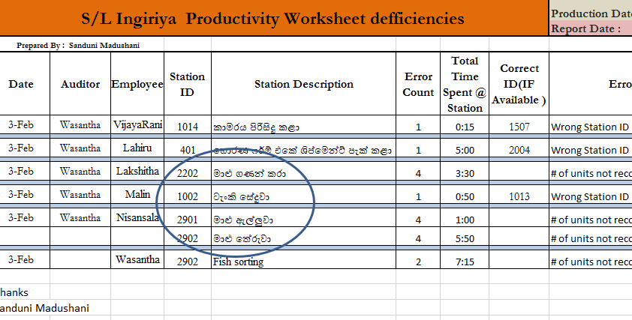

- Finally Checking Auditor Signature
