OFFICE PROCESS RECORD

Subject | How to Complete SL Ingiriya Weekly Productivity work sheet received summary report
Department | Labor Planing
Recorder | Sanduni Madushani
Approved by | Dilan Maduranga
Created date | 09/02/2015
Last updated | 20/03/2016
No. of pages including this page | 03

SL Ingiriya Weekly Productivity work sheet received summary report

- The Weekly Productivity work sheet received summary report on every week Monday.
- Weekly Productivity work sheet received report need to be posted in SL Ingiriya Farm On every week Monday.

Following guidelines can be used when updating the Weekly Productivity work sheet received summary report.

  - Daily Updated Productivity work sheets received summary data Enter to weekly Summary report date wise.
  - Marked Daily updated Details tally with attendance and Labor Schedule Reports accordingly.
  - Employees name wise Daily Productivity sheet sending total count reviewing.
  - Daily Productivity work sheet not received total deduction Mentioned on Weekly Productivity work sheet report.
(If any employees did not send his productivity work sheets on that Production Date. Deduction will be per day Rs.50)

How to Prepared Weekly Productivity received summary report.

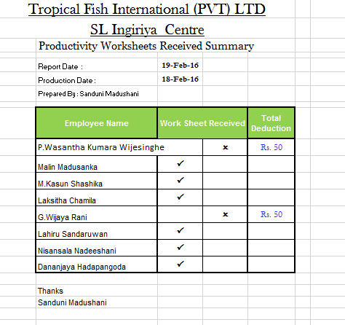
Updated daily Productivity work sheets received summary

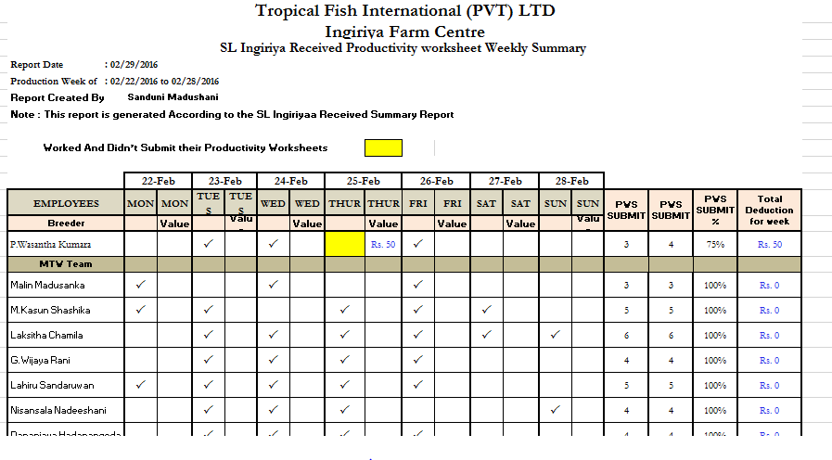
Date wise each employee’s sheet received details
Weekly total deduction
Daily sheet sent total count

- Marked Daily updated Details tally with attendance and Labor Schedule Reports accordingly.

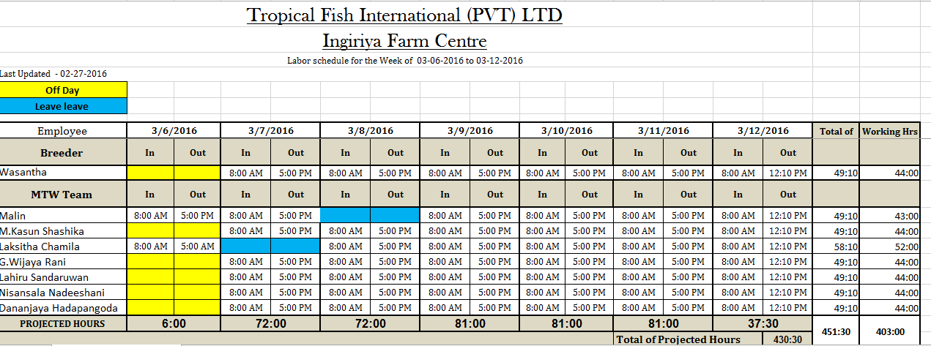
Each employee’s names and Schedule dates

