OFFICE PROCESS RECORD

Subject | How to Complete SL Wadduwa Productivity work sheet Analysis report
Department | Labor Planing
Recorder | Sanduni Madushani
Approved by | Dilan Maduranga
Created date | 09/02/2015
Last updated | 20/03/2016
No. of pages including this page | 05

SL Ingiriya Productivity work sheets Analysis report

- The Productivity work sheets analysis report Prepping for Daily
- The Productivity work sheets analysis report need to be reviewed and post in SL Wadduwa Farm.

- Productivity report is divided into the following sections

  - Productivity work sheet
  - Summary of labor Actual by Station
  - Summary of labor Total Actual vs Master Station Labor Involved Actual As a Percentage

- Productivity work sheet.

The Productivity work sheet completed by individual employees.

All Productivity work sheet Data enterd to Productivity sheet check with Station Id report for the Defficiencies

If found any error that recorded to Productivity work sheets Defficiencies report.

T
Task Relevant Substation I D
Task Relevant System Id

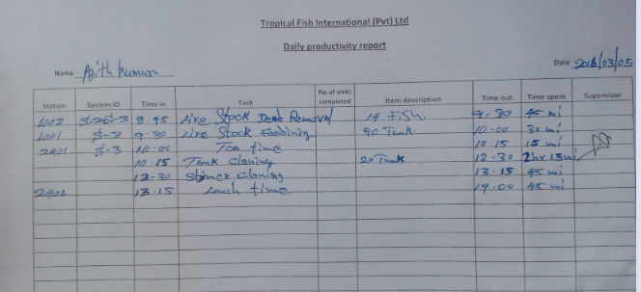
Time in How to Display
Total Count Of Completed
Farm Auditor Signature

Explain the task completed in Relevant Substation

Employees need to be recorded all the details that applicable

- Station Id – according to updated station id recorded
- System Id- this is applicable to QA and Maintenance Team.
- Time In- time that start to work relevant substation
- Time Out- time that ends working on same substation
- Task Description- explain the task completed in relevant substation
- Item Type- fish type, Bags and Boxes
- # Of units Completed- total count of completed
- Time Spent- total time spent on that particular substation
- Farm Auditor initial- each and every task need to audit by farm auditor for the work completion and also the productivity completion.

Enter above details that listed in the productivity work sheets to analysis report.

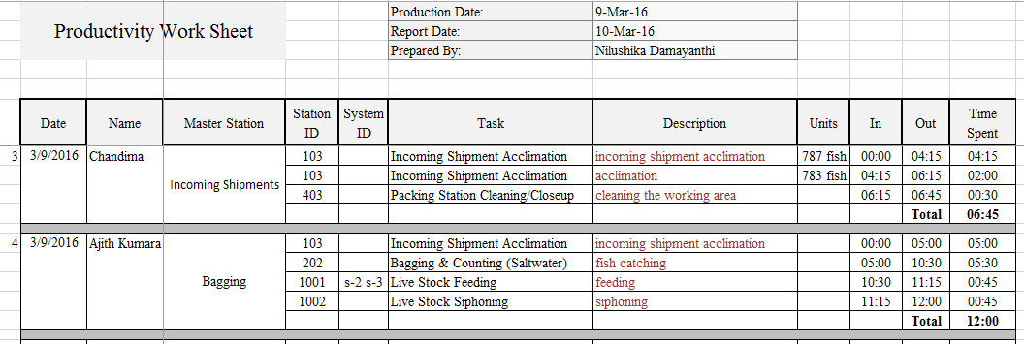
Explain the task completed in Relevant Substation
Item Description As a fish type, bags and boxes

Highlight break and Miscellaneous hours by using separate colour

- Summary Of Labor Actual By Station

Then calculated total time spent in a particular substation with in a day for the summary actual sheet.

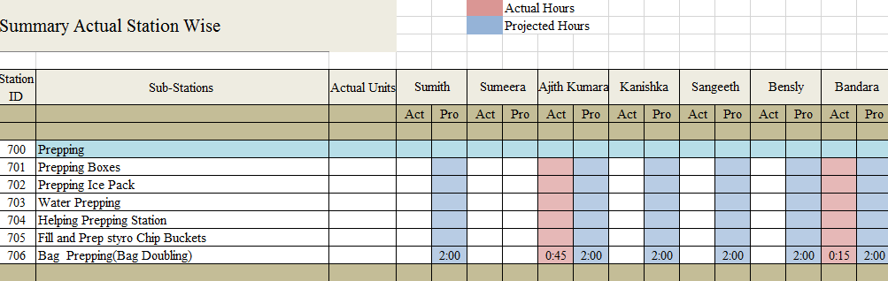

Recorded total time spent on each substation and recorded that each employee’s actual time.

- Summary of labor Total Actual vs Master Station Labor Involved Actual As a Percentage

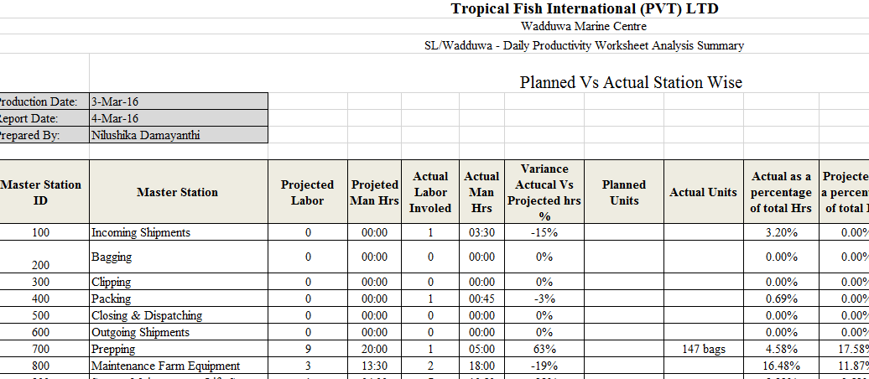

Below detail need to be update into this sheet.

- Master Station Id- Catagarize Master Station according to the Master Station Id’s
- Actual Man Hours – Total hours Spent on each Master Station ( Summary of labor station wise)
- Actual Labor – No of total employees involved in that particular Master Station

.

.

