OFFICE PROCESS RECORD
Subject | How to Complete SL Ingiriya Weekly Productivity work sheets Deficiencies report
Department | Labor Planing
Recorder | Sanduni Madushani
Approved by | Dilan Maduranga
Created date | 09/02/2015
Last updated | 20/03/2016
No. of pages including this page | 02

SL Ingiriya Farm Weekly Productivity work sheets Deficiencies report

- The Weekly Productivity work sheets Deficiencies report on every Monday.

- Weekly Productivity Deficiencies report needs to be reviewed and post in SL Ingiriya Farm Management.

Following guidelines can be used when updating the weekly Deficiencies report.

    - Daily updated Productivity work sheets errors total count enter to weekly summary report Date and Employee’s name wise
    - Employee wise total error count reviewing

How to Prepared Weekly Deficiencies report

- Daily updated Productivity work sheets errors total count enter to weekly summary report Date and Employee’s name wise

- Employee wise total error count reviewing

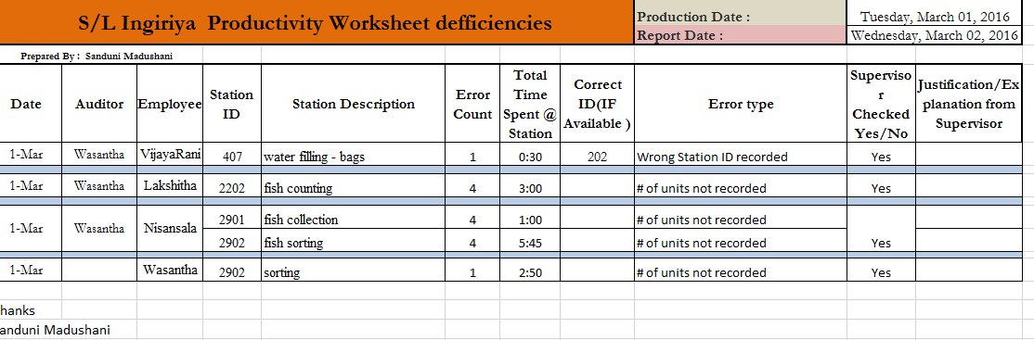
Production Date.
Employee Name and Error count

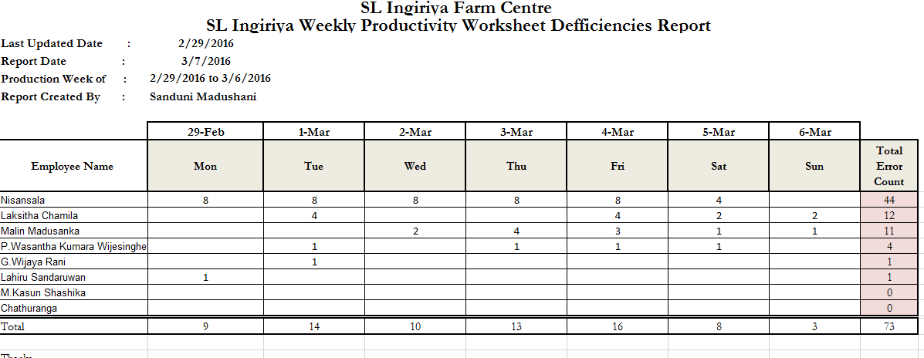
Production Week
Employee name and Date wise error count
Weekly Total error count name wise

