OFFICE PROCESS RECORD

Subject | How to Complete Productivity report
Department | Labor Planing
Recorder | Sanduni Madushani
Approved by | Dilan Maduranga
Created date | 09/02/2015
Last updated | 20/03/2016
No. of pages including this page | 04

Productivity report

- The Productivity report Prepping for Daily on “Monday to Saturday” in Time Projected hrs vs Actual hrs need to be post in Labor Mgt Daily.

Following guidelines can be used when updating the Productivity report.

- Productivity report is divided into the following sections

  - Data Enter to Productivity sheet
  - Sub Station wise Actual Hours Entering
  - Data Enter to Projected vs Actual Hours Sheet
  - Productivity work sheets Submission
.

- For above Process Data Getting From” CIS International Crop Productivity work sheet” via email

How to Prepared Productivity Report

- Productivity work sheet data enter to Productivity report

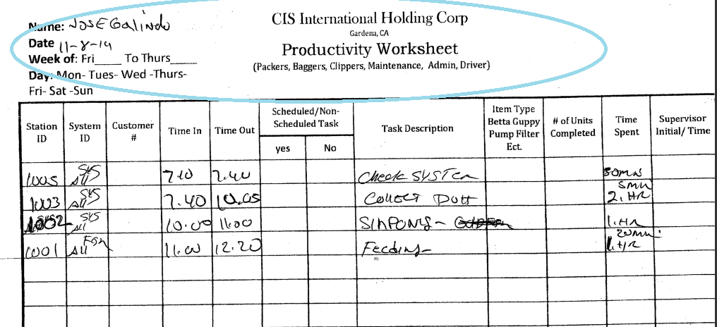

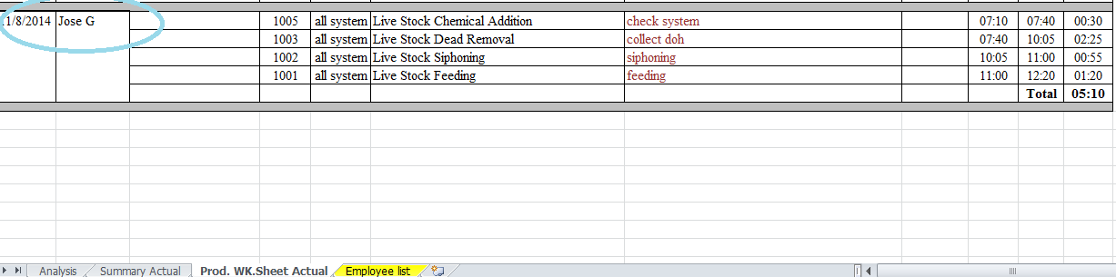

- Sub Station wise Actual Hours Entering – Filtering Productivity work sheets sheet Station Id Colum we are taking total time of each Substation.

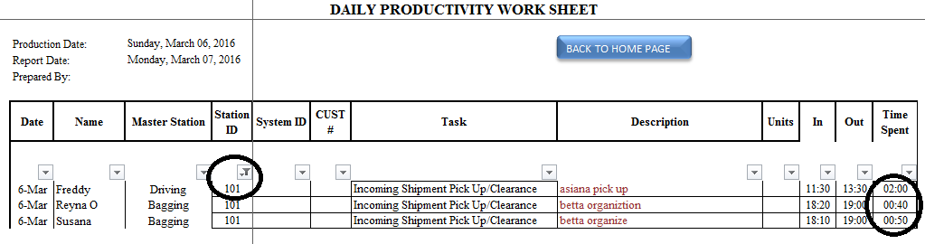
Substation wise Data Filtering
How to Showing Filtered time

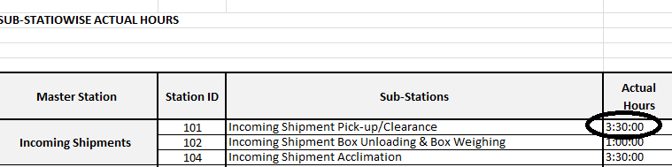
Substation wise Calculated Total hours entering to Substation wise Actual Hours sheet

- Data Enter to Projected vs Actual Hours Sheet – Employees wise projected Hours and Actual spent hours entering.

  - How to taking projected hours Employees Wise – From Daily Labor Forecast Man hours Report we are taking projected hours.

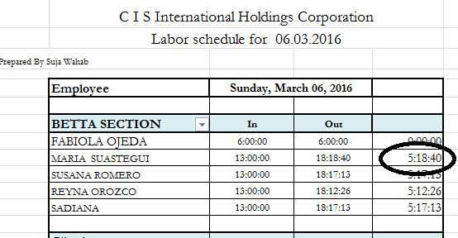
How to showing projected time Employee wise
Employees Name

  - Actual hours taking by Daily Productivity work sheets.

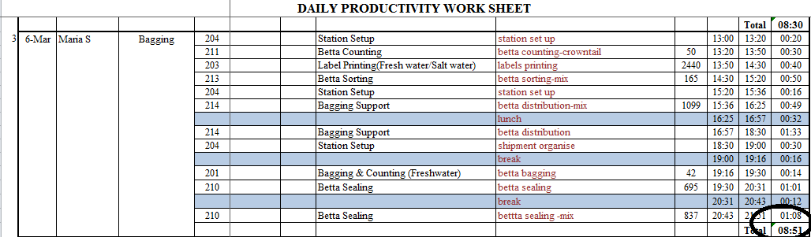

Employee wise Total Actual Time

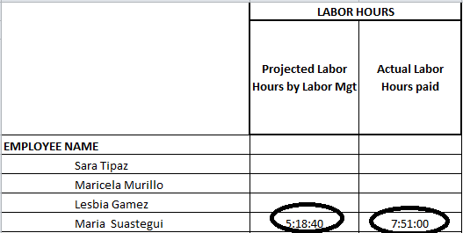
In total actual hours break time deduction

Employee wise projected hours entering

- Productivity work sheets Submission – According to Daily Signout sheet details below 3 points Updated to
Productivity work sheets Submission report.

  - Worked related Production Date and work sheets submitted on time - for these employees we are paying $5 dollar per Day.
  - Worked related Production Date. But did not Submission work sheets on time- that employees name highlighted.
  - Absent Employees.

All these information updating to Production Week.

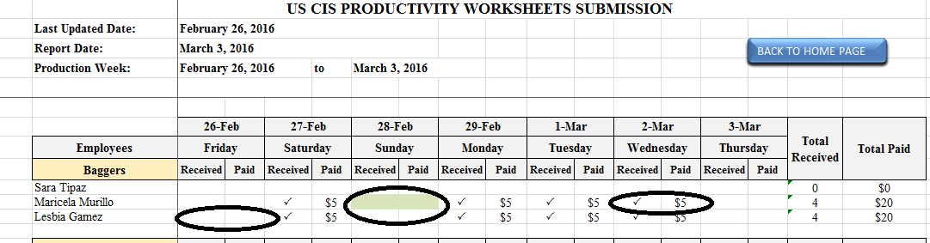

Absent Employees
Worked related Production Date and work sheet not submitted on time
Worked related Production Date and work sheet submitted on time

