OFFICE PROCESS RECORD

SUBJECT | Prepare monthly Divisional Profit and Loss Account
RECORDER(Name Designation) | Chathurangani Ranaweerage – Accounts Executive
APPROVED BY (Name Designation) | Stanley Samidas – Senior Accountant
CREATED DATE | 07/07/2016
NO. OF PAGES INCLUDING THIS PAGE | 02

Objective : Divisional P & L is the report management to measure the profitability of the company and Farms and monitor & control the expenses during the financial period.

- Once Accounting owners updating the accounts then exporting P & L monthly and Year to date from QB
- Getting closing inventory from each Farms.

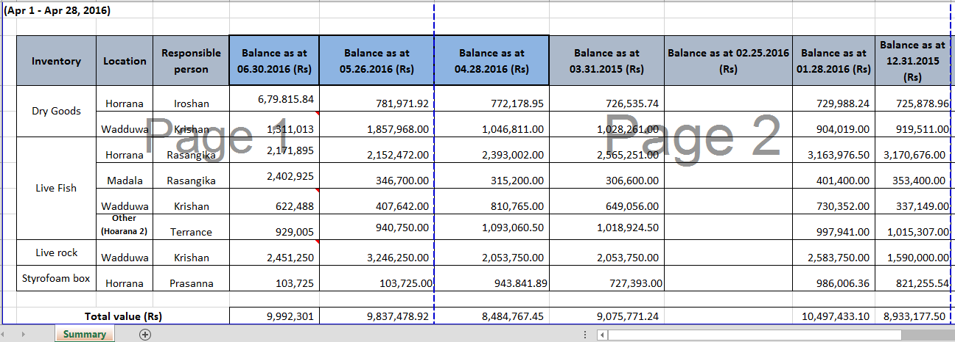

- Updating the Divisional P & L according to below format.

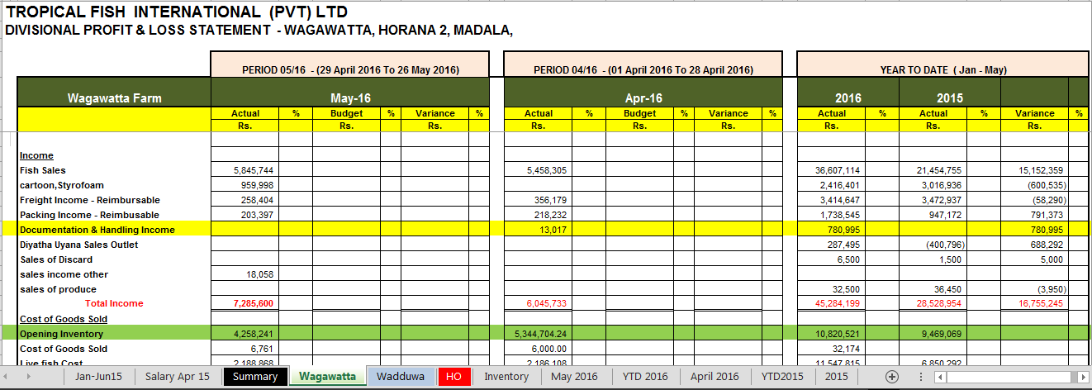

- Once Divisional P & L reports ready to be forwarded to Stanley for monthly meeting purpose.

