OFFICE PROCESS RECORD

SUBJECT | Export bills discounting – settlement schedule
RECORDER (Name Designation) | Lahiru Dharmasena - Accountant
APPROVED BY (Name Designation) | Stanley Samidas – Senior Accountant
CREATED DATE | 02/23/2016
NO. OF PAGES INCLUDING THIS PAGE | 02

Objective : To ensure all the Petty cash are Update in timely Manner

1. Each and every week Friday Lisa saving the petty cash in Drop box creating the relevant date range which is call tempary Folder
2. After saving we have to enter the Petty cash to Quick books.

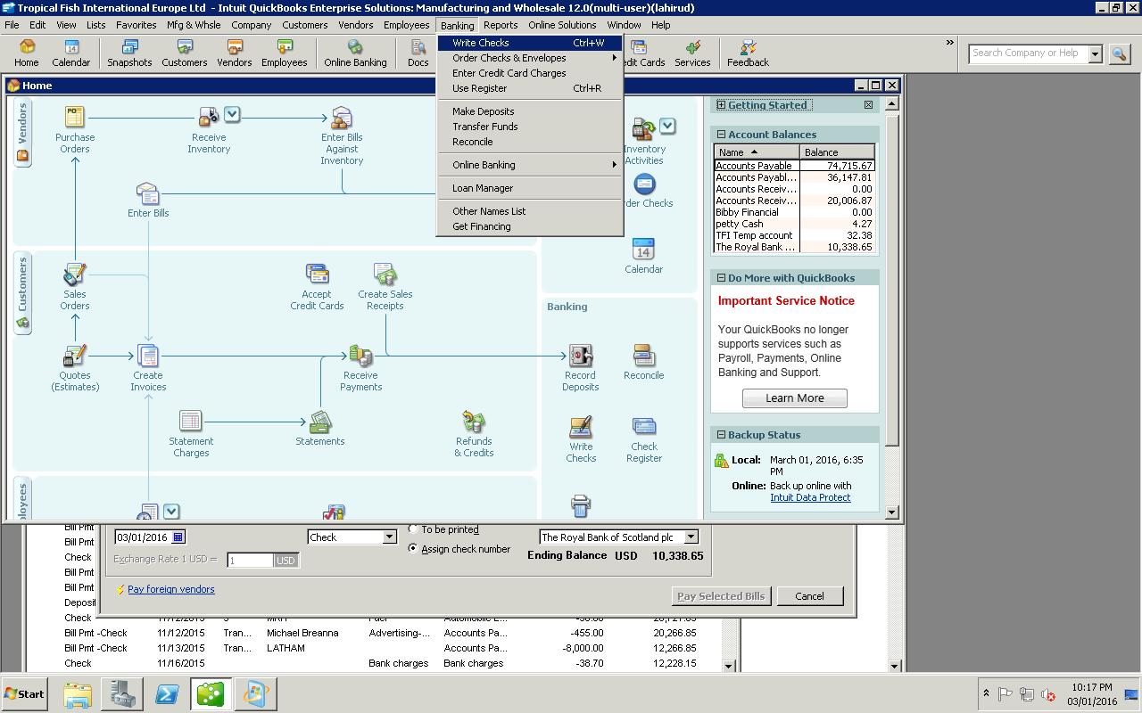
- Then
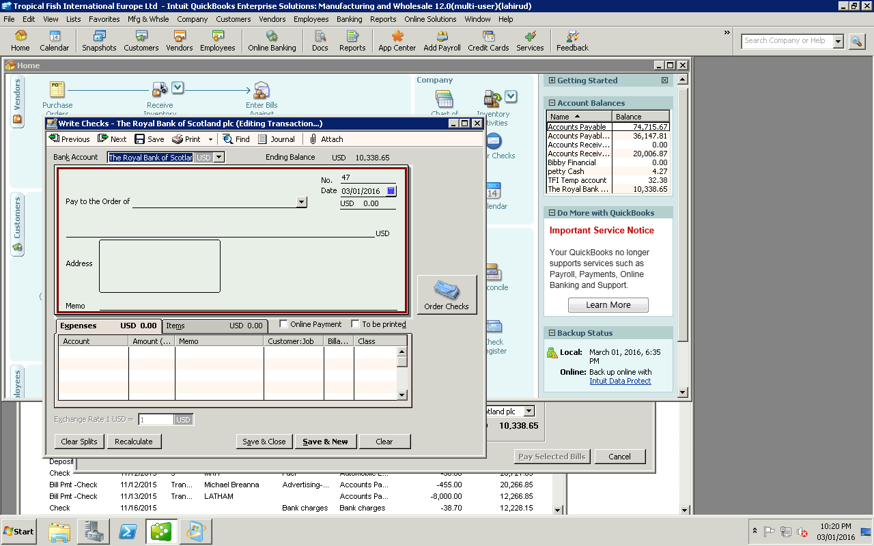
01) Select vendor 02) Select date 03) Enter amount 4) enter description

3. After update in Quick books we have to attached that bill to the system
4. Then we have to saved that Petty cash voucher in vendor folder in the drop box
5. After that needs Delete that tempaory folder in the drop box.

05) Select Accounts type 06) Click

