OFFICE PROCESS RECORD

SUBJECT | TFI SL bill entering
RECORDER (Name Designation) | Lahiru Dharmasena - Accountant
APPROVED BY (Name Designation) | Stanley Samidas – Senior Accountant
CREATED DATE | 03/11/2016
NO. OF PAGES INCLUDING THIS PAGE | 02

Objective : To ensure all the Invoices are Update in timely Manner.
When receiving the bills follow the bellow procedure.
- Go to Vendor and Select Enter bills.

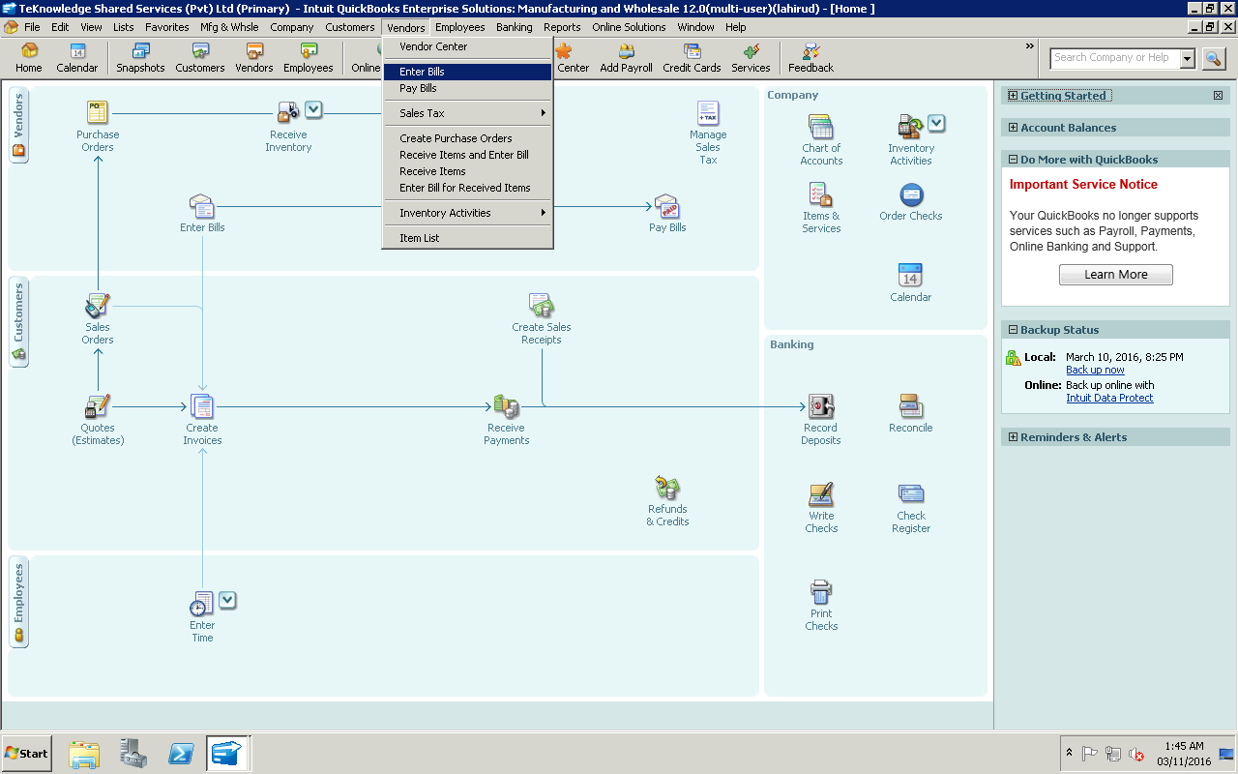

- Then Select the relevant Vendor from “Vendor Menu”
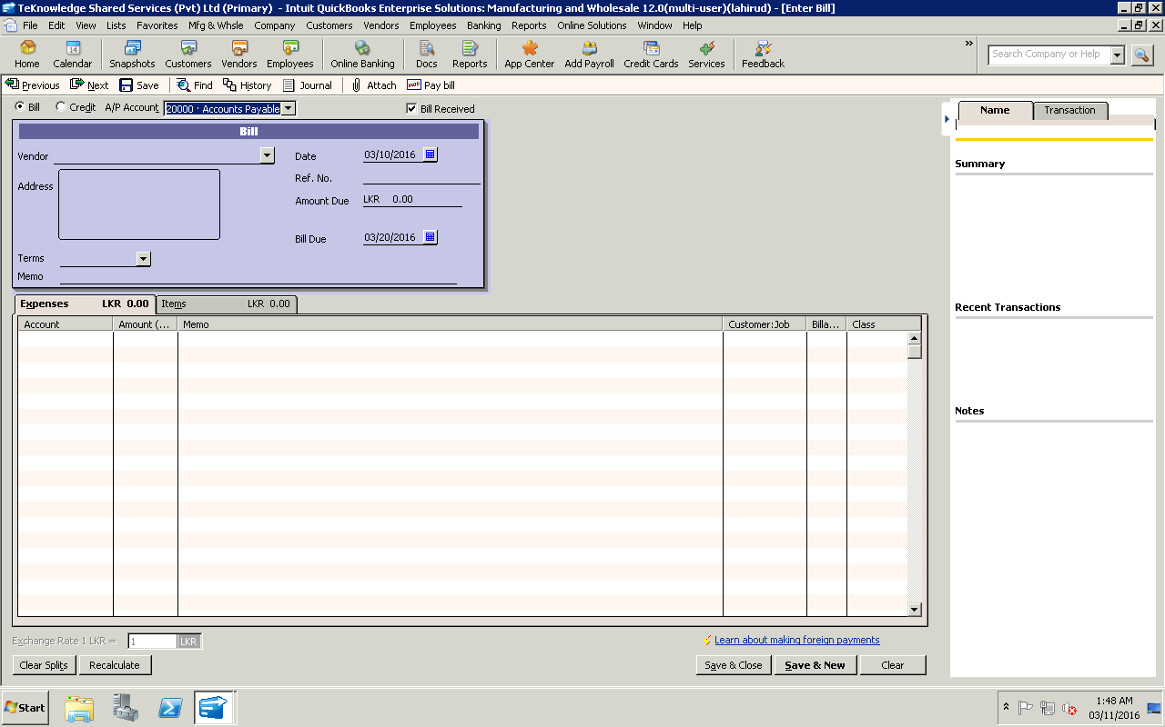

- Then put the Bill reference no in Ref No

Then enter the Amount in and select the date of the Bill due

Then select the Relevant Account that need to posted and select Save and close.

