OFFICE PROCESS RECORD

Date : 11th March 2016
Process : TEKSS incoming Sales
Recorder : Lahiru Udayanga

Objective : To ensure all the Invoices are Update in timely Manner

- Need to raise the invoice to every weekly to CIS international Holding USA
- Note - For a week we need to charged $ 7000 for the week FOR USA . and GBP 6,600 FOR TFI- UK
Process describe as follows.
- Go to Customer and Create invoice in QB.
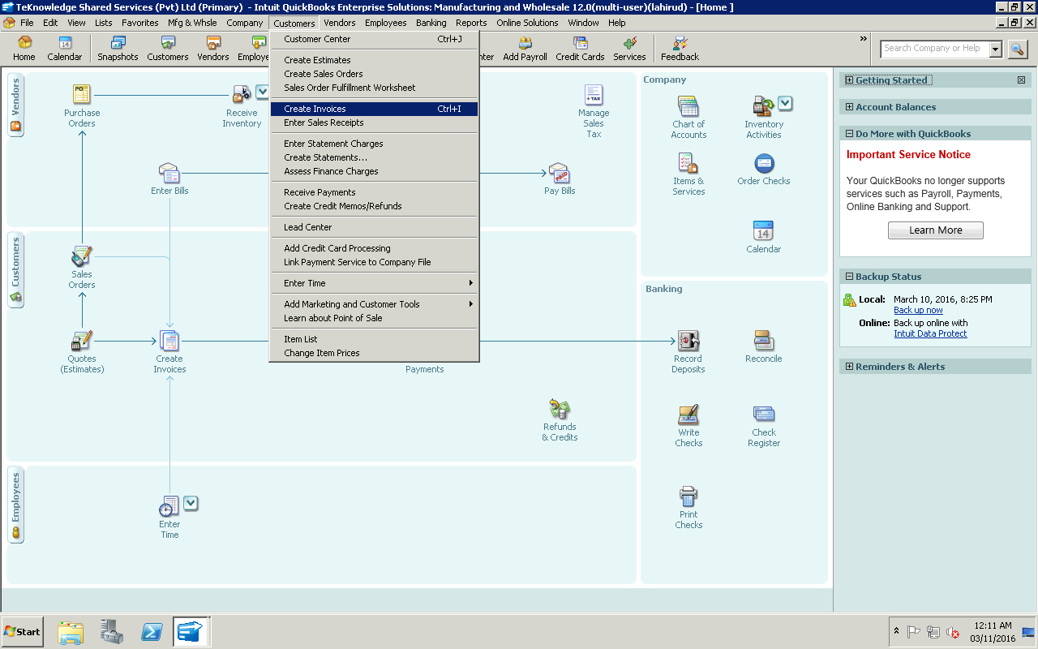

02).And then select from Item code( Down arrow “ service Income on Back Office”
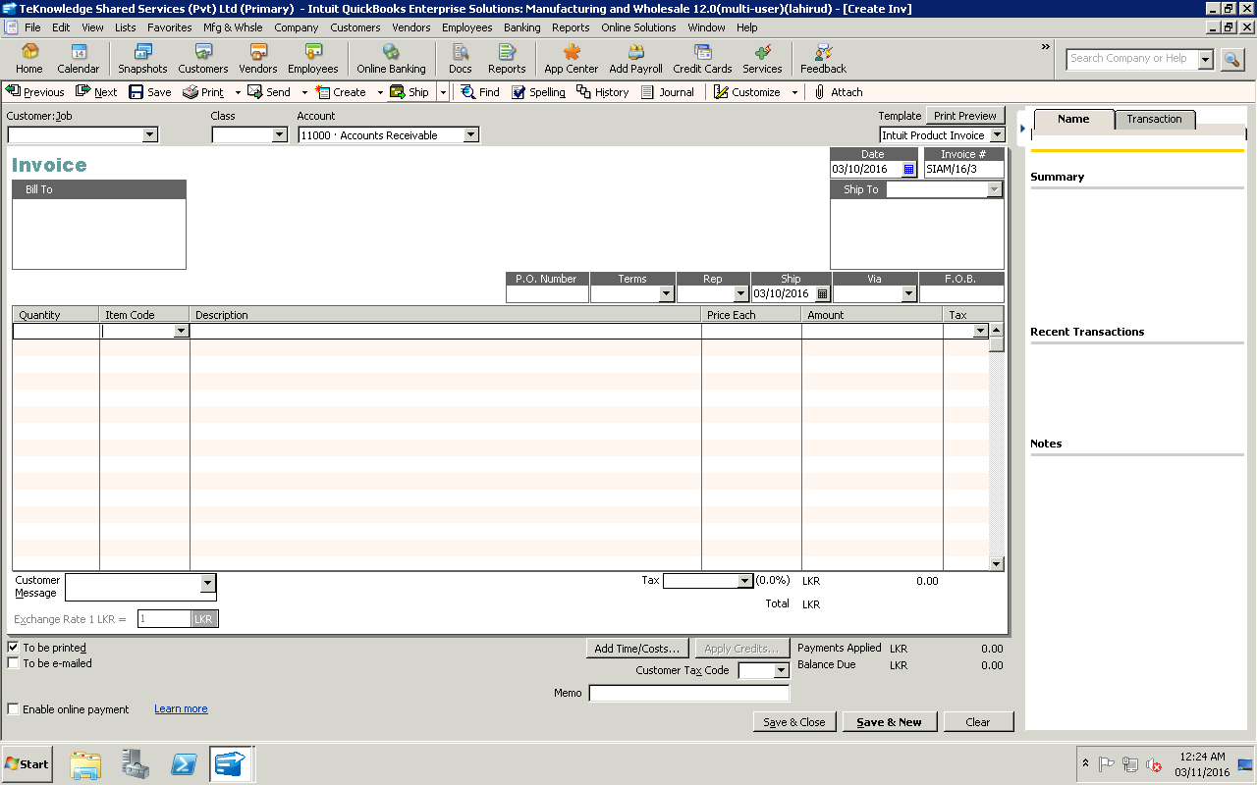

03)Selected the customer from Customer Job icon- “CIS international Holding”

04). Enter the Date and invoice no.
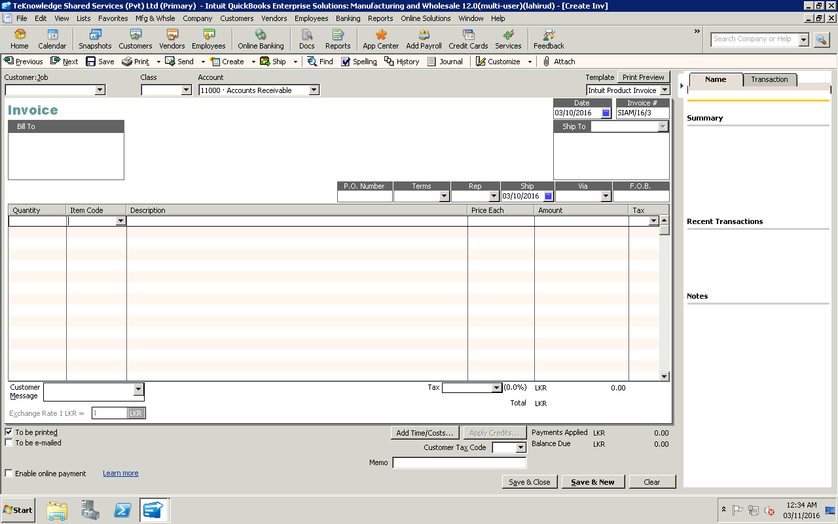

05) After that Click save and Close.

06. After entered Invoice need to enter funds transfer in following manner.

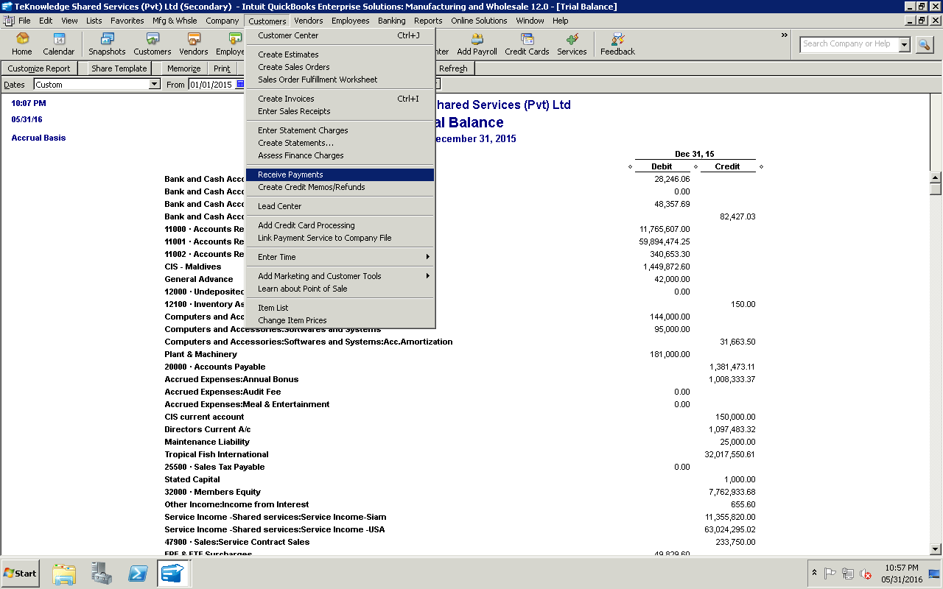

07. Select the relevant invoice and settle it as as follows.
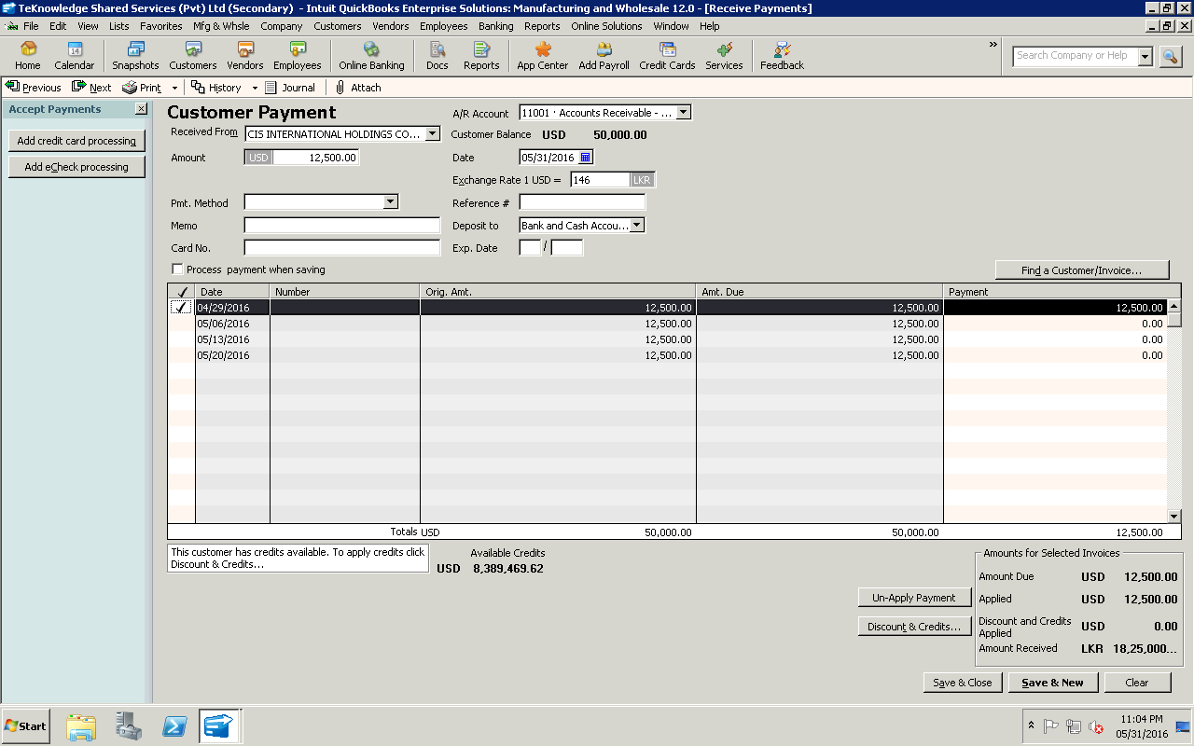

a)Select Custormer b)Select Amount c)Select invoice to settled. d) Select bank A/c

e Select Save and Close

