CASH ADVANCE SETTLEMENT POLICY
SUBJECT | Cash advance settlement policy
RECORDER (Name Designation) | Sajith Asanka – Accounts Executive
APPROVED BY (Name Designation) | Stanley Samidas – Senior Accountant
CREATED DATE | 03/08/2016
NO. OF PAGES INCLUDING THIS PAGE | 02

- Cash Advances should be requested through e-mail at least 2 days before the date on which it is required.

- The above request should be followed by either 2 quotes or vendor/contractor data capture sheet or with proper & detailed info.

- The above request should be approved either by CEO/Farm manager and Finance Manager.

- HO releases the advance via a cheque written to the Payee/Cash.

- BOAT updates the above advance releasing record to QB.

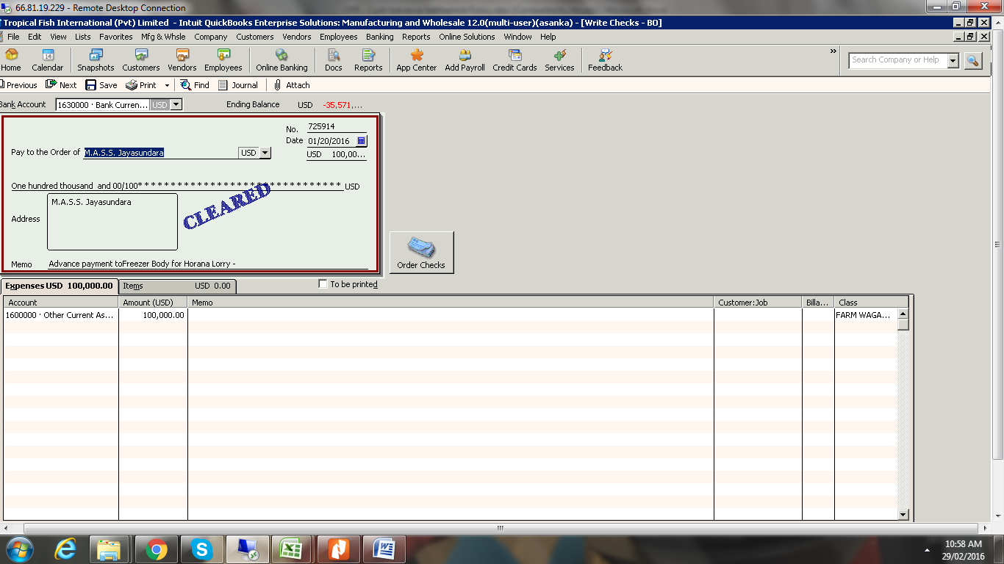

- All the source docs related to the advance should to be settled by two weeks from the date of releasing the advance. i.e. staff who takes the advance should complete the task & submit all source docs within two weeks from the date he/she takes the advance.

- BOAT audit the above docs & settle the advance account in QB

