OFFICE PROCESS RECORD

Date : 14th Mar 2015
Process : TFI UK and CIS incoming Sales
Recorder : Darshana Kumara

Objective : To ensure all the Invoices are Update in timely Manner

01. Collect the all Invoices from Andreas, Brian and Lisa as daily basis
2). after receive invoice from Lisa and CIS relating to that day enter the Quick books and attached it in proper manner in the system.
03) Maintain the Daily invoice work sheet
Process describe as follows. Click customer and then create invoice
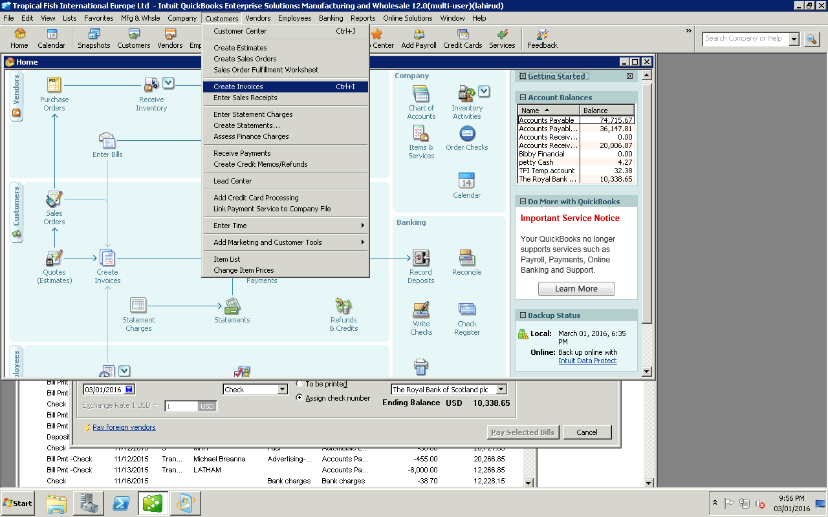

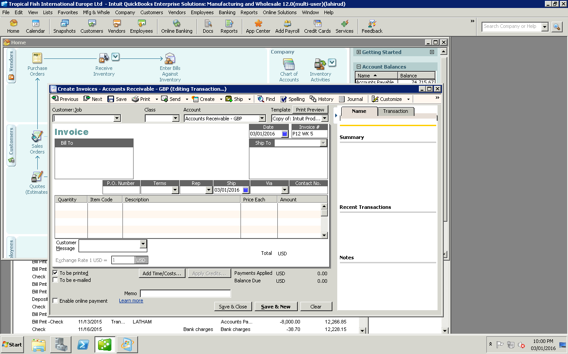
03) Select Date
04 Click save and new
01) Click arrow key-Select Pets at Home.
02) Select Invoice No

04) Get the Fund received from Paymentch web site and record it in to the QB
05) Maintain the AR outstanding balance report

