OFFICE PROCESS RECORD

Date : 14th March 2016
Process : TFI UK and CIS Bill entering
Recorder : Darshana Kumara

Objective : To ensure all the Expenses and Bills are Update in timely Manner

- End of the every day Lisa saving the Bills in Drop box creating the relevant folder which is call temporary Folder .

Drop Box- Accounts and finance folder-(Tempary Folder)
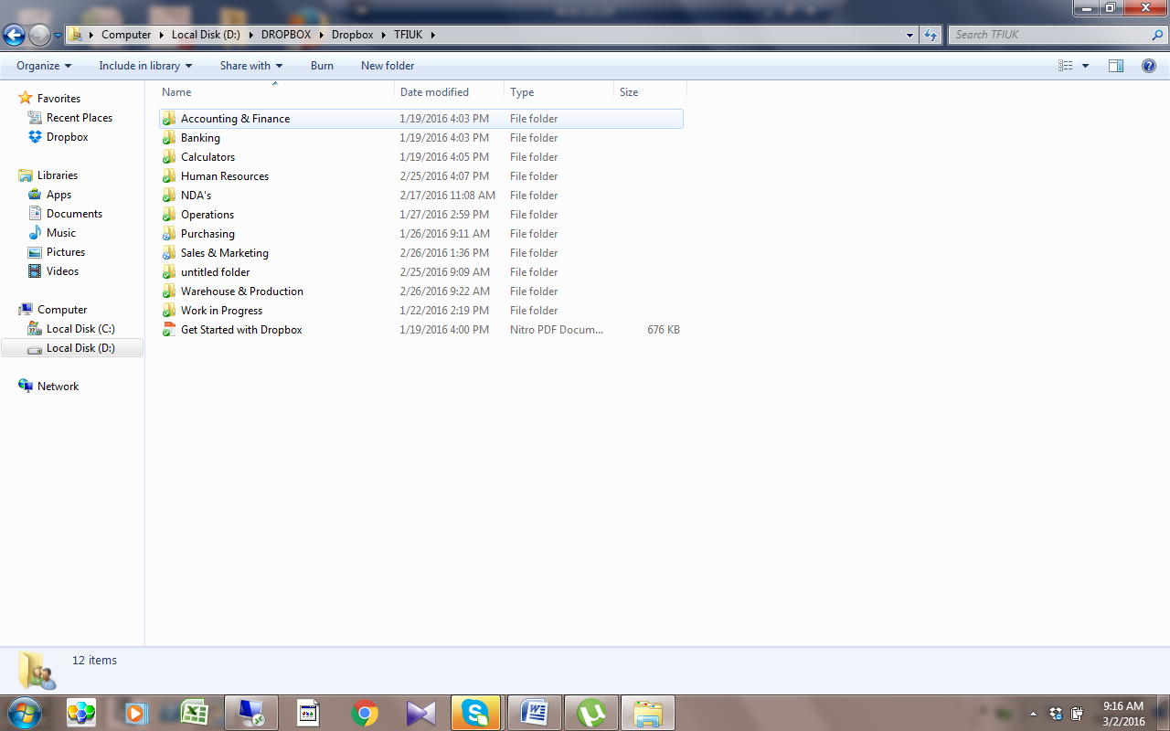

- After saving we have to enter the Bills to Quick books.
- Select- Vendor- enter bills.
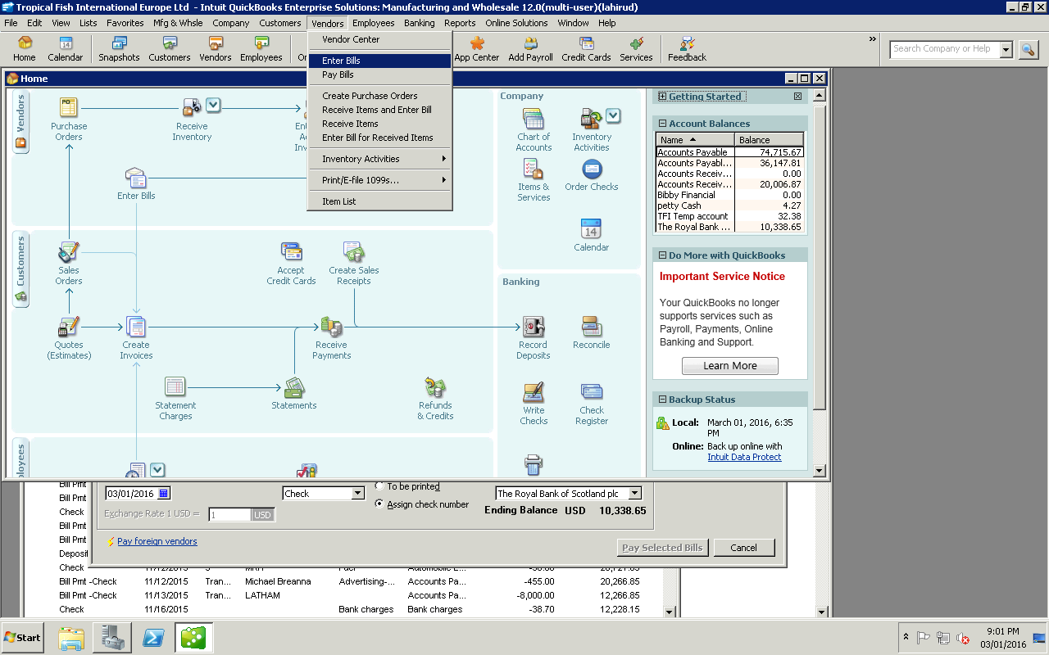

3. After update in Quick books we have to attached that bill to the system
4. Then we have to saved that bill in vendor folder in the drop box
5. After that needs Delete that tempaory folder in the drop box.

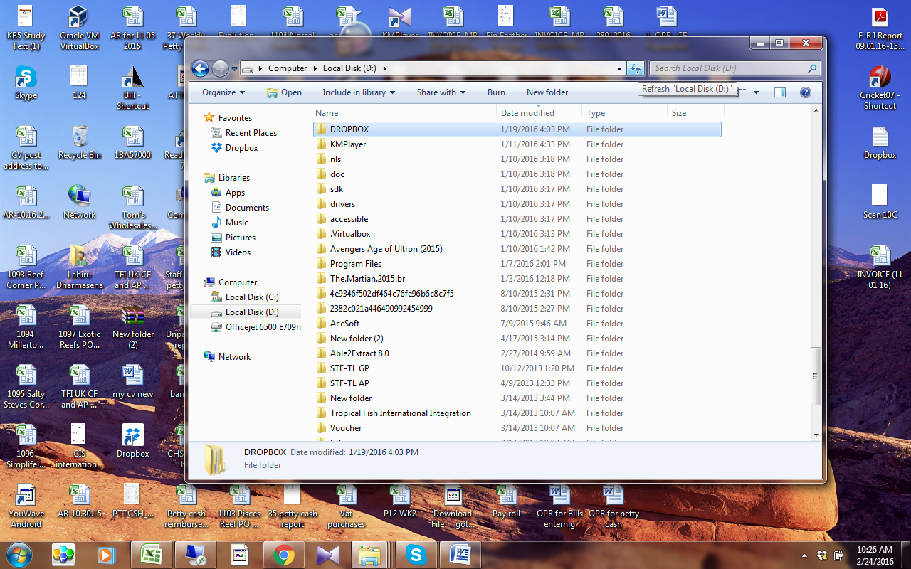

Enter amount
Select date
- Select vendor from QB. BY CLICKING THE DOWN ARROW KEY
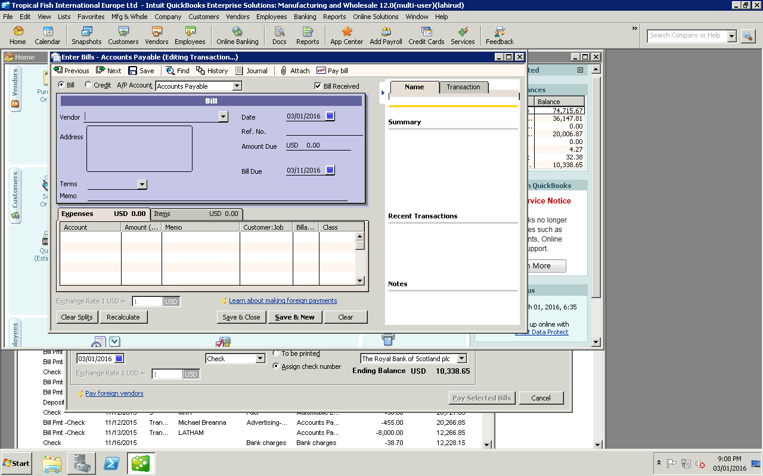

Process is described bellow How to extract the bills from the Drop Box

