OFFICE PROCESS RECORD

Date : 14th Mar 2015
Process : TFI UK, TFIAU and CIS Petty Cash
Recorder : Darshana Kumara

Objective : To ensure all the Petty cash are Update in timely Manner

1. Collect the Petty cash bills and summary list from Maria, Lisa and Danial
2. Prepare the petty cash report and enter the Petty cash into Quick books.
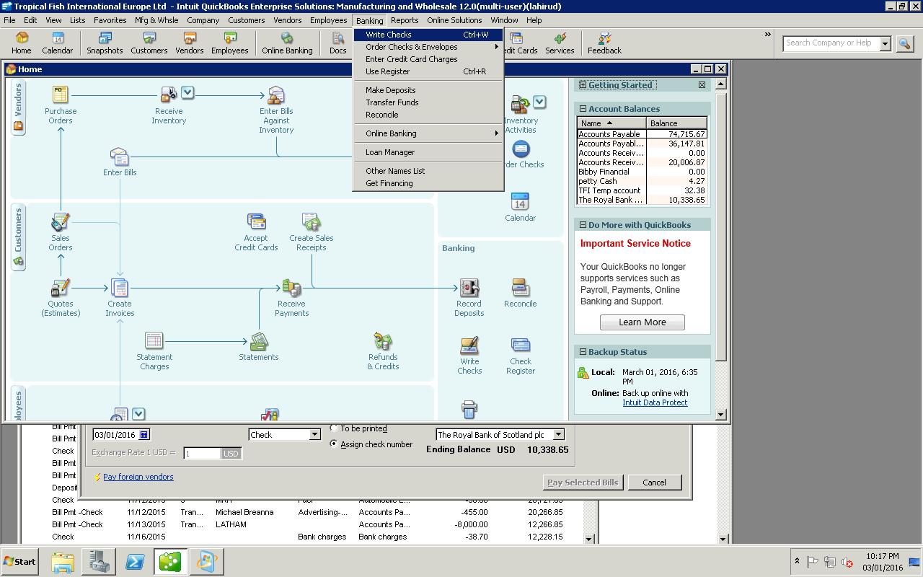

- Then
01)Select vendor. 02) Select date 03) Enter amount 4) enter discription
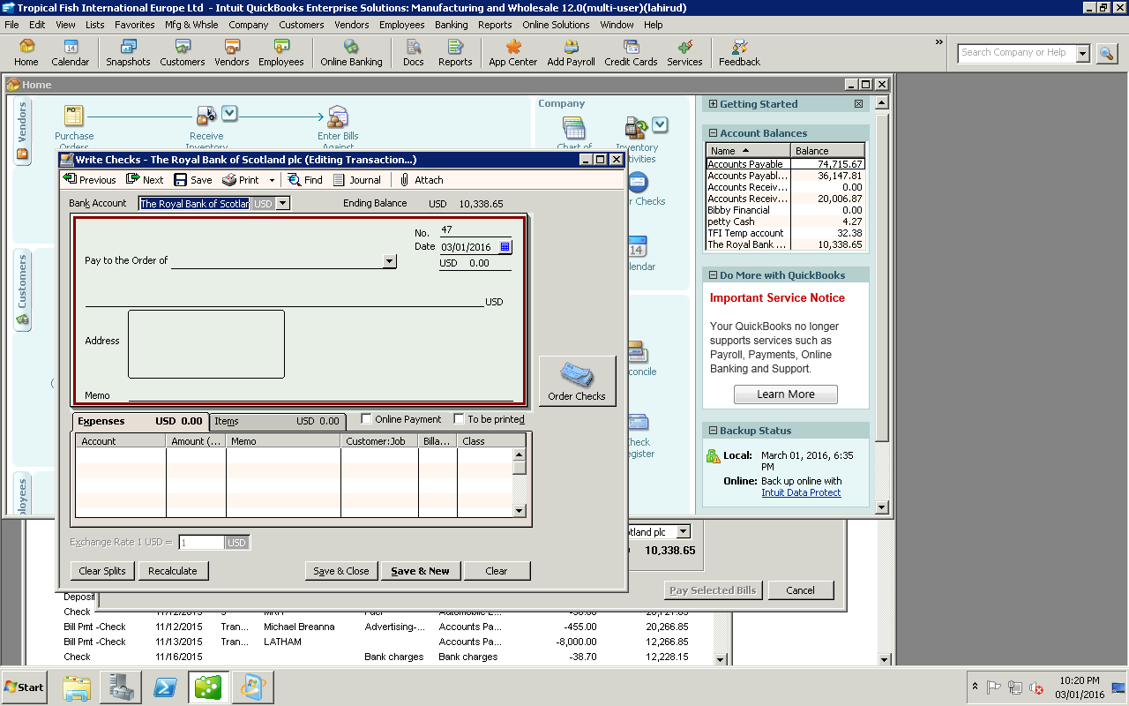

3. After update in Quick books we have to attached that bill to the system
4. Then we have to saved that Petty cash voucher in vendor folder in the drop box
5. After that needs Delete that tempaory folder in the drop box.

05) Select Accounts type 06) Click

