OFFICE PROCESS RECORD

Date : 14th March 2016
Process : TFI UK Transaction report
Recorder : Darshana Kumara

Objective : To ensure all the Transactions are Update in timely Manner.

Process is as bellow.
- Go to report and then click Accounts and Taxes after that Transaction detail by accounts
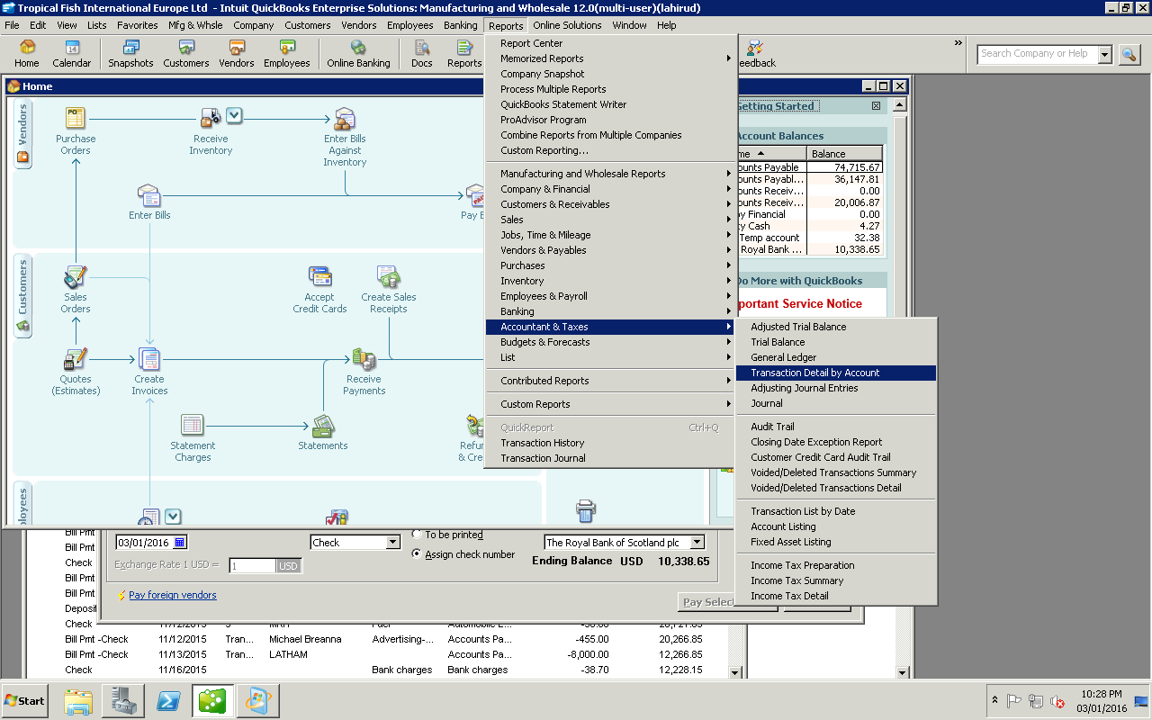

Then select the date range and export it to the excel by clicking exell
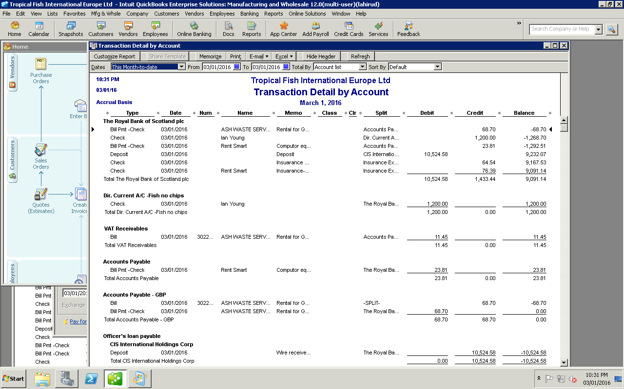
02.Need to send this to Ian Foster for review

