OFFICE PROCESS RECORD

Date : 14th March 2016
Process : POs Creation for CIS
Recorder : Darshana Kumara

Objective : To ensure the material availability of Warehouse.

Process is as bellow.
- Get the POs requesting Mail from CIS warehouse

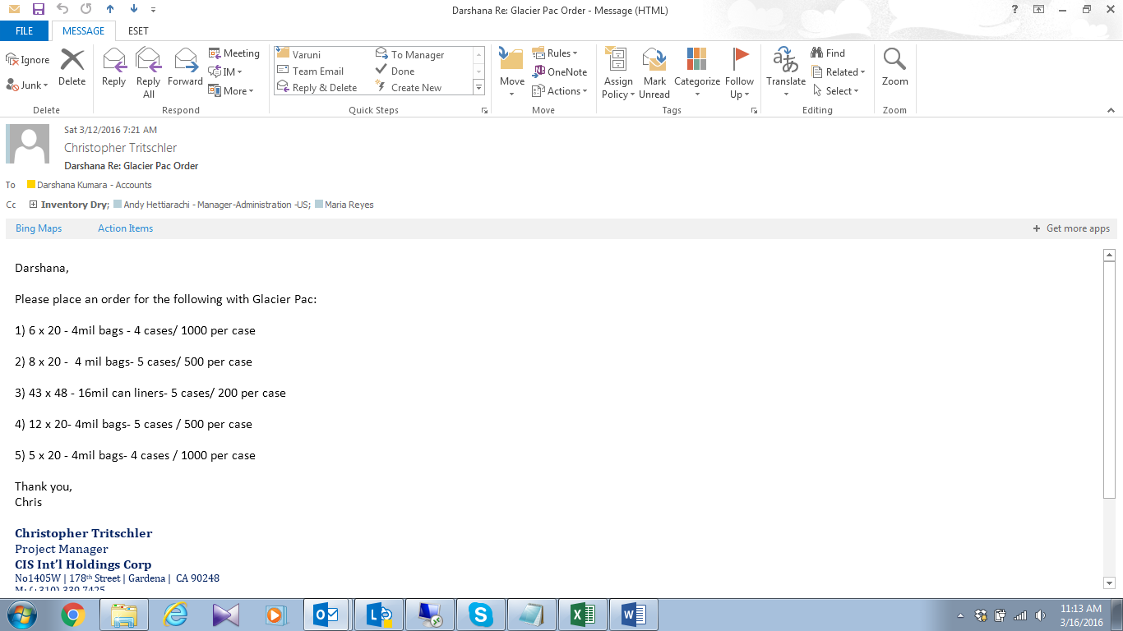

- Discussed with WH staff actual requirements and availability of the items

03. Then Enter to QB as request by Warehouse.
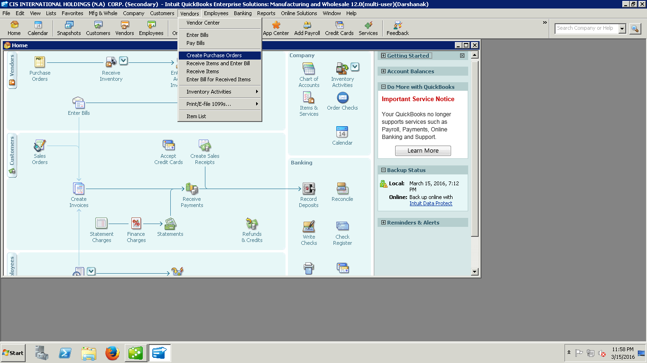

04. Need to send this to Relevant Vendor and Maria
05. Follow up and deal with vendor

