OFFICE PROCESS RECORD

Date : 14th March 2016
Process : Daily AR Report
Recorder : Darshana Kumara

Objective : To ensure the Account receivables are collected on time.

Process is as bellow.
- Generate the QB AR report

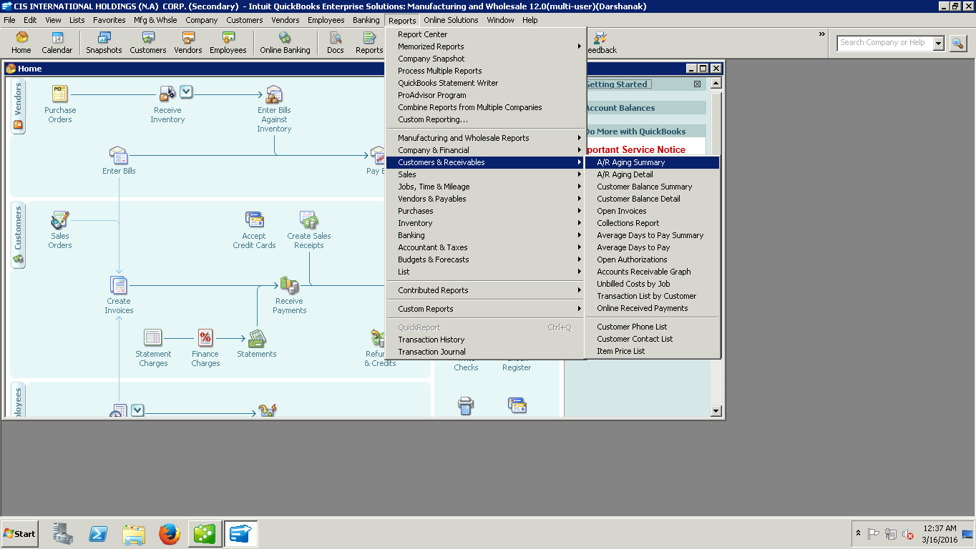

Edit the QB report As Available data in our record.
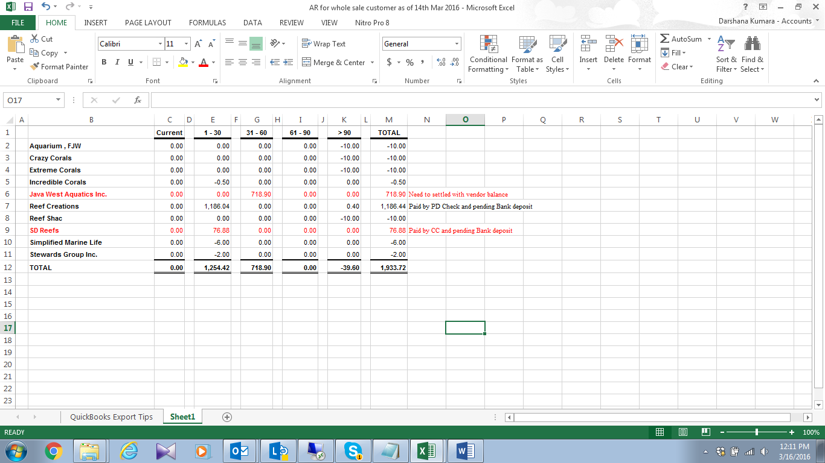

02. Need to send this Report to Andreas and Brian

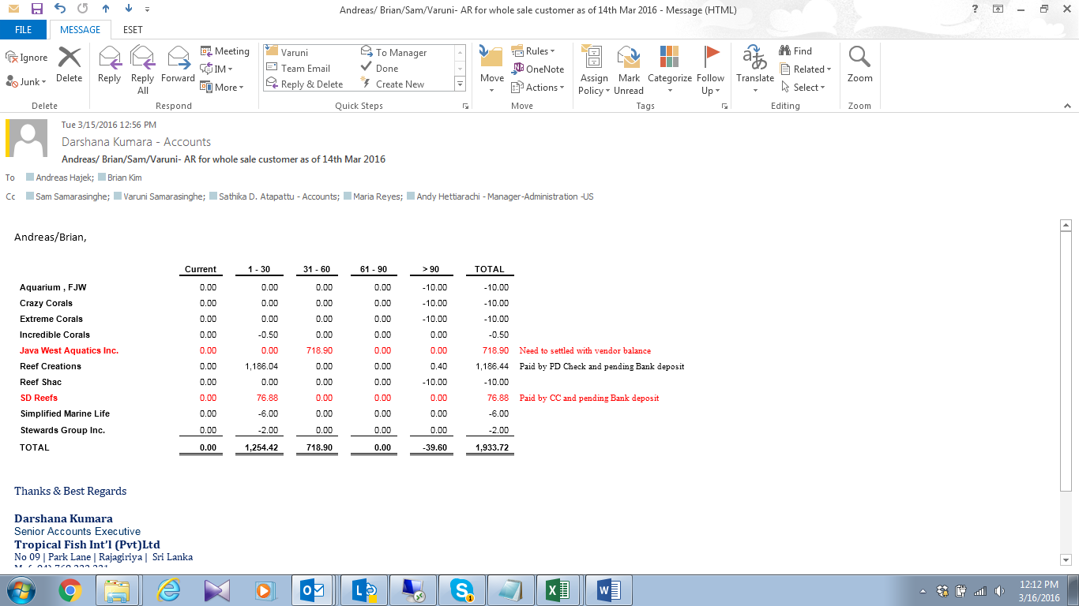
03. Discussed and inform to management if overdue or bad debts have

