OFFICE PROCESS RECORD

Date : 14th March 2016
Process : Petty Cash Report
Recorder : Darshana Kumara

Objective : To ensure the Petty cash incurred for correct purpose.

Process is as bellow.
- Get the Maria’s petty cash expenses details mail
- All petty cash should be record in QB and Excel and should check petty cash balance at the end of the week

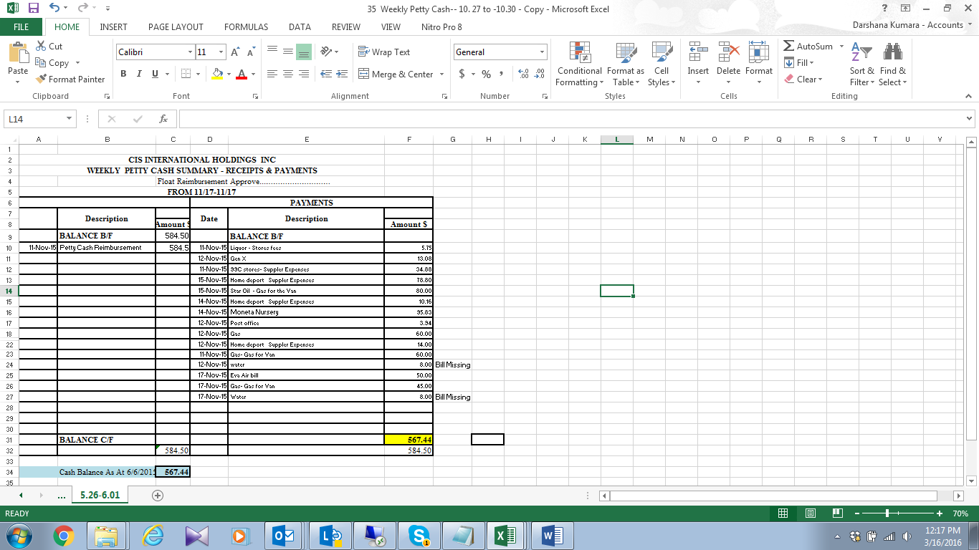

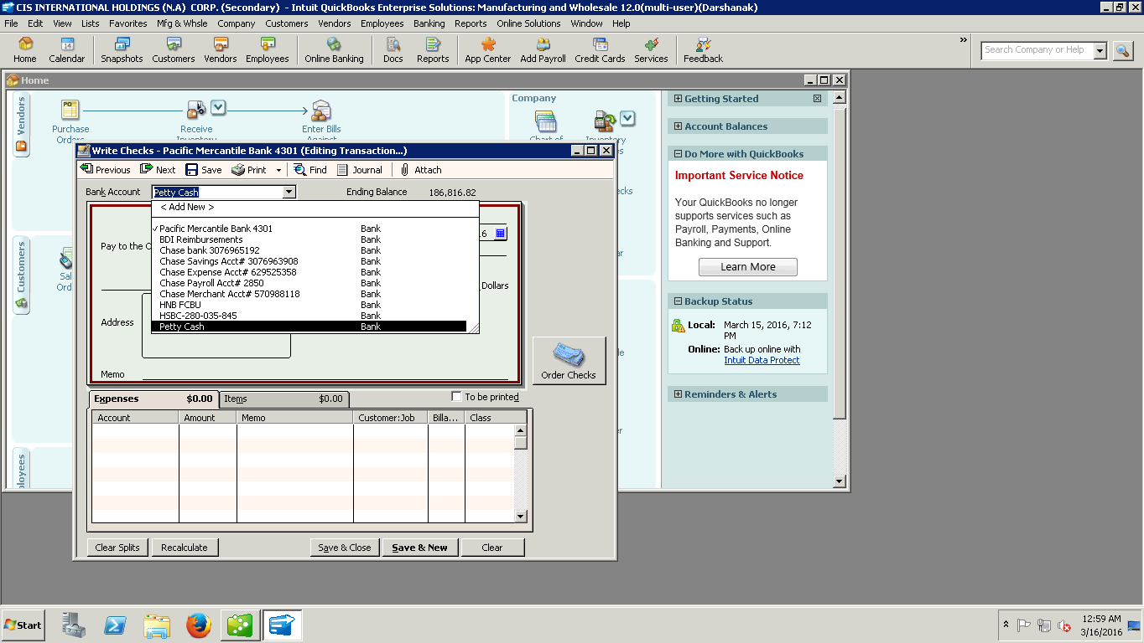

02. Send petty cash report to WH management and Accounts

03. Discussed and report to management , if have issues with petty cash incurred

