OFFICE PROCESS RECORD

Date : 16th March 2016
Process : Daily payments record
Recorder : Darshana Kumara

Objective : To ensure the all payments are record timely.

Process is as bellow.
- Check The RBS A/C daily

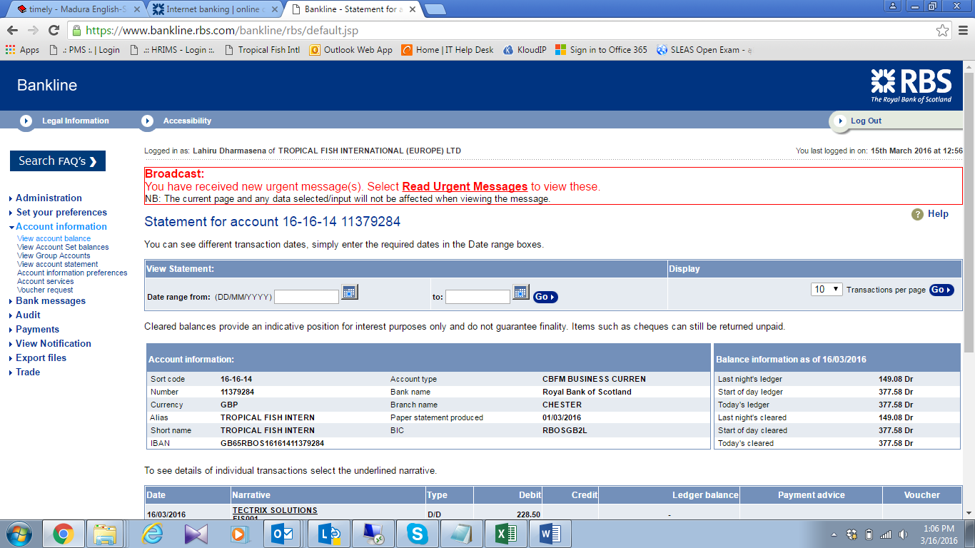

02. Record all RBS transaction and attached the relevant proof document of expenses in to the QB, (keep the note for unidentifiably transaction up to Friday,)

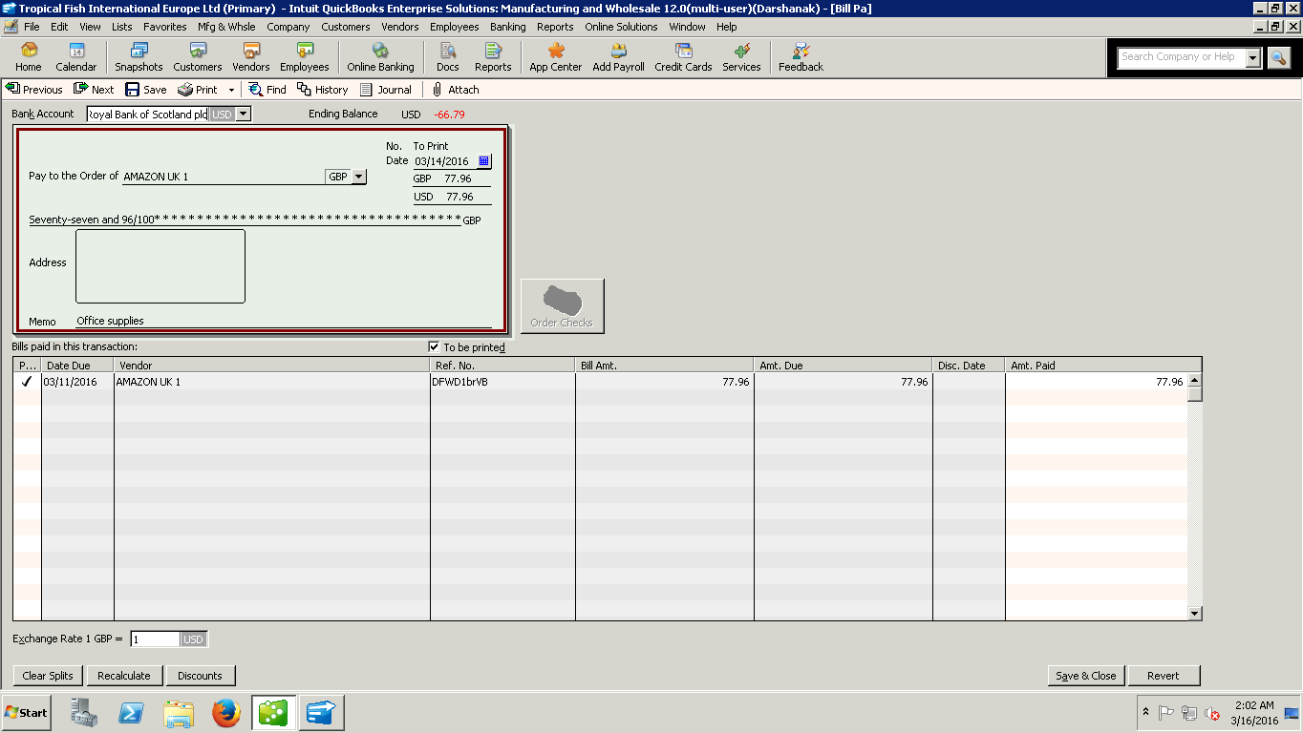

04. If could not be find the relevant proof document from Dropbox, then write a mail to Lisa with asking missing documents and follow up

