OFFICE PROCESS RECORD

Date : 16th March 2016
Process : Audit the #193 Material Usage sheet
Recorder : Darshana Kumara

Objective : To ensure the all POs and Material usage have record accurately.

Process is as bellow.
- Get the #193 Material usage sheet received from Production team
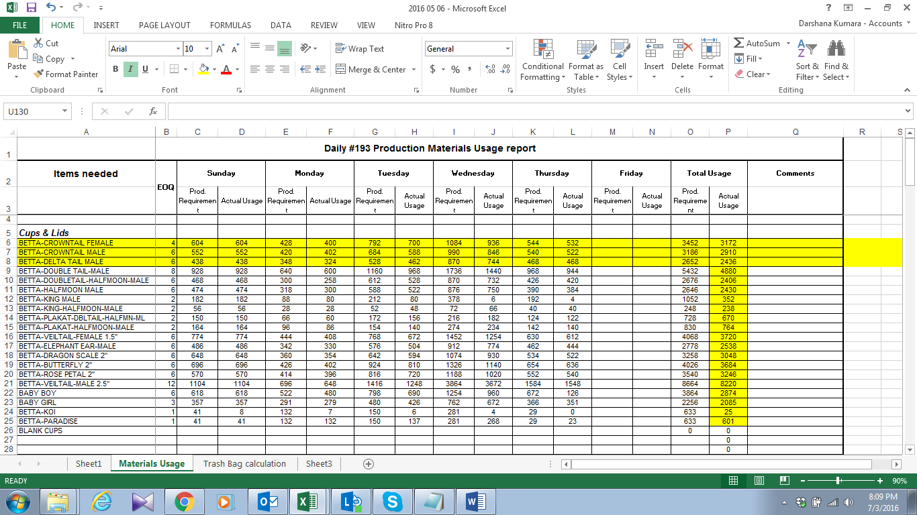

02. Check the betta cups usage with comparing Betta fish shipped quantity report (1 Betta fish = 1 Betta Cups)

03. Check the Packing material usage with PO quantities and Customer’s areas.
04. Check the special trash bag usage calculation with working sheet received from production department

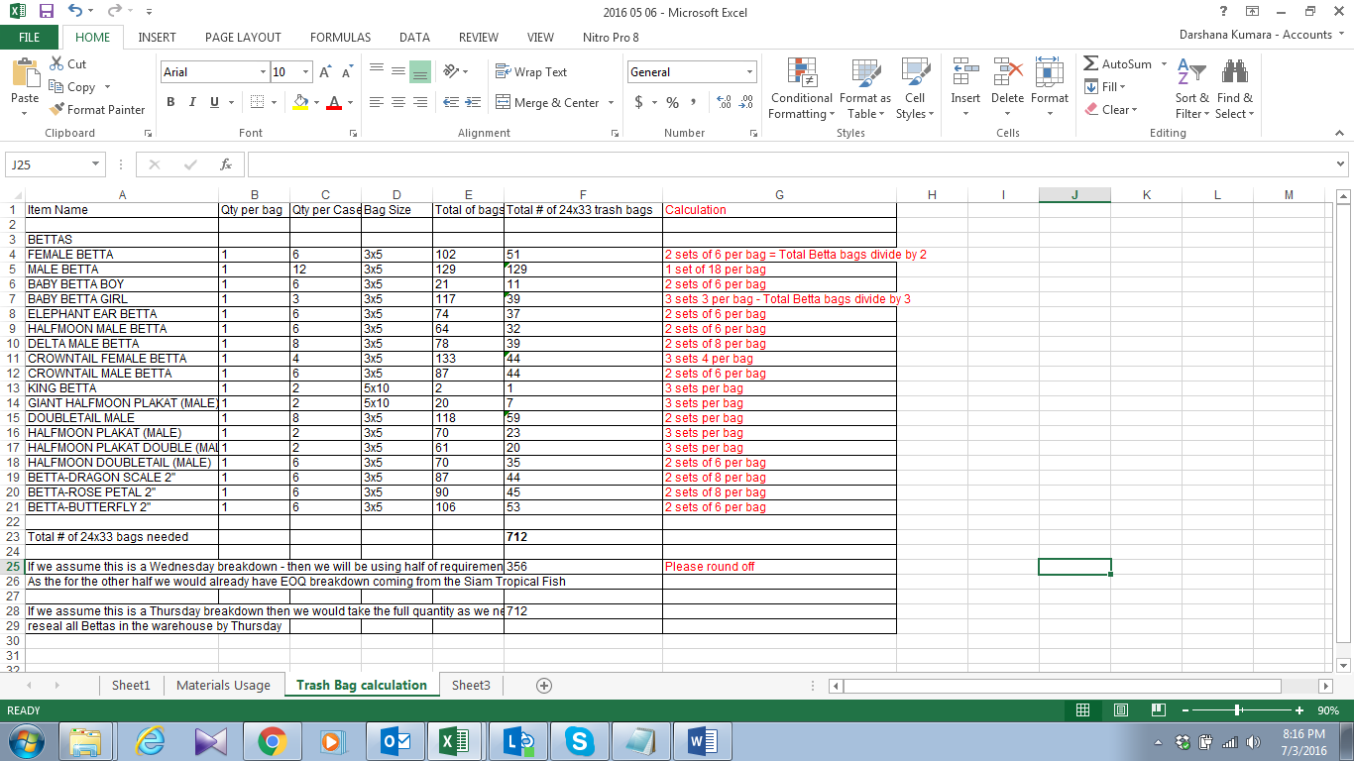

05. Discuses with production management team when have issue regarding # 193

