OFFICE PROCESS RECORD

Date : 16th March 2016
Process : Record the AR Factoring Charges and Interest in QB
Recorder : Darshana Kumara

Objective : To ensure the all AR Factoring charges and interest recorded in QB

Process is as bellow.
- Log Into Bibby Finance online site
https://bfsclientonline.hpdsc.com/SignOn.action;jsessionid=56D6EB2A356F6DA1153E7245BD482729.NN4?breakout=true

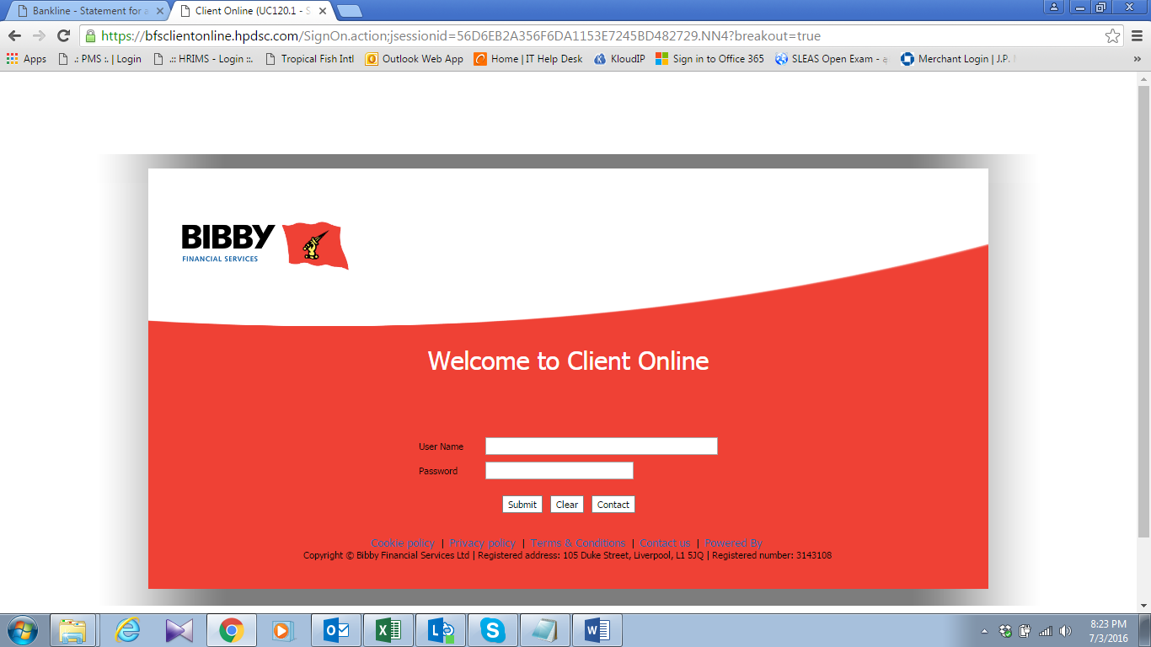

02. Viwe the Client legger account and update the QB using Client Ledger

