OFFICE PROCESS RECORD

Date : 16th March 2016
Process : Update AR , Factoring accounts in QB when fund received from Factoring
Recorder : Darshana Kumara

Objective : To ensure the all AR Factoring Cash inflows recorded in QB

Process is as bellow.
- Record the Customer invoices send to Bibby finance for factoring in QB
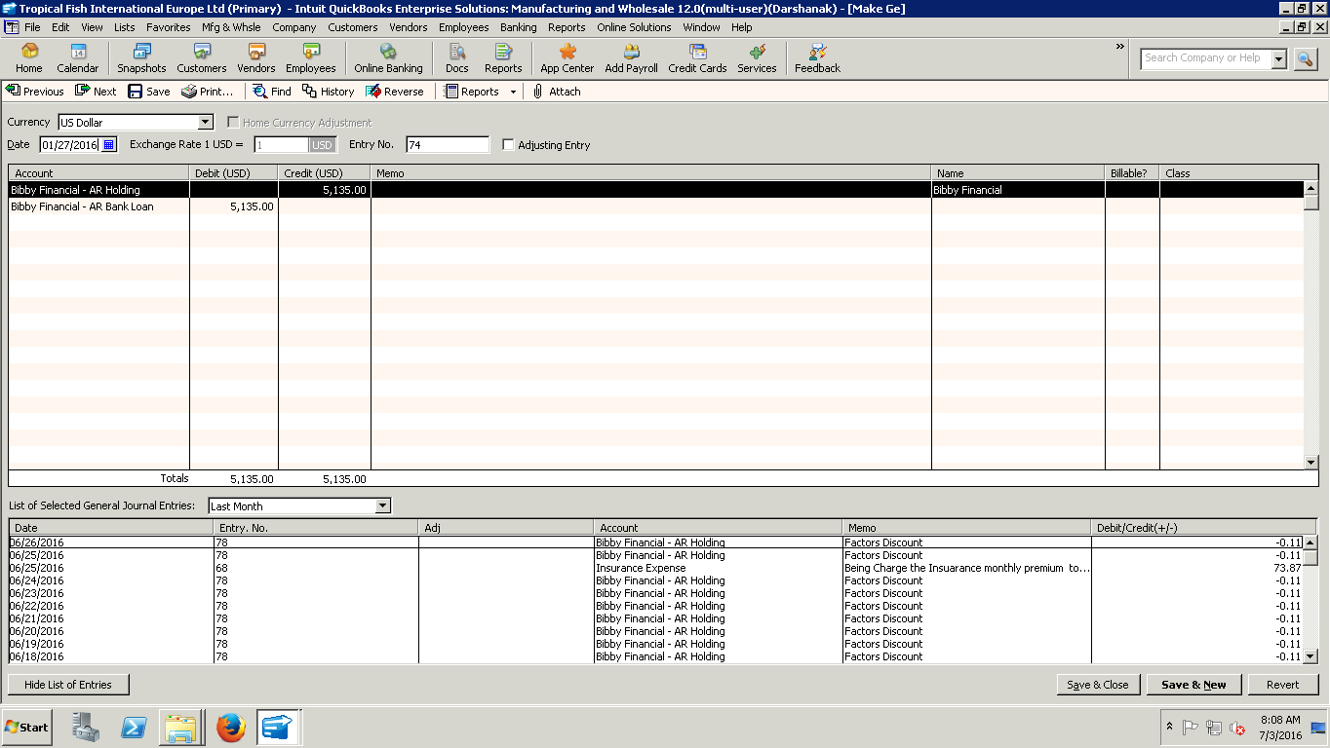

- Log into Bibby Online site and check the Client account and check the funds inflows with RBS bank account

- Record the all fund inflows in QB

