OFFICE PROCESS RECORD

Date : 16th March 2016
Process : Wire loaded in RBS A/C
Recorder : Darshana Kumara

Objective : To ensure the all Payment wires load in time

Process is as bellow.
- Get the payments approval from Sin. Accountant

- Setup the Wire template for vendors using vendor bank account details in RBS site

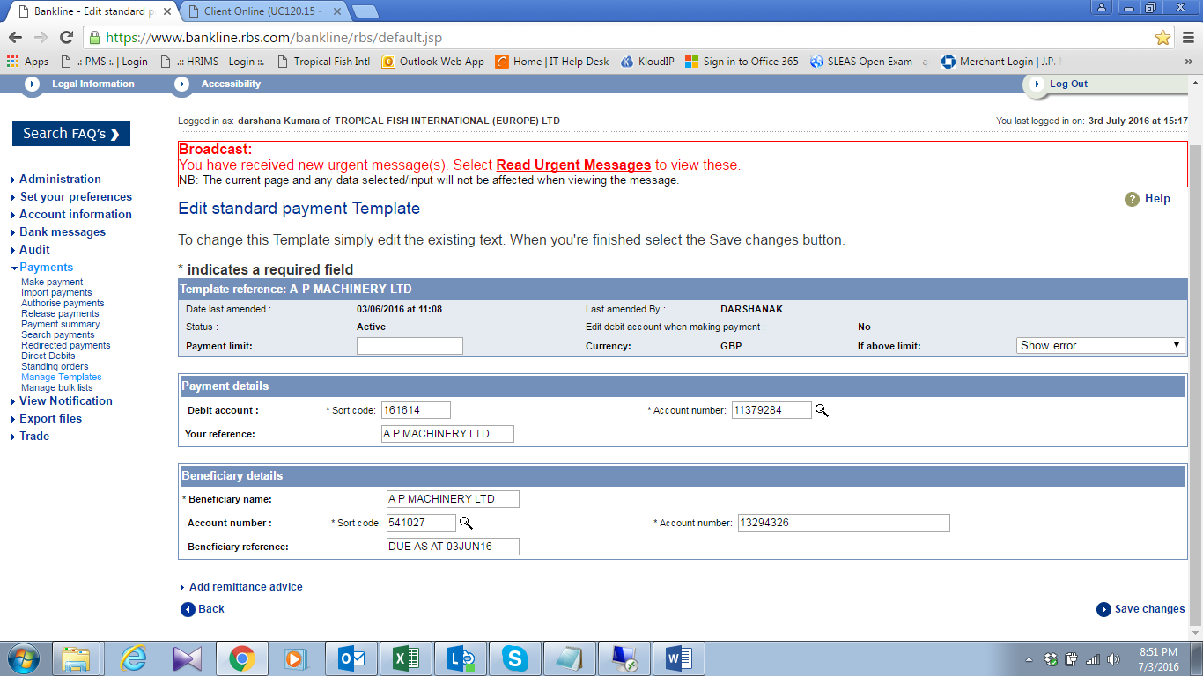

- Make the payment wire for all approved payments with using relevant wire template
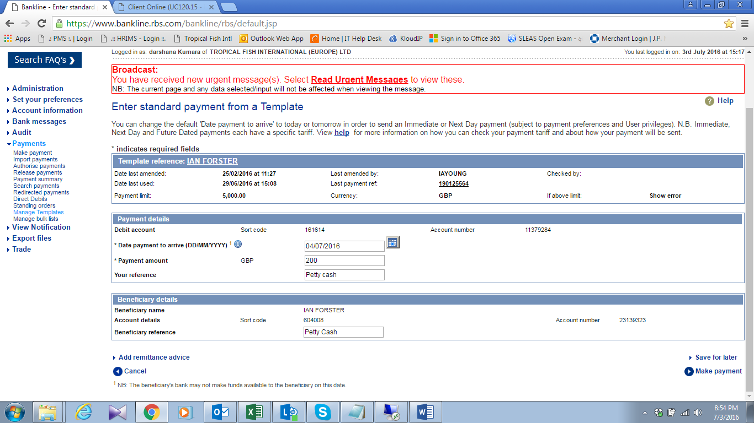

- Send the wire details to CEO to approve the payment
- Inform to vendors regarding payment details

