OFFICE PROCESS RECORD

Date : 14th March 2015
Process : Weekly and Monthly GP reports
Recorder : Darshana Kumara

Objective : Send the GP and NP reports for make the management decision

- Export the Weekly and monthly GP report from QB

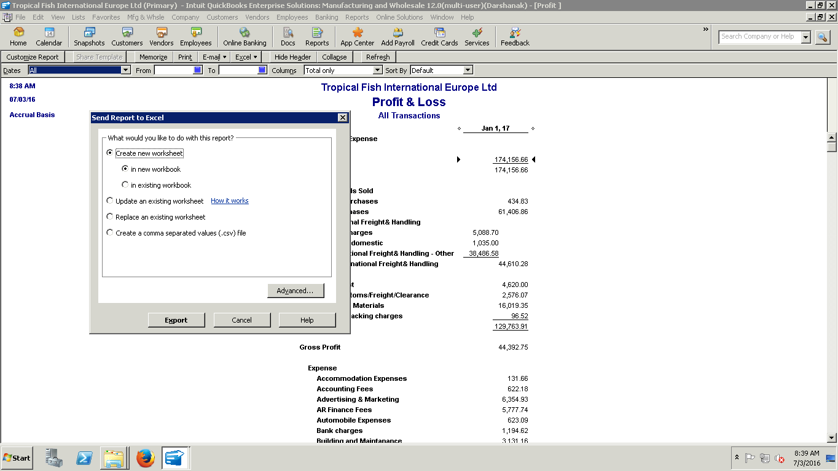

- Adjust the weekly provisions in weekly GP report and make the GP report as more usable for take the decision
- Send to Sin. Accountant to review

