OFFICE PROCESS RECORD

Date : 14th March 2015
Process : TFI UK CF preparation
Recorder : Darshana Kumara

Objective : To forecast of Cash flow for Next week

- Collecting all the bills from each week from lisa and update the Quick books accordingly.
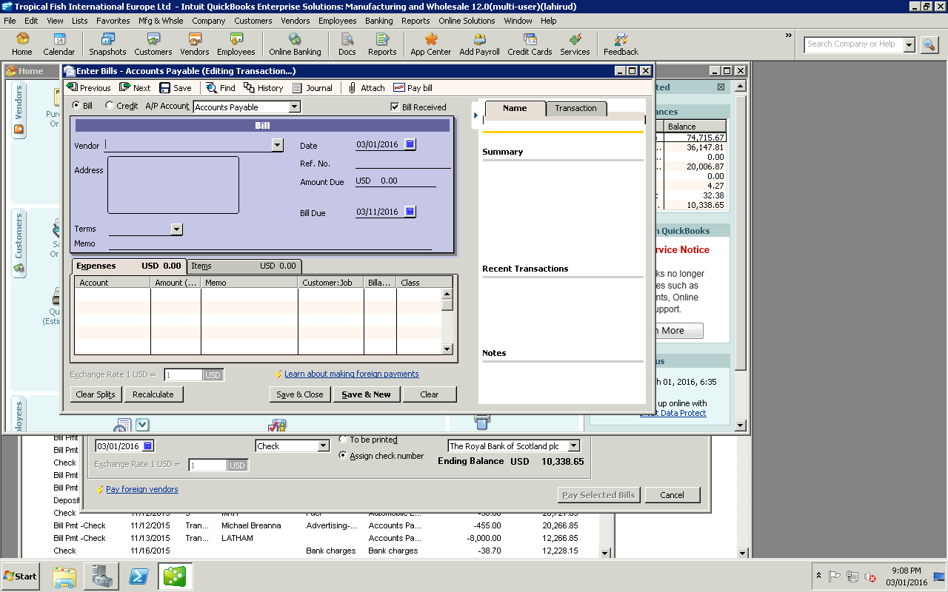

Enter amount
Select date
- Select vendor from QB. BY CLICKING THE DOWN ARROW KEY

Process is described bellow How to extract the bills from the Drop Box

- After update the Quick books run the Unpaid bill detail account and plug in the CF unpaid Bill sheet.
- 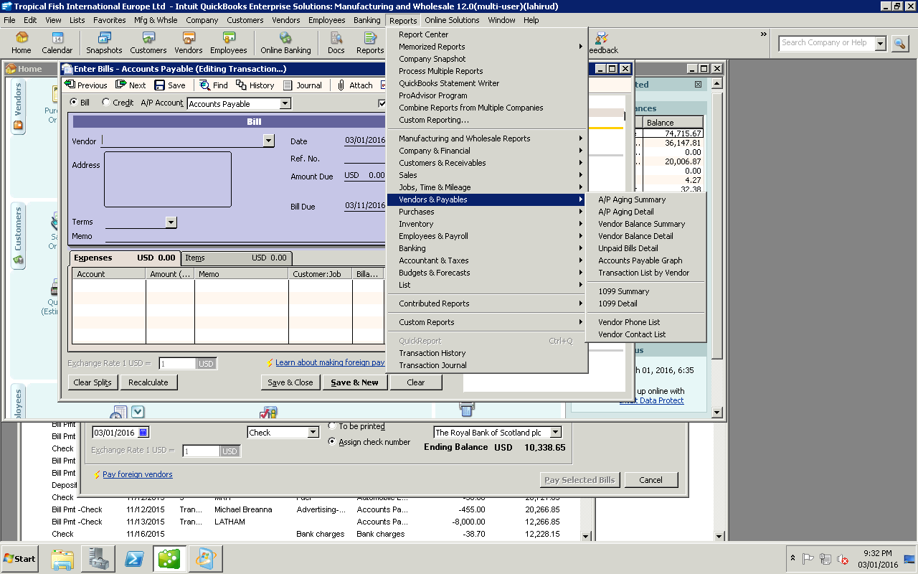

Pluging to CF unpaid bill colomn.
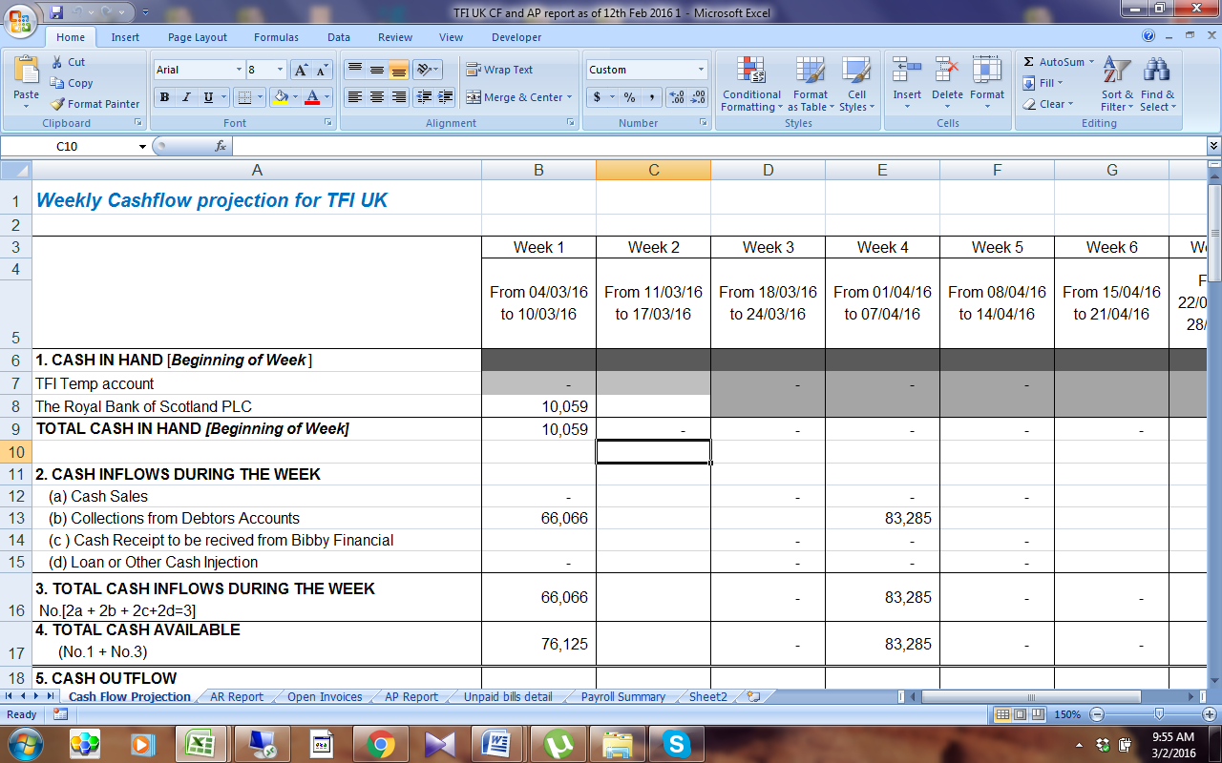
- after that run the Open invoice and AR summery report and plug in the relevant sheet.
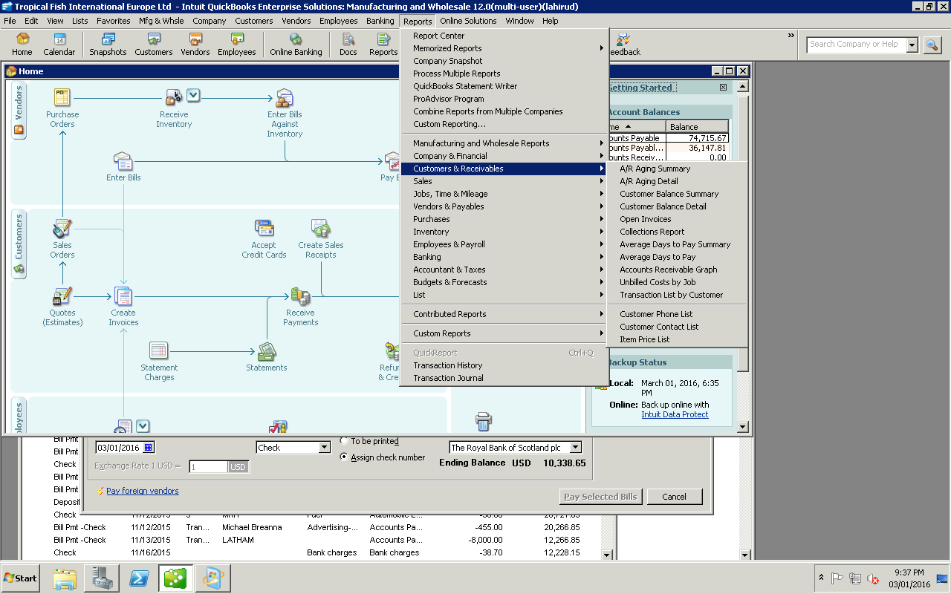
4. Give priority to expenses that need to paid urgently and allaocate to this week CF.
5. then sent to Ian Young for approval.
6 CF prepare twise in a week.
7 Need to checke daily bank balance and following are the Custormer and User ID
Customer ID 1064902.
User Name- Lahiru.
Pin No 3489
Password cistfi012345
Plugin Open invoice and AR summery reports to CF.
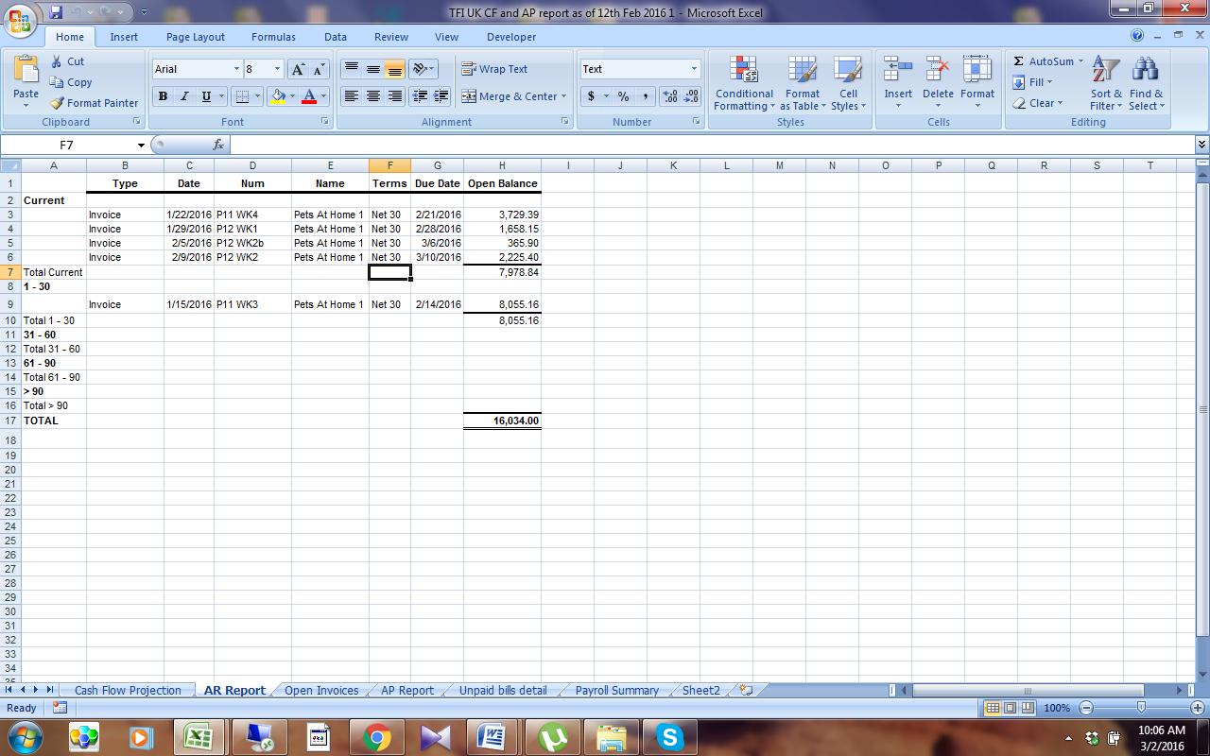



Bank access method
First click Log in
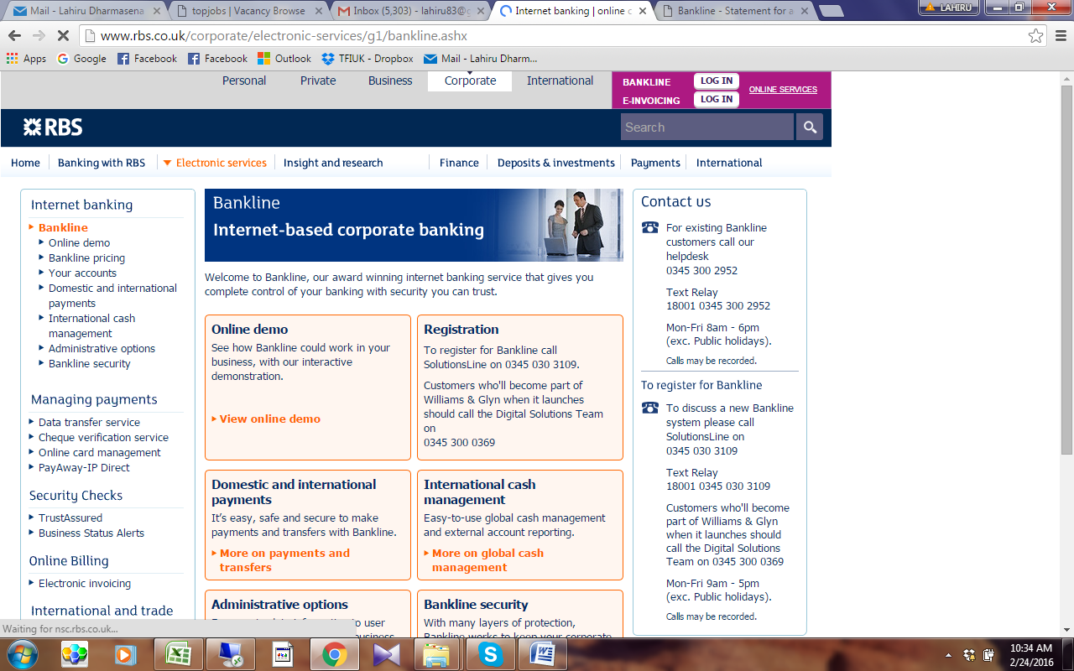

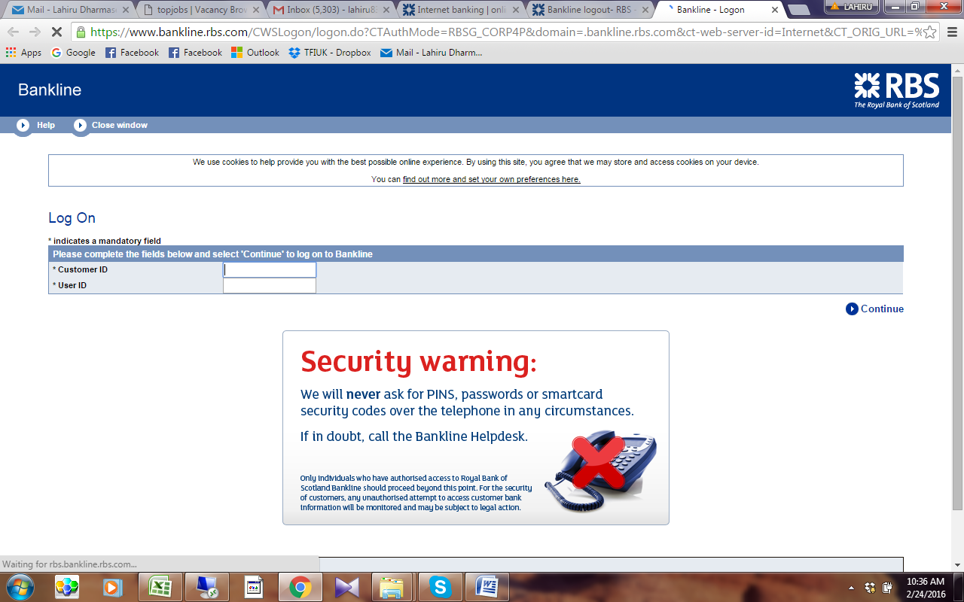
Enter custormer and User ID
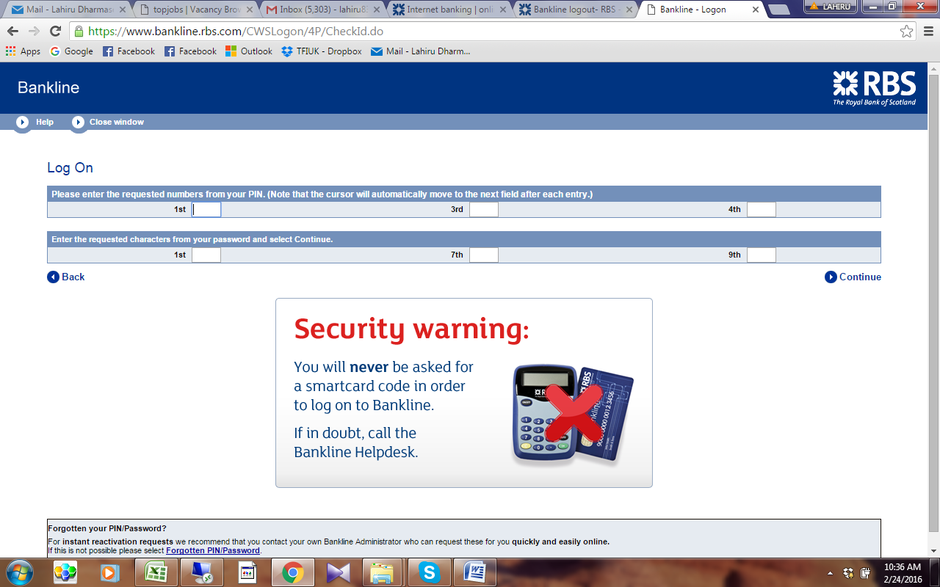

Enter Pin code and password-

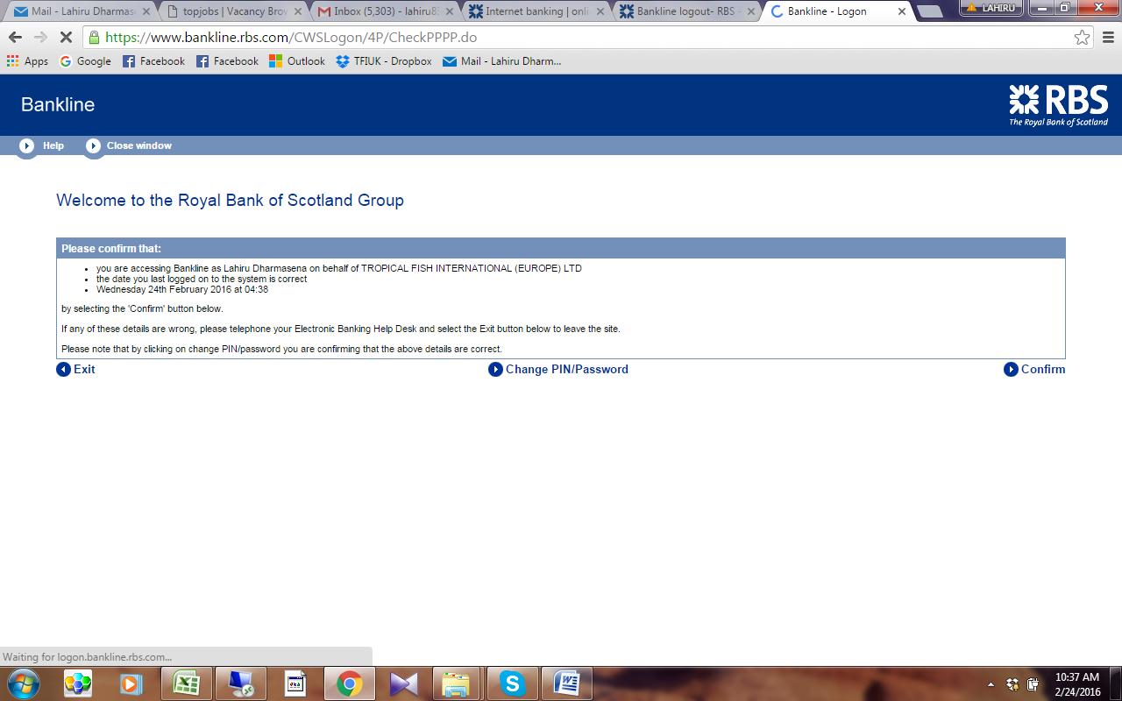

Click Confirmed
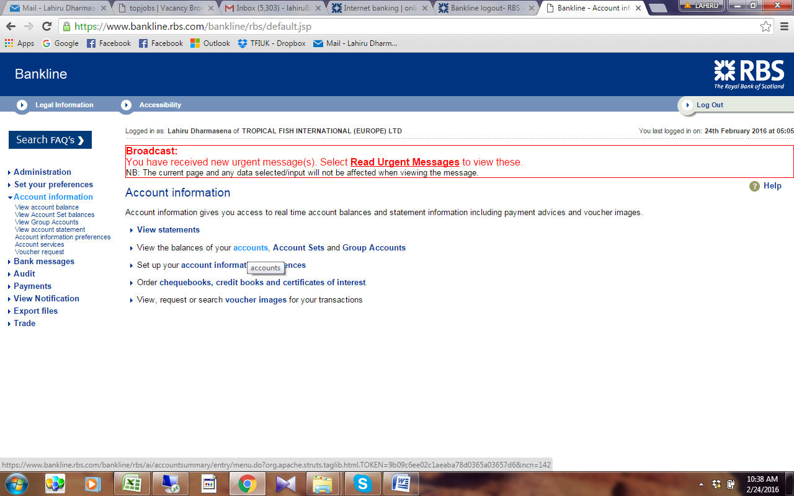

Click accounts to view the Balance
