OFFICE PROCESS RECORD

Date : 14th March 2016
Process : Betta Cups Discrepancy Work sheet
Recorder : Darshana Kumara

Objective : To verify the physical Betta Cups Stock availability in warehouse.

Process is as bellow.
- Get Betta Cups Physical Stock count from USWH (from Andy H.)

02. prepare the betta Cups Discrepancy sheet with using Physical Stock and relabeling Tracker

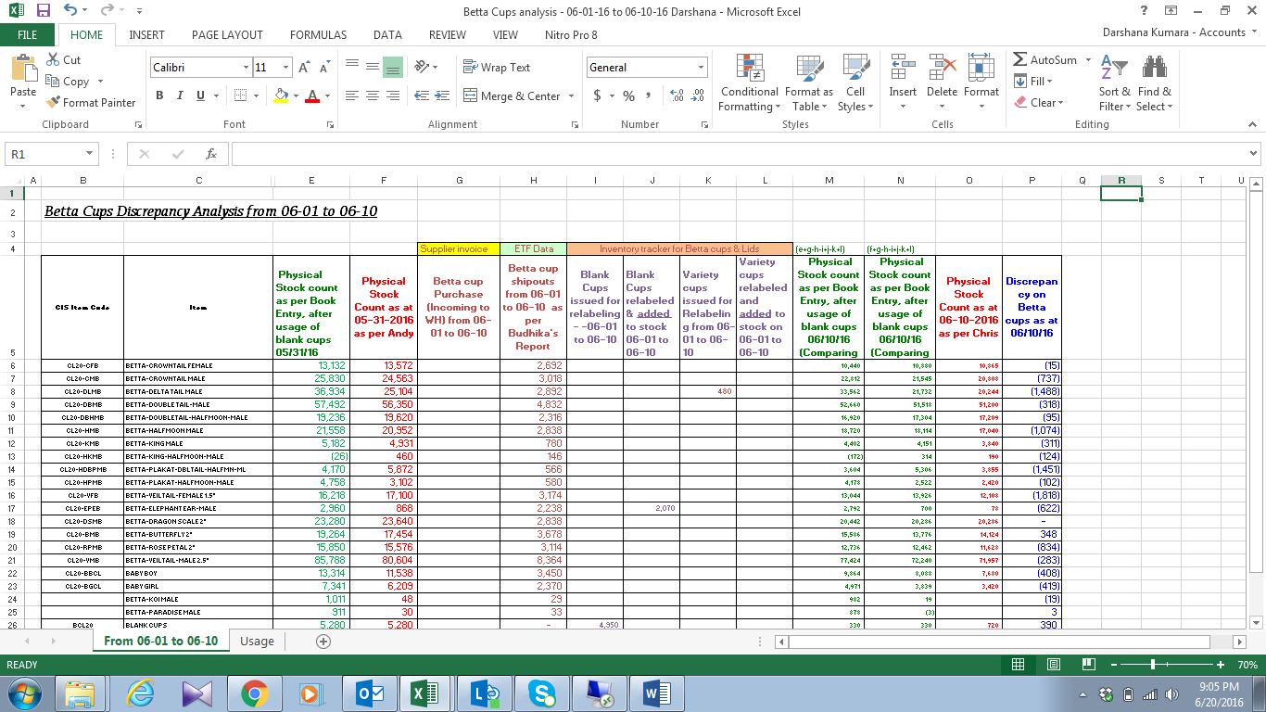

03. Enter the Bilging stock Balance , Cups shipped out in the period, Relabeling cups and closing betta cups stock

04. Get the variance with comparing QB book Balance and Physical Stock Balance.

05. Report to the Audit for review the Discrepancy.

