OFFICE PROCESS RECORD

Date : 14th March 2016
Process : Enter material Issue Note In QB
Recorder : Darshana Kumara

Objective : To ensure the Material Usage in warehouse.

Process is as bellow.
- Get the material Usage sheet send by Buddika.

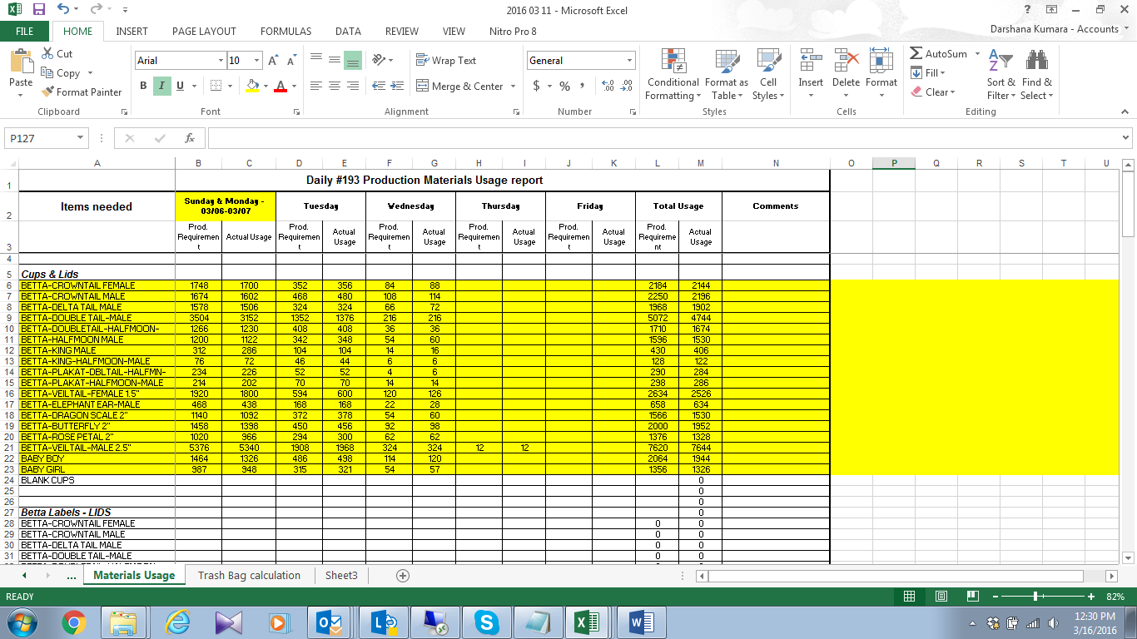

02. Create the Material Issue note in QB

