OFFICE PROCESS RECORD

Date : 14th March 2016
Process : Record the credit card transaction
Recorder : Darshana Kumara

Objective : To ensure the All credit card transaction recorded in QB.

Process is as bellow.
- Get the Credit card statement from web site or Shred folder .
- Prepare the Excel sheet with categorizing the expenses.

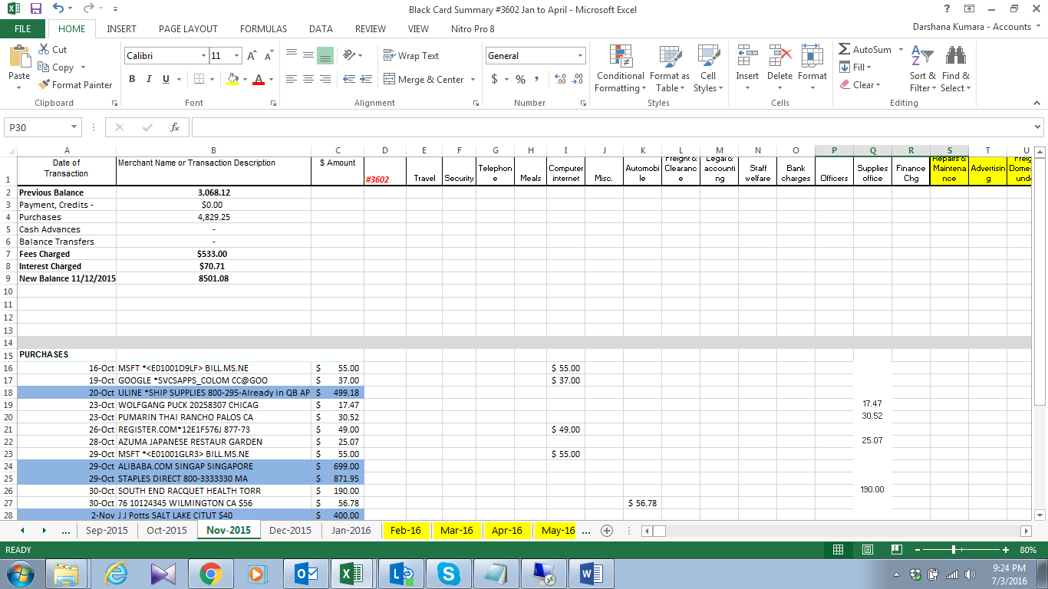

03. Send the excel sheet to Sathika to verify the expenses category
04. Enter the expenses to QB

