OFFICE PROCESS RECORD

Date : 14th March 2016
Process : Physical Inventory Verification
Recorder : Darshana Kumara

Objective : To tally the Physical Inventory and QB Inventory availability.

Process is as bellow.
- Get the Physical inventory count sheet from QB.

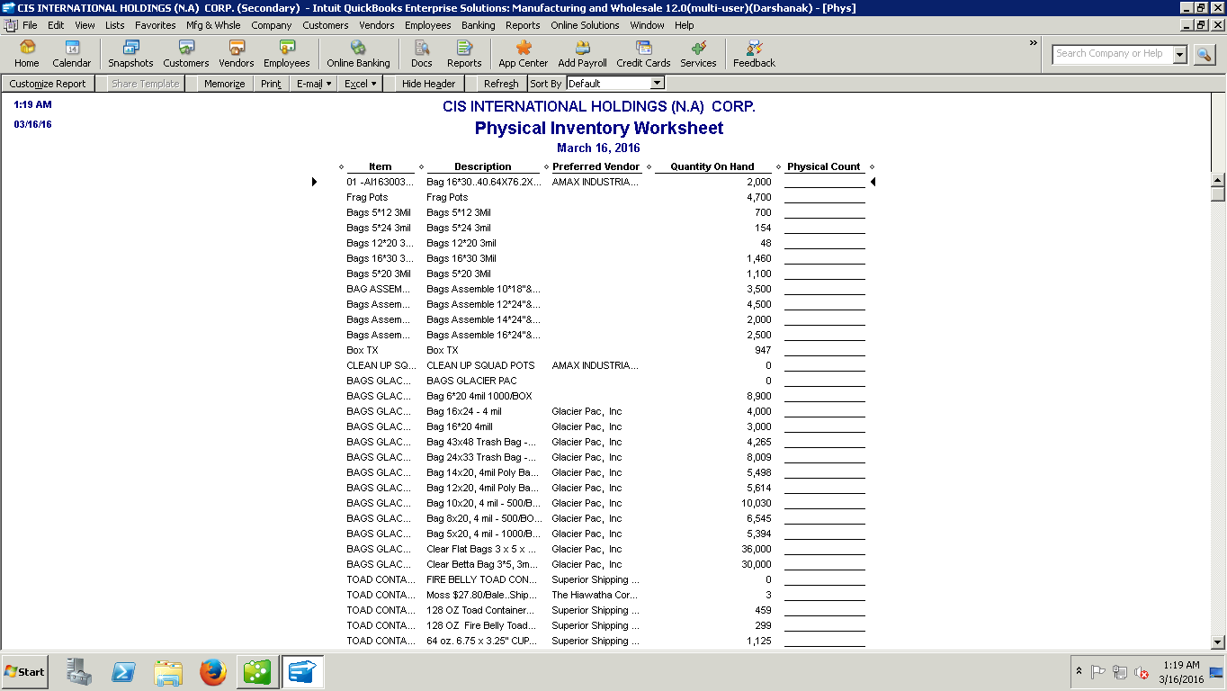

02. Prepare the Inventory count sheet in Excel and send to Chris at US warehouse

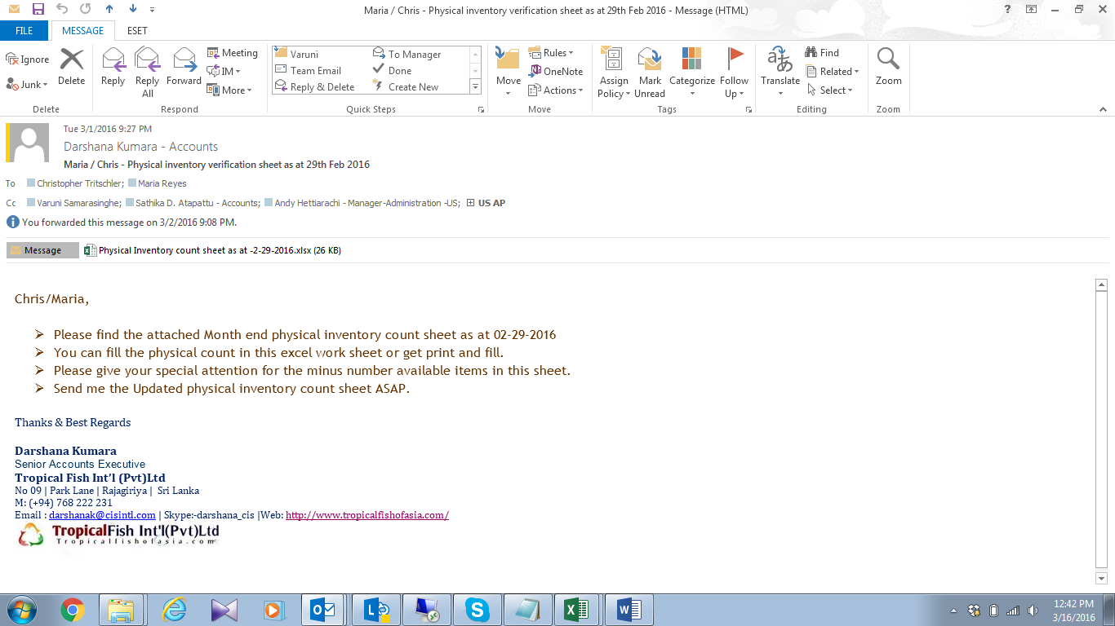

03. Follow up and get the counted sheet and adjust the QB balance according to Physical Balance

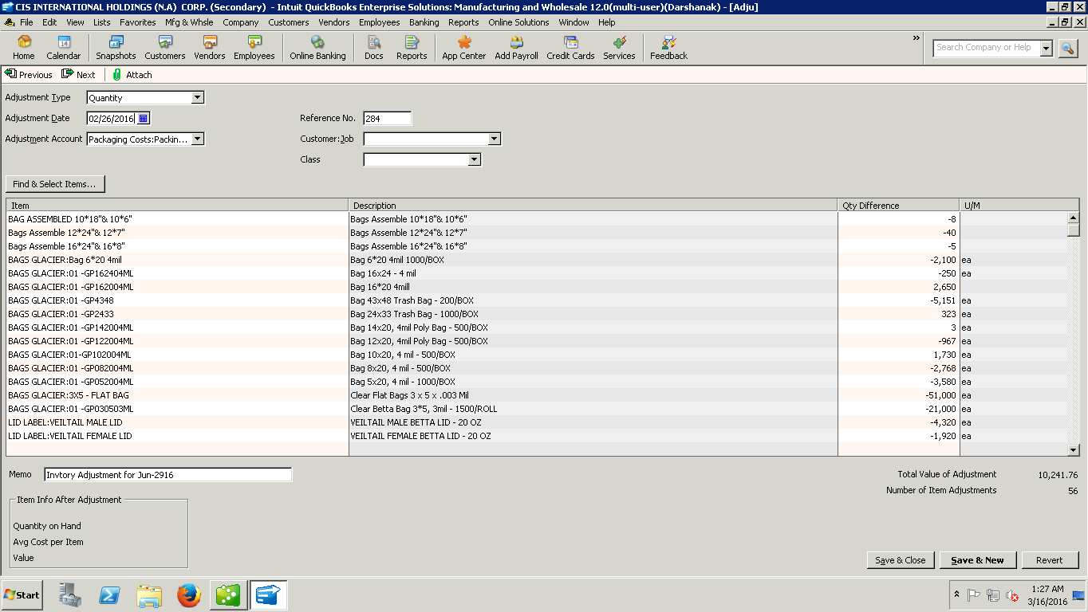

04. prepare the Stock discrepancy sheet and send to Audit

