OFFICE PROCESS RECORD

Date : 14th March 2016
Process : Commission Calculation
Recorder : Darshana Kumara

Objective : To prepare the sales commission in time

Process is as bellow.
- Prepare the Sales details excel in rep wise and send it to Sales reps to verify the sales details for the month

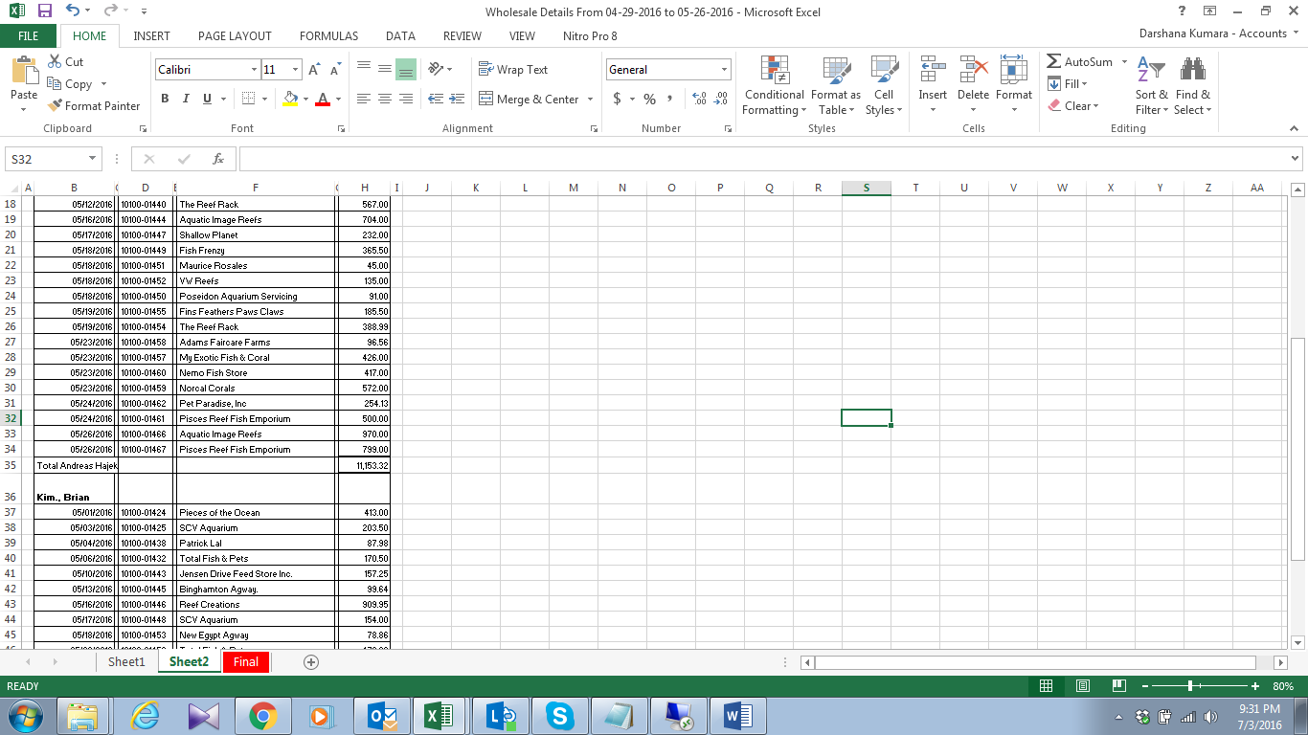

- If, the details are correct, then prepares the Commission calculation or if it’s wrong then investigate the errors disused with sales reps
- Send the commission calculation sheet to management for the Approval and make the payments

