OFFICE PROCESS RECORD

SUBJECT | Entering of the Sales Commercial Invoices
RECORDER (Name Designation) | Dulhan Nanayakkara
APPROVED BY (Name Designation) | Stanley Samidas
CREATED DATE | 28th February 2016
NO. OF PAGES INCLUDING THIS PAGE | 02

Objective : To ensure all the Invoices recorded and verified for the Final Accounts

1. Final invoices and Air way Bills will be saved in FTP folder by Siam officer. Take those scan images and two excel Workbook to own folder for easy use.
2. Enter Invoice in to the QB (Path is, Log in to QB - Select "Create Invoice" in Home Page / Select Customer / Select Class / Enter Invoice Number / Select the Date of Invoice / Then Enter Qty, Item Code, Description, Class and Total Thi Bhat Value of that Item under Amount column.
Note - In Description Column Should be Noted the "Total USD value of Relevant Item and Exchange Rate" in front of the Item Description (Eg. - Crown Tail Betta (Male) - US $ 443/- @ Ex.Rate THB 35/-) - Fish Name and Scientific Name will come automatically in to description Column when you select the Item code. The Exchange Rate of USD on the Date of Invoice can be received from the Bank of Thailand Web Site.
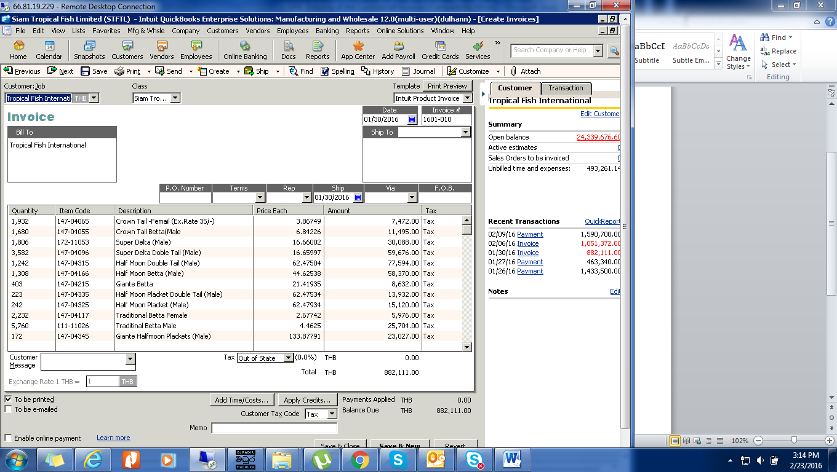
3. After entered an Invoice Completely, Check Total Value of Entered Invoice with Total Value of Commercial Invoice / then select "Save & Close" Button
4. Convert the Invoice in to PDF then send it to USA via e-mail (To – USAP and Order Entry. Cc – Sathika D. Athapattu)
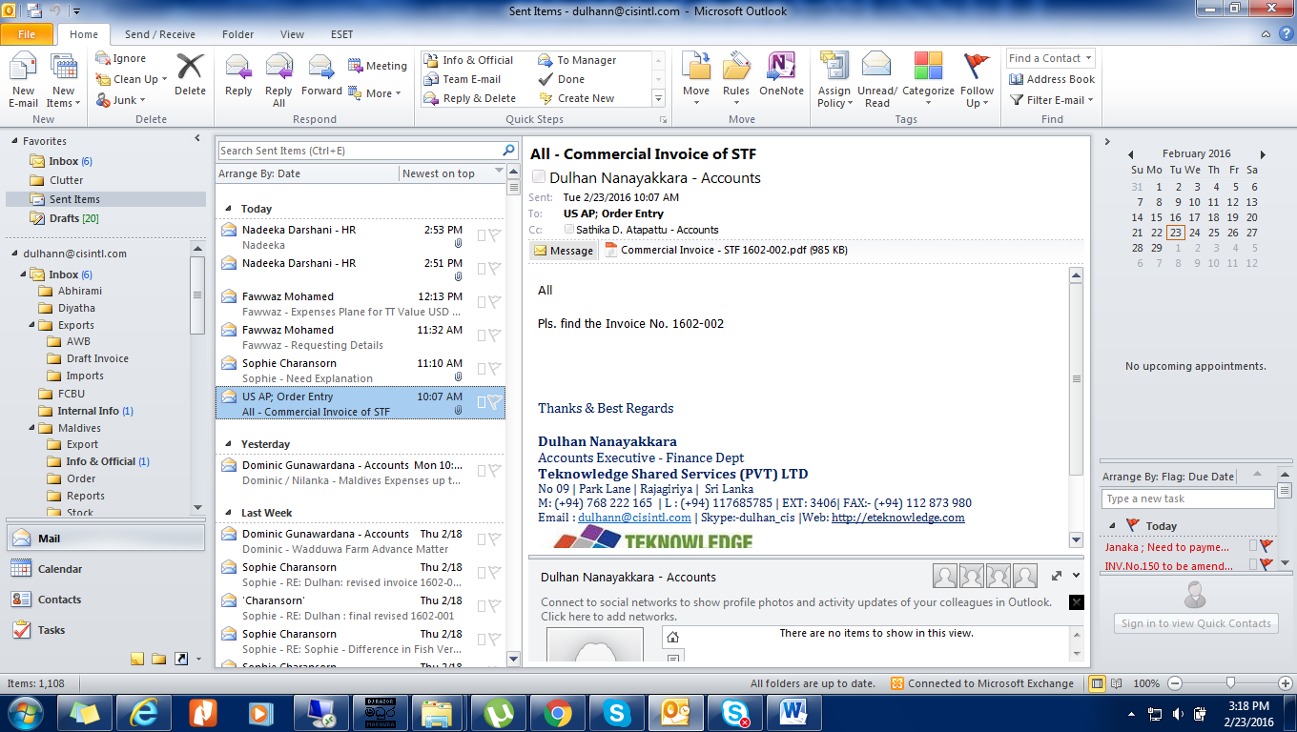

Note – Save the Commercial Invoice in the Network folder.

