OFFICE PROCESS RECORD

SUBJECT | Raise PO's for the Purchasing of Live Fish
RECORDER (Name Designation) | Dulhan Nanayakkara
APPROVED BY (Name Designation) | Stanley Samidas
CREATED DATE | 28th February 2016
NO. OF PAGES INCLUDING THIS PAGE | 02

Objective : To ensure the company purchasing process and verify the cost of sales

- Receiving the POs form Thailand (Image of Documents will be saved in FTP Folder and also summarized details are in two excel Workbooks).
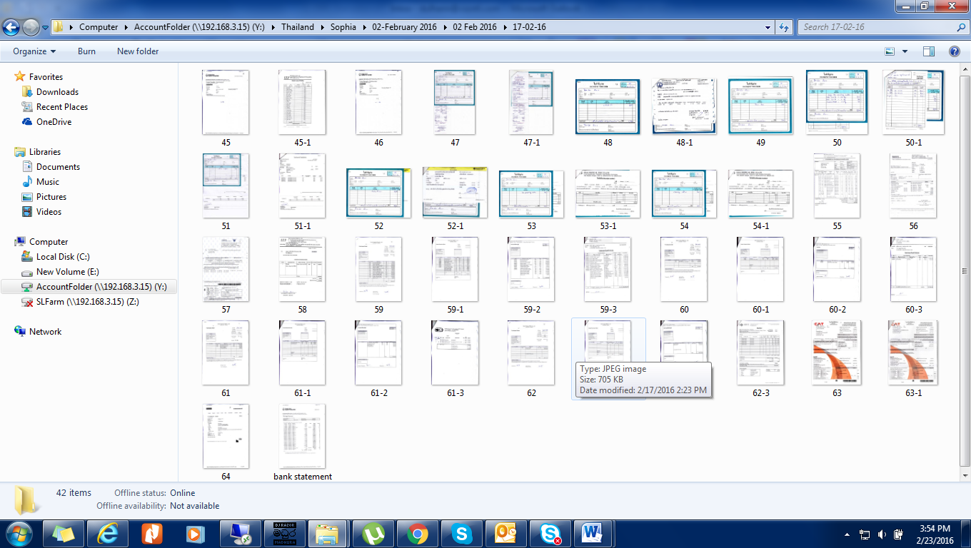

- Log in to QB - Select “Purchase Order” in Home Page / Get Confirmed that the PO Number Series is Correct / Select Vender Name / Select Class / Now Fill Other Details (Eg- Items, Description, Qty and Unit Price Etc....) / Select "Save & Close" or "Save & New" Button.
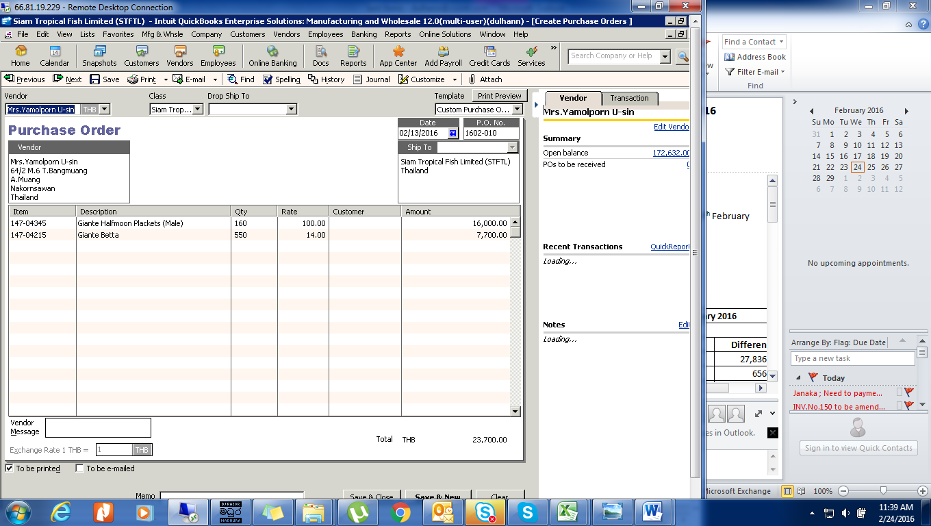
- Ensure the item Qty, Item prices and total value of the PO are complying with the value of PO Image which you received from Thailand. (Always check the Supplier invoices to identify the sample Qty and DOA compansation Qty)
