OFFICE PROCESS RECORD

SUBJECT | Recording the Bank Transactions and reconcile the bank a/c
RECORDER (Name Designation) | Dulhan Nanayakkara
APPROV28th February 2016ED BY (Name Designation) | Stanley Samidas
CREATED DATE | 28th February 2016
NO. OF PAGES INCLUDING THIS PAGE | 04

Objective : Ensure all bank transactions have been recorded correctly and identify the purpose of payments and cash status of the company.
1. Open the Payment & Invoice Info excel workbook and check the details in the Fund Transfer sheet with scan copies.
2. Record all bank payments in the QB (Go to QB Home – Pay Bill – select vendor name (Ref. Pic. 01) – put ✔ mark on paid bill (Ref. Pic. 02) – Select the bank a/c (Ref. Pic. 03) – set the payment date – click the “pay Selected Bill” – then;
i) If only that bill is to be paid click “Done”
ii) If more bills have to be paid click “Pay More Bill”

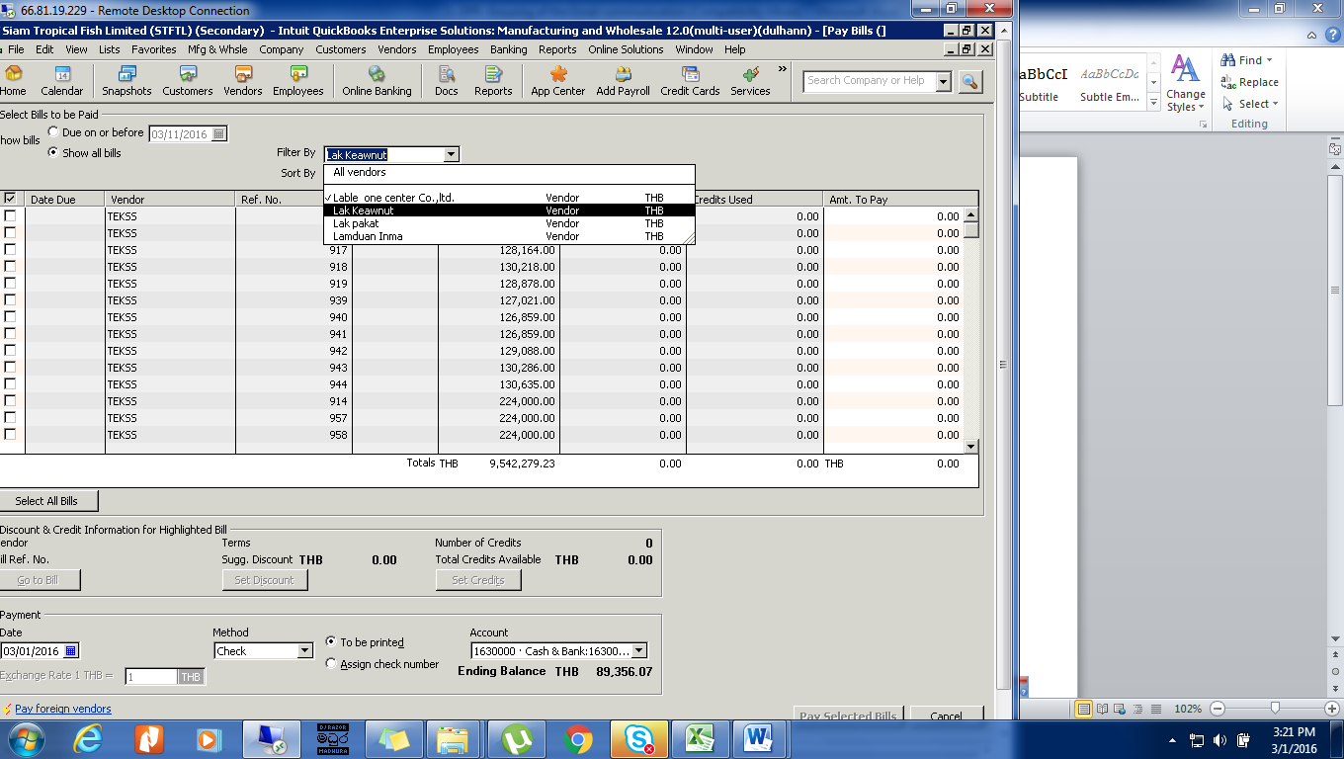
Pic. 01
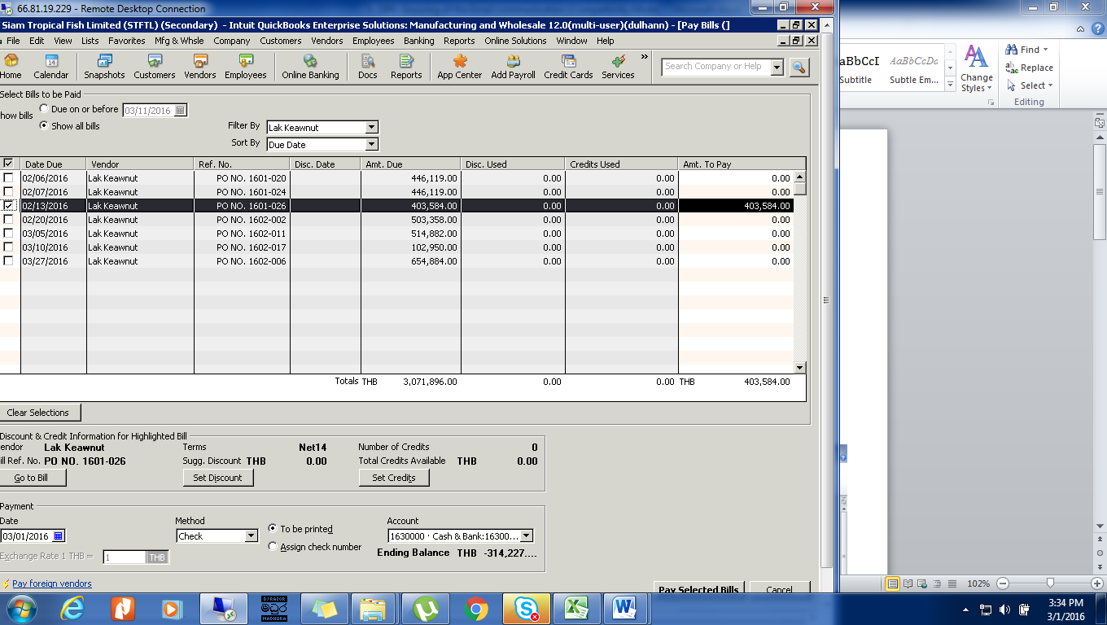
Pic. 02

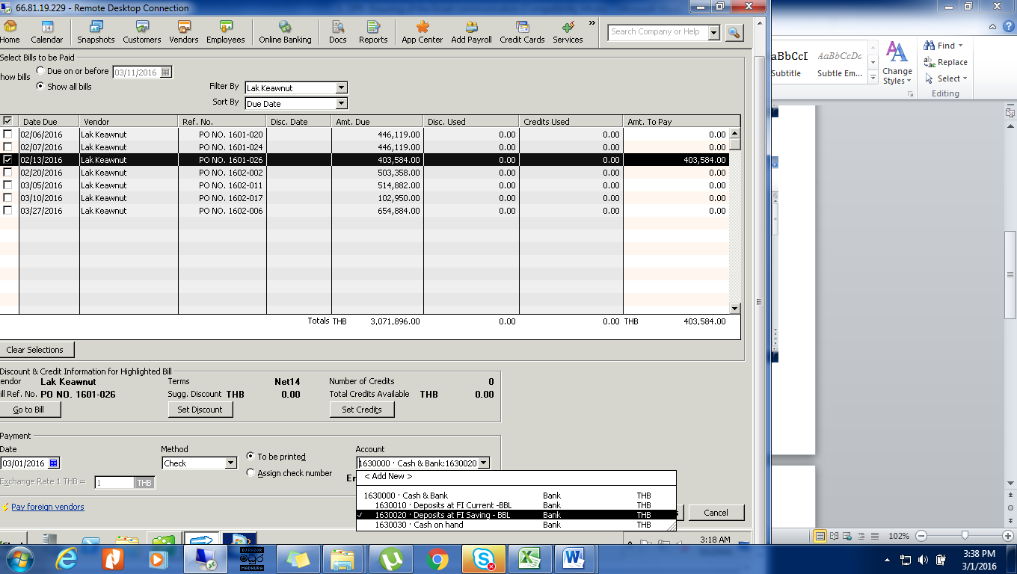
Pic. 03
03. Go to QB Home – Write checks – select the bank a/c (Ref. Pic. 04) – select the “previous” to go to paid bills – then remove the ✔ mark is in front of the word “To be printed” (Ref. Pic. 05) – then enter the payment no. (You can find it from the excel sheet or scan copy of the Bill) – Select the “Save and close” or “Select and New” as your requirement.
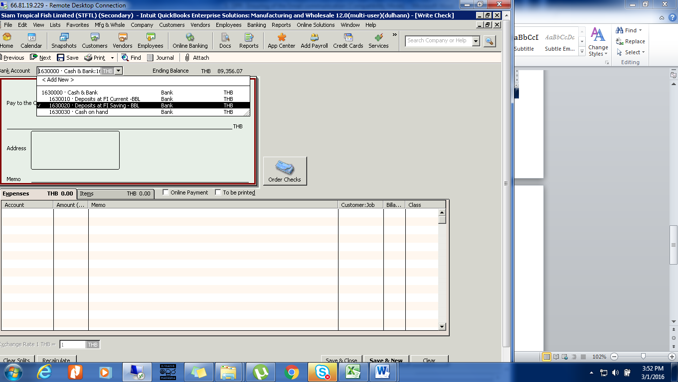
Pic. 04

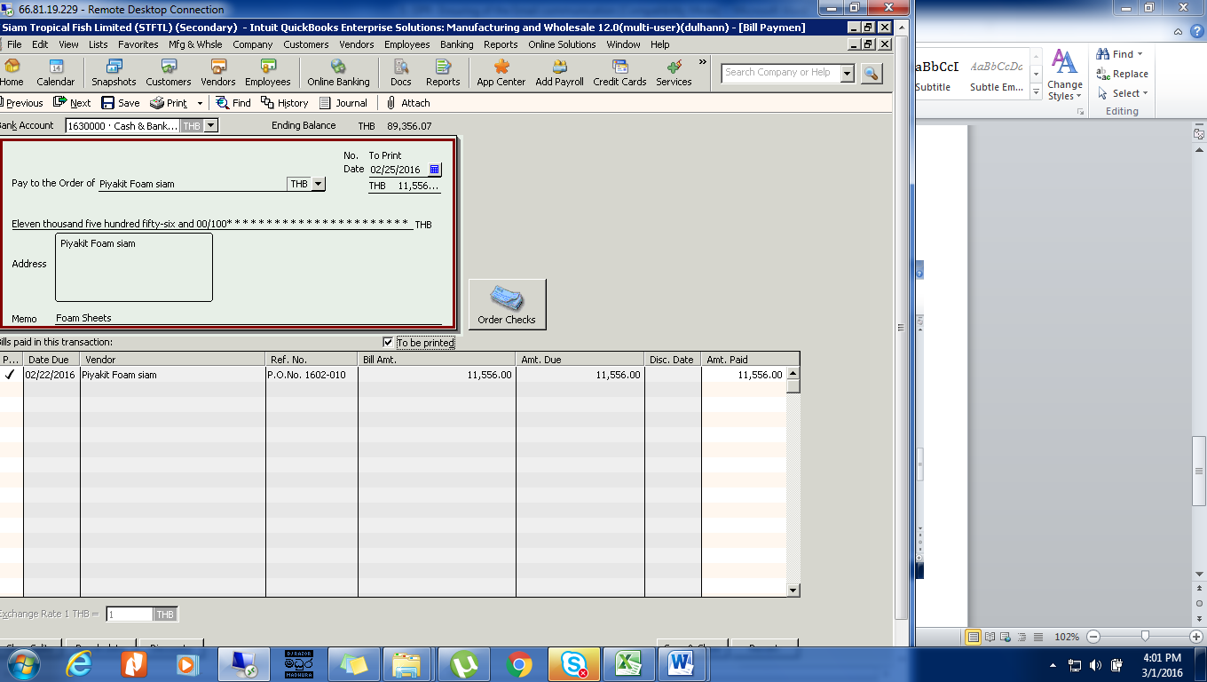
Pic. 05

