OFFICE PROCESS RECORD

SUBJECT | Recording the Petty cash Transaction
RECORDER (Name Designation) | Dulhan Nanayakkara
APPROVED BY (Name Designation) | 28th February 2015
CREATED DATE | 28th February 2015
NO. OF PAGES INCLUDING THIS PAGE | 03

Objective : To ensure all the petty cash transactions have been entered correctly and verify the purpose of cash usage.
- All bills and Invoices will be saved in the FTP Folder (path – Account Folder (\\192.168.3.15) - Thailand – Sophia – Find the correct month and folder to get scans of bills, invoices and other documents and also two updated excel sheets )
- Base on the two excel sheets for recording the Siam transaction
- Unpaid Bill Workbook – all accrual bills are mentioned in this sheet (Very Important at the preparing of AP Report
- Payment & Invoice Info Workbook – Petty cash details, Fund transfer details, Invoice Details and cash receiving details are in this sheet

Eg- Payment & Invoice Info Workbook
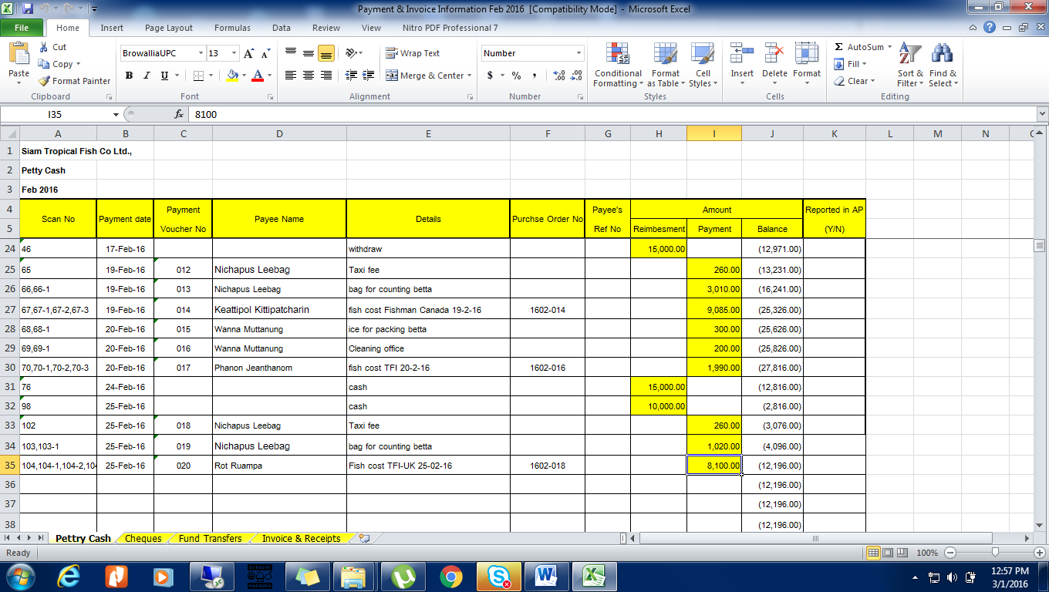
Eg- Unpaid Bill Workbook
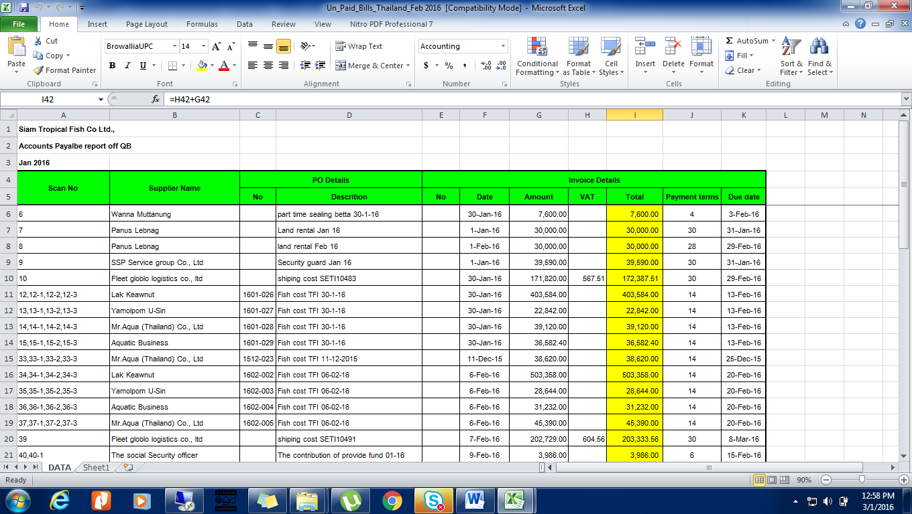

3. Record petty cash bills as payments (don’t enter the petty cash bills in to QB) (QB Home – Write Check – Select the petty cash A/c (Ref. pic. 01) – Enter petty cash bill details (Ref. Pic. 02) – Select “Save and Close” (If you enter more than one select “Save and New”)

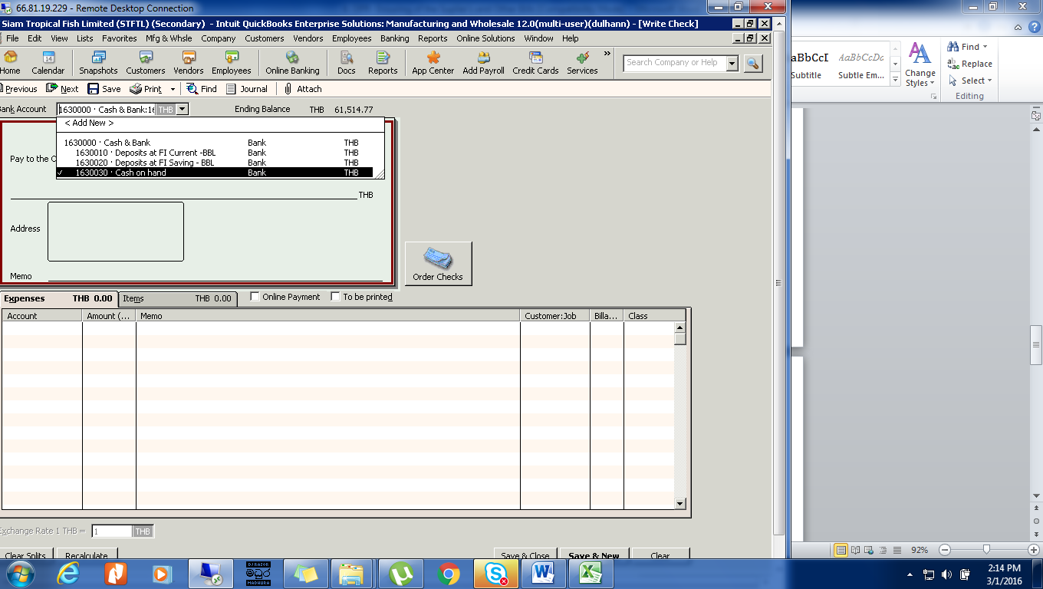
Pic. 01

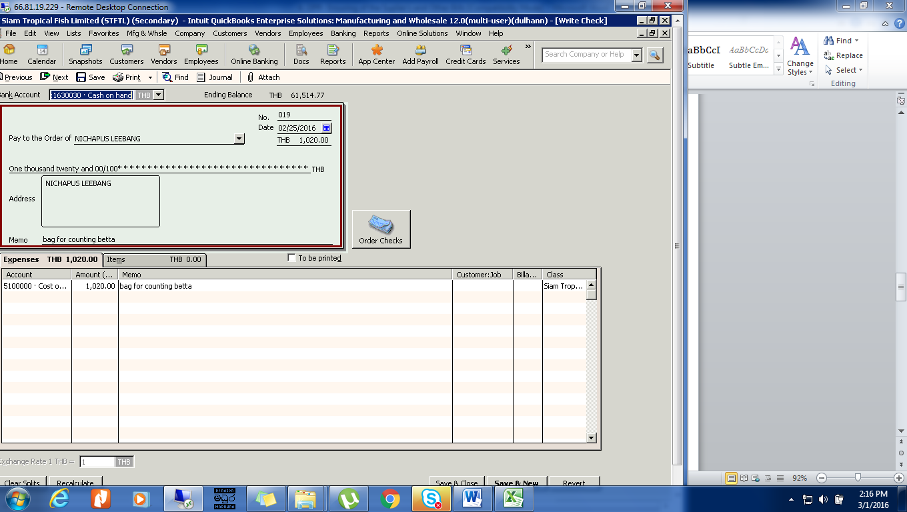
Pic. 02

5. Check Excel sheets data against scan copies to ratify that there is no any misplaced Bills, Invoices and error values.

