OFFICE PROCESS RECORD

SUBJECT | Reconcile the Siam Inventories
RECORDER (Name Designation) | Dulhan Nanayakkara
APPROV28th February 2016ED BY (Name Designation) | Stanley Samidas
CREATED DATE | 28th February 2015
NO. OF PAGES INCLUDING THIS PAGE | 02

Objective : To ensure the accuracy of Inventories and Financial Statements.

- Siam is not maintaining a fish stock. They purchase fish one or two days earlier before the Shipment day. Therefore after the shipment there should not be a fish stock or qty.
- To verify the Stocks (Go to QB Home – Reports – Inventory – Inventory Stock Status by Item (Ref. Pic. 01) – then check the on hand Qty.
- If there is any on hand Qty, it sould be verified to identify the reason for that.
- If there is no any on hand Qty, make sure that is correct or not.
- This task base on the analytical skills.
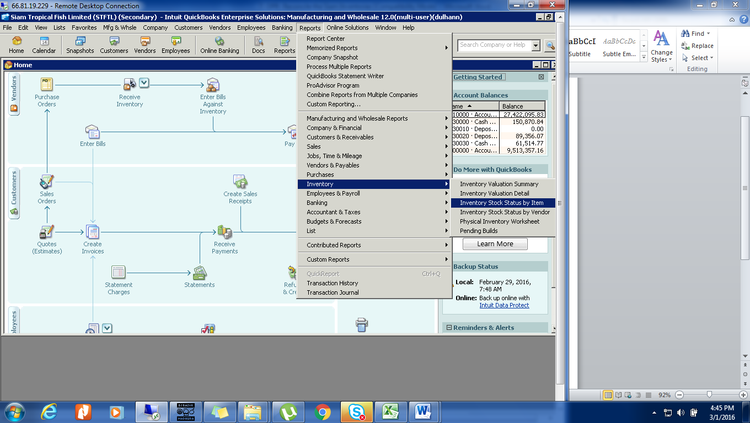
Pic. 01

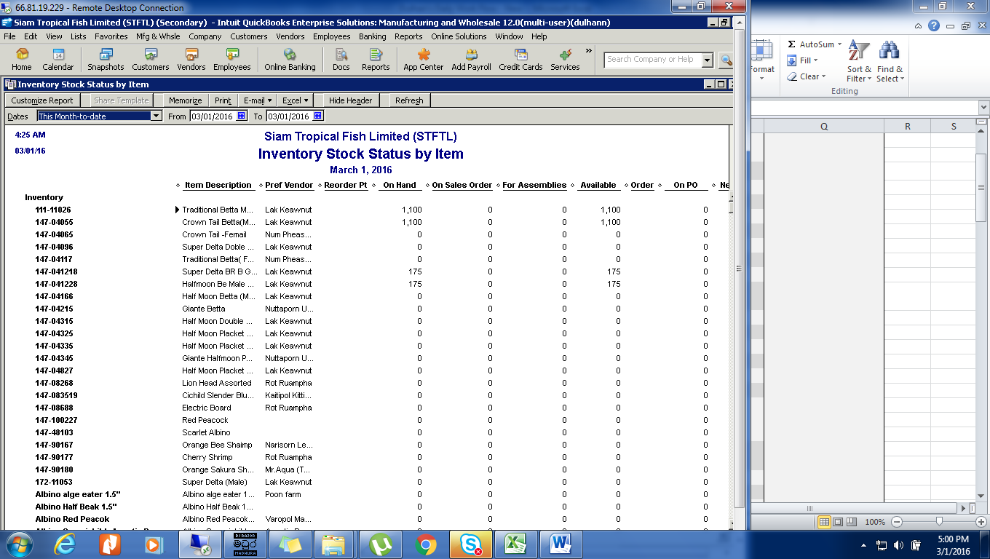
Pic. 02

