OFFICE PROCESS RECORD

SUBJECT | Recording the Wire Receiving and Invoice Settlement
RECORDER (Name Designation) | Dulhan Nanayakkara
APPROV28th February 2016ED BY (Name Designation) | Stanley Samidas
CREATED DATE | 28th February 2015
NO. OF PAGES INCLUDING THIS PAGE | 04

Objective : To ensure the customers Invoice settlement and record the cash receiving correctly.

- Open the Payment & Invoice Info Workbook and check the “Invoice and Receipt” Sheet (Ref. Pic. 01) to identify any receipts have been received or not.
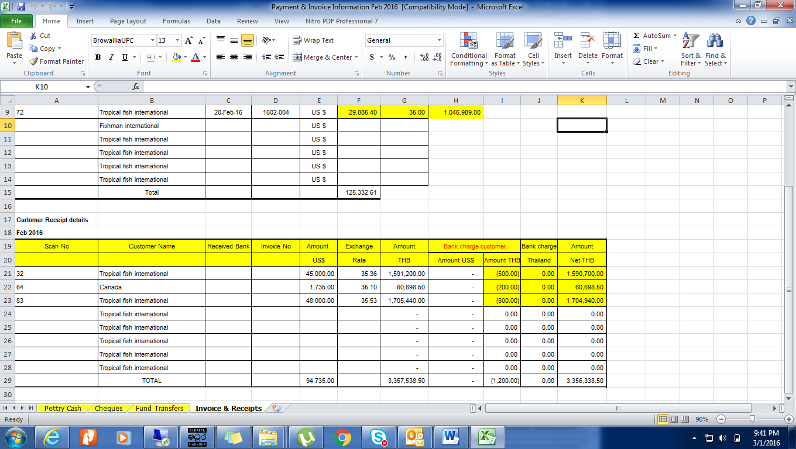
Pic. 01
- If there is a receipt from customers, it should be recorded in QB against the customer Bill. (Go to QB Home – Receive Payments – Enter the details of Wire Receipt (Ref. Pic. 02) (Enter the net value in the Amount Box that mean, net value after diducted the all charges) - (QB will select the Customer invoices automaticlly – Remove the ✔ mark of the alst Invoice – Select “Discount & Credit” Button (Ref. Pic. 03) – Select “Discount” Tab – Enter the Bank charges, Select the Bank charges A/c and select the Class – Click “Done” – Then put the ✔ mark for the next invoice according to the sequence of the invoice list – Select “Save & Close”).
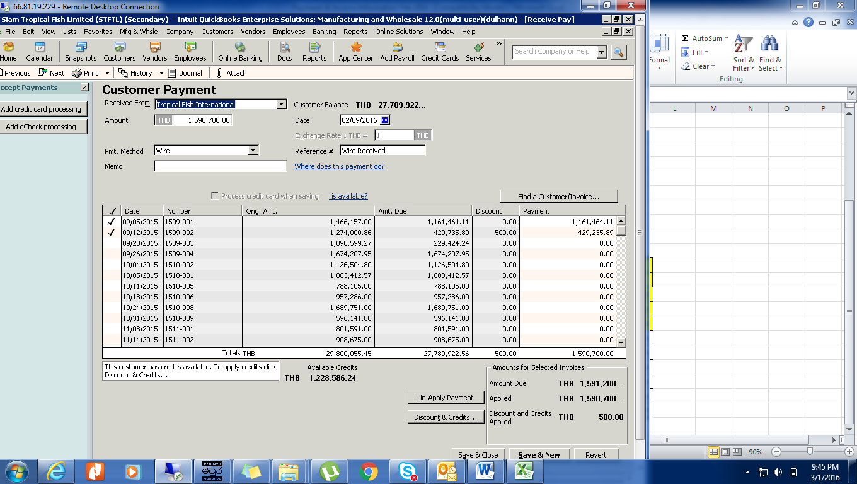
Pic. 02

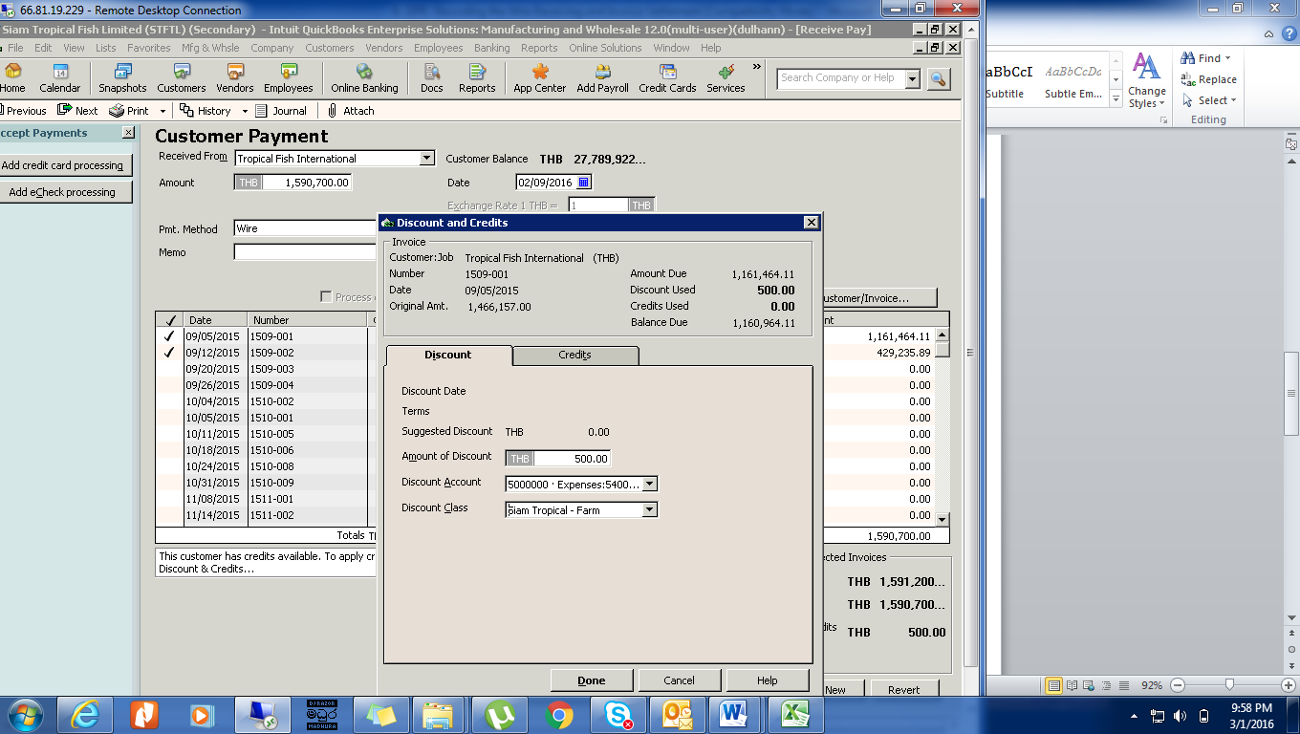
Pic. 03

- Now (Go to the QB Home – Record Deposit – then a window will come (Ref. Pic. 04) – put the ✔ mark in the first column against the payment deatis indicating row – select OK – Select the Correct Deposit A/c (Ref. Pic. 05) – Complete other requesting deatails (Memo, Class etc….) (Ref. Pic. 06) – Select “Save & Close” )
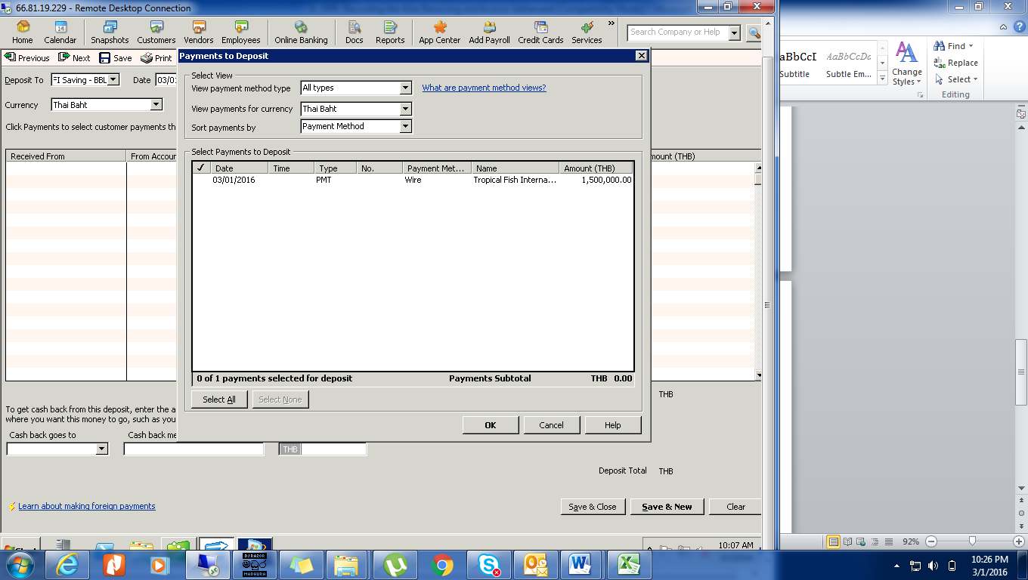
Pic. 04

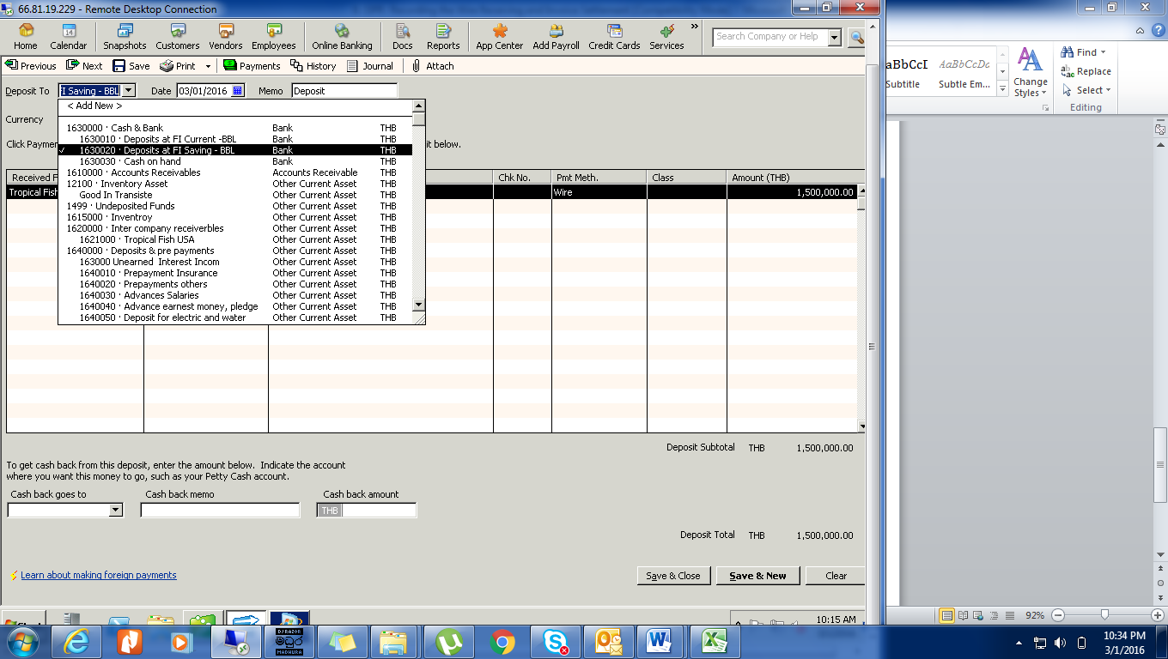
Pic. 05

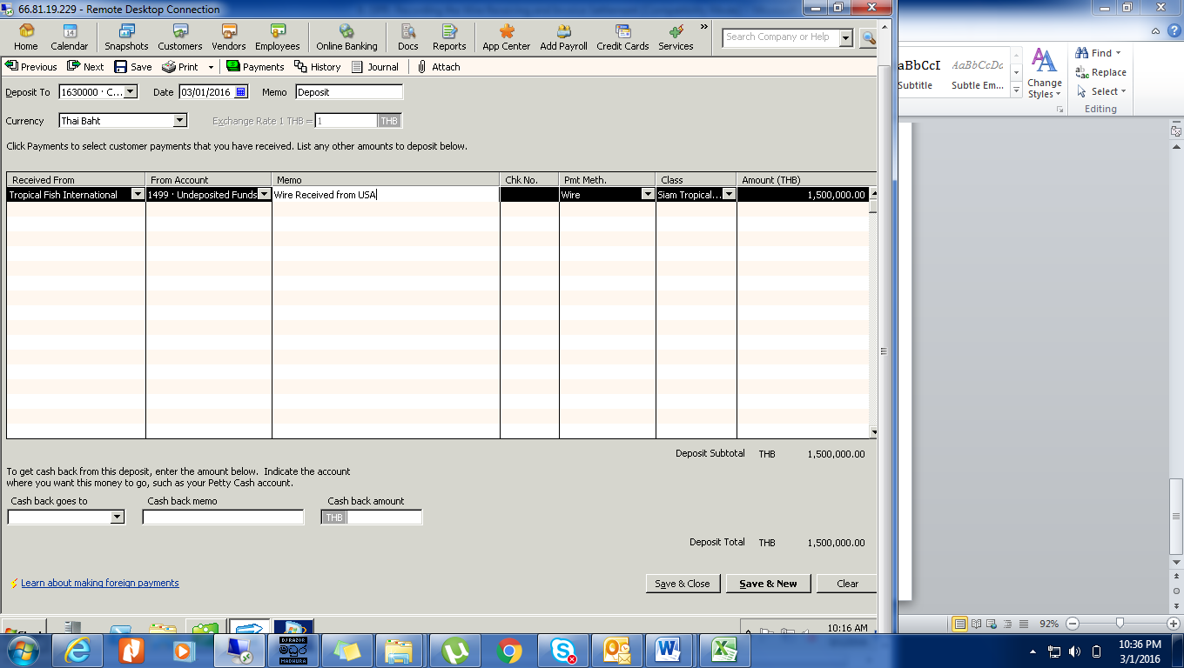
Pic. 06

